Intro to electricity

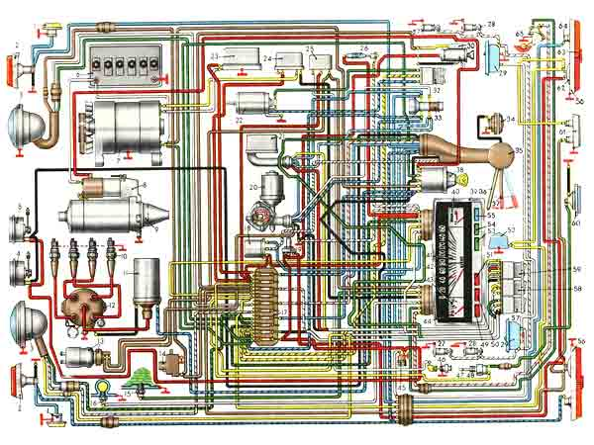

By Kevin Ruby
Introduction

This activity book was created to help you as a student to practice and grasp the concepts of Ohm's law and how they relate in various types of circuits. The activities contained in this book will help you develop these basic skills and so that we can take that understanding to a higher level through complex thinking in class. Upon completion of this book feedback will be given and you will then be asked to apply these skills in a real life experience in the lab using actual components and parts.

Contained in this workbook are basic principles that govern electricity, such as Ohm's law, that are then demonstrated by the construction of the various types of circuits like series and parallel along with combination circuits. There are several modules that you will complete that will help you understand the difference between each type of circuit and also how to apply the laws that govern amps, ohms, and volts, in the different types of circuits. Also included in this workbook are several common problems that can occur with electrical circuits.

Laws of electricity
The definition of electricity is the movement of electrons from one atom to another. Electrons are very small—so small that in order for you to seem them you would need an electron microscope. Understanding the concepts of electricity for many students can be one of the hardest and most stressful things to learn. Your success in this program and in this industry greatly depends on your ability as a student to grasp these concepts and master the test procedures that are associated with testing electricity within a circuit.
Within a working circuit you have a positive and a negative side of the circuit. In order for the electrons to flow from a power source through a circuit from the positive to negative post there needs to be an imbalance between the two posts. The theory that electrons move from positive to negative is called the conventional flow theory and it is the theory we use in this industry.
A properly constructed circuit will have all of the following components:
- Power source
- Circuit protection
- Switch or control
- Insulated path for electrons to flow through
- A load
- Return patch for electrons to flow back to the power source
In a properly working circuit, items 2, 3, 4, and 6 will have little to no resistance, while the load will have some form of resistance because it is designed to do the work. The load in a circuit will help to determine the amount of electrons that will make the trip from positive to negative on the battery.

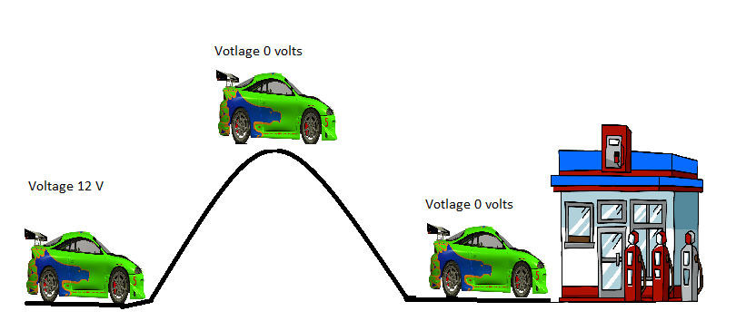

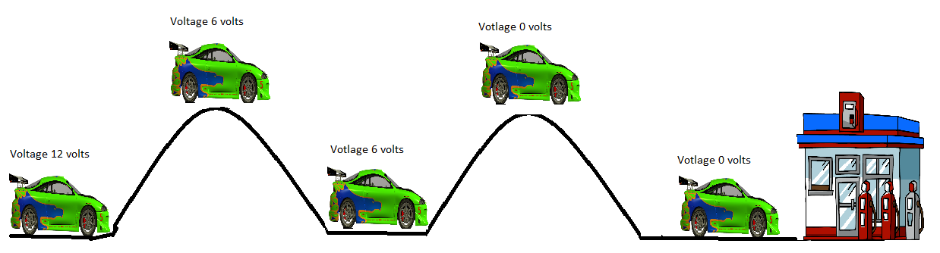

Voltage
In order for electrons to flow from positive to negative you need pressure. Voltage is the pressure in a circuit and the higher the pressure, the easier it is for these electrons to make the trip and to perform the work. Voltage drops in accordance to loads in the circuit. See the example of the car going over the hills to get to the gas station. This is much like how voltage flows in a circuit.

Amps
The measurement of electron movement is measured in amps, which is the amount of electrons that pass a point in one second. One amp is equal to 6.28 billion divided by electrons per second. The amount of amps that make the trip from positive to negative depends on the resistance of the circuit.
Resistance
Resistance is a measurement of the restriction to the flow of electrons and is represented by ohms. The greater the amount of resistance a circuit has, the larger the ohms it has. For example 1 ohm is ten times smaller than 10 ohms and as a result more electrons would flow.
Ohm's Law
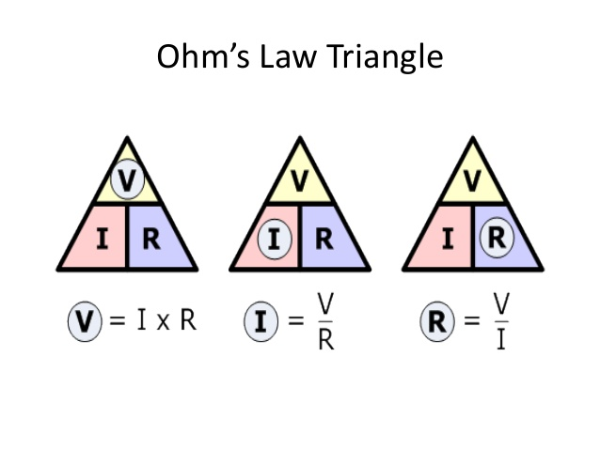
Volts, amps, and ohms are all interrelated and you can see in the above illustration how one affects the other two and vice versa. Ohm's law simply states this relationship, as it takes one volt to push one amp through one ohm.
In electric calculations we use (e or v) to represent electromotive force or voltage, (I or a) to represent intensity or amps, and (r or Ω) to represent resistance or ohms. If one of these variables changes it affects the other two. Using Ohm's law you can find an unknown like amps, ohms, or voltage in a circuit if two values are known.
There are three basic ways in which circuit loads can be arranged. They are series circuits, parallel circuits, and series parallel circuits.
Series
A series circuit is a simple circuit and what makes it different from the others is that it only has one path for current to flow. As a result series circuits are easy to solve and create; however they don’t always make for the best circuits because as you add loads the total circuit resistance goes up and current flow as a result goes down.
The laws that govern series circuits are as follows.
- Current is constant throughout the circuit. If 1 amp flows from the battery positive post one amp returns back to the negative post.
- Total circuit resistance is the sum of all the resistors added up.
- Voltage drops across each resistance in the circuit and all of the voltage drops add up to equal source voltage.

To find total circuit resistance use the formula below.
Rt = R1 + R2 + R3 + ……. Example: 3 Ω + 6 Ω + 3 Ω = 12 Ω
To find current in a series circuit use the formula below
I = E/R Example: 12 V/2 Ω = 6 A

To find voltage use the formula below.
V = E X R Example: 3 A X 4 Ω = 12 V

Parallel
Parallel circuits are complex circuits that have multiple paths for current to flow and like series circuits have several laws that govern how they operate.
Parallel circuits have three laws that govern them. They are:
- Total circuit resistance is less than the smallest resistance in any one of the legs of the circuit.
- The sum of individual current flowing in and out of a branch added with current flowing in other branches will equal total current.
- Voltage is the same at each leg of the circuit.

To find resistance in a parallel circuit use one of the following methods:
- Rt = (R1 x R2) / (R1 + R2)
Example 2 Ω = (3 Ω x 6 Ω) / (3 Ω + 6 Ω)
- 1/Rt =1/R1 + 1/R2 + 1/R3 + ……..
Example 1 Ω = 1/2 Ω + 1/4 Ω + 1/4 Ω
- Rt = value of equal resistors/ number of equal resistors
Example 4 Ω = 8 Ω / 2
To calculate current in a parallel circuit treat each branch like
a series circuit and then solve for current flowing through the
branch, then add all branches current flow up to equal total
current.
To solve for voltage drops on branches use current flowing
through the branch times resistance of the branch.
To solve for total voltage use total resistance times total
current.

Series/parallel
Complex circuits are a combination of series and parallel circuits and incorporate both sets of laws from each circuit type in order to solve. They are used in lighting circuits and various other systems.

Circuit diagnosis
A DVOM or digital volt, ohm, and amp meter is used to measure these three different values in a circuit. The method to measure these values varies and needs to be done correctly in order for your results to be accurate. Further on in the workbook I will have you measure these with your meter in a circuit that you have created but first let's go over the proper way to measure these values with a DVOM.
Volts are measured in either AC or DC. We deal primarily with direct current; however there are several places in which AC current or alternating current is generated—for example, in wheel speed sensors or the alternator. To accurately measure volts one would have their meter placed in parallel with the circuit so that the meter is reading a difference in potential between the two leads. The leads would be placed in parallel of the load as shown below.
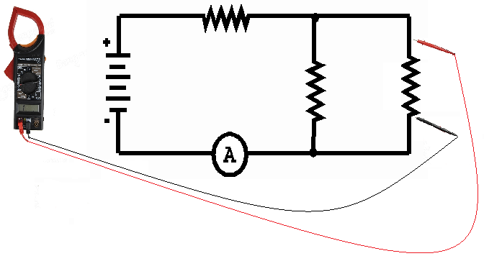

Resistance is measured with the voltage source removed or isolated from the circuit being measured. An ohmmeter works by sending a small amount of voltage and amps through one lead and measuring how long it takes the amps and volts to come back to the other lead. Remember that electrons will take the path of least resistance, so make sure what you are measuring is properly isolated from the circuit. Also make sure that there’s no voltage present in the circuit, otherwise the results won’t be accurate. To measure resistance the leads of the meter are placed in parallel from what you are measuring.
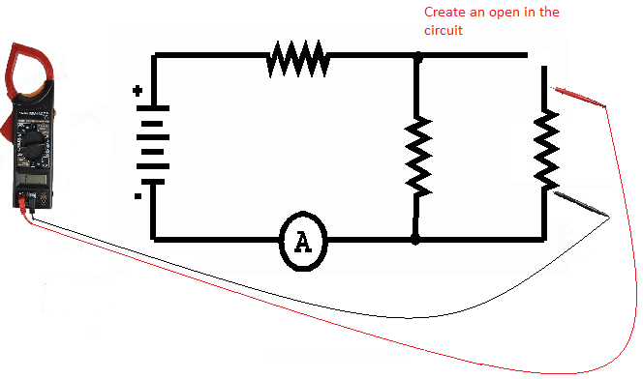
Amps are measured in series with the circuit and so you will need to create an open and then complete the circuit with the meter. The circuit will need to be complete and working in order to get an accurate reading. 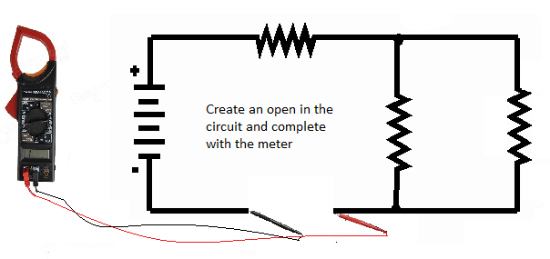

On the next pages properly trace the following circuits with your conductive ink pin being sure to darken the oval areas and line. Place the module that matches the symbol in the appropriate place with the magnetic board behind it and observe what happens. Below you will create several different series circuits and measure volt, amps, and ohms.

Define Ohm's law. ___________________________________________________________________________________________________________________________________________________________________________
What are amps? __________________________________________________________________________________________________________________
What is voltage? __________________________________________________________________________________________________________________
What is resistance? __________________________________________________________________________________________________________________
When measuring Amps how should the meter leads be placed in the circuit? __________________________________________________________________________________________________________________
When measuring voltage how should the meter leads be placed in the circuit? __________________________________________________________________________________________________________________

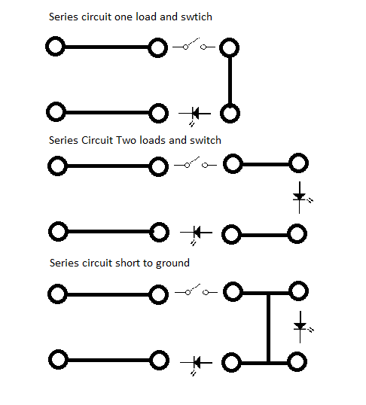
Circuit 1
Circuit 2
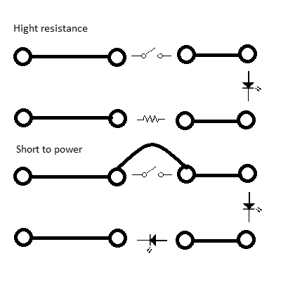
Based on your results what happened as you added loads? __________________________________________________________________________________________________________________
Based on your results what happened when there was a short to ground? __________________________________________________________________________________________________________________
Based on your results what occurred when you added high resistance? __________________________________________________________________________________________________________________
Based on your results what occurred when there was a short to voltage? __________________________________________________________________________________________________________________
Now calculate total circuit resistance, amps, and voltage in circuit 1 with one load. __________________________________________________________________________________________________________________
Now calculate total circuit resistance, amps, and voltage in circuit 2 with two loads. __________________________________________________________________________________________________________________
In the first circuit how much of the volts dropped on the first load? __________________________________________________________________________________________________________________
In the second circuit how much of the volts dropped on the first load and how much on the second load? __________________________________________________________________________________________________________________
According to Ohm's law in series circuits which law does the volts dropping in the second circuit follow? __________________________________________________________________________________________________________________
In circuit one why are there more amps than in circuit two moving through the circuit? __________________________________________________________________________________________________________________
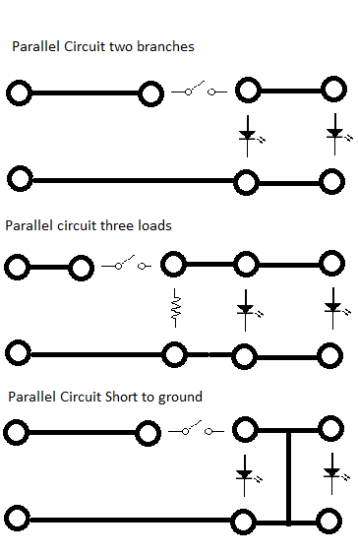
Now come up with your own series circuit and draw it below using the two LED modules, power source, switch, and select one other module out of your kit to include. Correctly calculate for amps, ohms, and volts, and include voltage drops. Please show your work.
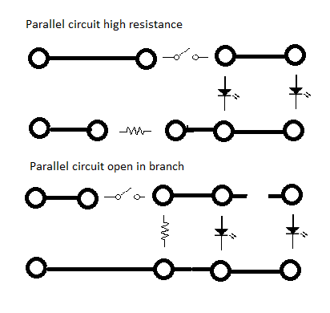

Based on your results what happened as you added loads? __________________________________________________________________________________________________________________
Based on your results what happened when there was an open in one of the branches? __________________________________________________________________________________________________________________
Based on your results what occurred when you added high resistance to the ground? __________________________________________________________________________________________________________________
Now calculate total circuit resistance, amps, and voltage in circuit 1 with two loads. __________________________________________________________________________________________________________________
Now calculate total circuit resistance, amps, and voltage in circuit 2 with three loads. __________________________________________________________________________________________________________________
In the first circuit how much of the volts dropped on the first load? __________________________________________________________________________________________________________________
In circuit two why would there be more amps moving through the circuit? __________________________________________________________________________________________________________________

Now come up with your own parallel circuit and draw it below using the two LED modules, power source, switch, and select one other module out of your kit to include. Correctly calculate for amps, ohms, and volts, and include voltage drops. Please show your work.

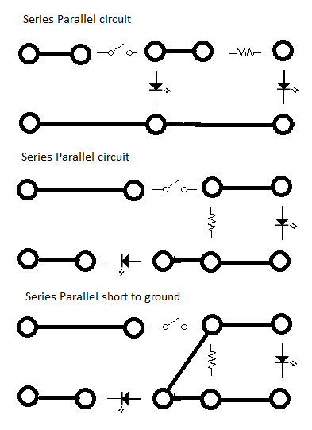
Circuit 2
Circuit 1
Circuit 2
Based on the first circuit where is the series portion? __________________________________________________________________________________________________________________
Based on your results what happened when there was an extra light added in series to the parallel circuit? __________________________________________________________________________________________________________________
Now calculate total circuit resistance, amps, and voltage in circuit 1 with three loads. __________________________________________________________________________________________________________________
Now calculate total circuit resistance, amps, and voltage in circuit 2 with three loads. __________________________________________________________________________________________________________________
In the first circuit how much of the volts dropped on the first load? __________________________________________________________________________________________________________________
In circuit two why would there be less amps moving through the circuit? __________________________________________________________________________________________________________________

