The Bee-sy Life of Worker Bees

Introduction

- Worker bees are all female.
- They have many different jobs to perform in the hive.
- A worker bee takes about 21 days to go from egg to adult.
- She lives for about 6 weeks and sometimes more.

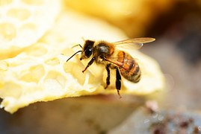

Duties of a worker honey bee

A worker bee’s job changes as she gets older.
She has a special body to help her do her job.

Day 1 to 2 – House Worker Bee

The Worker bee cleans the Hive.

Day 3 to 12 – Nurse Worker Bee

She feeds and takes care of the larvae.

Day 12 to 17 - Construction Worker Bee

- She helps build and repair the cells of the nest.
- She makes wax from glands in her abdomen.
- Small spurs on the back of the legs pull the Beeswax off.
- This wax is used for constructing the Honeycomb.
- The Honeycomb is made of hexagon shaped cells.
- She also stores nectar and pollen brought in by other bees.

Gland - Tiny part in body which produces a special chemical.
Spur - Projection.

Day18 to 21 days - Guard Worker Bees

- They protect the hive from enemies and invaders.
- They check if worker bees entering the nest belong to same colony.
- An intruder is stopped from entering the hive.

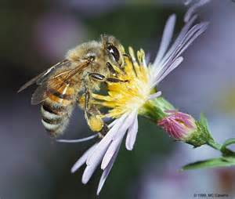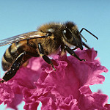

Day 22 to 42 - Forager Worker Bee.

- This is last job a worker bee does before it dies.
- The job involves gathering nectar and pollen for the colony.
- There are pollen baskets on their hind legs.
- Pollen baskets help carry pollen back to the hive.
- Pollen provides the protein diet for the growing larvae.

Sometimes Pollen may get dropped off at another flower. This is called pollination.
Pollen – A dust like substance, usually yellow in color, found in flowers.

Pollination

When a forager visits a flower, it packs pollen into the pollen baskets. Next time you
see a bee visiting a flower, look for the pollen basket. A full pollen basket is yellow and round. Pollen baskets are used to store pollen so the bee can carry as much as possible back to their hive. Sometimes pollen is picked up on their body and dropped off at another flower.
This is called pollination.

The Sweet Story of Honey

Worker bees also suck up nectar with their lapping mouthparts. Parts of
their lapping mouthpart are like a long tongue with a spoon at the end.
They take the nectar back to the hive where they store it in a honey cells as honey.

- Foragers also suck up nectar with their lapping mouthparts.
- Nectar is a sweet sap taken from flowers.
- The nectar is stored in the Honey cells in the hive.
- When full the honey cell is capped.
- Excess water gets evaporated and the nectar will become HONEY.

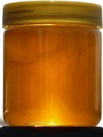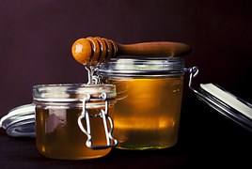

Other duties of foragers – keep the hive cool

- Foragers bring water to keep the nest at a constant temperature.
- Water is sprayed on the colony in droplets.
- Worker bees fan the air with their wings making the water to evaporate.
- This keeps the hive cool.
- This prevents the wax from melting.

