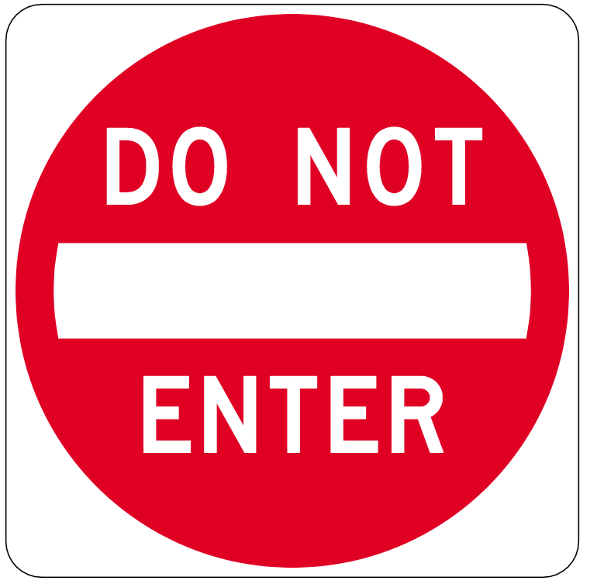

Write a description of this sign and what it means here:

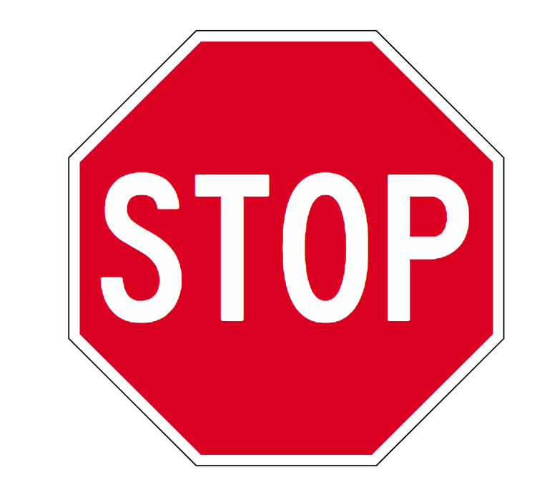

Write a description of this sign and what it means here:

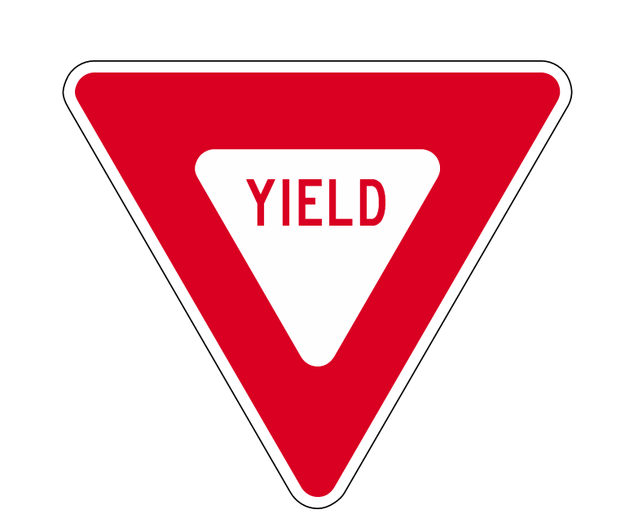
Write a description of this sign and what it means here:

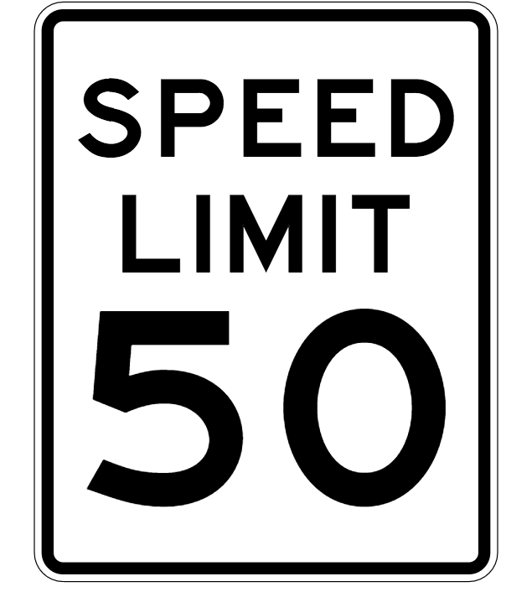
Write a description of this sign and what it means here:

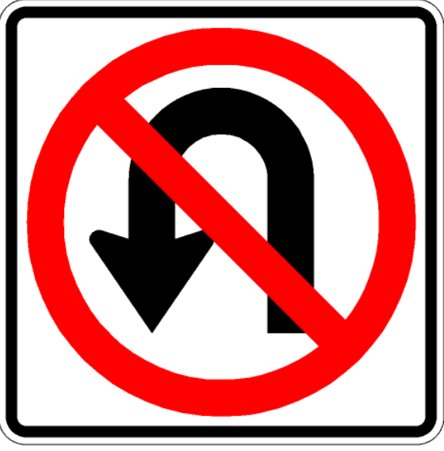
Write a description of this sign and what it means here:
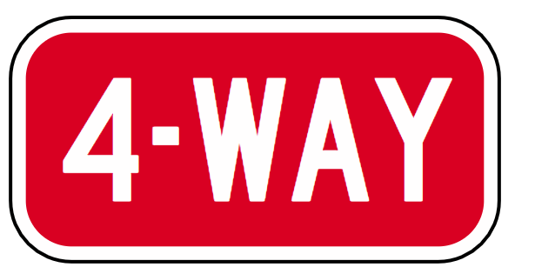
Write a description of this sign and what it means here:

Write a description of this sign and what it means here:

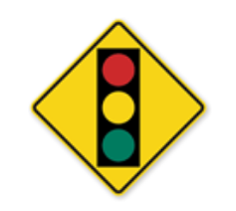

Write a description of this sign and what it means here:

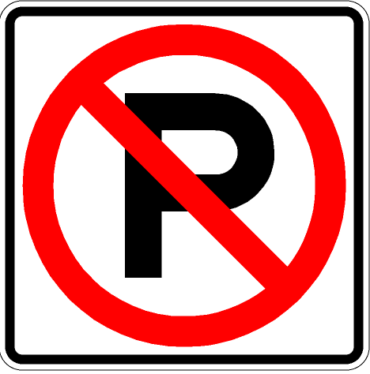

Write a description of this sign and what it means here:

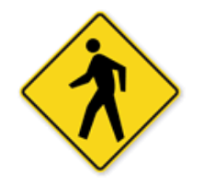
Write a description of this sign and what it means here:

Write a description of this sign and what it means here:

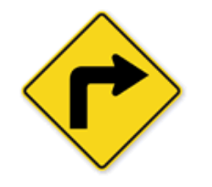

Write a description of this sign and what it means here:

