Vapor Pressure & Phase Changes – Study Guide
sections 10.3 and 10.4 in OpenStax

Vapor Pressure (section 10.3)
How is the vapor pressure of a substance related to its Intermolecular Forces?

Referring to Example 10.5 in OpenStax:
Which liquid, diethyl ether or ethylene glycol, has the strongest intermolecular forces?_________________
Which liquid has the highest vapor pressure? _____________________
Which liquid has the highest boiling point? _______________________

Boiling point and vapor pressure of a liquid are ____________________ (directly, inversely) proportional to one another.
example: Which of the following liquids would have the highest vapor pressure?
H₂S H₂O NH₃ CO₂ CH₄

Boiling Point (section 10.3)
Explain briefly the difference between boiling point and normal boiling point.

How does the boiling point of a liquid change at higher elevations? Explain why.

Phase Changes (section 10.3)
What does ΔH_{vap} represent? How is it related to Intermolecular Forces?

What does ΔH_{fus} represent? How is it related to Intermolecular Forces?

Phase Diagrams (section 10.4)
A phase diagram is a graph of _____________________ on the y-axis versus _______________________ on the x-axis.
The three regions present in a phase diagram represent ______________________________.
The lines in a phase diagram represent ____________________________________________.
The conditions under which a substance has all three states in equilibrium with one another is called the ______________________.

example: Referring to the phase diagram of carbon dioxide below:
Label the areas with the correct state of matter for each.
Label the fusion curve, the sublimation curve and the vaporization curve.
What are the pressure and temperature corresponding to the triple point: Pressure_____________ atm, temperature _________________Kelvin
In what state does CO₂ exist at 1 atm pressure and 298K?________________
Suppose a sample of CO₂ is at 5 atm and 250K. Describe all of the phase changes that
occur as the temperature is decreased to 200K but the pressure remains constant:
___________________________________________________________________
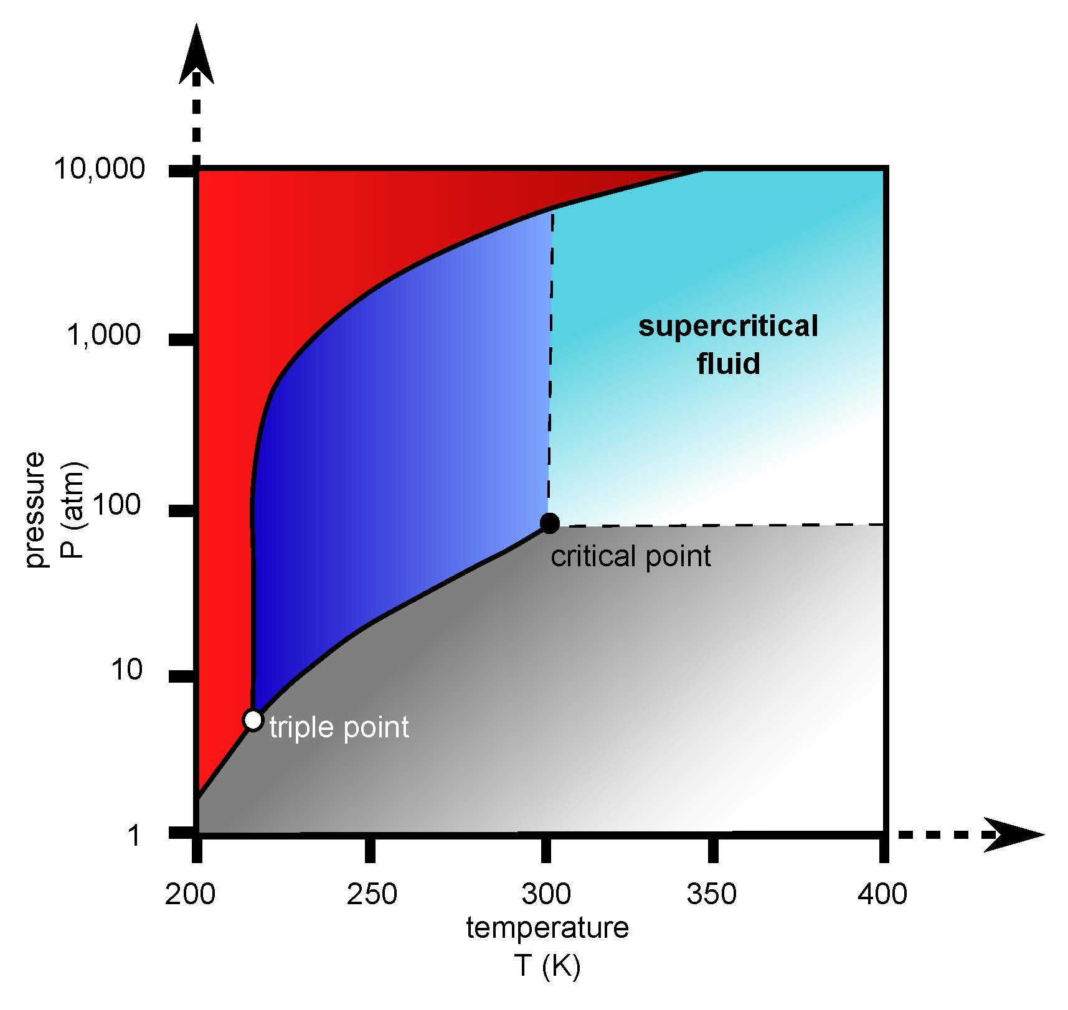

End of Chapter 10 Practice Problems

#45, 50, 55, 63

For detailed solutions to these problems, go to the OpenStax website and download the “Student Answer and Solution Guide.”

