Electron Configurations and Orbital Diagrams – Study Guide
Sections 6.4 in OpenStax

Electron Configurations and Orbital Diagrams
An electron configuration for an atom shows _________________________________________________.
Electron Configurations consist of a

  - number denoting the ________________ level.
  - letter denoting the ________________ of orbital.
  - superscript denoting the _____________________ of electrons in those orbitals.

The electron configuration of an S atom is: 1s²2s²2p⁶3s²3p⁴

An orbital diagram can also be used to represent the location of electrons in an atom. In an orbital diagram:
Each box represents one__________________.
Half-arrows represent the__________________.
The direction of the arrow represents the ______________of the electron.

The orbital diagram of helium is ↑↓
1s

The spin of an electron is specified by a fourth quantum number called the _________________.
The two possible values of, m_{s}, are _______ (spin up) and _________ (spin down)

The three principles that are needed to specify orbital occupancy for the electrons are:
- Pauli Exclusion Principle: No orbital may have more than ______ electrons, and they must have __________________spins

- Hund’s rule: Orbitals of the same energy fill _______________ with electrons of the _____________ spins before pairing.

- Aufbau Principle: energy levels fill from ______________ energy to ______________ energy
energy sublevels fill from _____________energy to _____________energy

Watch the video tutorial on Writing Electron Configurations

Electron Configurations and the Periodic Table

Valence electrons are _____________________________________________________________________.
For main group elements, the valence electrons are located in ______________________________.

Anions are formed when atoms ___________ enough electrons to have 8 valence electrons
Cations are formed when an atom ________________ its valence electrons

The periodic table can be divided into blocks representing the filling of particular sublevels (s, p, d or f).
Label the colored sections of the following periodic table as “s-block elements”, “p-block elements”, “d-block elements” or “f-block elements”

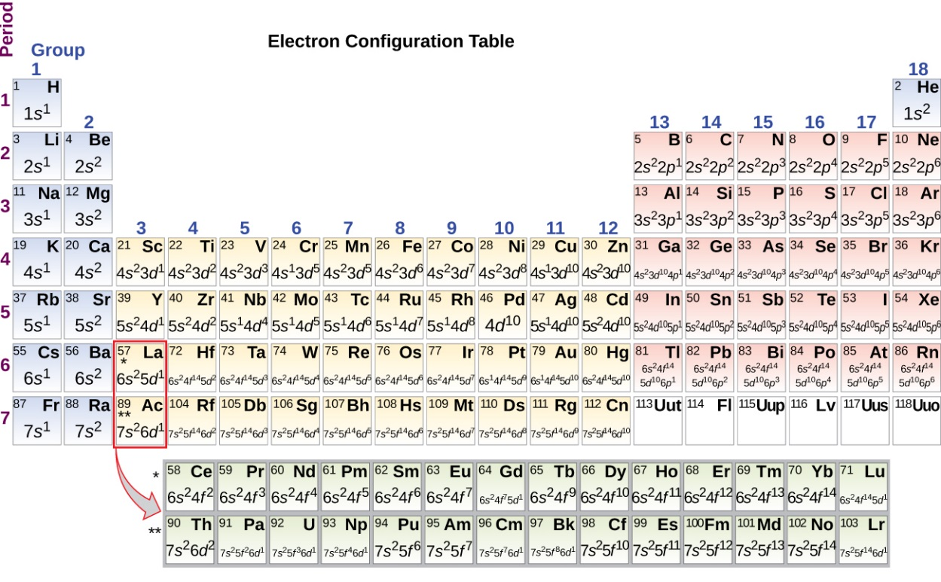

The number of columns in a block corresponds to the maximum _____________________________________.
The row number in the periodic table is equal to the number (or n value) of _____________________________.

End of Chapter 6 Practice Problems

#49, 51, 53, 55, 57

For detailed solutions to these problems, go to the OpenStax website and download the “Student Answer and Solution Guide.”

