Names and Formulas of Compounds – Study Guide
sections 2.4, 2.6, and 2.7 in OpenStax

Chemical Formulas (section 2.4)

The Molecular Formula shows the number of ________________________________ in a molecule.

The 7 elements that exist in nature as diatomic molecules are ____, ____, ____, ____, ____, ____, and ____.

The Empirical Formula indicates the ________________________________________ in a compound.

Molecular and Ionic Compounds (section 2.6)
Ionic Compounds are composed of _____________ and ___________ bonded together by ________________.
An Ionic Bond is _______________________________________.

A cation is a ______________ charged ion. An anion is a __________________ charged ion.

When writing the chemical formula of an ionic compound, the following rules apply:
1. Ionic compounds always contain a ______________ and a ________________.
2. The sum of the charges of the ______________ must always equal to sum of the charges of the _______________.
3. The chemical formula indicates the ____________ _____________ of its constituent ions.

Molecular Compounds are composed of 2 or more _________________ bonded together by _____________________.

A Covalent Bond is _______________________________________.

Molecular compounds exist as discrete, neutral _____________________.

Chemical Nomenclature (section 2.6)

When naming ionic compounds, the following rule applies:
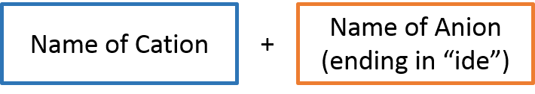
What is the difference between a fixed-charge metal and a variable-charge metal?

Watch video tutorial on Naming Ionic Compounds

When naming binary molecular compounds, use the following rule:
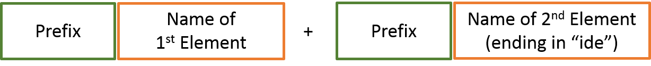
and the following prefixes:
mono = ____ tri = ____ penta = ____ hepta = ____ nona = ____

di = ____ tetra = ____ hexa = ____ octa = ____ deca = ____

Acids are molecular compounds that release ___________________ when dissolved in water.
An acid that is composed of only hydrogen and a nonmetal is called a ___________________ acid.
An acid that contains hydrogen and an oxyanion is called an ___________________ acid.
An oxyanion is __________________________________.

When naming binary acids, use the following rule:
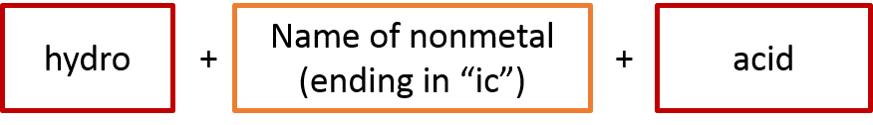

When naming oxyacids, use the following rules:

If the anion’s name ends in “-ate”, then the acid’s name is determined by: | If the anion’s name ends in “-ite”, then the acid’s name is determined by:
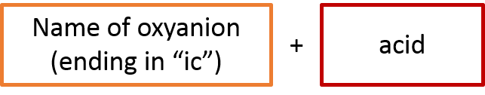 | 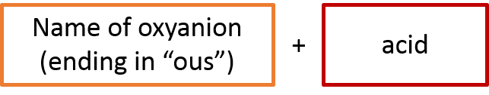
Give one example | Give one example

End of Chapter 2 Practice Problems

#45, 49, 51, 53, 55, 57, 59
For detailed solutions to these problems, go to the OpenStax website and download the “Student Answer and Solution Guide.”

