Name: __________________________________________________________________ Period: ______________

- Where did you locate your civilization?

- next to an ocean
- in the mountains
- on an island
- in the rainforest 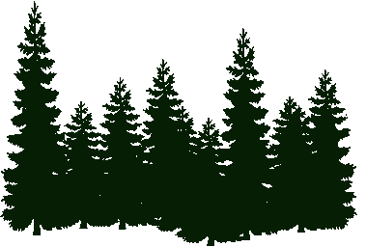
- next to a river
- in the desert 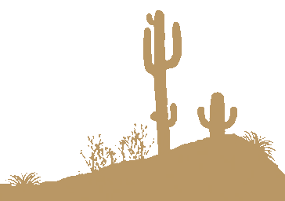

- Why did you locate your civilization there?
____________________________________________________________________________________________________________________________________________________________________________________________________________________________________________________________________________________________________________________________________________________________________________________________________________________________________________________________________________________________________________________________________________________________________________________________________________
- How did you spend your 20 Resource Points on animals?

_______ camels 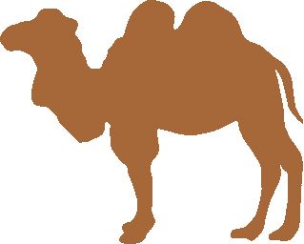
_______ cats
_______ chickens
_______ cows
_______ dogs
_______ fish
_______ horses
_______ llamas 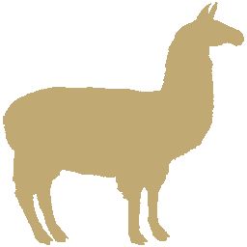

- Why did you choose those animals?
____________________________________________________________________________________________________________________________________________________________________________________________________________________________________________________________________________________________________________________________________________________________________________________________________________________________________________________________________________________________________________________________________________________________________________________________________________
- How did you spend your 20 Resource Points on plants?

_______ beans
_______ corn
_______ oranges
_______ pine trees 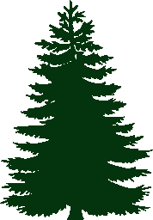
_______ potatoes
_______ roses
_______ wheat

- Why did you choose those plants?
__________________________________________________________________________________________________________________________________________________________________________________________________________________________________________________________________________________________________________________________________________________________________________________________________________________________________________________________________________________________________________
- How did you spend your 10 Resource Points on materials?

_______ bronze
_______ gold
_______ iron
_______ silk
_______ stone

- Why did you choose those materials??
__________________________________________________________________________________________________________________________________________________________________________________________________________________________________________________________________________________________________________________________________________________________________________________________________________________________________________________________________________________________________________
- Were you surprised by any of the resource bonus values? Why?
__________________________________________________________________________________________________________________________________________________________________________________________________________________________________________________________________________________________________________________________________________________________________________________________________________________________________________________________________________________________________________
- What was the best event that happened in Year 1? What was the worst?
________________________________________________________________________________________________________________________________________________________________________________________________________________________________________________________________________________________________________________________________________________________________________________________________________
- Did your population shrink or grow in Year 1? How many civilians did you end with?
______________________________________________________________________________________________________________________________________________________________________________________________________________________________________________________________________________________________________
- What happened during your first war in Year 3? Did any of your huts survive?
______________________________________________________________________________________________________________________________________________________________________________________________________________________________________________________________________________________________________
- What happened during the Events round in Year 4?
______________________________________________________________________________________________________________________________________________________________________________________________________________________________________________________________________________________________________
- At the end of Year 7, what is your most valuable resource? What about your least valuable resource? Why?
__________________________________________________________________________________________________________________________________________________________________________________________________________________________________________________________________________________________________________________________________________________________________________________________________________________________________________________________________________________________________________
- What happened during the Events round in Year 10?
______________________________________________________________________________________________________________________________________________________________________________________________________________________________________________________________________________________________________
- In what year did your population reach 100,000 civilians? In a complete paragraph below, explain what you think led to your success, and what you would do differently with a new civilization.
____________________________________________________________________________________________________________________________________________________________________________________________________________________________________________________________________________________________________________________________________________________________________________________________________________________________________________________________________________________________________________________________________________________________________________________________________________________________________________________________________________________________________________________________________________________________________________________________________________________________________________________________________________________________________________________________________________________________________________________________________________________
__________________________________________________________________________________________________________________________________________________________________________________________________________________________________________________________________________________________________________________________________________________________________________________________________________________________________________________________________________________________________________
________________________________________________________________________________________________________________________________________________________________________________________________________________________________________________________________________________________________________________________________________________________________________________________________________

