Astronomy 10A:
Introduction to the Solar System
(or Planets and Life, Here and Elsewhere)

Instructor: Andrew Fraknoi
Office: Phone:

This is a non-technical, non-mathematical introduction to the planets, moons, and smaller bodies in our solar system, to the discovery of planets around other stars, and to the search for life (including intelligent life) on other worlds. Students should also come away from the course with an understanding of the scientific method and what tools and procedures scientists use to learn about the many worlds with which we share the neighborhood of the Sun.

Topics Covered (not at all at the same length):

1. A Grand Tour of the Solar System
2. The Nature of Science
3. How Do We Get Information about the Universe (Radiation and Telescopes)
4. Mars, Venus, Mercury, the Moon, and the Earth: The Terrestrials
5. Jupiter, Saturn, Uranus, and Neptune: The Jovians
6. The Moons of the Big Planets (including some of the weirdest worlds we know)
7. Pluto, Eris, and Maybe Many More: The Dwarf Planets
8. Cosmic Debris: Comets, Asteroids, and Meteoroids
9. Cosmic Catastrophes: When Cosmic Debris Hits the Planets
10. The Search for Planets Elsewhere in the Universe
11. The Search for Life Elsewhere in the Universe
12. Space Travel: Separating Science from Fiction
13. Communication Across Cosmic Distances and SETI Projects

Textbook: Fraknoi, Morrison, & Wolff: Astronomy (2016, OpenStax) This is a free, electronic textbook available at: http://openstax.org/details/astronomy
You can download the PDF or read the on-line version, and print out any pages you want.
We will not read every section or chapter, and we will not read chapters in order! See the attached list of required readings.

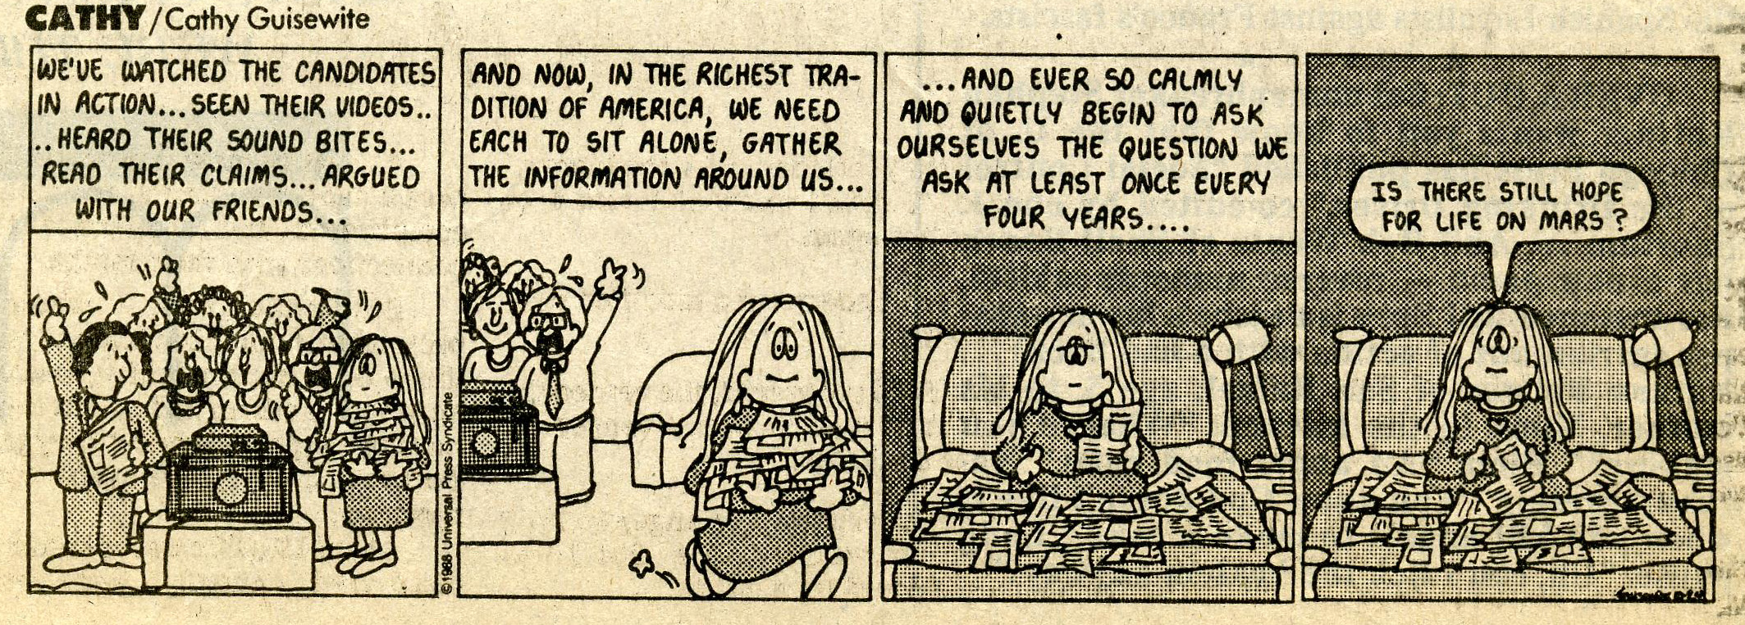
Astronomy 10A: Course Rules and Requirements ← IMPORTANT STUFF !!!

- During the course, we will sometimes divide the class into groups of four and do collaborative group activities. The write-ups from these activities count for your grade.

- Attendance is required and counts for your grade.

- Please bring a notebook to take notes in, a Scantron sheet, a pen, and #2 pencil to class each day!

- I do not permit the use of laptops or tablets in this class, except when required by a doctor or a counselor. When you take notes on a laptop, you tend to go into automatic scribe mode and stop thinking. Also, it’s too easy to check messages, play games, and do other things instead of paying attention to astronomy.

- If you need to drop the course, you must inform the instructor AND drop on the registration website. Otherwise you will receive an F grade at the end. No exceptions, no excuses!

- There will be 1 midterm and 1 final exam, for which you will be able to bring one 3x5” card of notes. Also there will be quizzes, mostly unannounced, plus the group activities. No electronic devices may be used during any exams or quizzes. Your grade will roughly be computed as follows: Midterm = 25%, Final = 45%, Quizzes = 20%, Group Activities = 5%, Attendance = 5% or more

- The accompanying lab, Astronomy 10L, is optional, but recommended for those who need a lab science. You can take the lab this quarter or sometime in the future, but register early.

- Disturbing the class in any way will not be tolerated. The instructor can drop any student who does not behave in a way appropriate to a college class. This includes coming late or leaving early, talking to your neighbor, snoring loudly, rudeness, or acting out in other ways.

- You are responsible for all exams, assignments, and other work, whether you are here or not. Please find a classmate who can fill you in on missed work (and be your “study buddy”.) I STRONGLY recommend forming an astronomy study group to go over class material. You should spend 5-10 hours per week at home studying for this class (including the reading).

- If you are having trouble with the class (or if you are enjoying it and want to talk further about astronomy), please come to or call during my office hours. I am generally rushed, and therefore have little time just before the class. I’m much nicer in office hours!!!

- Students who are registered with the Disabilities Resource Center should see me as soon as possible during office hours to discuss accommodations and your options concerning the surprise quizzes.

- There is an observatory on campus and it is open free to the public every clear Friday night from 9 to 11 pm.

First Homework Assignment:
a. Find the textbook on line, buy a notebook for taking notes and six Scantron sheets (green form 882)
b. Read Chapter 1 and Chapter 7, section 1 only.

PEANUTS by Charles Schulz

On Expectations
By Andrew Fraknoi, Astronomy Professor, Foothill College

What I Expect from You

- That you come to every class (unless you are seriously ill)
- That you come on time and sit in the rows of seats that I suggest for the class (not way in the back)
- That you do not use a laptop, tablet, or phone during class – I suggest that you take notes in a notebook
- That you respect what your fellow students and I have to say
- That you help me maintain a quiet learning environment
- That you come to class prepared – with your homework reading and any required writing done
- That you devote a significant amount of time to studying for the midterm and the final (including making a 3x5 card of notes to use on each test)
- That you notify me if you drop the class and also withdraw using Foothill’s MyPortal site

What You Can Expect from Me

- That I will be present, prepared, and on time for every class (unless I am seriously ill)
- That I will explain astronomy in everyday language, with clear analogies, and humor
- That I will first warn, and then remove, students from the class who are not respectful of our learning environment
- That I will grade fairly and anonymously (that means I will only look at your score and not your name when assigning grades)
- That I will give you and other students my attention and help during office hours
- That I will respect each student who is serious about the class and meets the expectations I have listed above

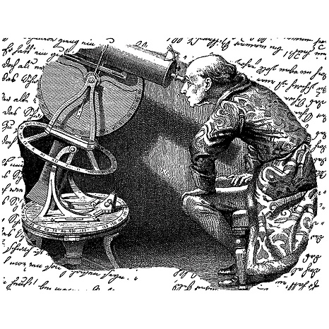
READING ASSIGNMENTS:

Week Assignment in Astronomy, by Fraknoi, Morrison, & Wolff
http://openstax.org/details/astronomy

1 Chapter 1: Science & Universe, plus section 1 in Chapter 7. Also read the sheets you receive in class. Buy six Scantron sheets (form 882) for tests and quizzes.

2 Chapter 5: Radiation & Spectra: sections 1, 2, 3, 6 (skip math parts); Chapter 6: Instruments: Sections 1, 2, 3, skim section 4 (skip the long tables listing individual telescopes); fill out green sheet

3 Chapter 7 (Solar System): review section 1, read sections 2 & 3
Chapter 10 (Mars): sections 1, 4, & 5

4 Chapter 10 (Venus): sections 2, 3, 6

5 Chapter 9 (Mercury): section 5; Chapter 9 (Moon): sections 1, 2, 3, 4

6 Study for the Midterm! Read Chapter 11 (Giant Planets): whole chapter (it’s short)

7 Chapter 12 (Moons of Giant Planets): sections 1 and 2 and part of 3 (on Titan)

8 Chapter 12 (Rings and Pluto): section 4 & the other part of section 3 (on Pluto)
Chapter 13 (Asteroids): sections 1 & 2

9 Chapter 13 (Comets): section 3 & 4

10 Chapter 14 (Our Solar System & Others): sections 1, 2, 3 & 4

11 Chapter 30 (Life in the Universe): sections 1, 2, 3, & 4
Study for the final, be sure to make a really good 3x5 inch card of notes



