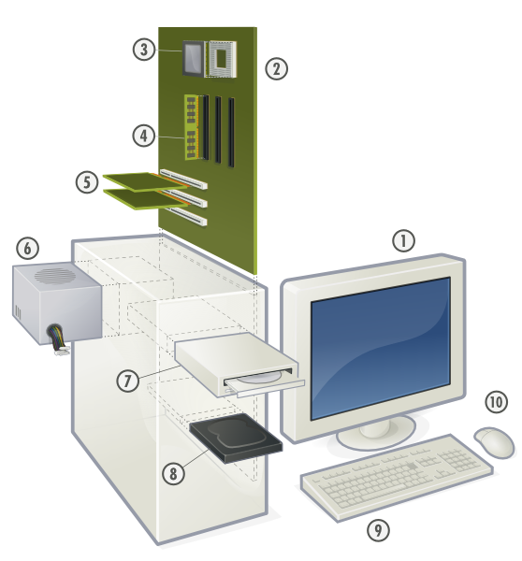

Write the correct number next to the word that matches the number on the picture.
10_Mouse
_1_Monitor
_3_CPU (Microprocessor)
_7_Compact disk drive (CDD)
_5_Expansion cards
_6_Power supply unit
_8_Hard disk drive (HDD)
_4_Main memory (RAM)
_9_Keyboard
_2_Motherboard

Description: Components of a personal computer License: GNU (FDL)
Source: http://commons.wikimedia.org/wiki/Image:Personal_computer%2C_exploded_5.svg Date: 24 June 2007 Author: Gustavb

