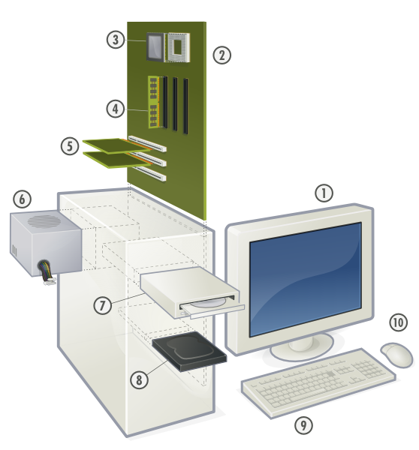

Write the correct number next to the word that matches the number on the picture.
___Mouse
___Monitor
___CPU (Microprocessor)
___Compact disk drive (CDD)
___Expansion cards
___Power supply unit
___Hard disk drive (HDD)
___Main memory (RAM)
___Keyboard
___Motherboard

Description: Components of a personal computer License: GNU (FDL)
Source: http://commons.wikimedia.org/wiki/Image:Personal_computer%2C_exploded_5.svg Date: 24 June 2007 Author: Gustavb

