Match the Computer Parts and Their Names
Draw a line between the picture and the name of that part
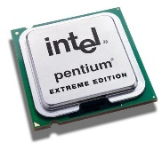 | RAM (Random Access Memory)
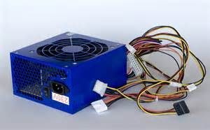 | COMPUTER MOTHER BOARD
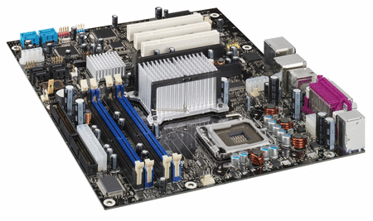 | CPU / PROCESSOR
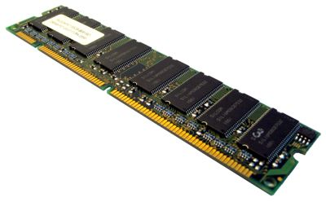 | COMPUTER POWER SUPPLY

