Computer Parts and Their Definitions
COMPUTER PART | DEFINITION
CPU / PROCESSOR  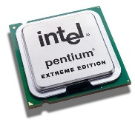 | - The CPU is a silicon chip which has thousands of electronic circuits. It has a fan to keep it cool.  - The CPU processes the data in the computer – it does the work.  - It sends messages to and from the input devices, output devices, and storage devices.
COMPUTER POWER SUPPLY  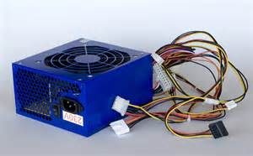 | - Converts energy source (electricity) into power.
COMPUTER MOTHER BOARD  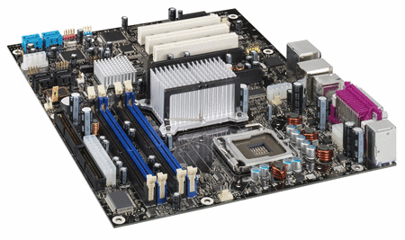 | - The computer’s main printed circuit board, which is inside the unit.  - It holds the processor (CPU), memory (RAM), and other parts such as graphic and sound cards.
RAM (Random Access Memory)  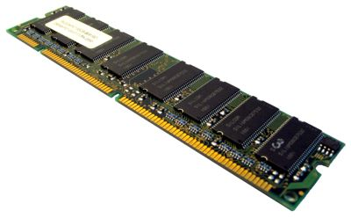 | - A series of chips on the motherboard.  - Temporary holding area for data while CPU processing occurs.  - More RAM provides better performance because the computer can "think" faster.
KEYBOARD  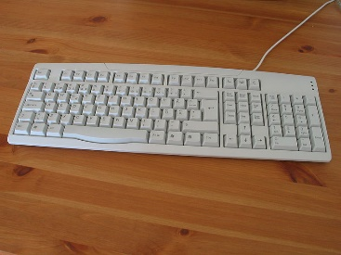 | - Looks like a typewriter with extra keys!!  - Used to type data into the computer
MOUSE  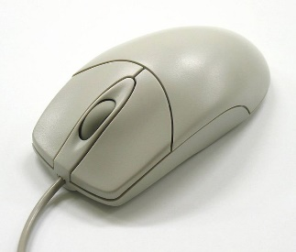 | A hand-held device that moves on a ball, and has buttons on top that you click.  - Point and click mouse pointer to move the cursor on the monitor screen.  - Double click with the left button on an object to take an action (such as open a file or choose something).  - Click on an object, hold down the left button and drag, in order to move objects around the screen on the monitor.
MONITOR  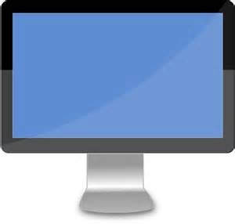 | - A visual display for computers, like a TV screen.  - Connected to the main computer.
HARD DISK DRIVE  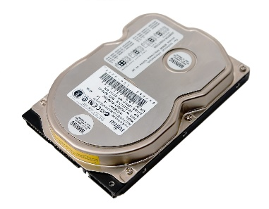 | - Main and usually largest permanent data storage device in a computer.

