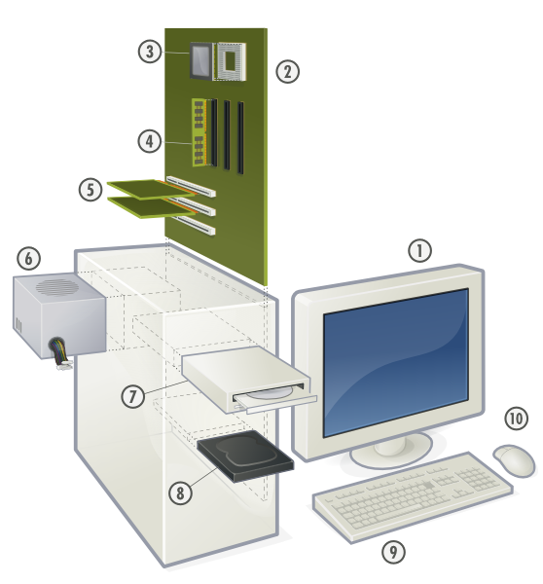

1. Monitor
2. Motherboard
3. CPU (Microprocessor)
4. Main memory (RAM)
5. Expansion cards
6. Power supply unit
7. Compact disk drive (CDD)
8. Hard disk drive (HDD)
9. Keyboard
10. Mouse

Description: Components of a personal computer
Source: http://commons.wikimedia.org/wiki/Image:Personal_computer%2C_exploded_5.svg
Date: 24 June 2007
Author: Gustavb
License: GNU (FDL)

