Computer and Human Body Comparison

COMPUTER | HUMAN BODY
CENTRAL PROCESSING UNIT (CPU)  - Located on the mother board  - Carries out commands  - 2 inch ceramic square  - The CPU of the computer gets INPUT from a keyboard, a touch screen or a mouse  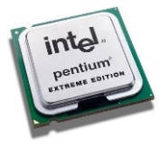  - The CPU takes action by producing OUTPUT, such as print or pictures on a monitor screen or a printer or sound through the speakers. | THE BRAIN  - The CPU is the like the BRAIN.  - The brain gets INPUT from a person’s eyes, ears, nose, or touch  - The brain responds to input by creating OUTPUT such as movement, an image, a sound, decision-making  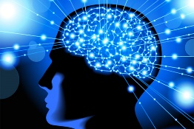
COMPUTER POWER SUPPLY  - The computer gets its power from an energy source such as electricity  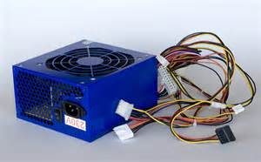 | EATING FOOD  - The human body needs power to stay alive, and converts food and water into energy
COMPUTER MOTHER BOARD  - The CPU and the RAM sit on a piece of circuit board known as the MOTHER BOARD.  - Main circuit board holds parts together such as the CPU, memory, connecters, hard drives, optic drive, expansion cards, & USB ports  - Cables in a computer system connect important parts to the mother board and allow the flow of electricity  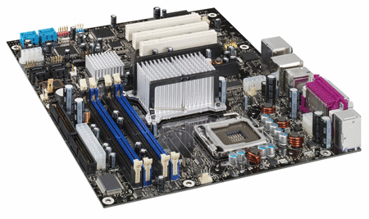 | SKELETON AND BODY SYSTEMS  - The brain does the majority of the processing work, but there are other systems of the body that are vital for our health and well-being, such as organs, and the nervous and circulatory systems  - Our skeleton is the framework that holds our parts together  - The nerves in a body use electrical impulses to send messages to other parts of the body
RAM (Random Access Memory)  - A CPU passes data that it is not ready to deal with to a temporary location  - This location is called Random Access Memory (RAM)  - The data sits in RAM until the CPU is ready to use it to perform calculations or follow instructions  - Once passed to the CPU the data is wiped from the RAM  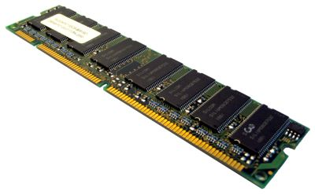 | SHORT TERM MEMORY  - The brain has different areas to hold information for the short term and for the long term  - Some short term memory will turn into long term memory  - If we do not work to make short term memory into long term, we lose the information  - Once we go to sleep, we often lose what is in short-term memory  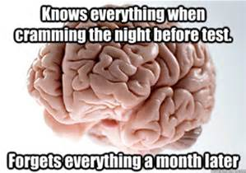  Short-term memory in the brain

