Computer and Car Comparison
COMPUTER | CAR
CPU / PROCESSOR  - 2 inch ceramic square located on the mother board  - Complex control center, that acts like a brain  - processes incoming instructions to determine what to do  - Controls other parts of the computer  - Needs a heat sink to prevent overheating  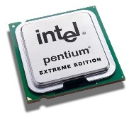 | THE DRIVER OF THE CAR  - The person driving the car has a brain that processes what needs to be done to drive the car  - Controls parts of the car to make it work (steps on gas or brakes, steers, signals)  - Uses cars AC to keep from overheating
COMPUTER POWER SUPPLY  - Converts energy source into power  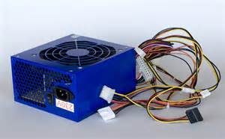 | THE ENGINE OF A CAR  - Is the power supply because it converts gasoline into energy  - Makes the car faster
COMPUTER MOTHER BOARD  - Main circuit board that holds important parts of the computer  - Holds CPU, memory, connecters, hard drives, optic drive, expansion cards, & USB ports  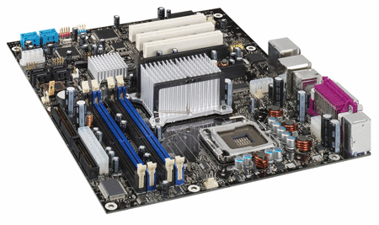 | THE DASHBOARD  - The dashboard is like the motherboard because it holds essential parts for the cars operation  - Holds the steering wheel, ignition, controls for radio, air conditioning
RAM (Random Access Memory)  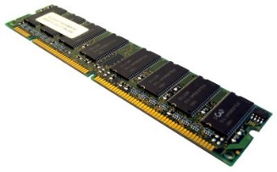  - RAM chips store things only while a computer is on, so they're used for storing whatever a computer is working on in the very short term. | ELECTRICAL SYSTEM  - The electrical system of a car is like the RAM of a computer because it is accessed as soon as you start the car, and powers AC, windows, etc.  - Only works while it is on

