**Hi, I’m Kate. I’m here to tell you a few stories about people who’ve just started to use computers, and how it is changing their lives. These are people who, maybe like you, haven’t felt that using computers and the internet made sense for them.**

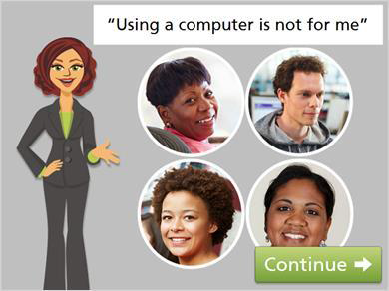

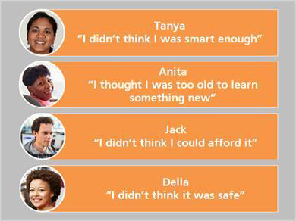

**Family is very important to Anita, but her daughter and grandchildren moved out of state. Anita still sees her family once a month, but it is harder to stay in touch.**

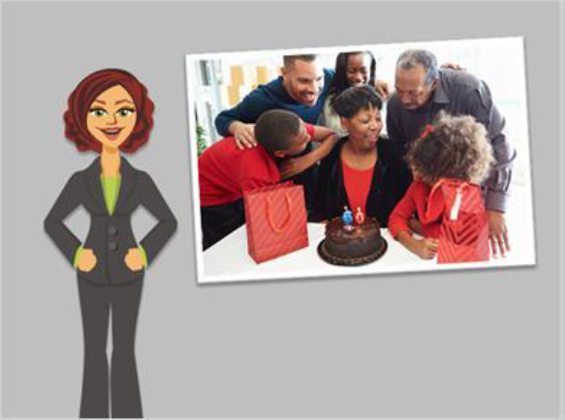**Anita had friends who use the computer for keeping in touch,   
but she felt it is hard for older people to learn new things.   
Technology seemed so complicated! But if her friends could learn, couldn’t she?**



**Now that Tanya has taken computer classes, she can help Terrell with school work and follow his progress on the school’s website.**

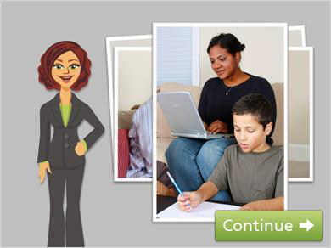

**Tanya is now a role model for her son and is more   
involved in his learning. And Terrell’s grades are going up!**



**Jack never had to use a computer in his line of work, and he   
always thought they were too expensive to use at home.   
But then Jack needed to find a new job. He was not sure where   
to begin, especially since these days you need to apply for most  
 jobs online.**



**Jack heard from a friend that the library has computers and offers free classes. Using these free community resources,   
Jack was able to create a resume and apply for jobs online. Now Jack has learned new skills he can put on his resume and bring to a new job.**

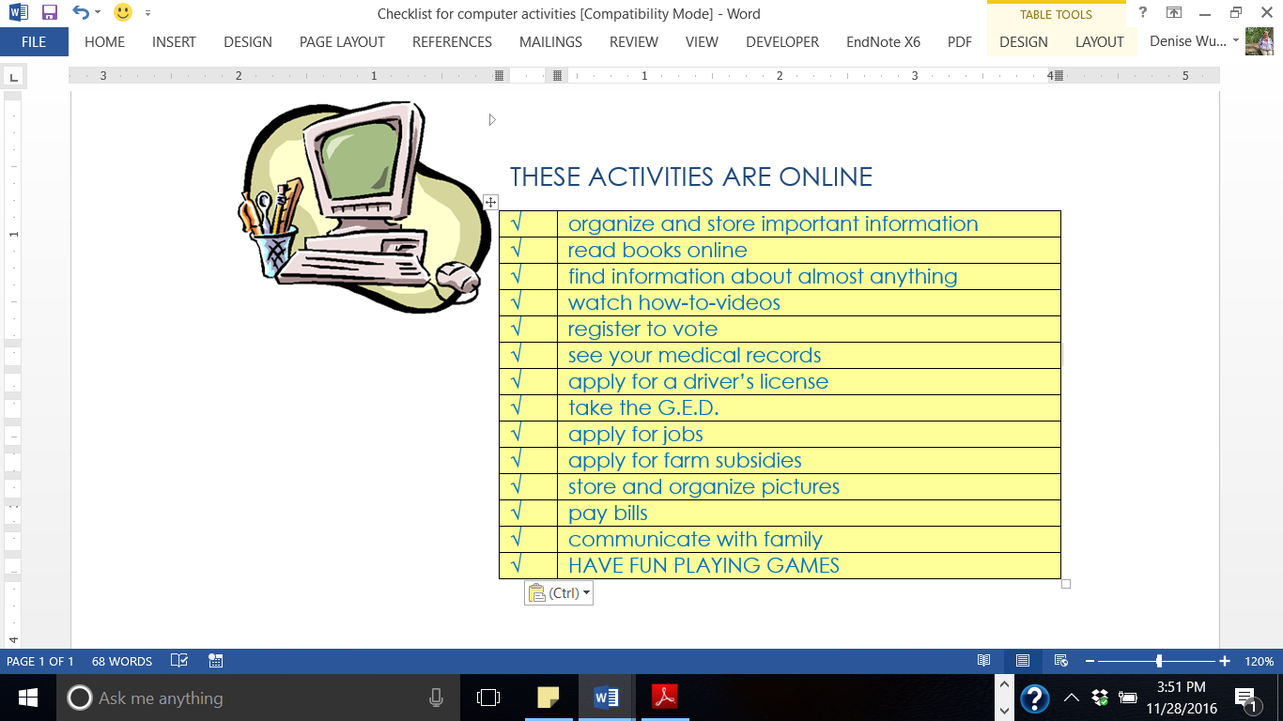

**The fact is, more and more of what we need to do to engage in the world is taking place online. If you aren’t online, it’s more difficult to access resources and services, and to stay in touch with the things that matter.**

**How about you? Have you noticed how much is online, and that you need a computer to access those things?**

**Many people, maybe just like you, are worried about using computers. When Tanya, Anita, and Jack overcame their worries and faced the challenge of needing to learn how to use computers, their lives improved.**

**Looking at the pros and cons of using a computer can help you work through whether you want to learn how to use computers.**



**Many people would list CONS or reasons not to do more on the computer,**

**like the ones that are on this list. Can you relate to any of these reasons?**

**Do you have reasons that are not on this list?**

**Take a few minutes to write them down.**



**Now let’s look at a list of common PROS or reasons to do more on the computer.**

**How about this list? Do any of these reasons match with your own?**

**Do you have reasons to use a computer that are not on this list?**

**Take a few minutes to write them down.**

THREE REASONS PEOPLE LIST FOR NOT USING A COMPUTER



***“It’s too hard! It’s too complicated!”***

**Learning something new, like using a computer can seem overwhelming at first. But if we go step by step, and learn one skill at a time, we can build skills quickly. Research shows that as we learn a new skill, it gets easier and easier to do. Basic tasks become automatic, and it becomes easier to build on our knowledge.**

***“I’m too old to start now”***

**Some older adults lack interest in learning new things. Using a computer can help with exercising the brain. Nearly 60% of seniors use the internet, and that percentage is increasing every year.**

***“Getting online just is not safe.”***

**Concern about safety is a common reason people are afraid to use the internet. There are stories about people getting scammed. There are risks to going online, but you can learn to stay safe. Millions of people do it every day!**

Not at all important

Extremely important

|  |  |  |  |  |  |  |  |  |  |
| --- | --- | --- | --- | --- | --- | --- | --- | --- | --- |
| 1 | 2 | 3 | 4 | 5 | 6 | 7 | 8 | 9 | 10 |
| ○ | ○ | ○ | ○ | ○ | ○ | ○ | ○ | ○ | ○ |

**On a scale of 1 to 10, how important is it to you to learn to use a computer or the internet? Fill in the circle of the number you choose.**

**Think about this: why did you choose that number and not one number lower or one number higher?**

**What is it for you that is making the goal of learning how to use a computer at least a little bit important?**

**Place a checkmark next to the sentences that are true for you**

|  |  |
| --- | --- |
| **√** | **Which of these statements is true for you?** |
|  | I would feel good about myself if I learned to use a computer. |
|  | Even someone like me can learn to use a computer. |
|  | Learning to use a computer is at least a little bit important to me. |
|  | I can take a small step to increase my confidence in using a computer. |
|  | There are reasons why I might want to learn to use a computer. |
|  | I plan to set at least one goal about learning to use a computer. |
|  | None of these are true for me. |

***Now imagine* that it is a year into the future and you have learned to use a computer. You are using it regularly to accomplish all kinds of tasks, to stay connected to family and friends, and to have fun! With that picture in mind, how do you feel about yourself?**