Print out Materials

Warm Up

$$\frac{1 }{4}$$

Numerator

Denominator

$$\frac{2 }{3}$$

denominator

numerator

$\frac{2 }{3}$

The top tells us part of a whole we are interested in. This fraction tells us we are interested in 2 out of the whole.

This bottom number tells us how many parts a whole has been divided into.

This fraction tells us the whole has been divided into three parts.

$\frac{2 }{3}$

This top number tells us how many parts a whole has been divided into.

This fraction tells us the whole has been divided into two parts.

This bottom number is part of a whole we are interested in. This fraction tells us we are interested in 3 out of the whole.

Equivalent Fractions?

$$\frac{1}{5}$$

=

$$\frac{2}{10}$$

Equivalent Fractions?

$$\frac{3}{5}$$

=

$$\frac{9}{10}$$

**Guided Practice**

(Remind learners to use the 3 steps procedure in all cases.)

Always write your answer using the symbol >, or <.

1. A cosmetic company revealed consumers’ satisfaction through its survey about its skin cream. From the table below,
   1. Which area do customers give highest ranking? Write the fraction []/[]
   2. Which area do customers give lowest ranking? Write the fraction []/[]
   3. Is this cream appropriate for a person looking for a cream to reduce dryness and eczema? Explain (Answer: No, is cream is not appropriate because it scores lowest for protection from dryness. It is more ideal for those with normal skin looking for to give their skin a radiant look and feel of smoothness)

|  |  |
| --- | --- |
| Intensive nourishment from dryness | 52/100 |
| Visible smoothness | 96/100 |
| Glowing finish | 78/100 |

1. Molly is trying to live a healthier lifestyle. One of her goals is to lower the amount of added sugar in her diets. An oatmeal recipe calls for 3/5 cup brown sugar while another calls for 2/3 cup brown sugar. Each recipe serves four. Which recipe should Molly use?

**Evaluation/Application**

1. Compare these discounts off original price of a vegetable. 'Get 2/5 off ' or 'Get 2/3 off'. Which discount is larger?
2. A worker at a grocery store needs to figure out which of these discounts is smaller before offering them. Get 3/5 off or ¾ off.
3. Use a ½ benchmark to compare them.
4. Which discount is lesser?
5. A sales person is studying customers’ preference of bread made by two bakeries. He found that over a month 7/8 of Delights was sold while 4/5 of Tasty was sold. Which sold more?
6. The table below is part of the Sample Score Report for Maths Grade 3-8 that Florida State Assessment provided to parents to help them understand the state assessments.

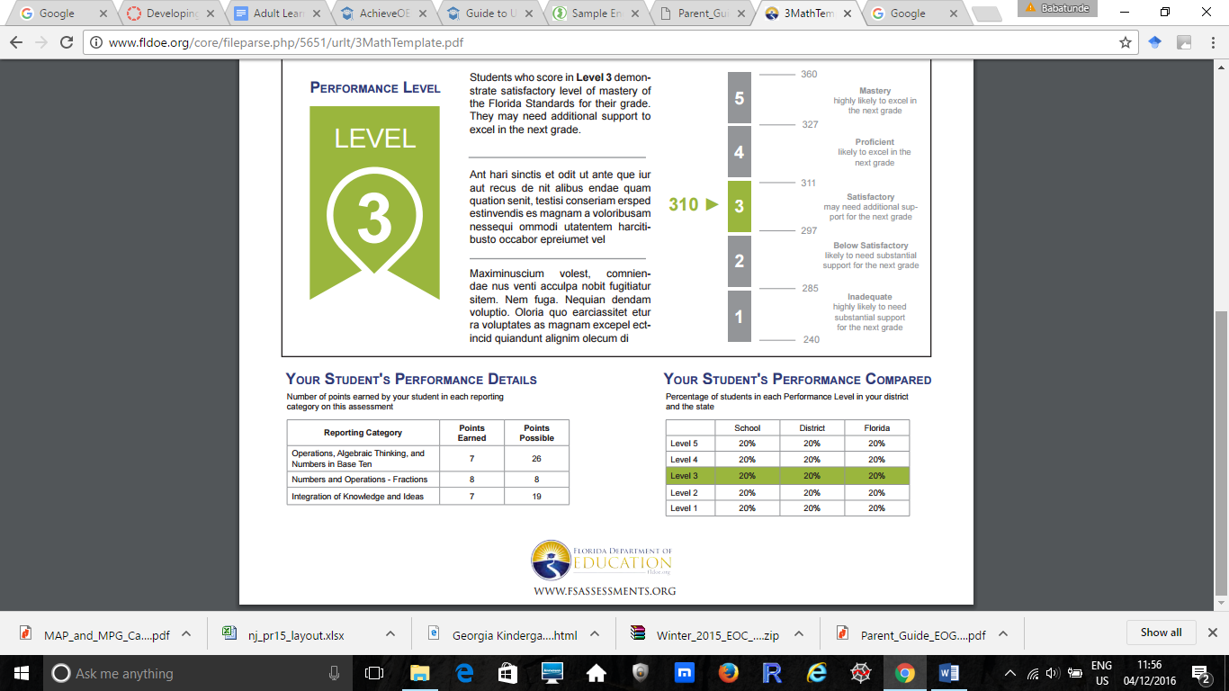

1. Write the scores for this student in Operations and Numbers in Base Ten and the score in Integration of Knowledge and Ideas.
2. Compare the scores you wrote. Which category did the student have a greater score?
3. The table below shows a part of a sample score report from the Wisconsin Department of Public Instruction User’s Guide to Interpreting Report.

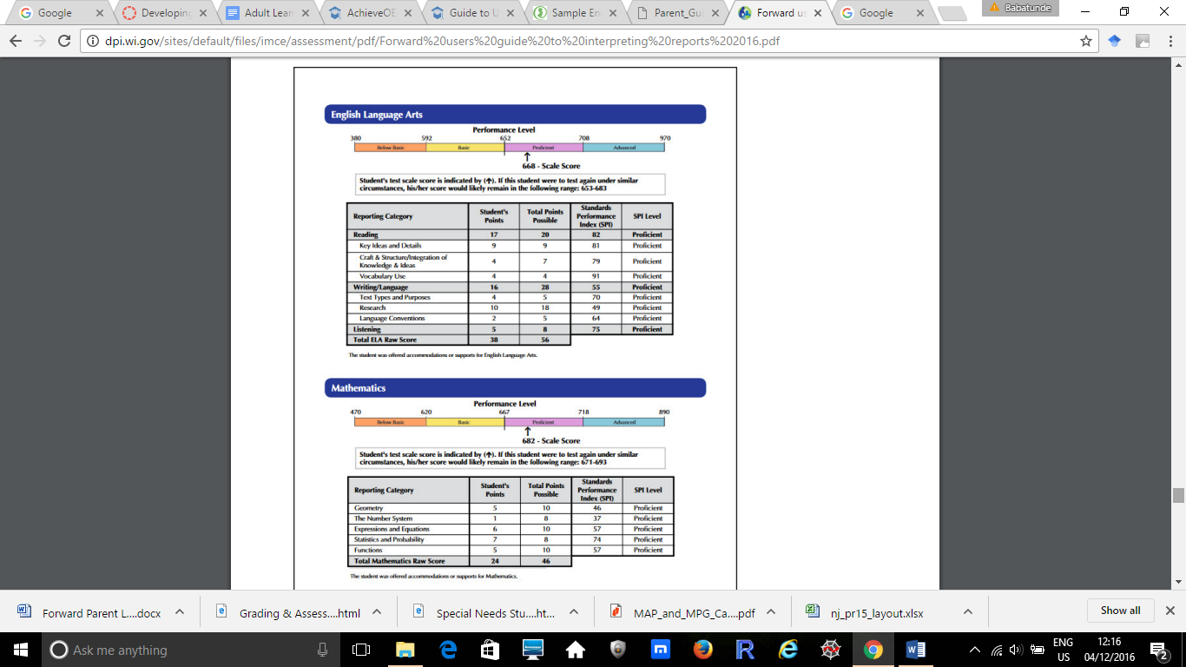

1. Compare the student score in Geometry to the score in The Number System. Which category did the student score lesser?
2. Compare the student score in Statistics and Probability to the score in Functions. Which category did the student score greater?

Answer Key:

Guided practice

1. Answer
2. 96/100
3. 52/100
4. No, this cream is not an appropriate choice because it scores lowest for protection from dryness. It is more ideal for those with normal skin looking to give their skin a radiant look and a feeling of smoothness.
5. Since 2/3 and 3/5 have different numerators and denominators, they need to be converted into fractions that have common or like denominator using the lowest common multiple 15.

2 x5/3 x 5 = 10/15 and

3 x 3/5 x 3 = 9/15

9/15 < 10/15 so Molly should use the recipe that calls for 3/5 cup.

Evaluation/ Application

1. 2/3 > 2/5



|  |  |  |  |  |  |
| --- | --- | --- | --- | --- | --- |
|  |  |  | 3/5 |  |  |

|  |  |  |  |
| --- | --- | --- | --- |
|  |  | 3/4 |  |

1. The fractions have the same numerator so they can be ordered as they are. Therefore, 3/5 < ¾ so he should offer 3/5 discount.
2. Again these fractions have different numerators and denominators so they need to be changed to fractions that have common or like denominator usin6g the least common multiple 40.

Therefore, 7/8 is equivalent to 35/40 and 4/5 = 32/40

So 35/40 > 32/40 and that means Delights sold more than Tasty.

2. Score in Operations and Number in Base Ten: 7/26

Score in Integration of Knowledge and Ideas: 7/19

1. Since the fractions have a common numerator, 7, it is easy to compare as they are. 7/19 > 7/26 because to have 7 parts from 19 is more than having 7 parts from 26.

So the student has a higher score in Integration of Knowledge and Ideas.

2. Geometry score = 5/10

Number System score = 1/8

The easier technique to use here is to compare the fractions to a benchmark. When each fraction is compared to a ½ benchmark

Then in Geometry half of a tenths is 5/10 which is equal to the score.

For the eighths, in the number system, half of eights = 4/8

Student Number System score is 1/8, but 1/8 < 4/8

So the student’s score is lesser in Number System because it is lesser than the ½ benchmark.

1. Statistics score = 7/8

Functions score = 5/10

Again using a ½ benchmark to compare the fractions,

Half of eighths is 4/8, so 7/8 is more than the half benchmark

Half of tenths is 5/10 so the same as the student’s score in Function score.

Since 7/8 is more than the its half benchmark, the student’s score in Statistics is greater than the score in Function.