6.7 – Exponential and Logarithmic Models

Modeling Exponential Growth and Decay
In real-world applications, we need to model the behavior of a function. In mathematical modeling, we choose a familiar general function with properties that suggest that it will model the real-world phenomenon we wish to analyze. In the case of rapid growth, we may choose the exponential growth function:
y=A₀e^{kt}
In our choice of a function to serve as a mathematical model, we often use data points gathered by careful observation and measurement to construct points on a graph and hope we can recognize the shape of the graph. Exponential growth and decay graphs have a distinctive shape. It is important to remember that, although parts of each of the two graphs seem to lie on the x-axis, they are really a tiny distance above the x-axis.

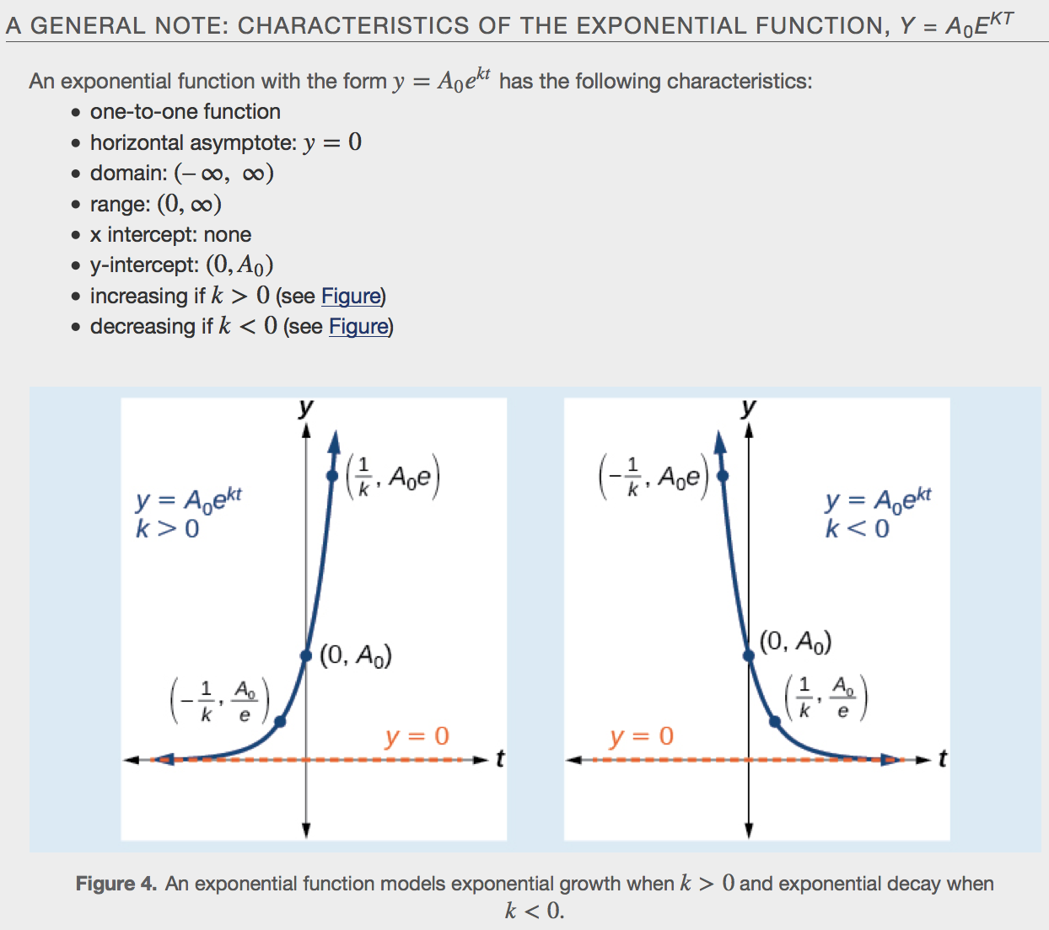

Example

Half-Life
We now turn to exponential decay. One of the common terms associated with exponential _______________, as stated above, is __________-__________, the length of time it takes an exponentially decaying quantity to decrease to half its original amount. Every radioactive isotope has a half-life, and the process describing the exponential decay of an isotope is called radioactive decay. To find the half-life of a function describing exponential decay, solve the following equation:
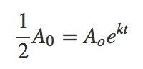

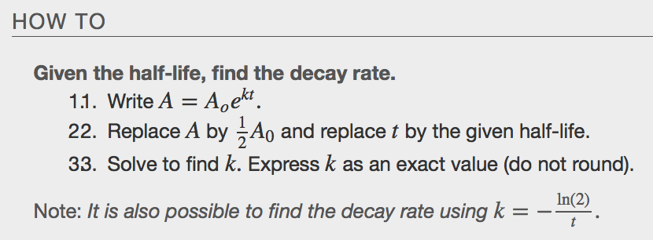
Example

Radiocarbon Dating
The formula for radioactive decay is important in radiocarbon dating, which is used to calculate the approximate date a plant or animal died. It is believed to be accurate to within about 1% error for plants or animals that died within the last 60,000 years.

As long as a plant or animal is alive, the ratio of the two isotopes of carbon in its body is close to the ratio in the atmosphere. When it dies, the carbon-14 in its body decays and is not replaced. By comparing the ratio of carbon-14 to carbon-12 in a decaying sample to the known ratio in the atmosphere, the date the plant or animal died can be approximated.

Since the half-life of carbon-14 is 5,730 years, the formula for the amount of carbon-14 remaining after t years is 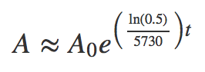

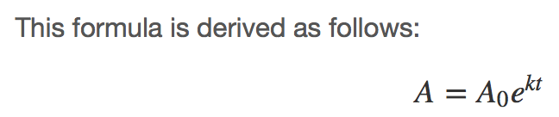

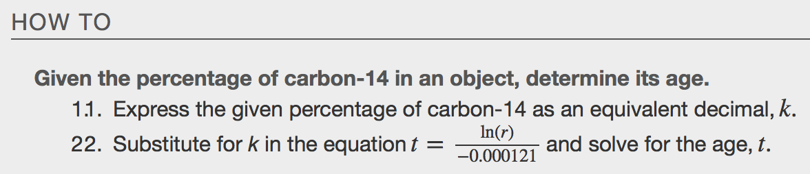
Examples

Calculating Doubling Time
For decaying quantities, we determined how long it took for half of a substance to decay. For growing quantities, we might want to find out how long it takes for a quantity to double. As we mentioned above, the time it takes for a quantity to double is called the ____________________________________ time.
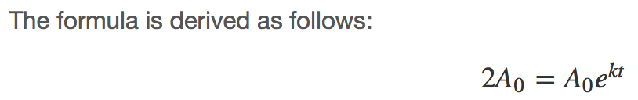

Examples

Using Newton’s Law of Cooling
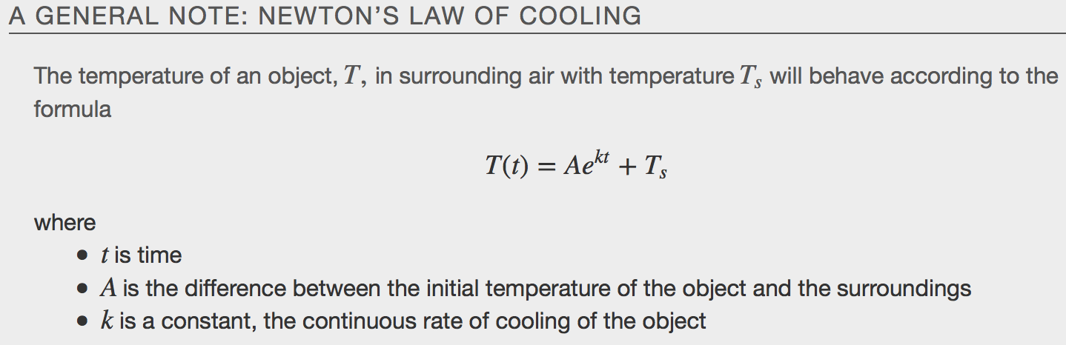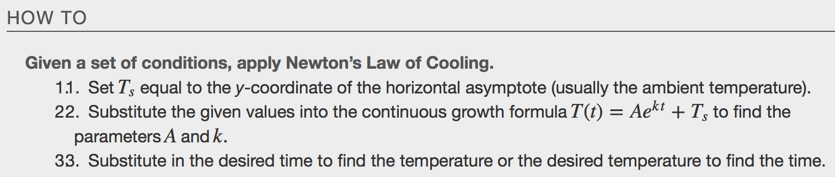
Example
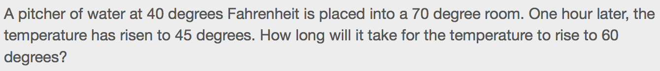

Using Logistic Growth Models
Exponential growth cannot continue forever. Exponential models, while they may be useful in the short term, tend to fall apart the longer they continue. Eventually, an exponential model must begin to approach some limiting value, and then the growth is forced to slow. For this reason, it is often better to use a model with an upper bound instead of an exponential growth model, though the exponential growth model is still useful over a short term, before approaching the limiting value.
The _____________________________ growth model is approximately exponential at first, but it has a reduced rate of growth as the output approaches the model’s upper bound, called the _______________________ capacity. For constants a, b, and c, the logistic growth of a population over time x is represented by the model
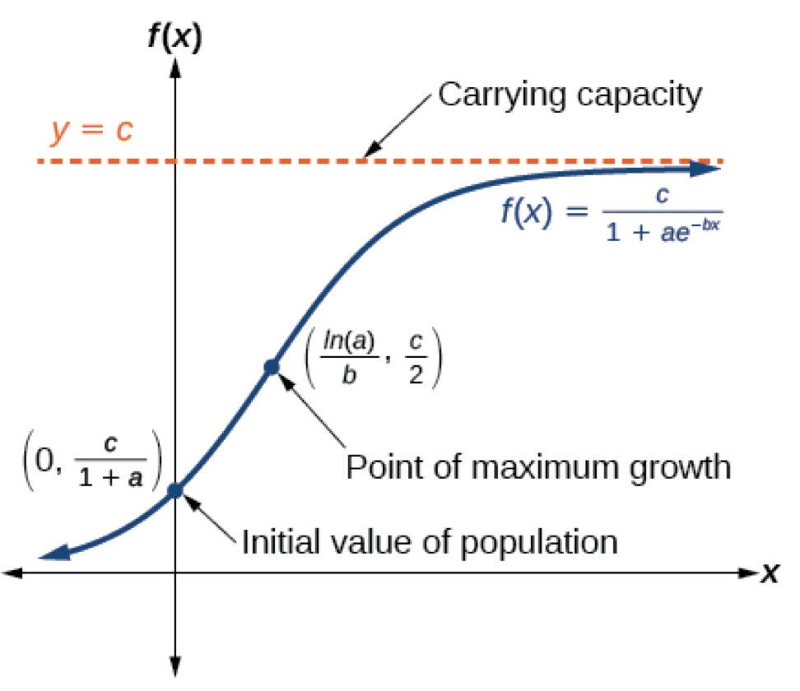
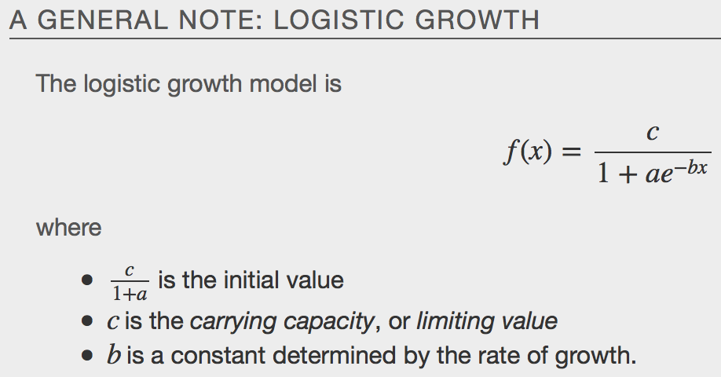
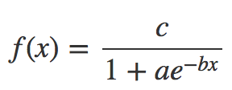
Example
