5.7 – Inverses and Radical Functions
Finding the Inverse of a Polynomial Function

Two functions f and g are inverse functions if for every coordinate pair in f, (a,b),there exists a corresponding coordinate pair in the ______________________ function, g,(b,a).In other words, the coordinate pairs of the inverse functions have the input and output interchanged. Only one-to-one functions have inverses. Recall that a ______ to _______function has a unique output value for each input value and passes the horizontal line test.

For example, suppose a water runoff collector is built in the shape of a parabolic trough as shown in Figure. We can use the information in the figure to find the surface area of the water in the trough as a function of the depth of the water.

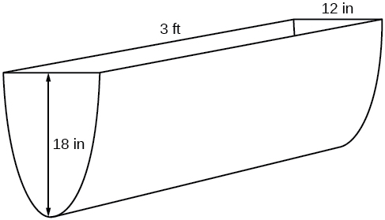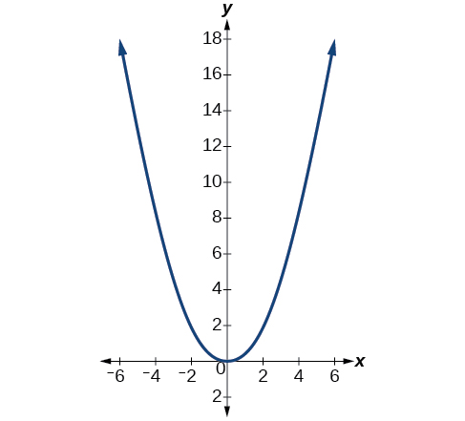

From this we find an equation for the parabolic shape. We placed the origin at the vertex of the parabola, so we know the equation will have form __________________.Our equation will need to pass through the point (6, 18), from which we can solve for the stretch factor a.

Parabolic Cross Section Function:
Domain:
Surface Area of Water Function:
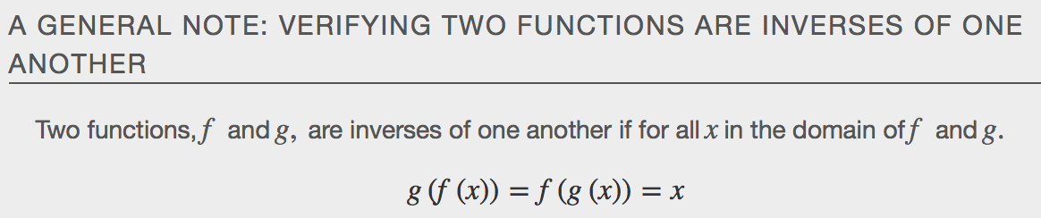

f⁻¹(f(x))=x,for all x in the domain of f
f(f⁻¹(x))=x,for all x in the domain of f−1

Warning:
f−1(x)is not the same as the reciprocal of the functionf(x).This use of “–1” is reserved to denote inverse functions. To denote the reciprocal of a functionf(x),we would need to write(f(x))−1=1f(x).
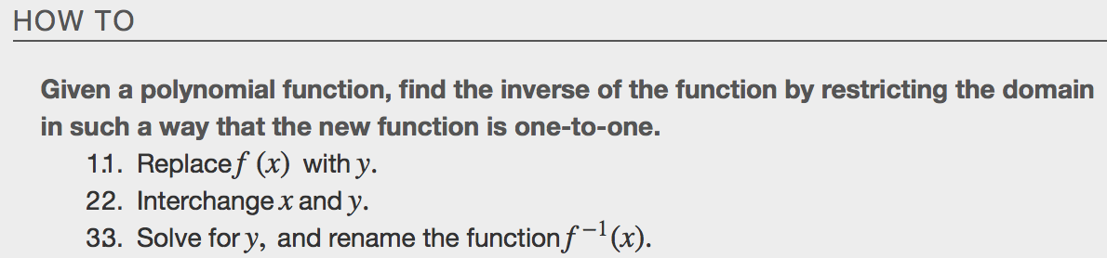

desmos.com

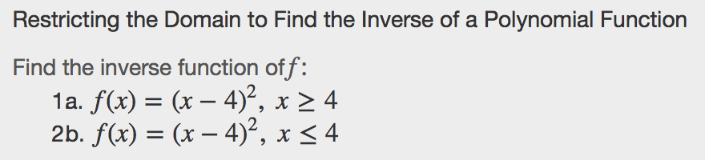

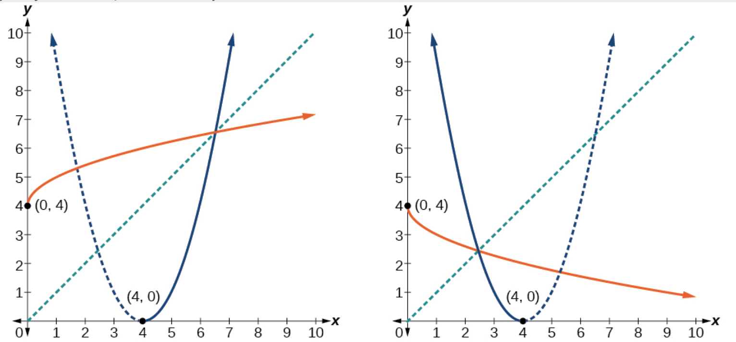
Determine the Domain of a Radical Function Composed with Other Functions
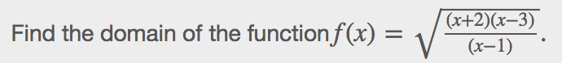
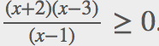
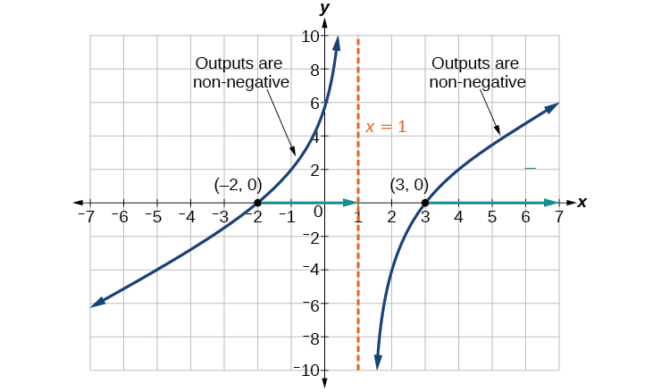
Solving Applications of Radical Functions
