3.6 – Absolute Value Functions

Understanding Absolute Value
Recall that in its basic form f(x)=|x|,the absolute value function is one of our toolkit functions. The absolute value function is commonly thought of as providing the _____________________________ the number is from _______________ (the origin) on a number line.

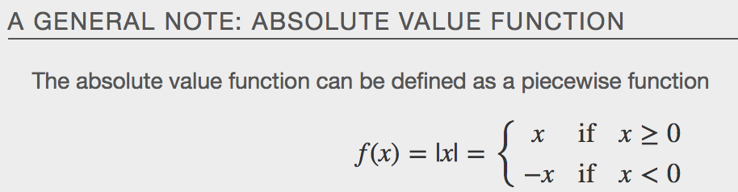

Example

Graphing an Absolute Value Function
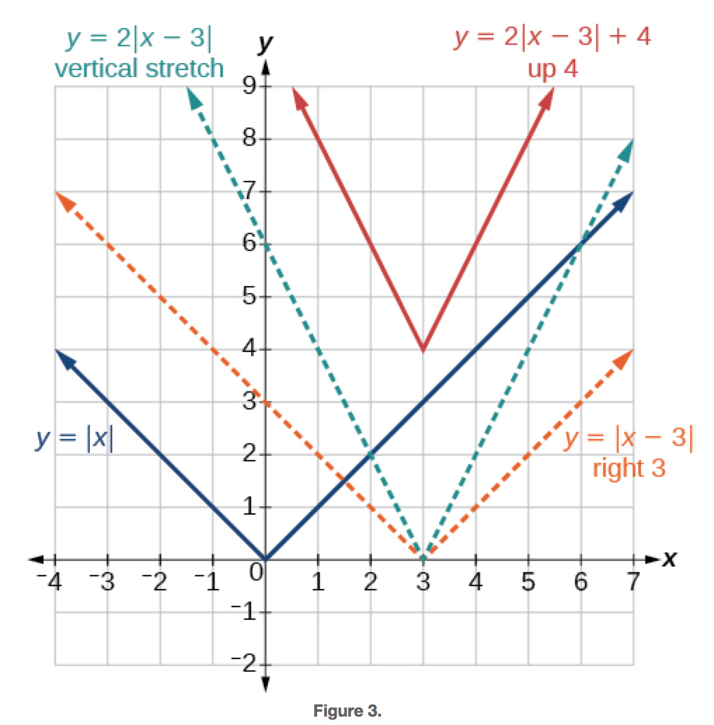
Examples
a.
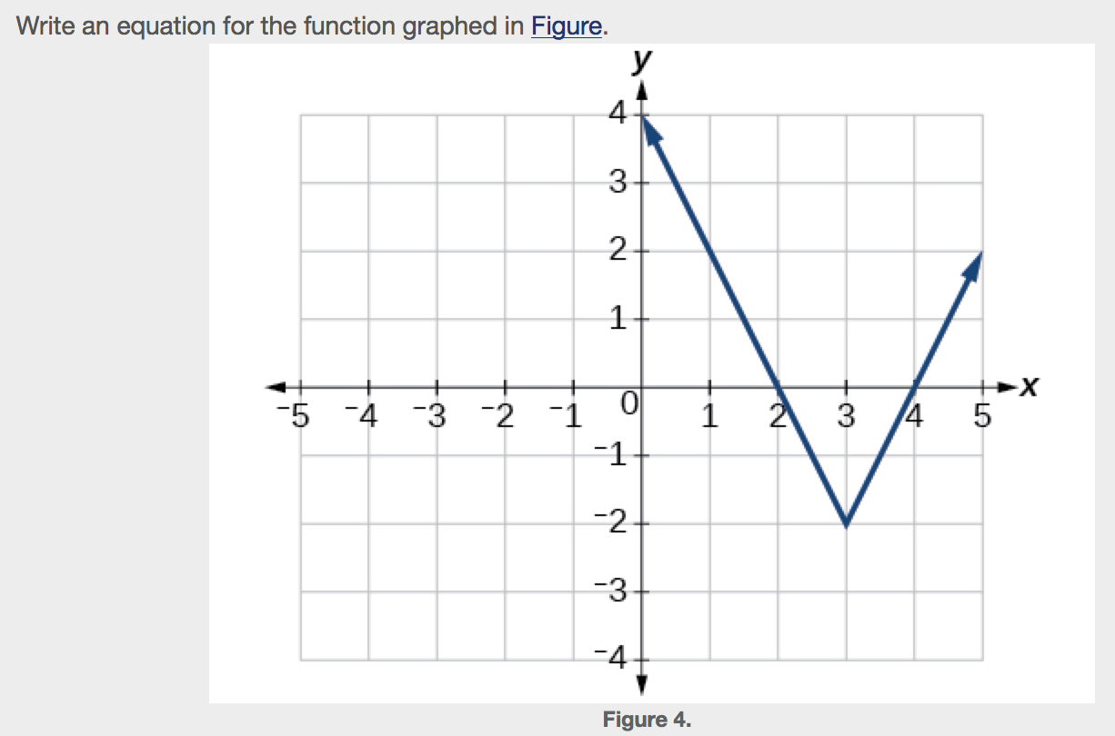

b.

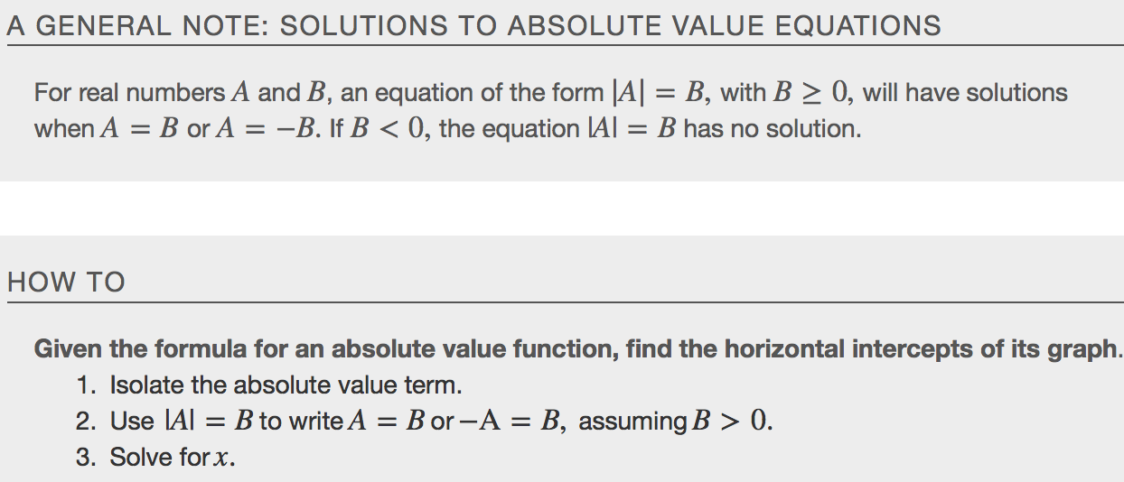
Example
a. 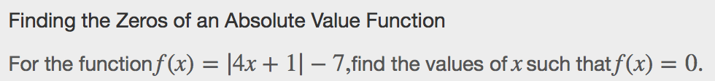

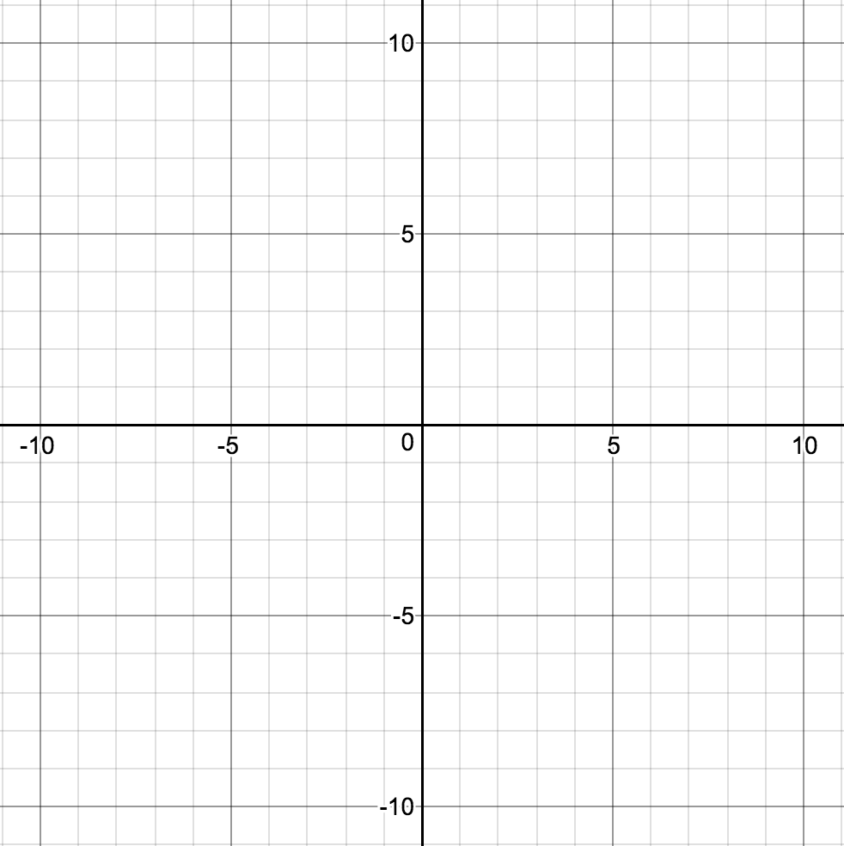

b.
