2.6 – Other Types of Equations

Solving Equations Involving Rational Exponents
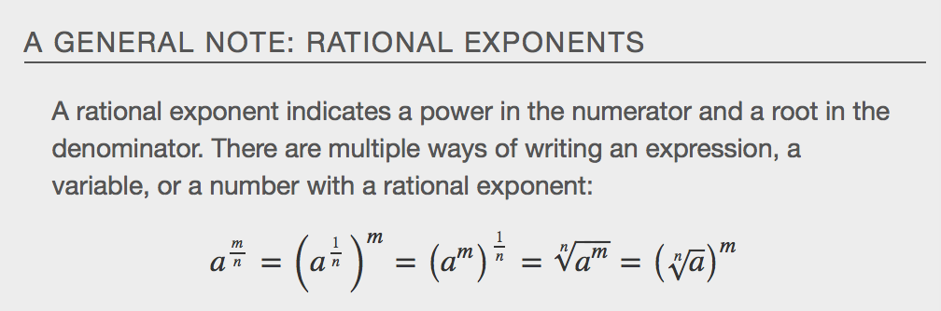

Examples:

- 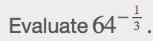 b. 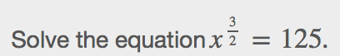

c. 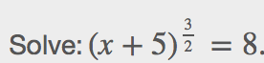

Solving Equations Using Factoring
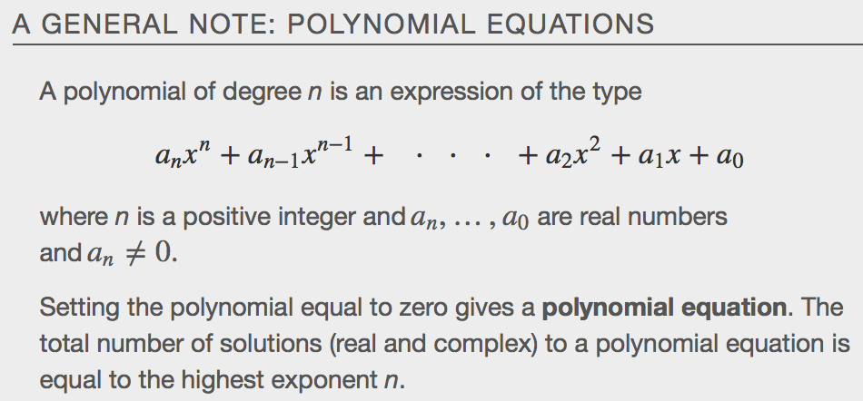

Examples:

- 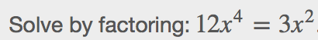 b. 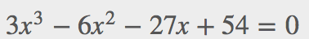

www.desmos.com
Solving Radical Equations
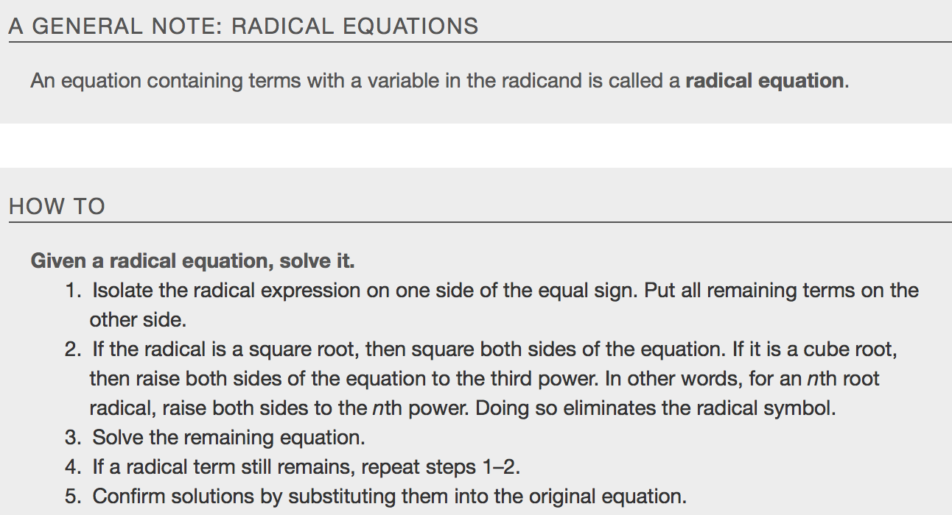
Examples:
- b.

Solving Absolute Value Equations
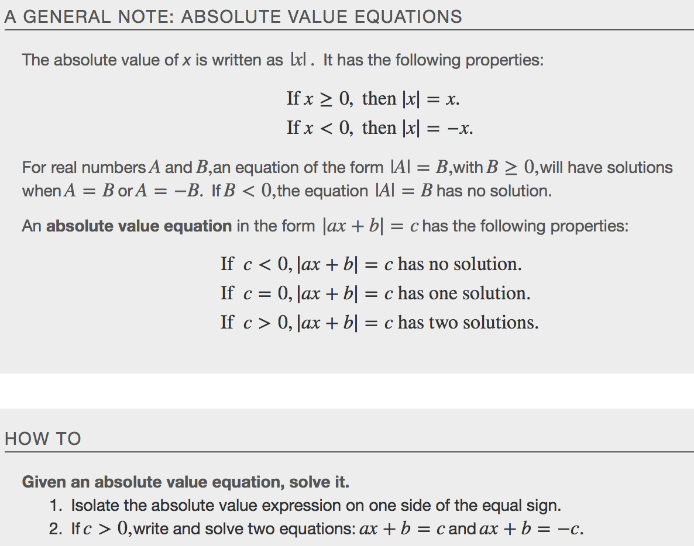
Examples:

- b. 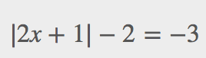

Solving Quadratic Equations
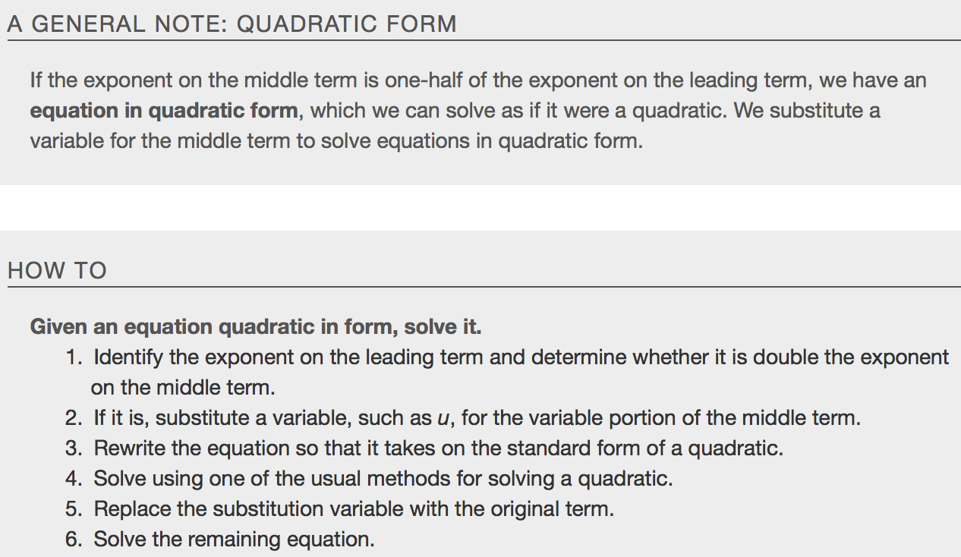
- 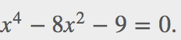 b. 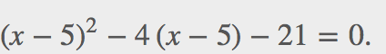

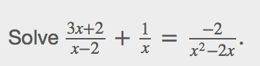

Key Concepts
- Rational exponents can be rewritten several ways depending on what is most convenient for the problem. To solve, both sides of the equation are raised to a power that will render the exponent on the variable equal to 1. See Example, Example, and Example.
- Factoring extends to higher-order polynomials when it involves factoring out the GCF or factoring by grouping. See Example and Example.
- We can solve radical equations by isolating the radical and raising both sides of the equation to a power that matches the index. See Example and Example.
- To solve absolute value equations, we need to write two equations, one for the positive value and one for the negative value. See Example.
- Equations in quadratic form are easy to spot, as the exponent on the first term is double the exponent on the second term and the third term is a constant. We may also see a binomial in place of the single variable. We use substitution to solve. See Example and Example.
- Solving a rational equation may also lead to a quadratic equation or an equation in quadratic form. See Example.

