2.5 – Quadratic Equations

Solving Quadratic Equations By Factoring

** This method is useful only if the quadratic expression can be ______________________. Factoring means finding expressions that can be _____________________________ together to give the expression on one side of the equation.**

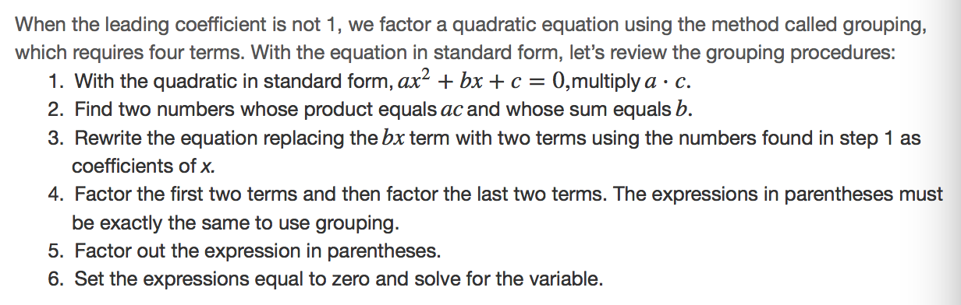

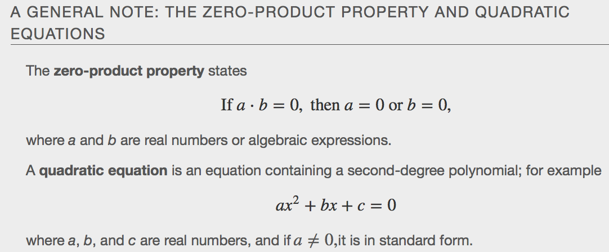
Examples

Using the Square Root Property
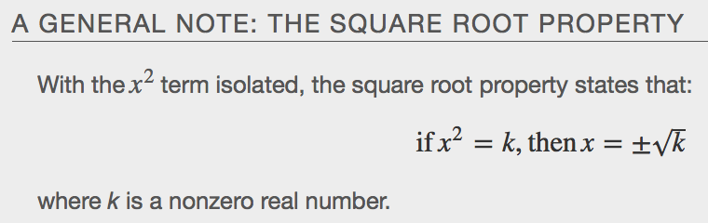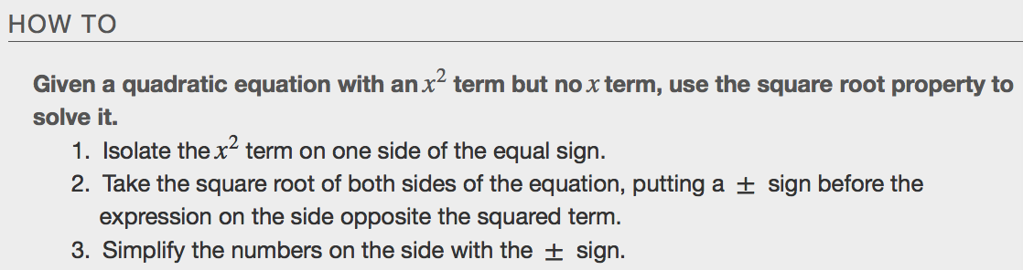
Examples

Completing the Square
Not all quadratic equations can be factored or can be solved in their original form using the square root property. In these cases, we may use a method for solving a quadratic equation known as _____________________________ the _________________. Using this method, we add or subtract terms to both sides of the equation until we have a perfect square trinomial on one side of the equal sign. We then apply the square root property. To complete the square, the leading coefficient, a, must equal _________. If it does not, then divide the entire equation by a. Then, we can use the following procedures to solve a quadratic equation by completing the square.

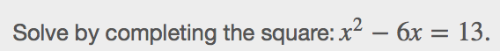

Using the Quadratic Formula
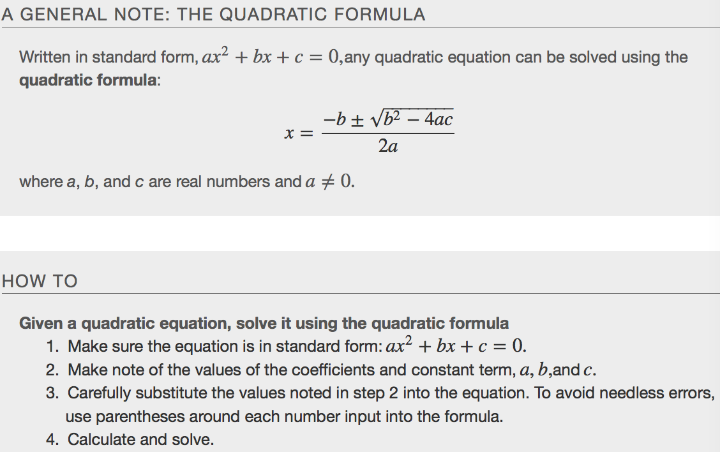

The Discriminant
The quadratic formula not only generates the solutions to a quadratic equation, it tells us about the nature of the solutions when we consider the _______________________________, or the expression under the radical, b²−4ac.The discriminant tells us whether the solutions are real numbers or complex numbers, and how many solutions of each type to expect. Table relates the value of the discriminant to the solutions of a quadratic equation.
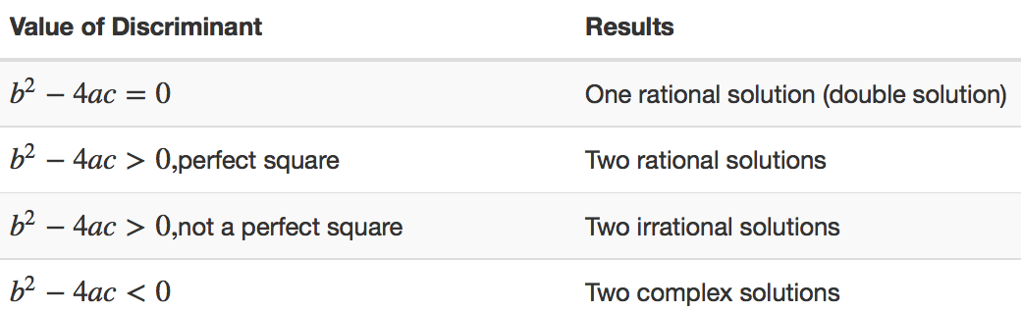
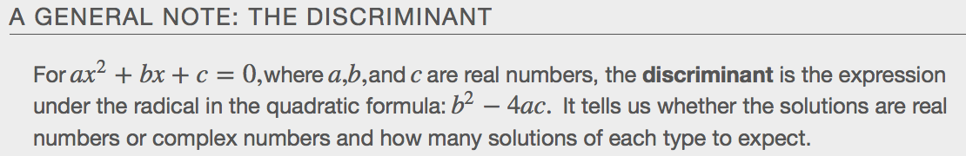

Examples
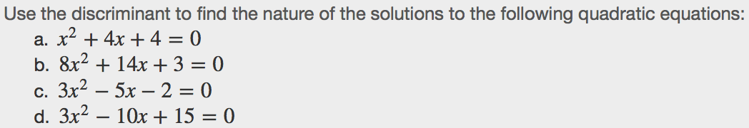

Using the Pythagorean Theorem
One of the most famous formulas in mathematics is the Pythagorean Theorem. It is based on a right triangle, and states the relationship among the lengths of the sides asa²+b2=c2, where a and b refer to the legs of a right triangle adjacent to the 90°angle, and c refers to the hypotenuse. It has immeasurable uses in architecture, engineering, the sciences, geometry, trigonometry, and algebra, and in everyday applications.
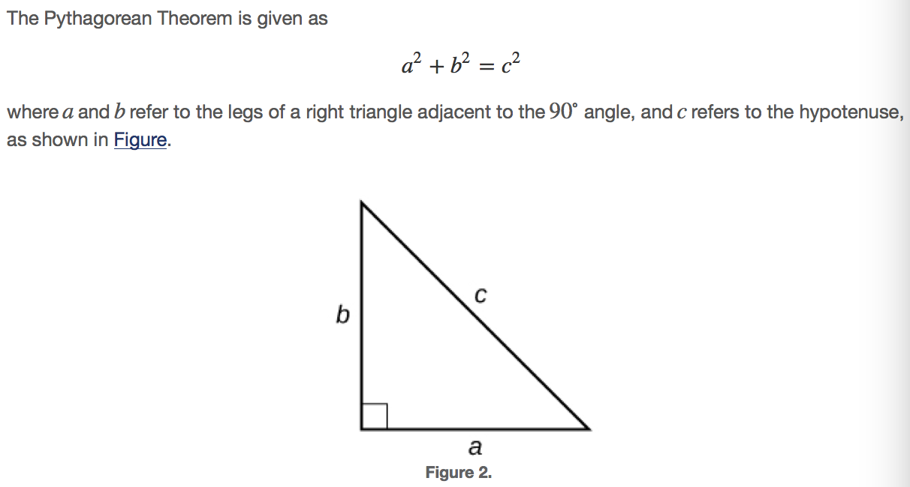
Examples
