6.6 – Exponential and Logarithmic Equations
Using Like Bases to Solve Exponential Equations

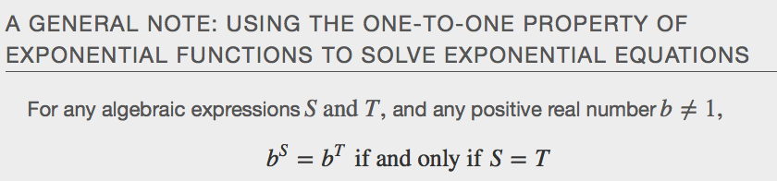

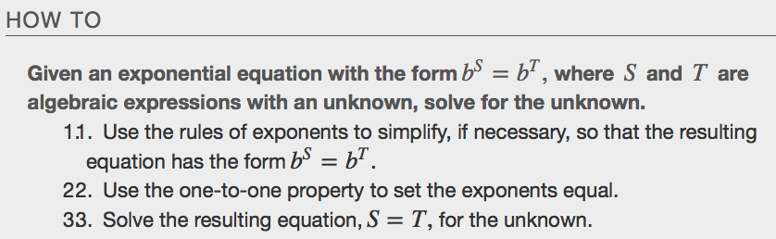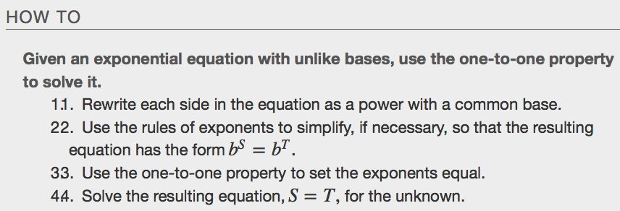
Examples
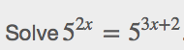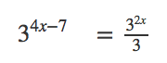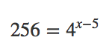

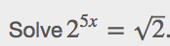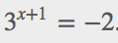
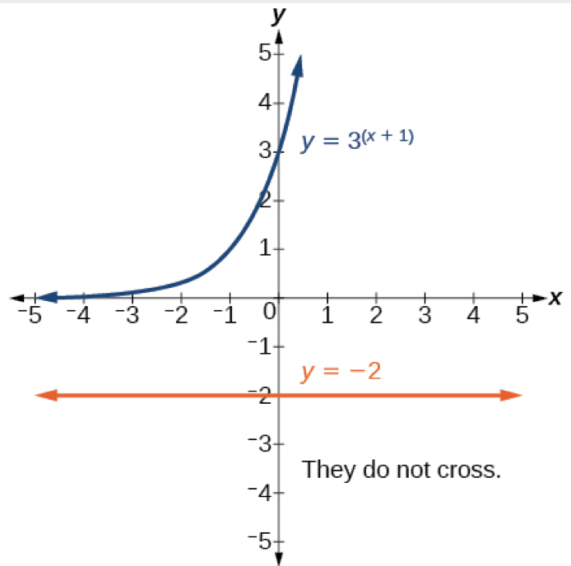

Solving Exponential Equations Using Logarithms
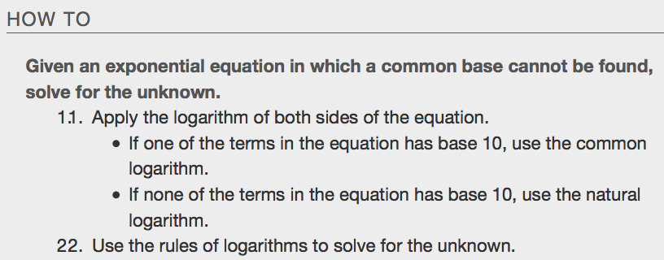
Examples
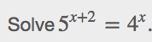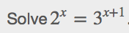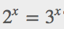

Equations Containing e
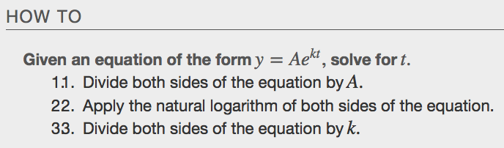
Examples
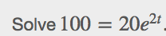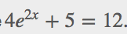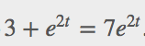

Extraneous Solutions
Sometimes the methods used to solve an equation introduce an ______________________________solution, which is a solution that is correct algebraically but does not satisfy the conditions of the original equation. One such situation arises in solving when the logarithm is taken on both sides of the equation. In such cases, remember that the argument of the logarithm must be positive. If the number we are evaluating in a logarithm function is negative, there is no output.
Examples
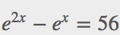

Using the Definition of a Logarithm to Solve Logarithmic Equations
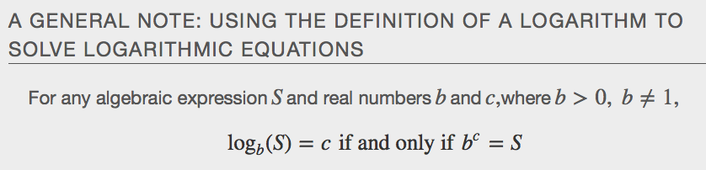
Examples
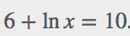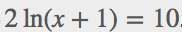

Using the One-To-One Property to Solve Logarithmic Equations
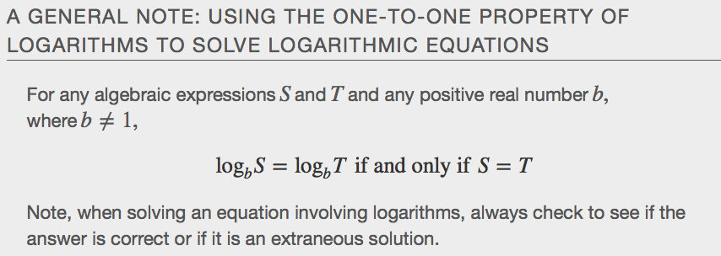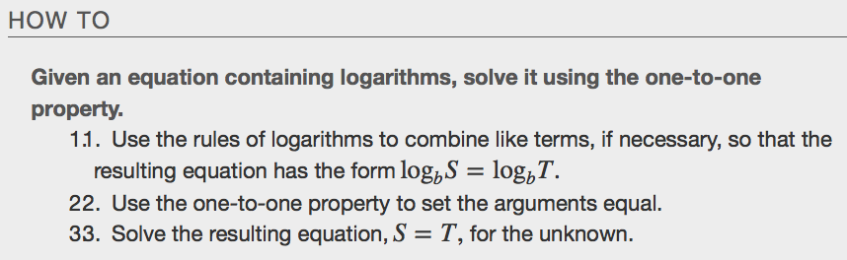
Examples
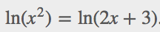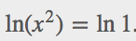

Using the Formula for Radioactive Decay
