6.4 – Graphs of Logarithmic Functions
How do logarithmic graphs give us insight into situations? Because every logarithmic function is the inverse function of an exponential function, we can think of every output on a logarithmic graph as the input for the corresponding inverse exponential equation. In other words, logarithms give the cause for an effect.

To illustrate, suppose we invest$2500in an account that offers an annual interest rate of 5%, compounded continuously. We already know that the balance in our account for any year t can be found with the equation A=2500e^{0.05t}.
But what if we wanted to know the year for any balance? We would need to create a corresponding new function by interchanging the input and the output; thus we would need to create a logarithmic model for this situation. By graphing the model, we can see the output (year) for any input (account balance). For instance, what if we wanted to know how many years it would take for our initial investment to double? Figure shows this point on the logarithmic graph.

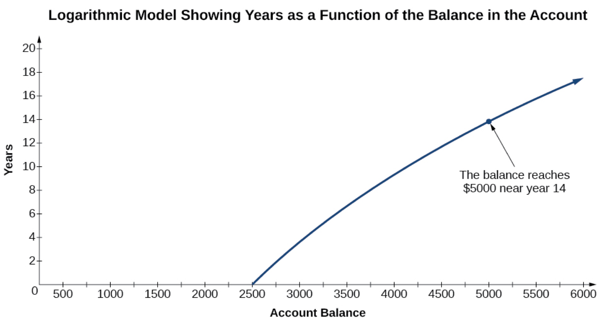

Finding the Domain of a Logarithmic Function
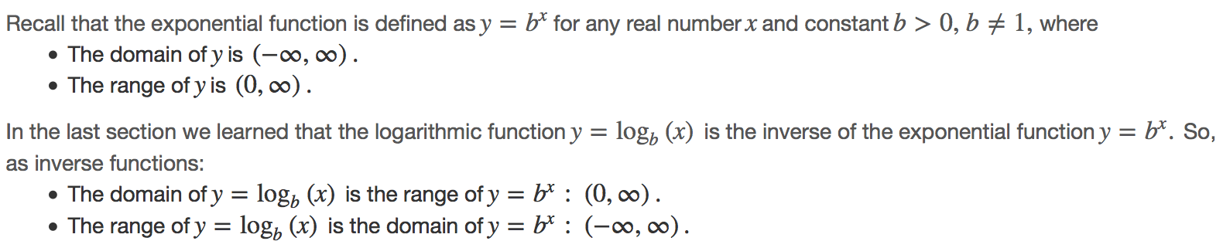

Transformations of the parent function y=log_{b}(x)behave similarly to those of other functions. Just as with other parent functions, we can apply the four types of transformations—shifts, stretches, compressions, and reflections—to the parent function without loss of shape.
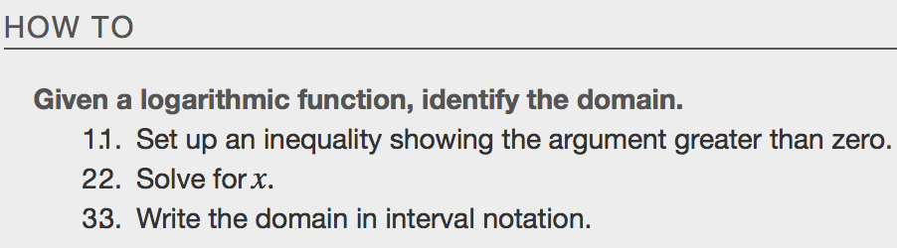
Example

Graphing Logarithmic Function
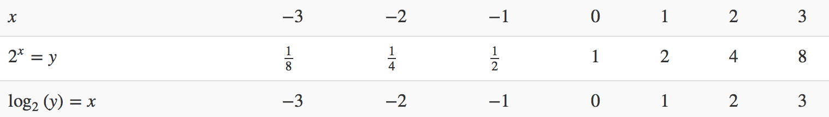

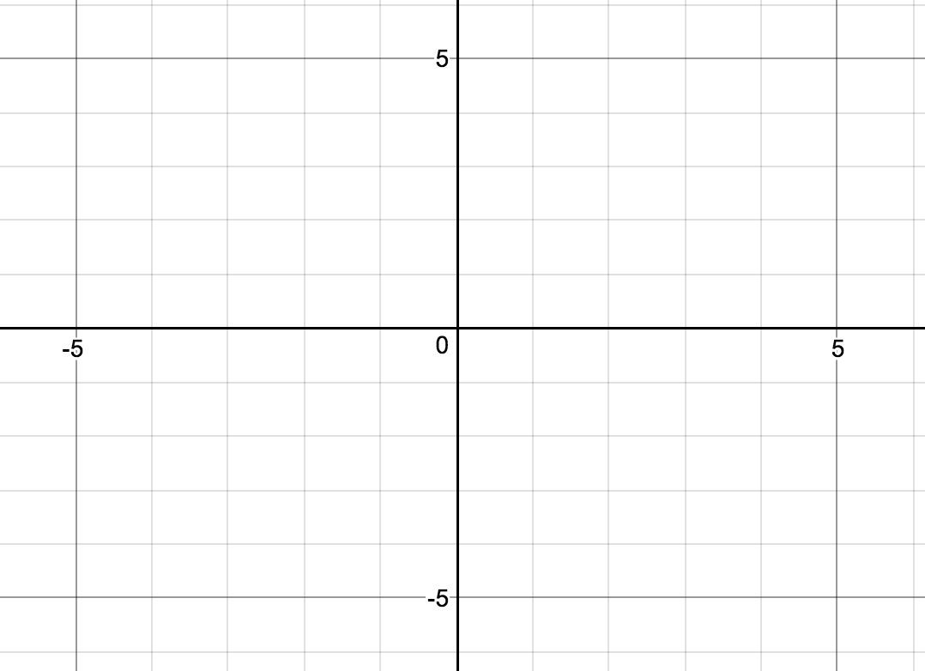
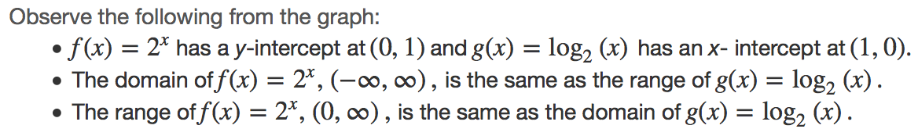
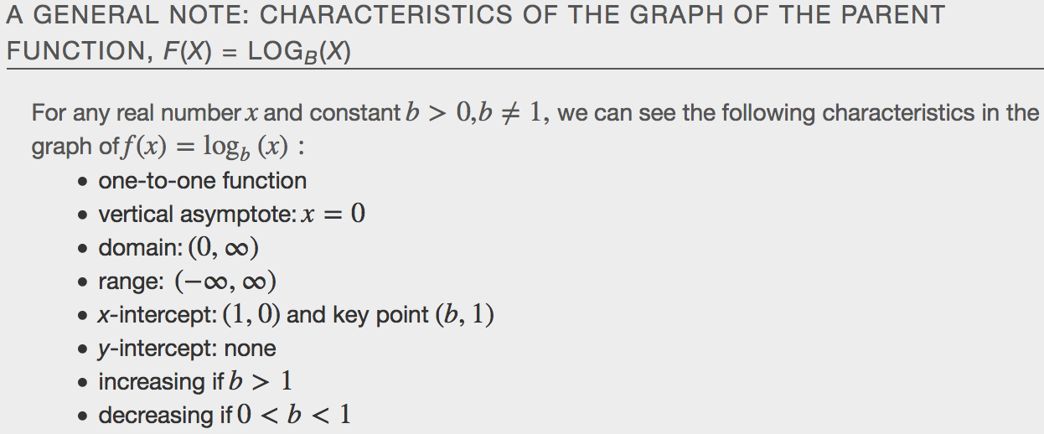
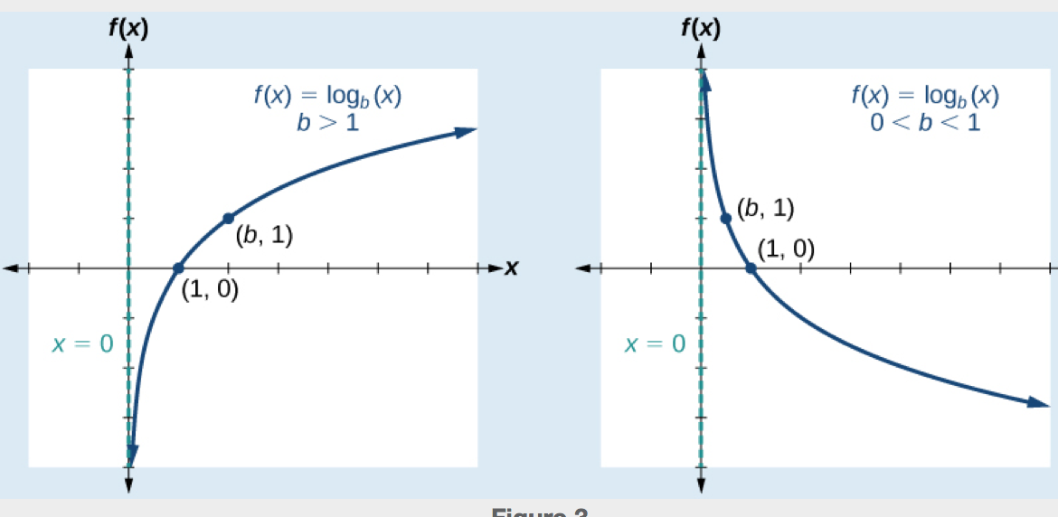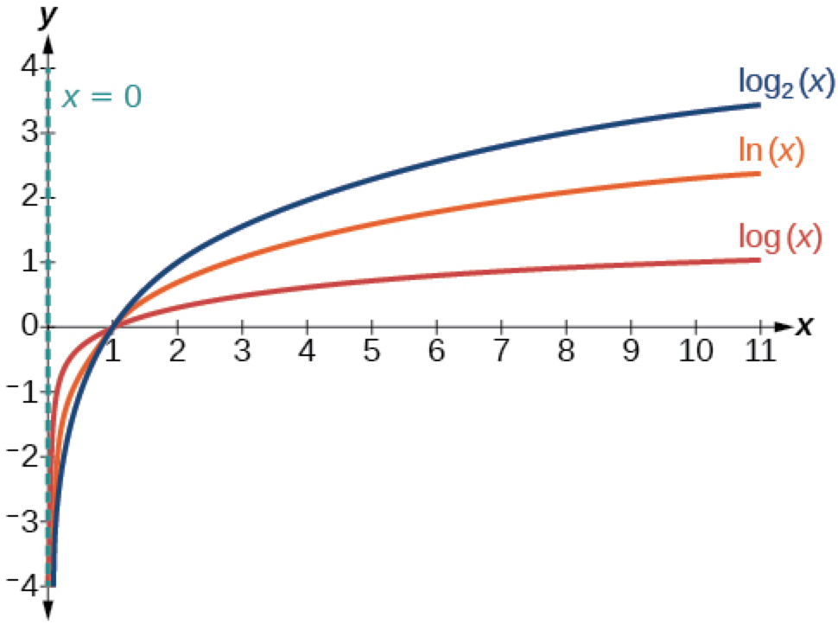
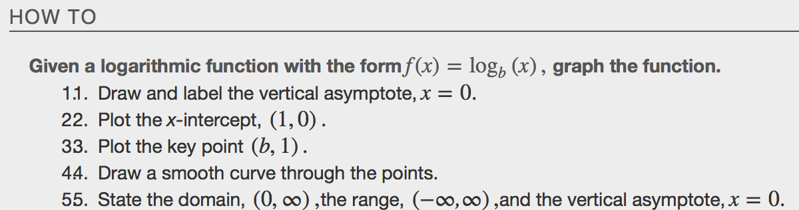
Example
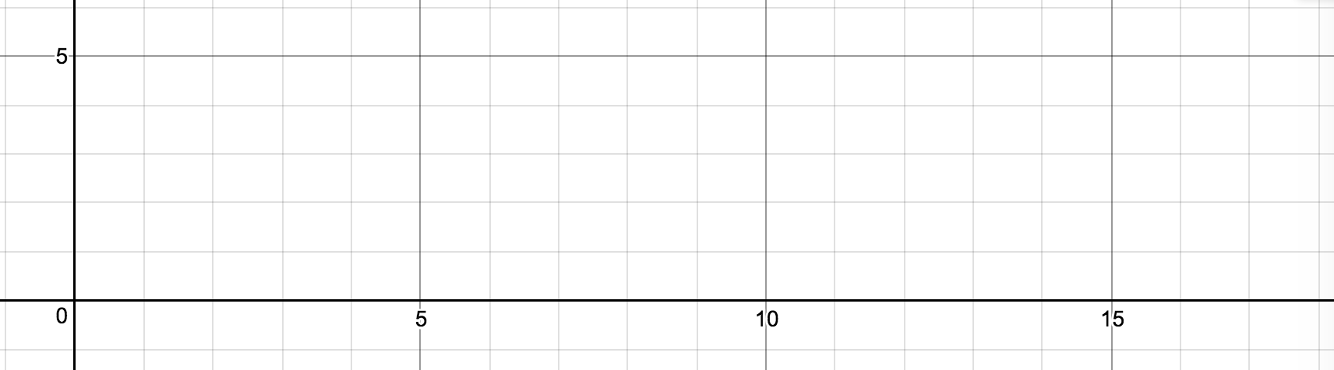

Graphing Transformations of Logarithmic Functions
Graphing a Horizontal Shift
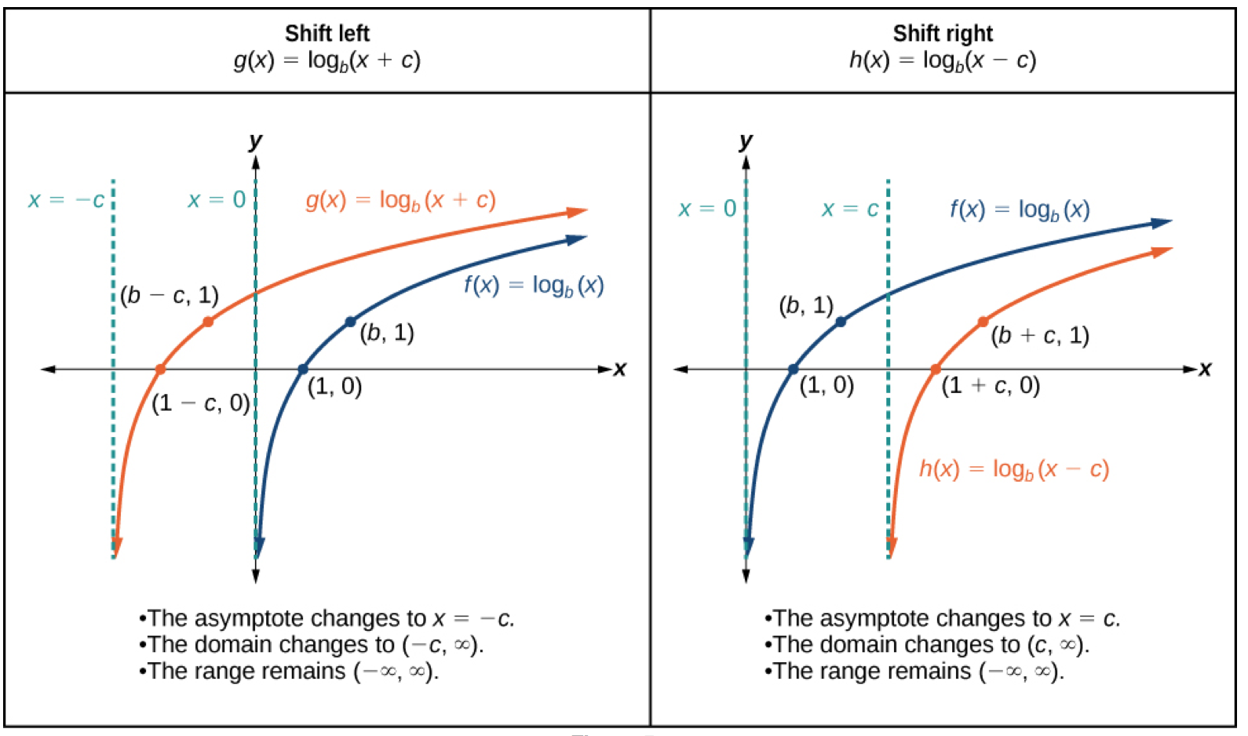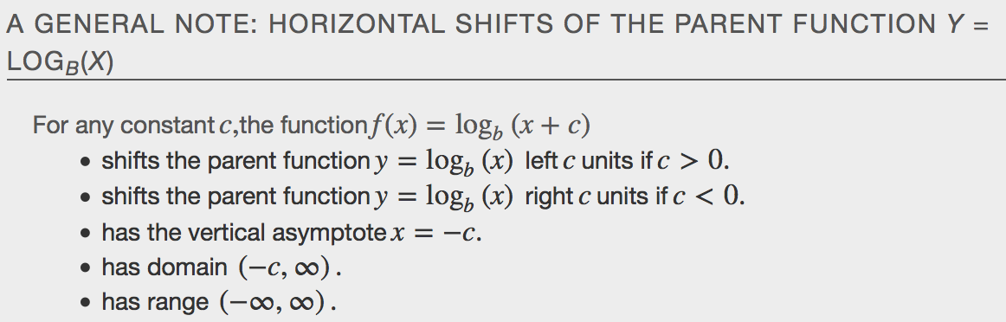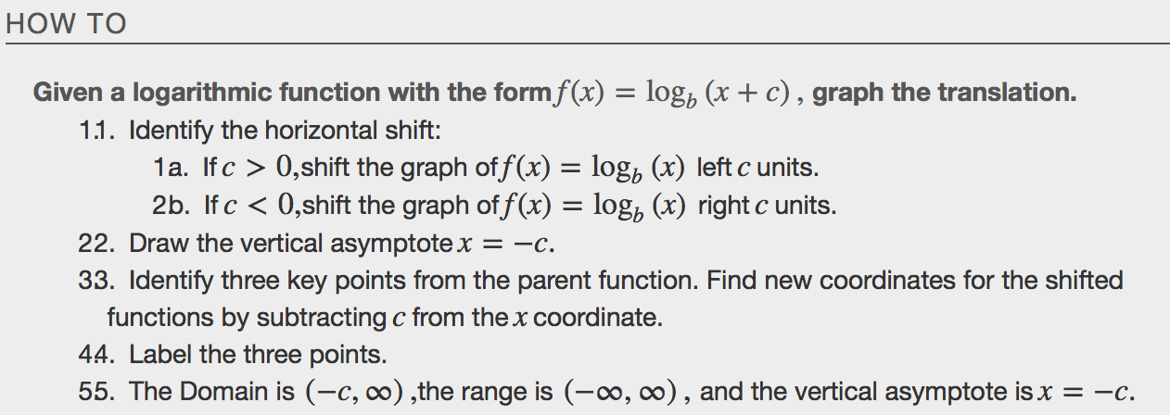
Example

Graphing a Vertical Shift
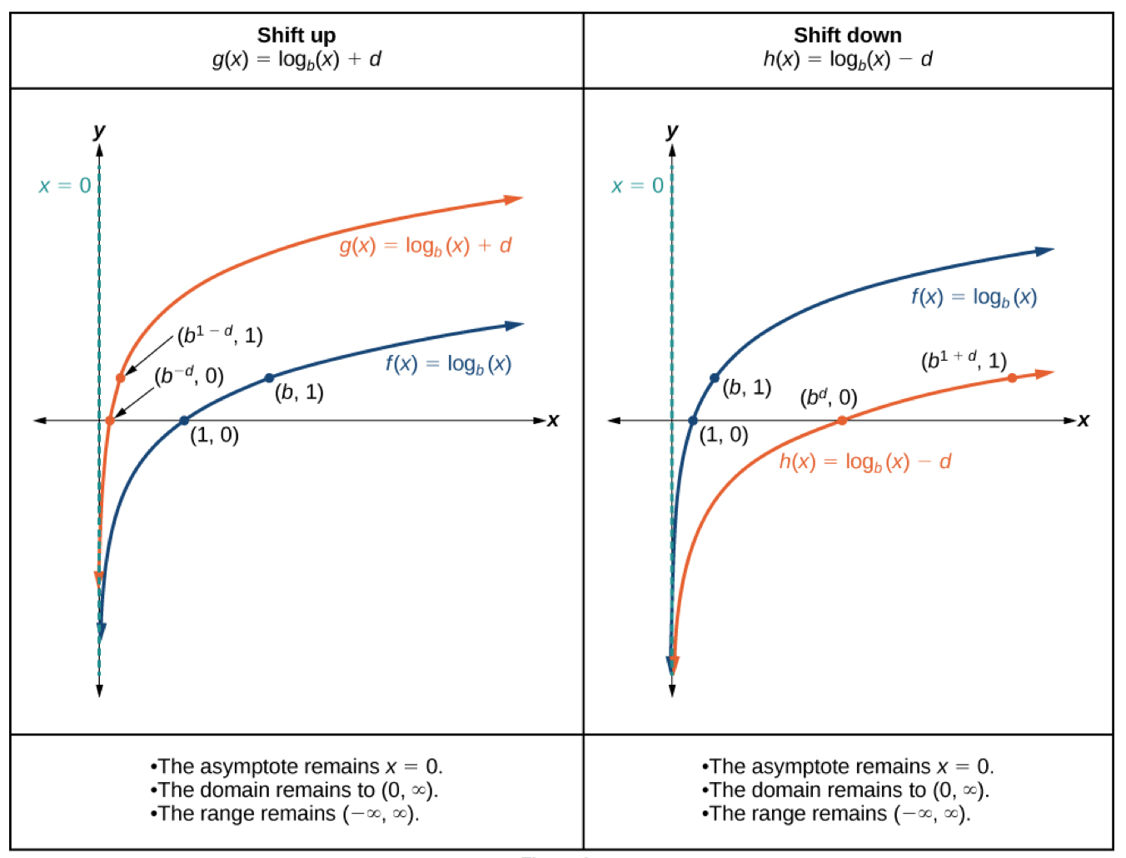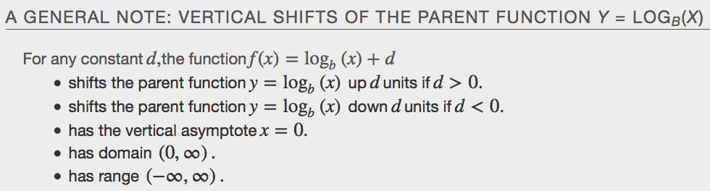
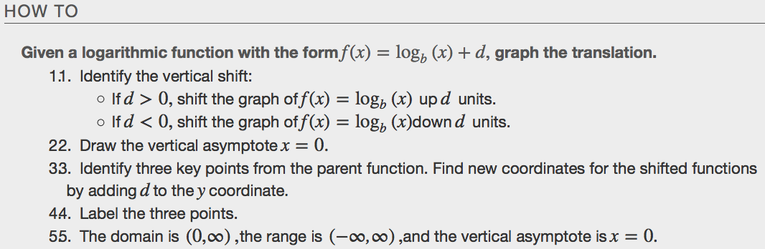
Example

Graphing Stretches and Compressions
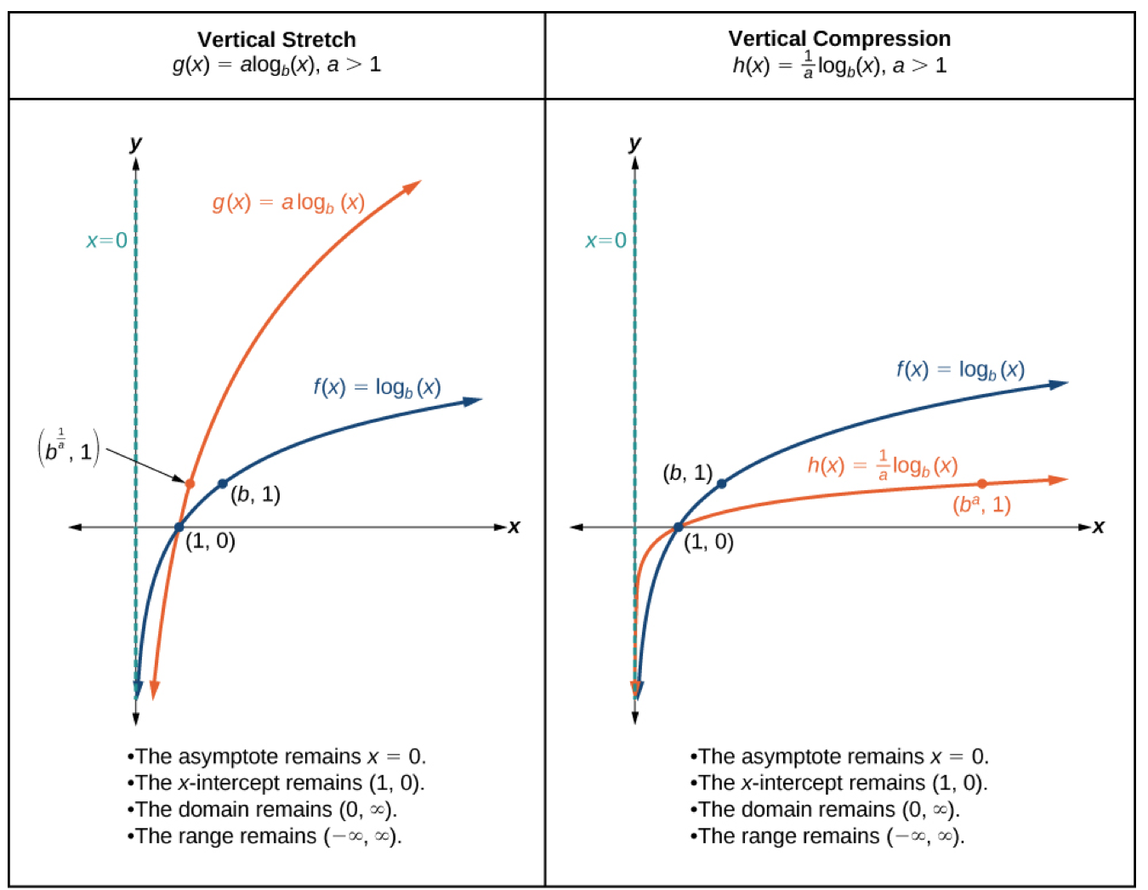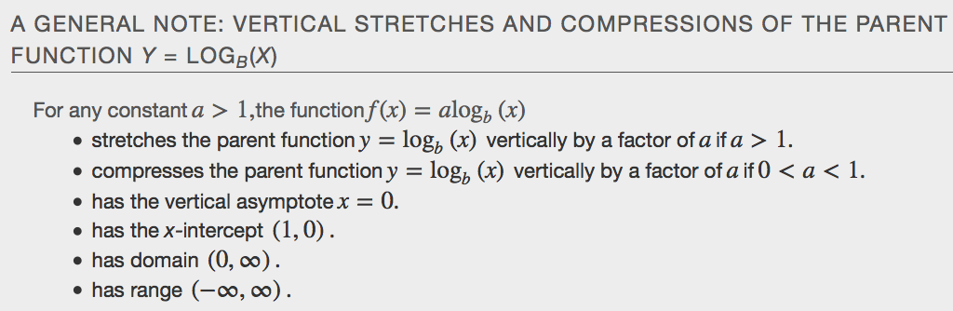
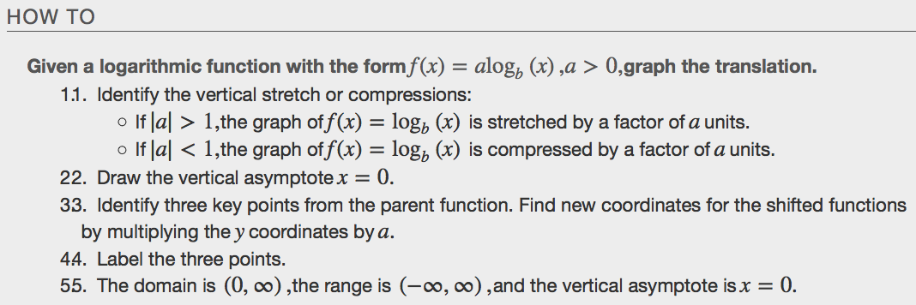
Example

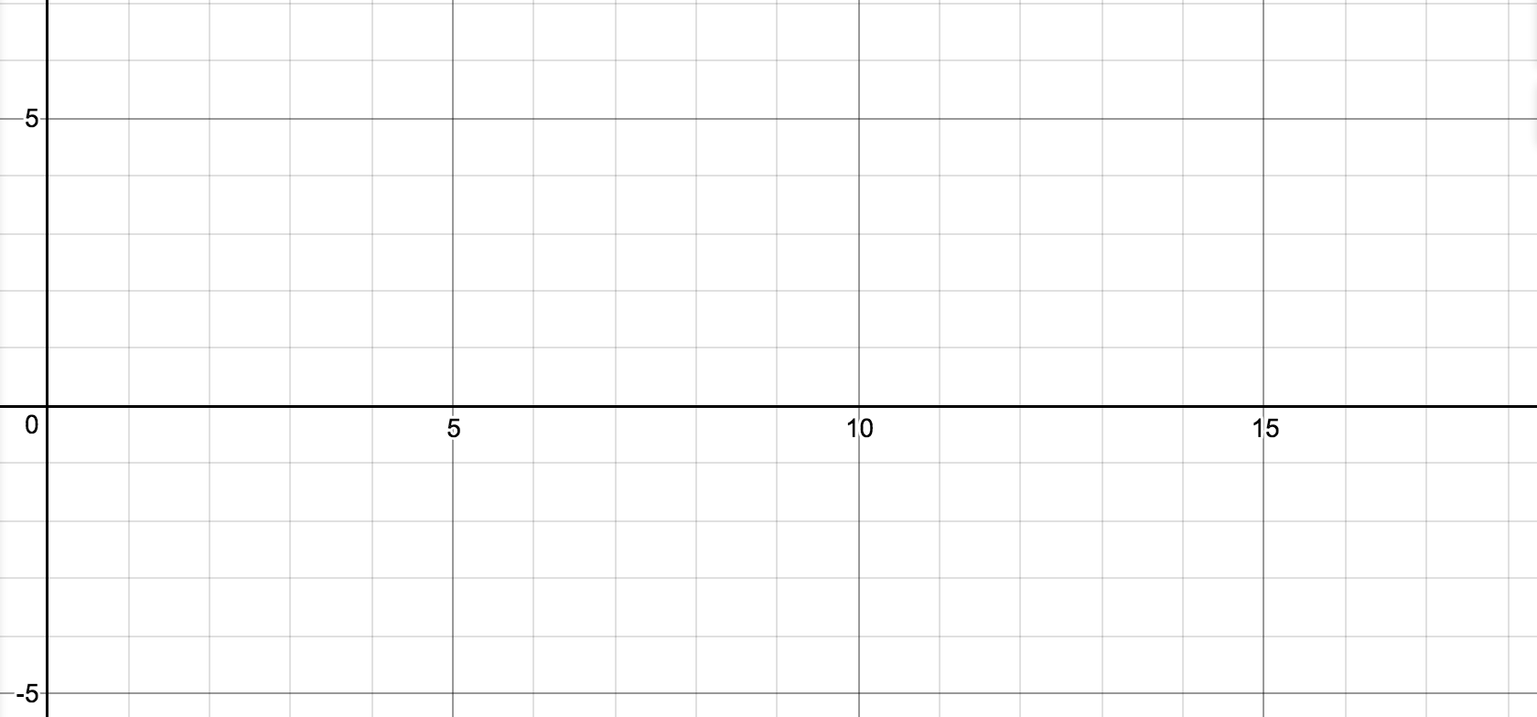
Graphing Reflections
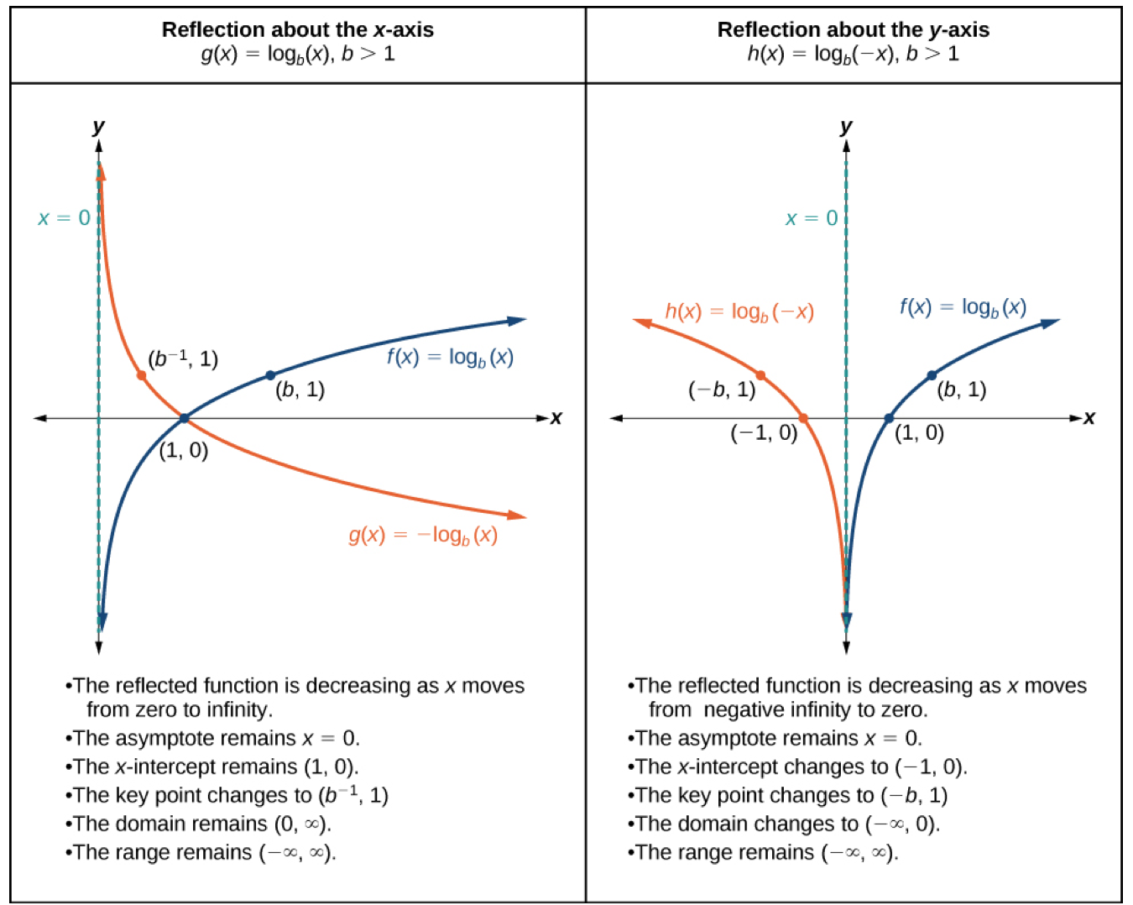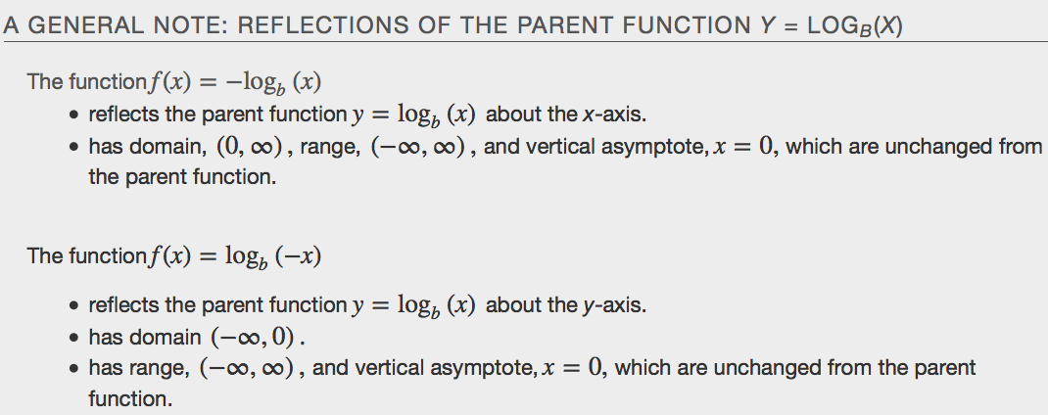
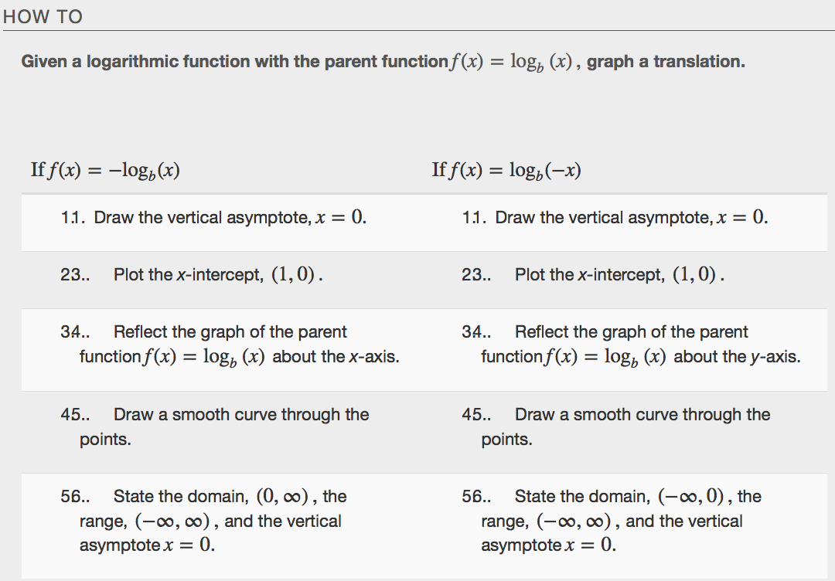
Example

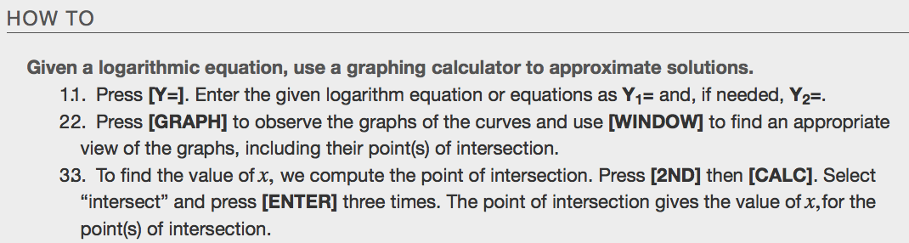
Examples

Summary of Translations of the Logarithmic Functions
