6.3 – Logarithmic Functions
Converting from Logarithmic to Exponential
The Richter Scale is a base-ten logarithmic scale. In other words, an earthquake of magnitude 8 is not twice as great as an earthquake of magnitude 4. It is 10⁸⁻⁴=10⁴=10,000 times as great! In this lesson, we will investigate the nature of the Richter Scale and the base-ten function upon which it depends.

In order to analyze the magnitude of earthquakes or compare the magnitudes of two different earthquakes, we need to be able to convert between logarithmic and exponential form. For example, suppose the amount of energy released from one earthquake were 500 times greater than the amount of energy released from another. We want to calculate the difference in magnitude. The equation that represents this problem is10^{x}=500, where x represents the difference in magnitudes on the ________________________ Scale.

How would we solve for x?

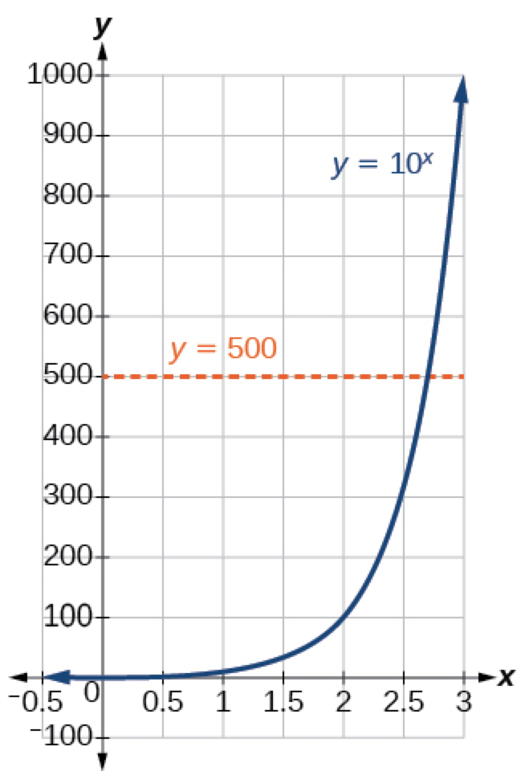
Estimating from a graph, however, is imprecise. To find an algebraic solution, we must introduce a new function. Observe that the graph in Figure passes the horizontal line test. The exponential function y=b^{x} is _______-to-________, so its inverse, x=b^{y} is also a ________________. As is the case with all inverse functions, we simply interchange x and y and solve for y to find the inverse function. To represent y as a function of x, we use a logarithmic function of the form y=log_{b}(x).The base b ________________________________ of a number is the exponent by which we must raise b to get that number.

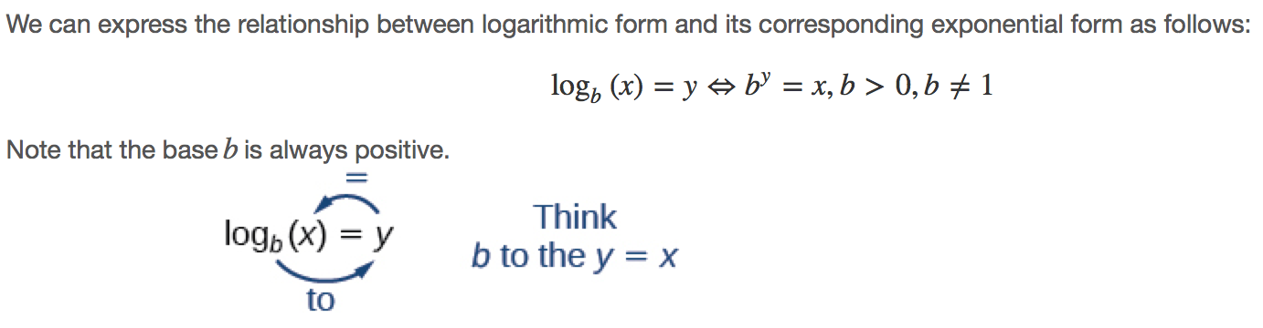
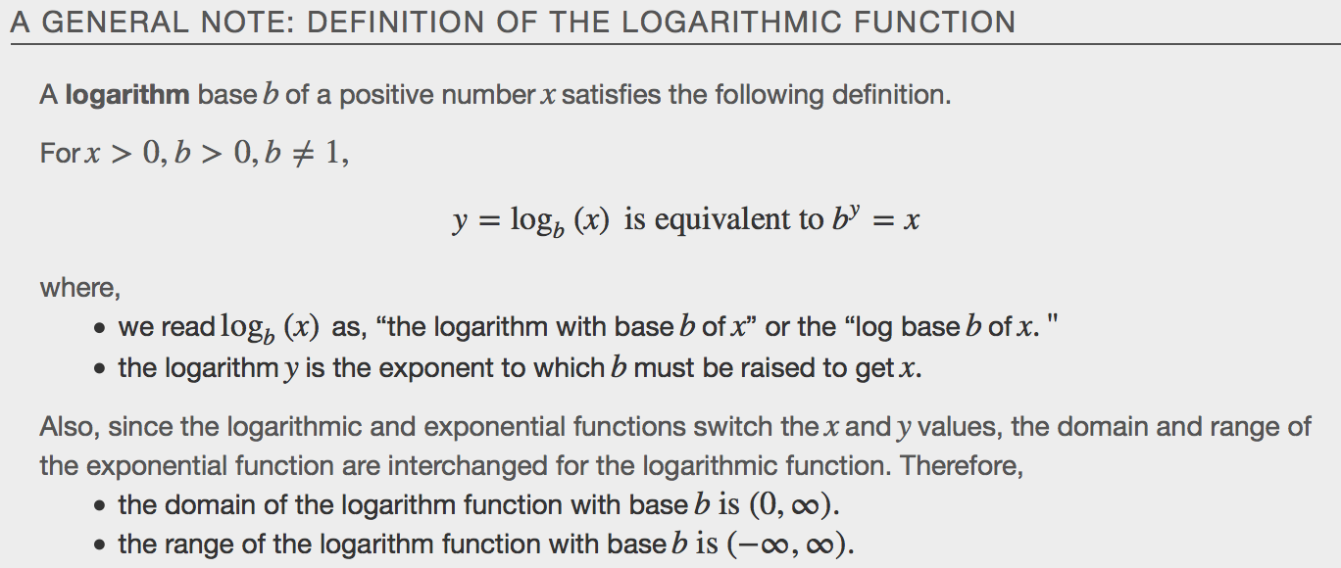
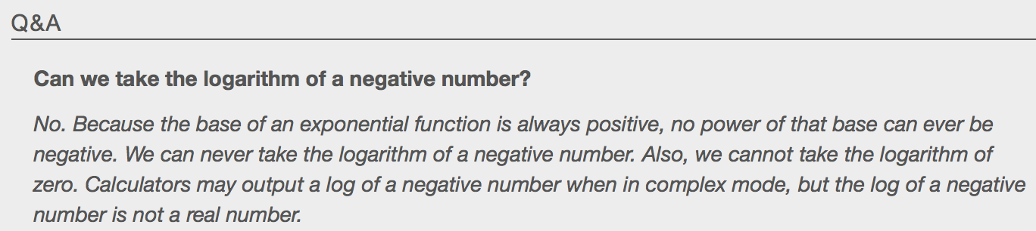

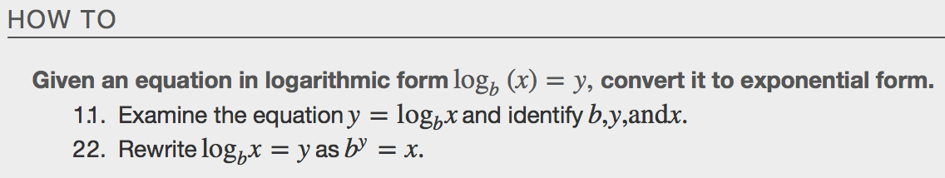
Examples
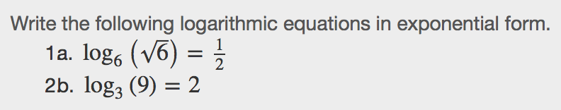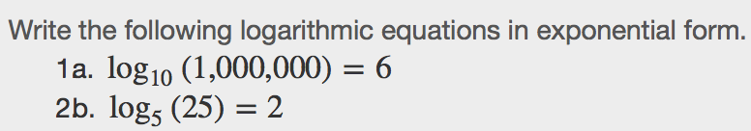

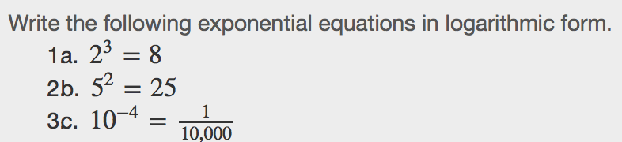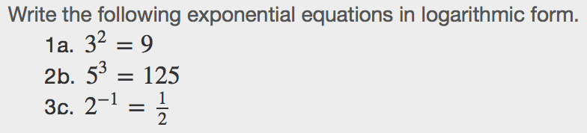

Evaluating Logarithms
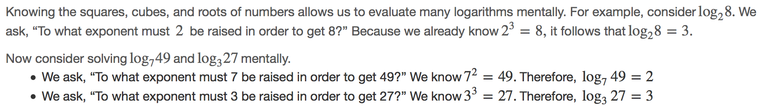
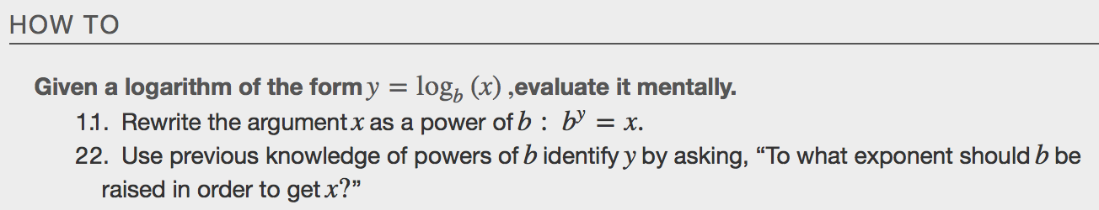
Examples

Using Common Logarithm
Sometimes we may see a logarithm written without a base. In this case, we assume that the base is 10. In other words, the expression log(x) means log₁₀(x).
We call a base-10 logarithm a _______________________________ logarithm.
Common logarithms are used to measure the Richter Scale mentioned at the beginning of the section. Scales for measuring the brightness of stars and the pH of acids and bases also use common logarithms.
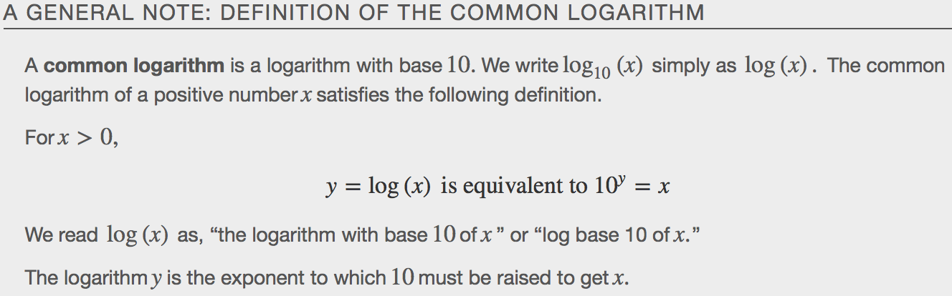
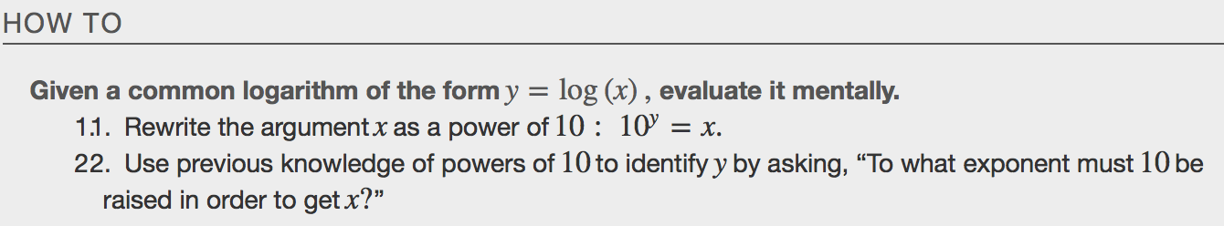
Examples

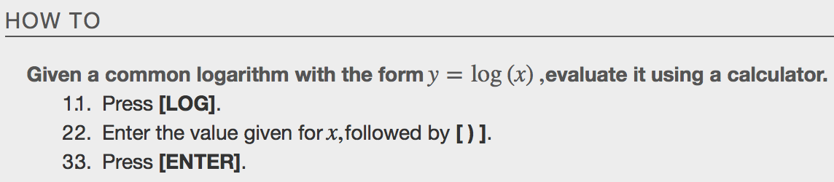

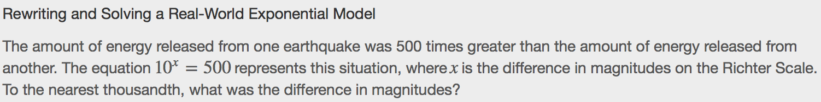

Using Natural Logarithms
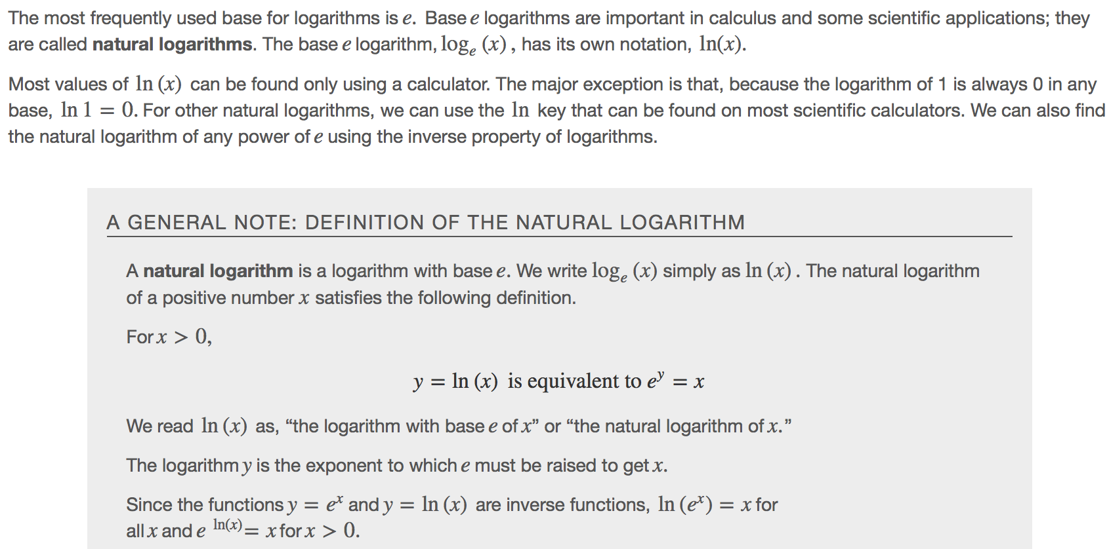
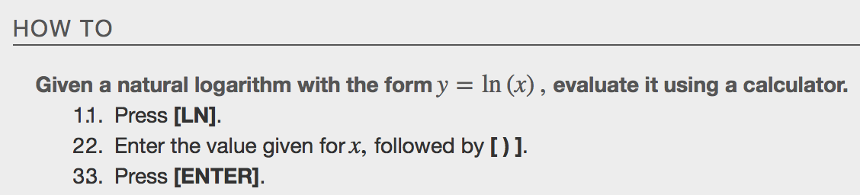
Examples

Extra Practice
