5.5 – Zeros of Polynomial Functions

Evaluating a Polynomial Using the Remainder Theorem
In the last section, we learned how to divide polynomials. We can now use polynomial division to evaluate polynomials using the Remainder Theorem. If the polynomial is divided by x–k, the remainder may be found quickly by evaluating the polynomial function at k,that is, f(k).
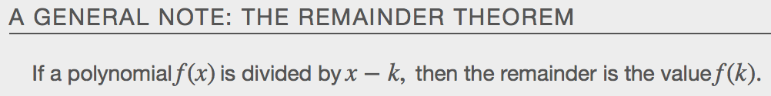

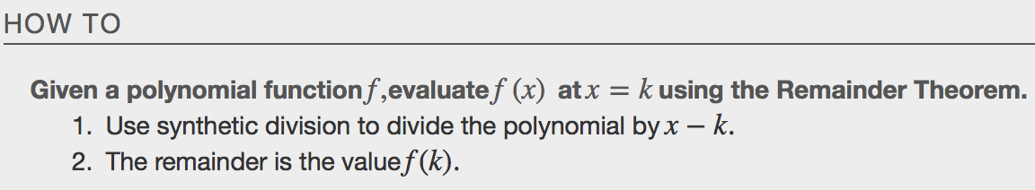

Examples

Using the Factor Theorem to Solve a Polynomial Equation
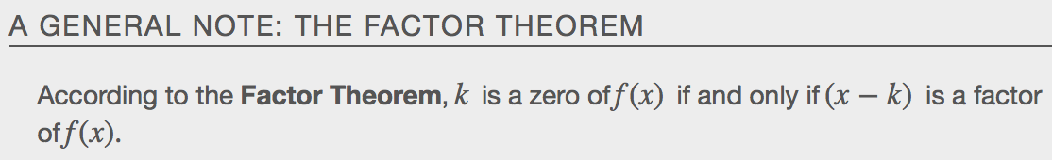

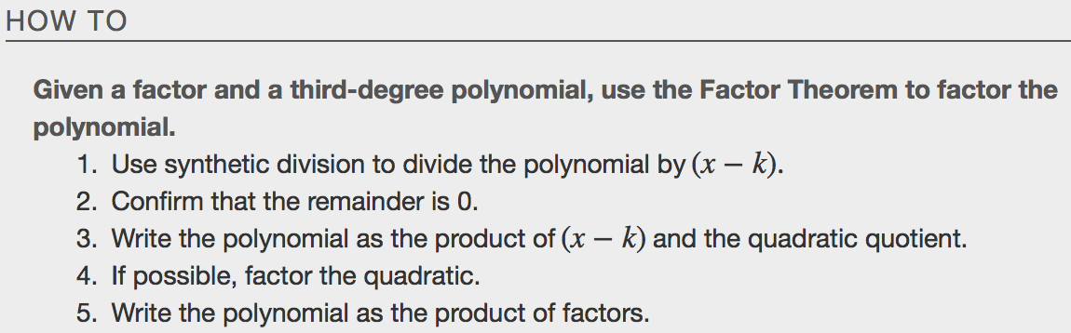
Examples

Using the Rational Zero Theorem to Find Rational Zeros
Another use for the Remainder Theorem is to test whether a rational number is a zero for a given polynomial. But first we need a pool of rational numbers to test. The Rational Zero Theorem helps us to narrow down the number of possible rational zeros using the ratio of the factors of the constant term and factors of the leading coefficient of the polynomial.

Consider a quadratic function with two zeros, x=2/5 and x=3/4 . By the Factor Theorem, these zeros have factors associated with them. Let us set each factor equal to 0, and then construct the original quadratic function absent its stretching factor.
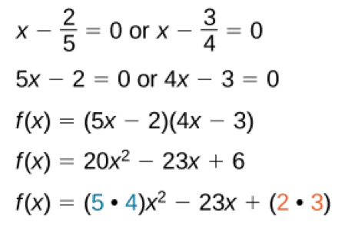
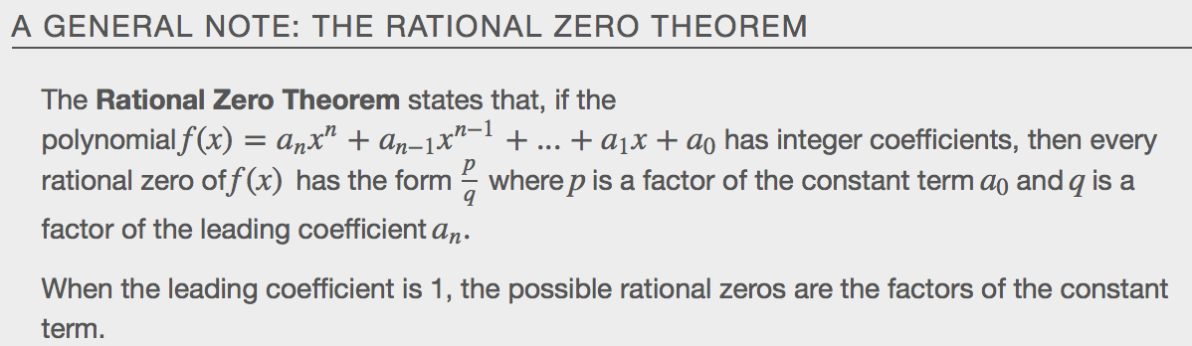

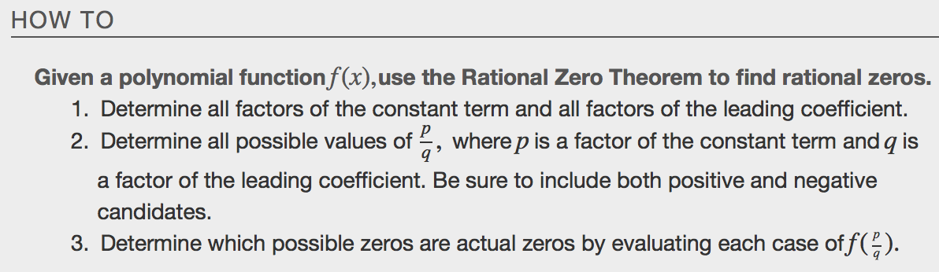
Example

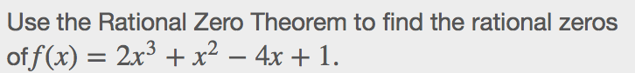

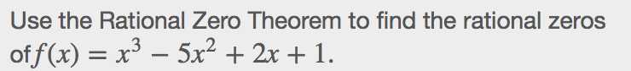

Finding the Zeros of Polynomial Functions
The Rational Zero Theorem helps us to narrow down the list of possible rational zeros for a polynomial function. Once we have done this, we can use __________________________________ division repeatedly to determine all of the zeros of a polynomial function.

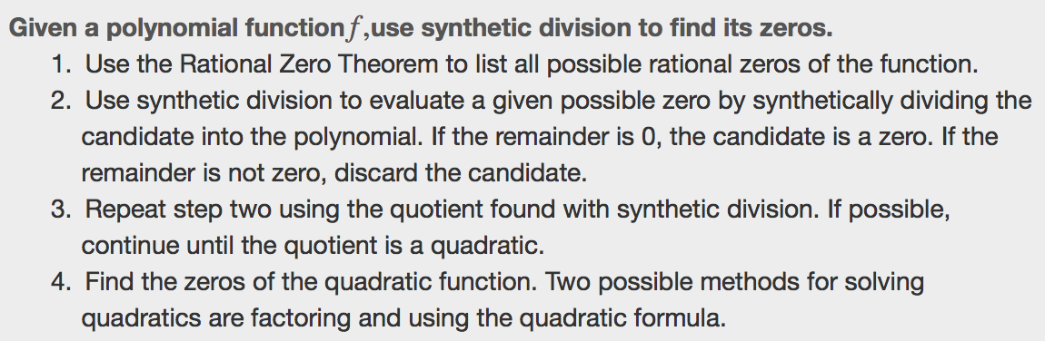
Examples
desmos.com

Using the Fundamental Theorem of Algebra
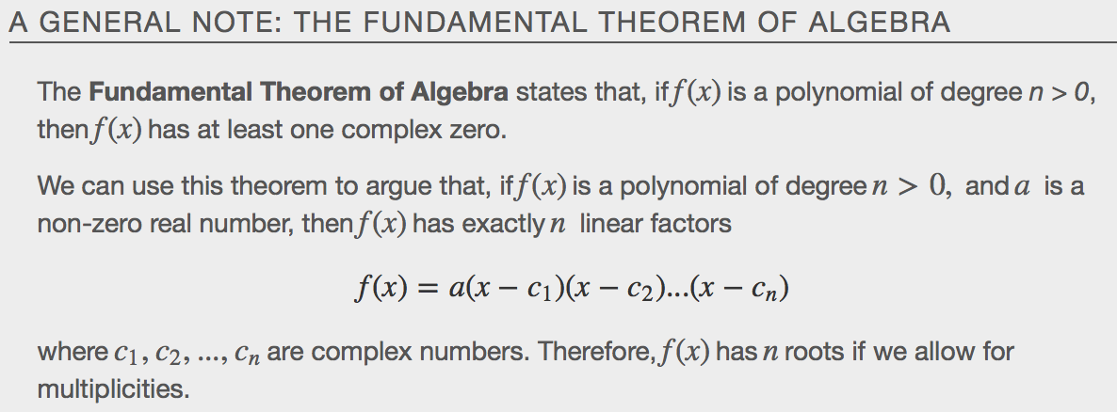

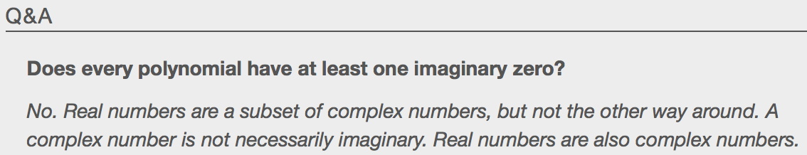
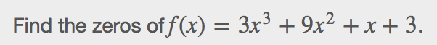

Using the Linear Factorization Theorem to Find Polynomials
The Linear Factorization Theorem tells us that a polynomial function will have the same number of factors as its degree, and that each factor will be in the form (x−c), where c is a complex number.
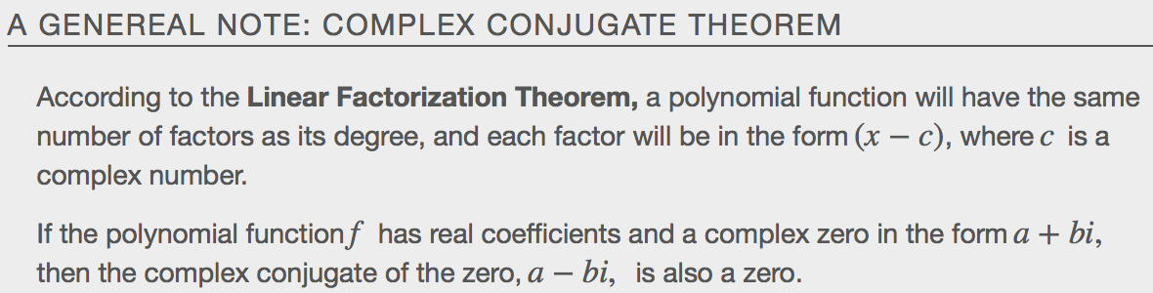
Letf be a polynomial function with real coefficients, and suppose a+bi, b≠0, is a zero off(x). Then, by the Factor Theorem, x−(a+bi) is a factor of f(x). Forf to have real coefficients, x−(a−bi) must also be a factor off(x). This is true because any factor other than x−(a−bi), when multiplied by x−(a+bi), will leave imaginary components in the product. Only multiplication with conjugate pairs will eliminate the imaginary parts and result in real coefficients. In other words, if a polynomial function f with real coefficients has a complex zeroa+bi, then the complex conjugate a−bi must also be a zero of f(x).This is called the Complex Conjugate Theorem.
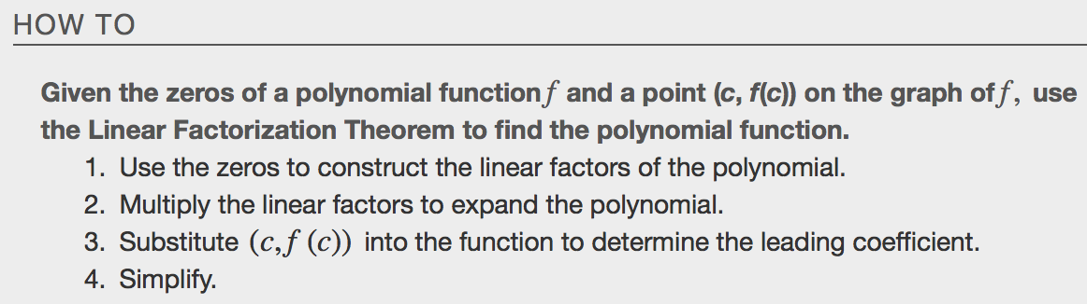
Example

