5.4 – Dividing Polynomials

Using Long Division to Divide Polynomials
We are familiar with the long division algorithm for ordinary arithmetic. We begin by dividing into the digits of the dividend that have the greatest place value. We divide, multiply, subtract, include the digit in the next place value position, and repeat.

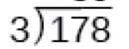

Division of polynomials that contain more than one term has similarities to long division of whole numbers. We can write a polynomial dividend as the product of the divisor and the quotient added to the remainder. The terms of the polynomial division correspond to the digits (and place values) of the whole number division. This method allows us to divide two polynomials.

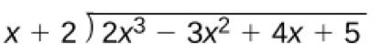

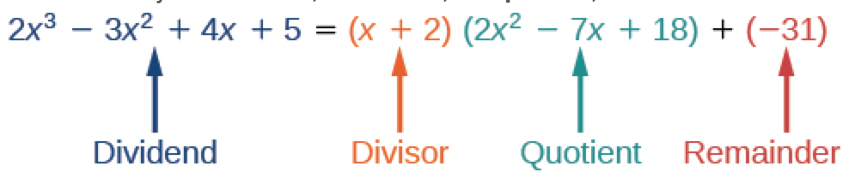
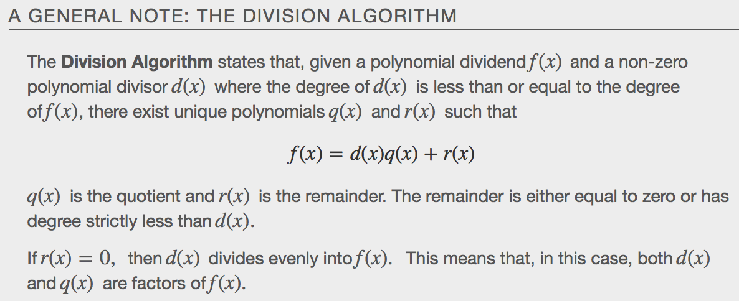

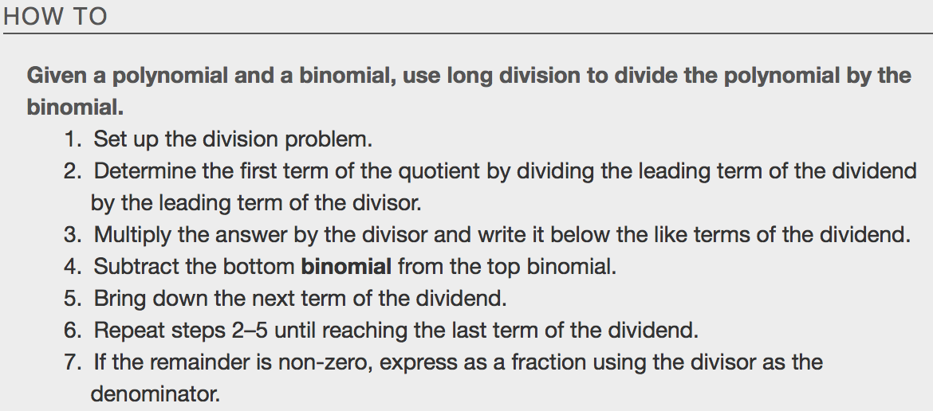

Examples

Synthetic Division

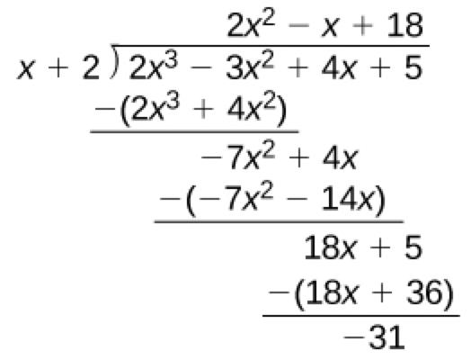
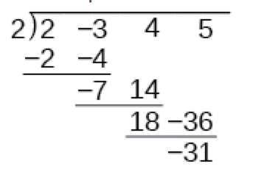

Let’s look at this same example through the lens of synthetic division.

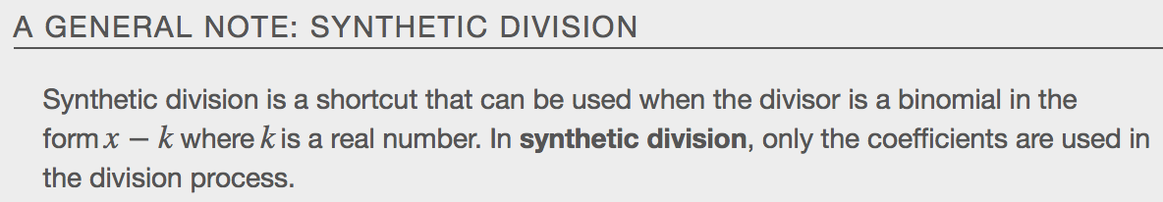

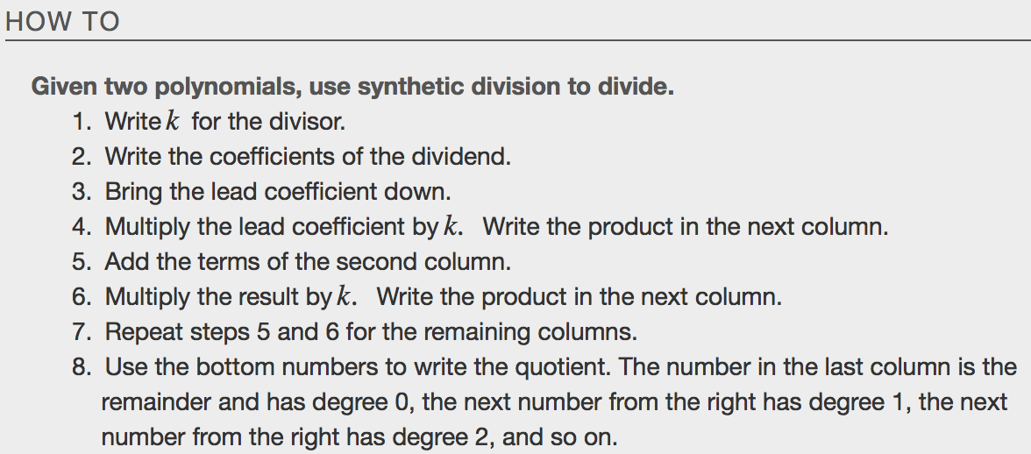
Examples
Is the first expression a factor of the second?

