5.3 – Polynomial Functions
Recognizing Characteristics of Graphs of Polynomial Functions
Polynomial functions also display graphs that have no breaks. Curves with no breaks are called continuous. Figure shows a graph that represents a polynomial function and a graph that represents a function that is not a polynomial.
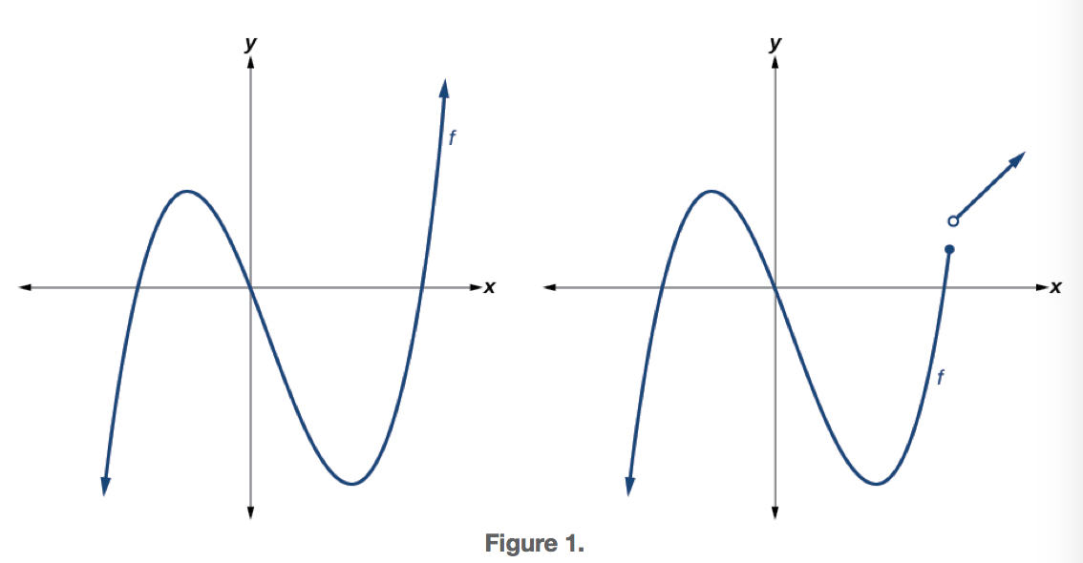
Examples
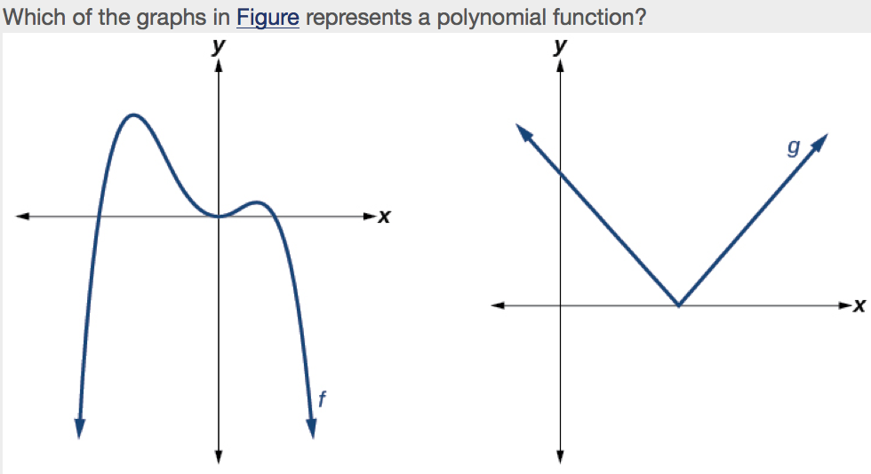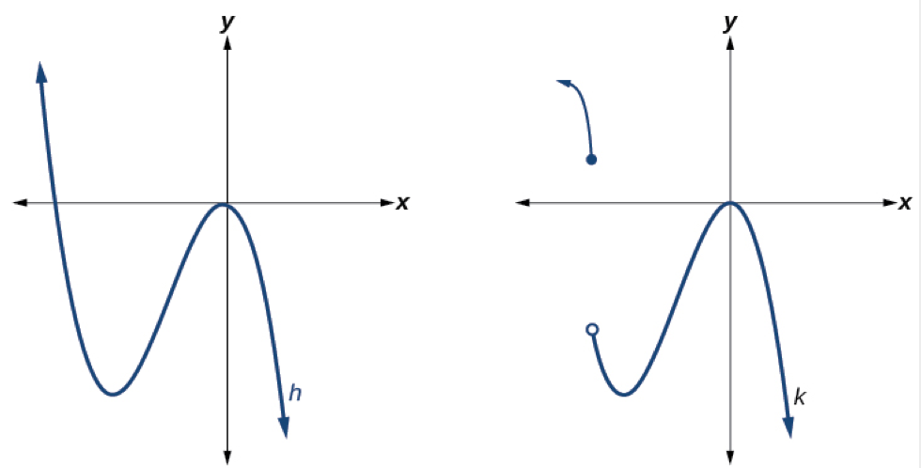

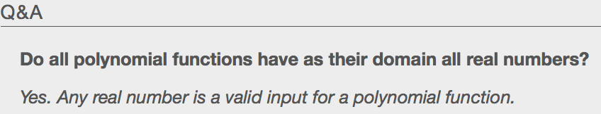

Using Factoring to Find Zeros of Polynomial Functions
Recall that if f is a polynomial function, the values of x for which f(x)=0 are called zeros of f. If the equation of the polynomial function can be factored, we can set each factor equal to zero and solve for the zeros. We can use this method to find x-intercepts because at the x-intercepts we find the input values when the output value is zero. For general polynomials, this can be a challenging prospect. While quadratics can be solved using the relatively simple quadratic formula, the corresponding formulas for cubic and fourth-degree polynomials are not simple enough to remember, and formulas do not exist for general higher-degree polynomials. Consequently, we will limit ourselves to three cases:
- The polynomial can be factored using known methods: greatest common factor and trinomial factoring.
- The polynomial is given in factored form.
- Technology is used to determine the intercepts.
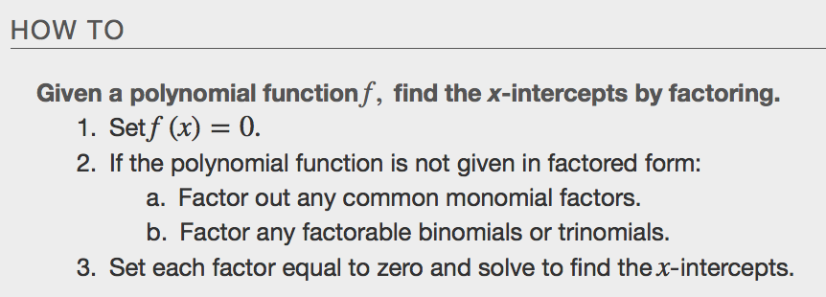
Examples
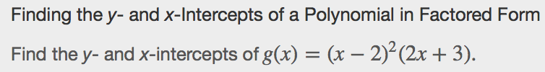

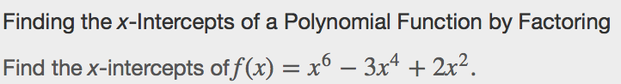

Identifying Zeros and Their Multiplicities
The number of times a given factor appears in the factored form of the equation of a polynomial is called the _____________________________________. For zeros with even multiplicities, the graphs touch or are tangent to the x-axis. For zeros with odd multiplicities, the graphs cross or intersect the x-axis. See Figure for examples of graphs of polynomial functions with multiplicity 1, 2, and 3.
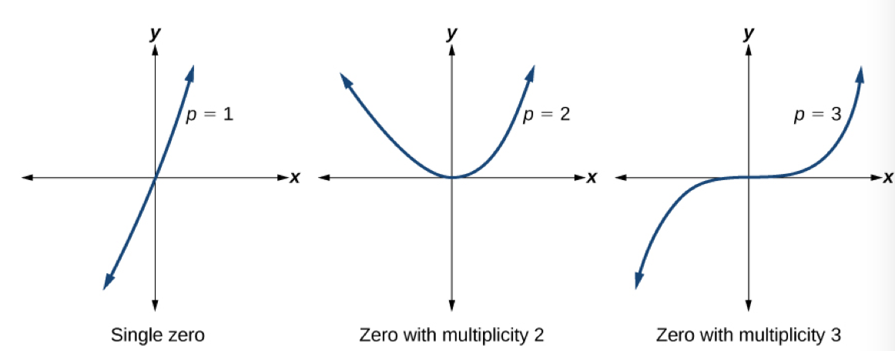
For higher even powers, such as 4, 6, and 8, the graph will still touch and bounce off of the horizontal axis but, for each increasing even power, the graph will appear flatter as it approaches and leaves the x-axis.
For higher odd powers, such as 5, 7, and 9, the graph will still cross through the horizontal axis, but for each increasing odd power, the graph will appear flatter as it approaches and leaves the x-axis.
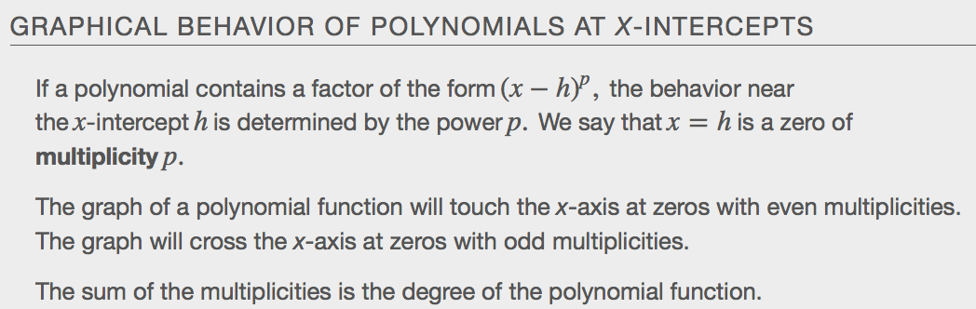

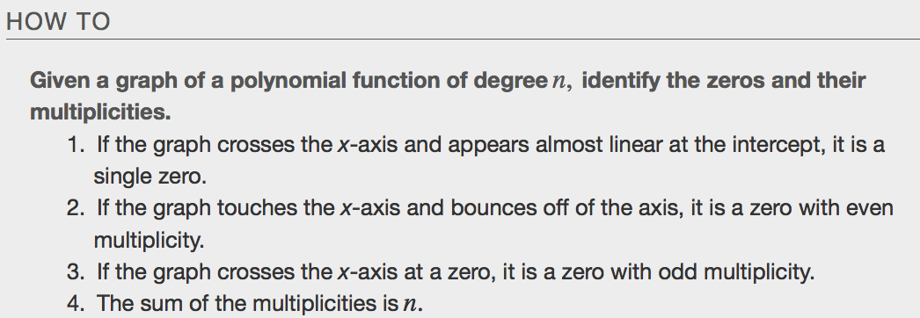
Examples
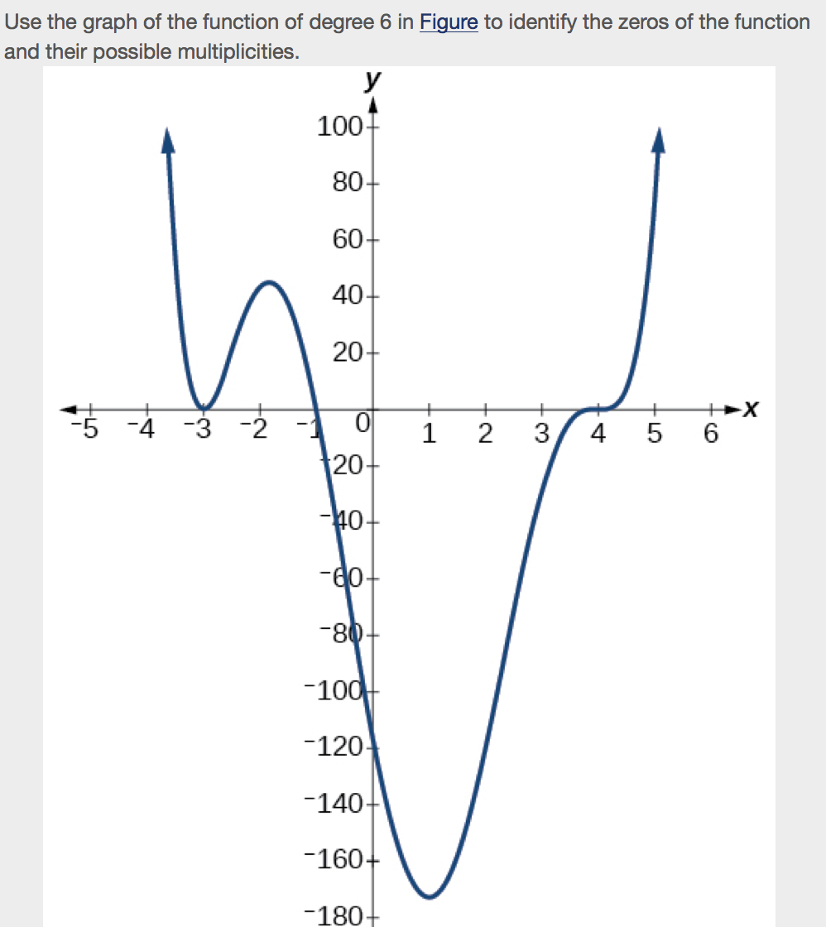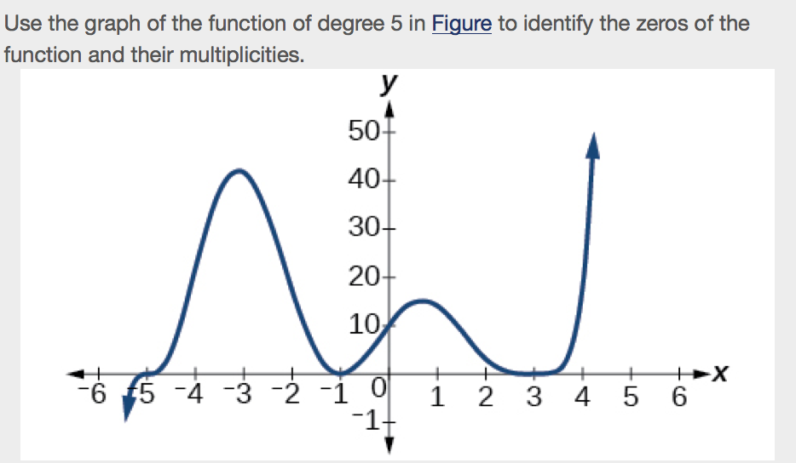

Determining End Behavior
As we have already learned, the behavior of a graph of a polynomial function of the form
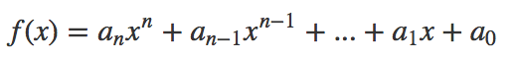
will either ultimately rise or fall as x increases without bound and will either rise or fall as x decreases without bound.
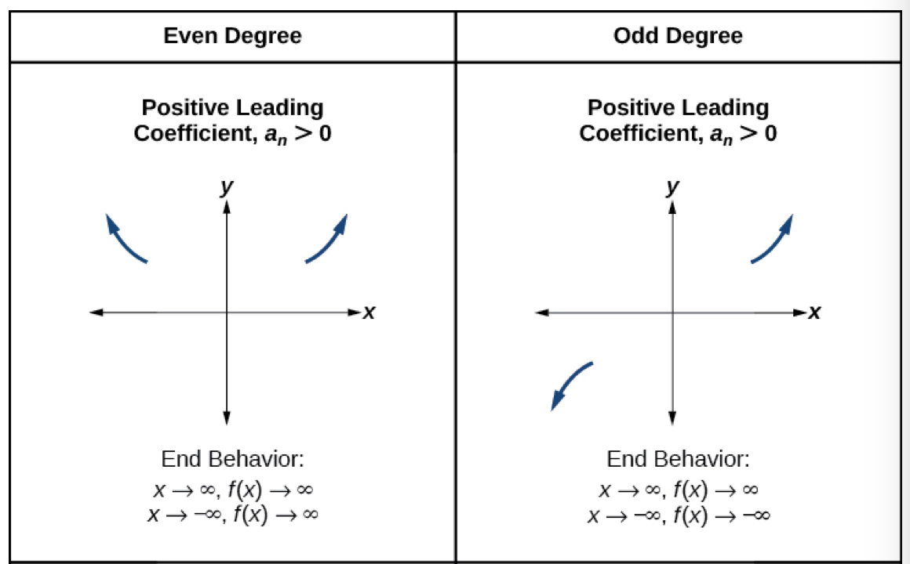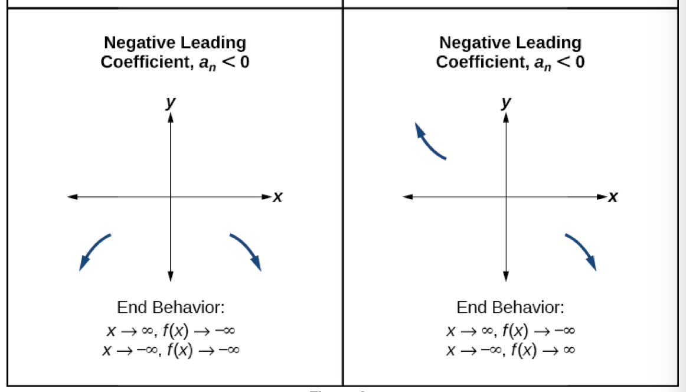
Understanding the Relationship Between Degree and Turning Points
In addition to the end behavior, recall that we can analyze a polynomial function’s local behavior. It may have a turning point where the graph changes from increasing to decreasing (rising to falling) or decreasing to increasing (falling to rising). Look at the graph of the polynomial function 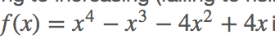Figure. The graph has three turning points. This function f is a 4th degree polynomial function and has 3 turning points. The maximum number of turning points of a polynomial function is always one less than the degree of the function.

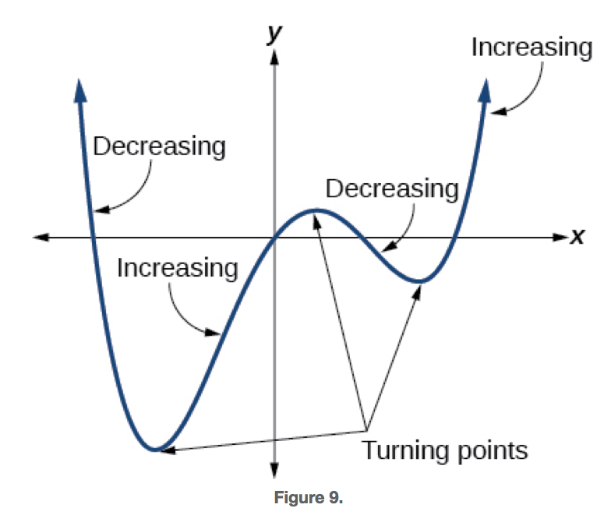
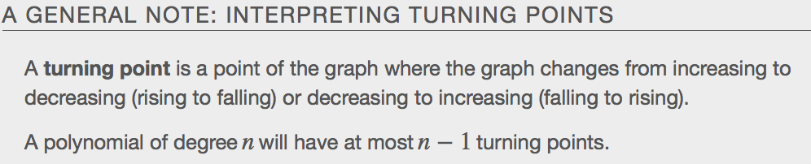
Examples
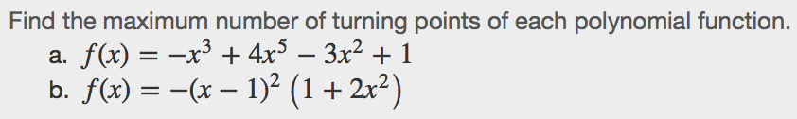
Graphing Polynomial Functions
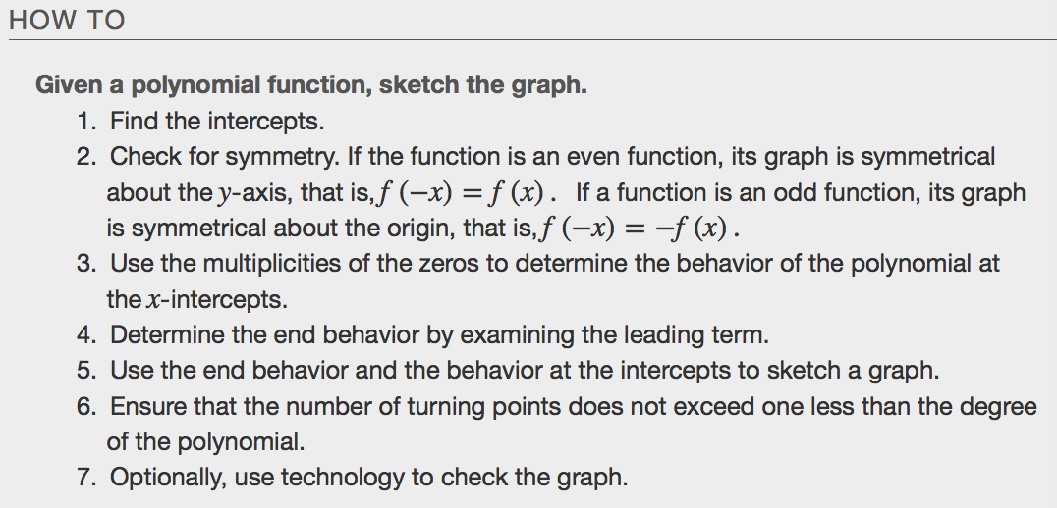
Examples
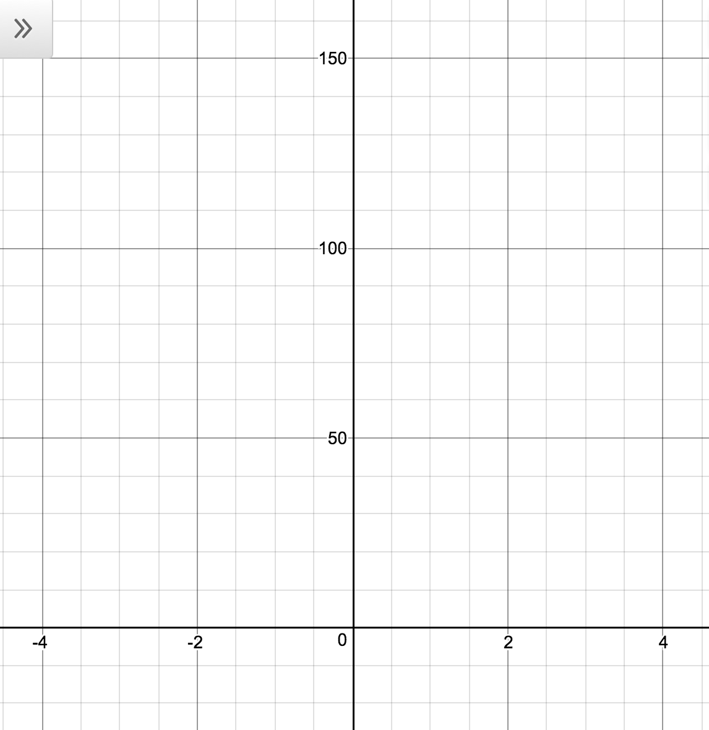

Using the Intermediate Value Theorem
The Intermediate Value Theorem tells us that when a polynomial function changes from a negative value to a positive value, the function must cross the x-axis. Figure shows that there is a zero between a and b.
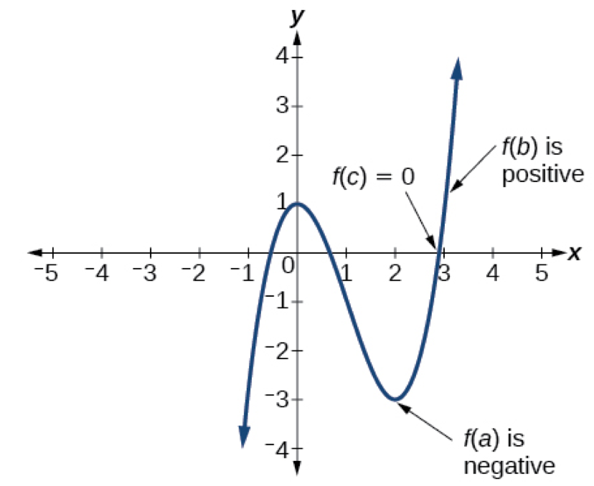
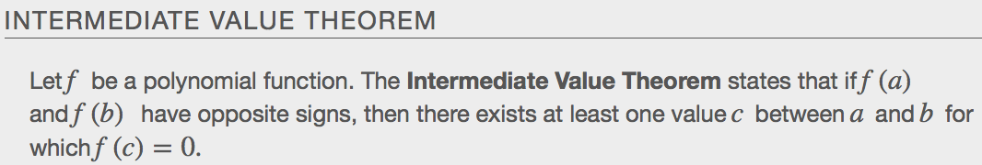
Examples
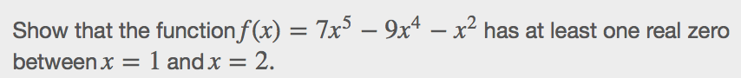

Writing Formulas for Polynomial Functions
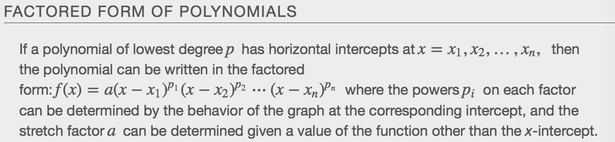

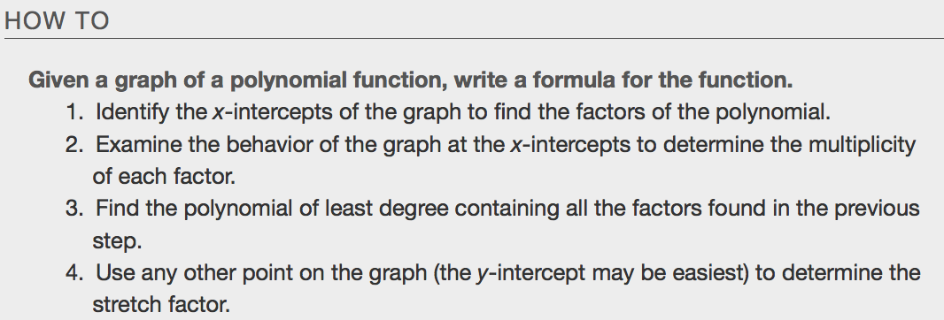
Examples
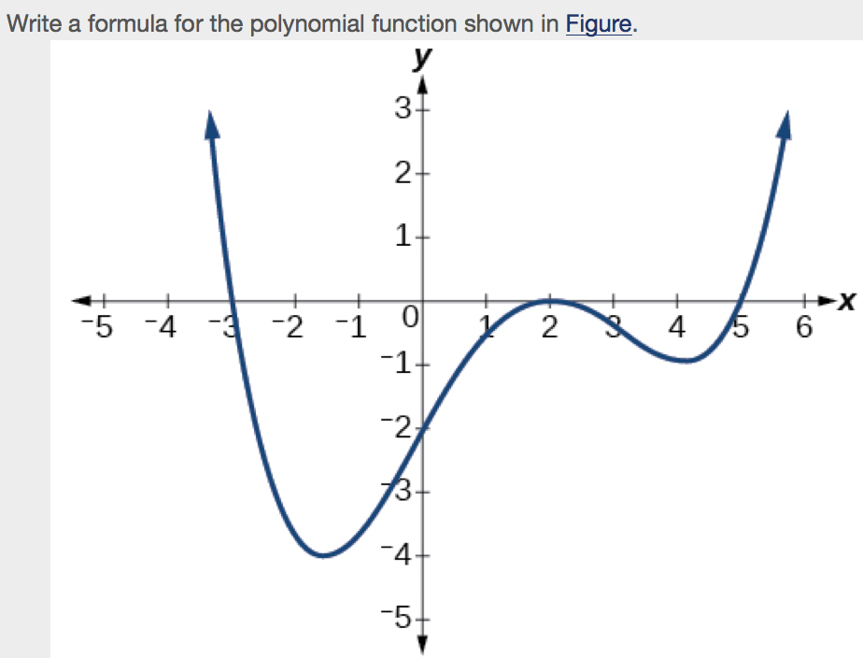

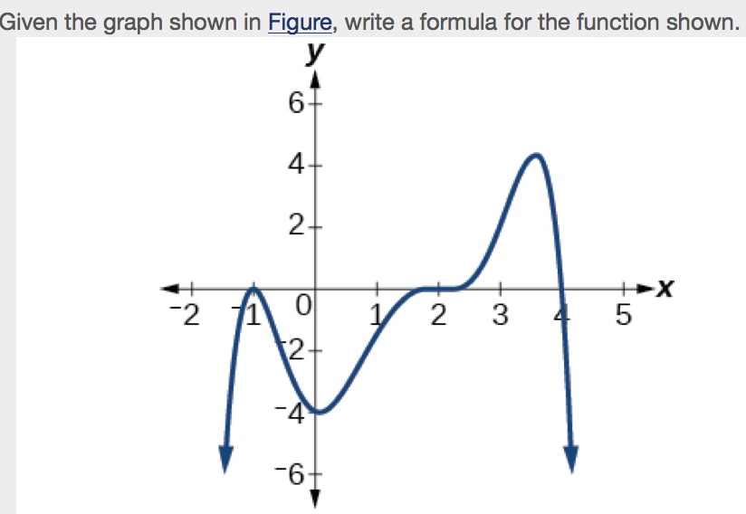
Using Local and Global Extrema
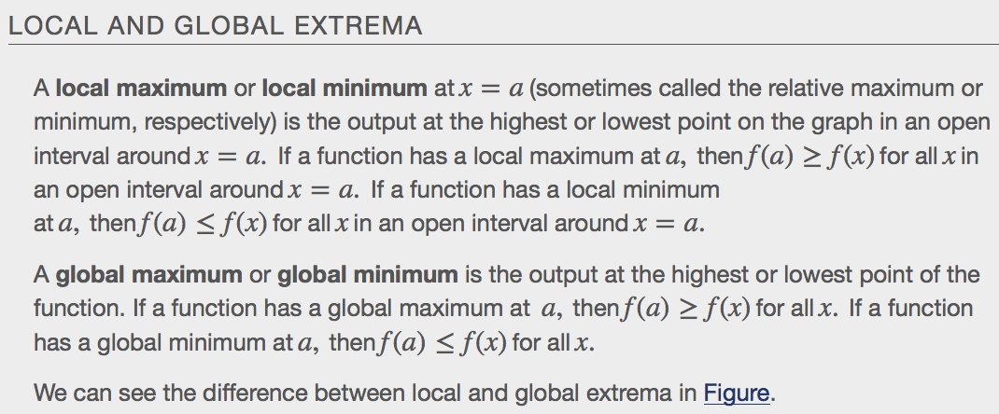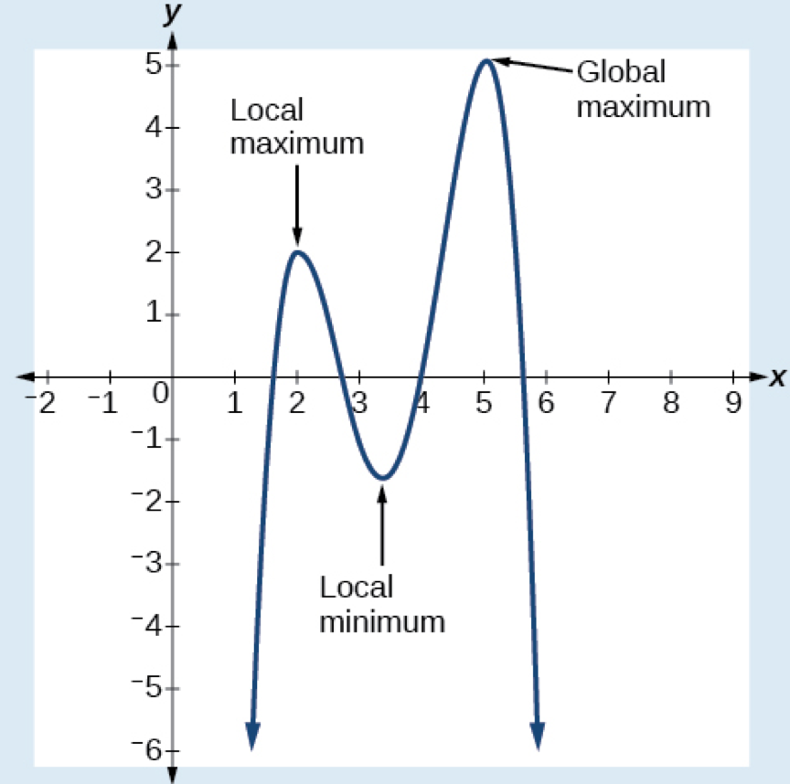

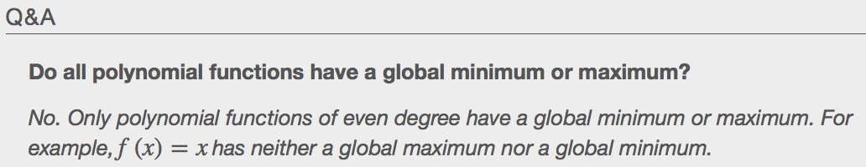

Examples
