5.2 – Power Functions and Polynomial Functions

A ___________________________ function is a function with a _______________________ term that is the product of a real number, a coefficient, and a variable raised to a ______________________ real number.
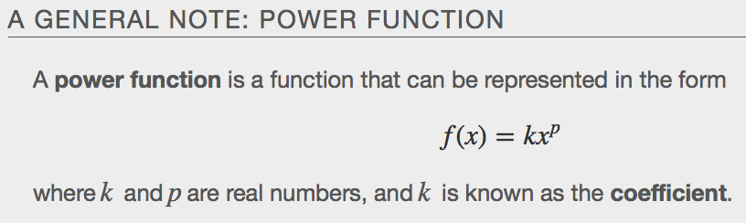
Examples
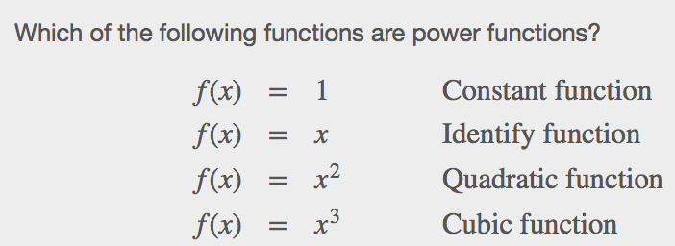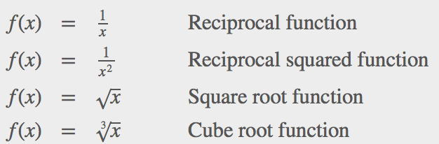

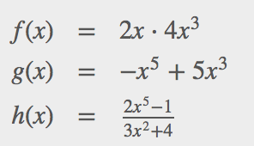

Identifying End Behavior of Power Functions
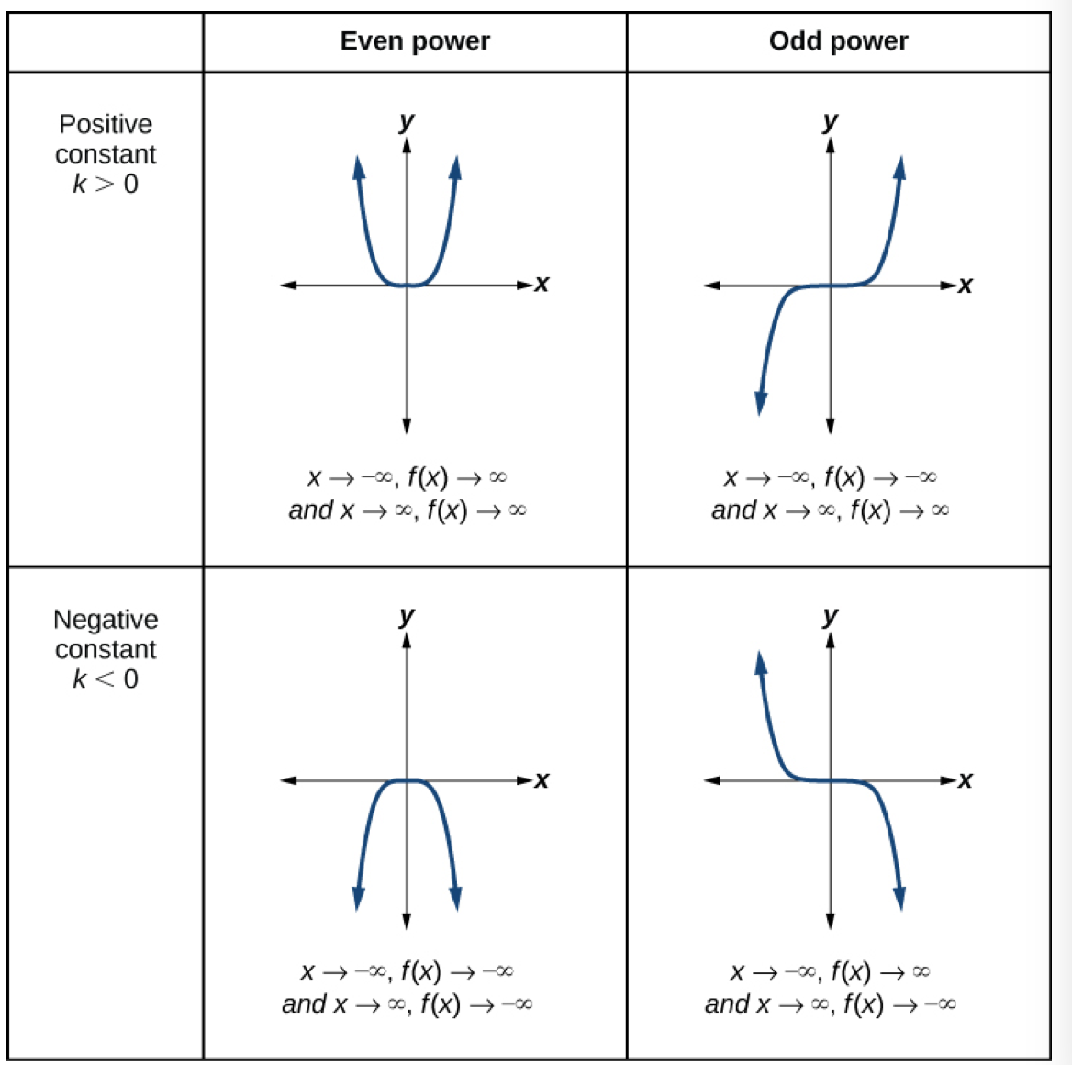
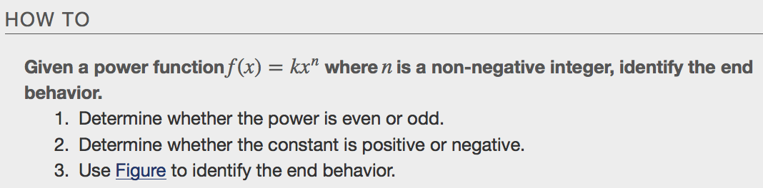
Examples

Identifying Polynomial Functions
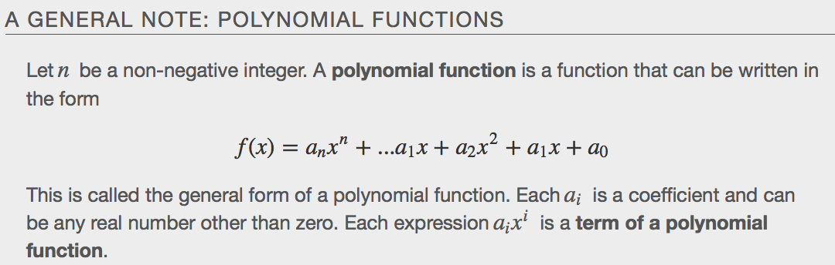
Example
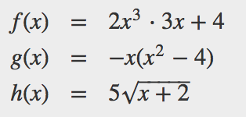
Identifying the Degree and Leading Coefficient of a Polynomial Function
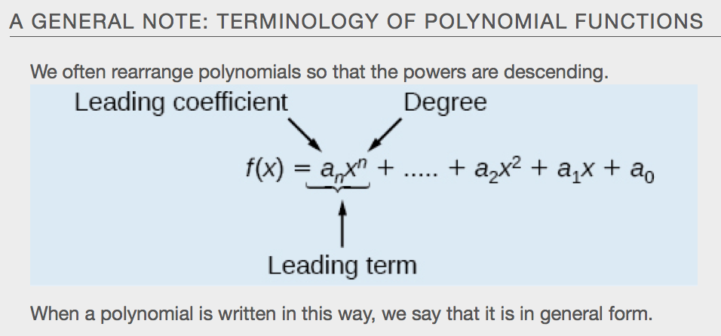

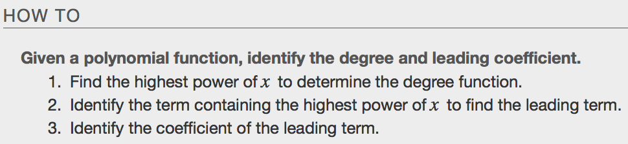

Examples
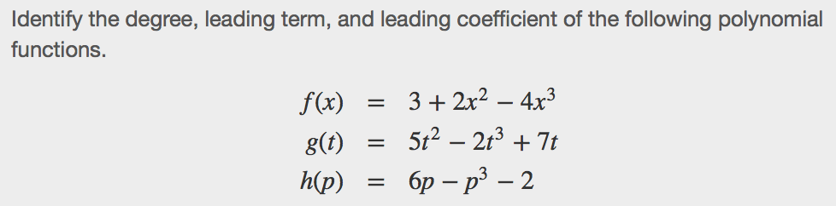

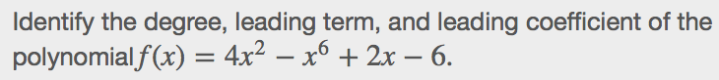

Identifying End Behavior of a Polynomial Function
Knowing the degree of a polynomial function is useful in helping us predict its end behavior. To determine its end behavior, look at the __________________________ term of the polynomial function. Because the power of the leading term is the highest, that term will grow significantly faster than the other terms as x gets very large or very small, so its behavior will dominate the graph. For any polynomial, the end behavior of the polynomial will match the end behavior of the _________________________ function consisting of the leading term.
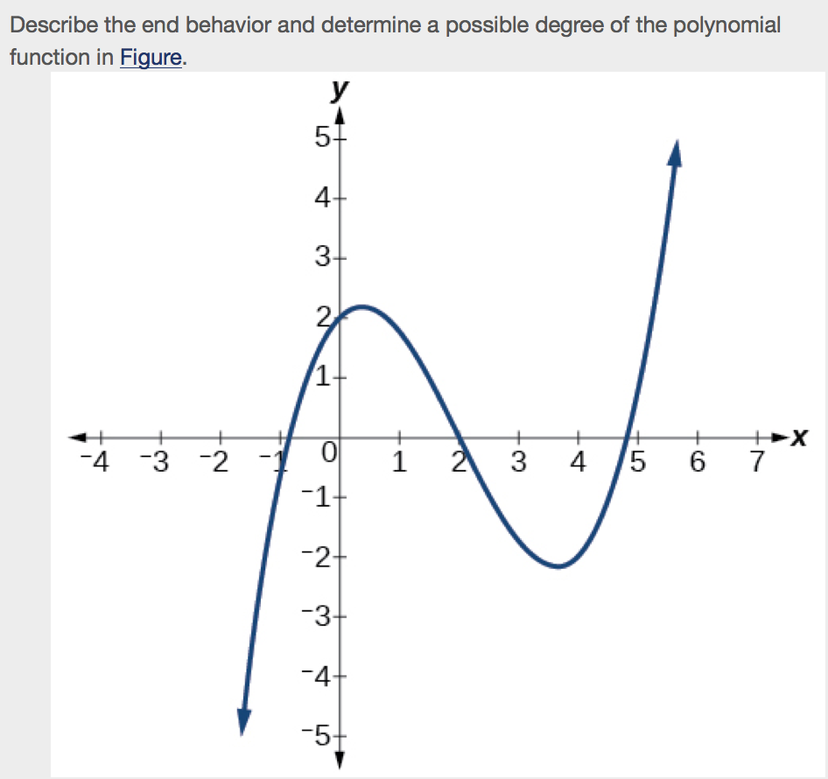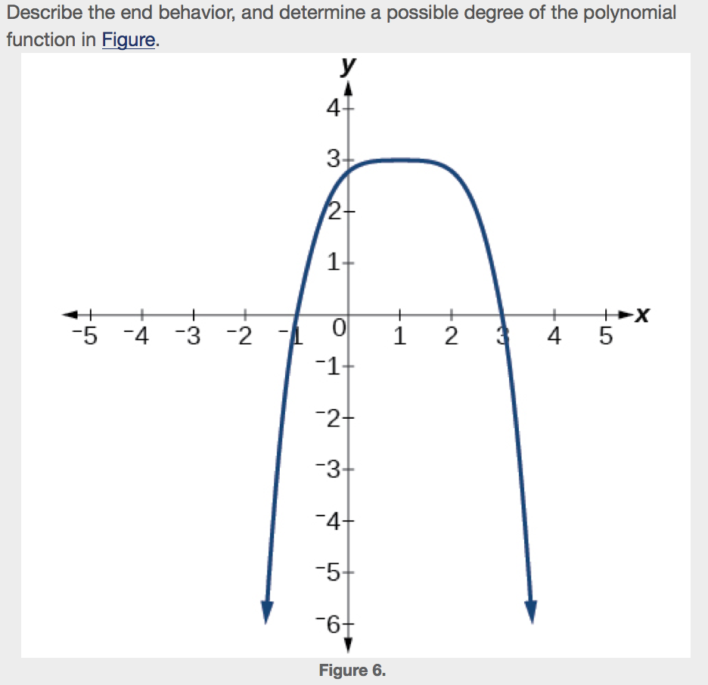

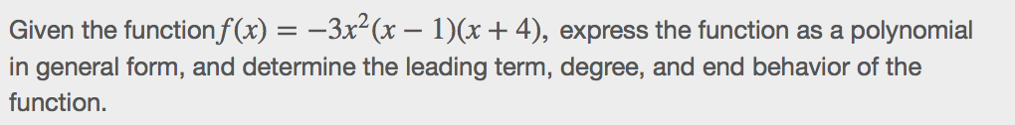

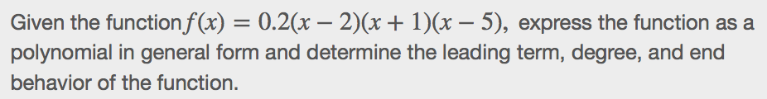

Identifying Local Behavior of Polynomial Functions
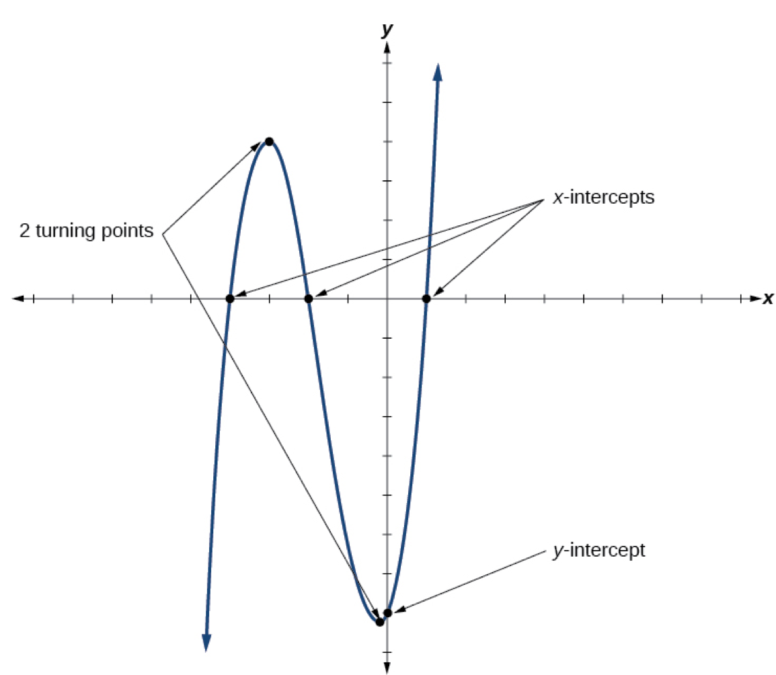
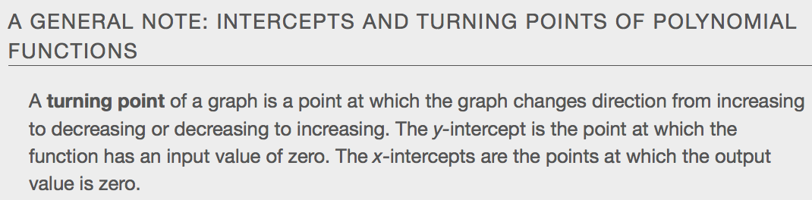

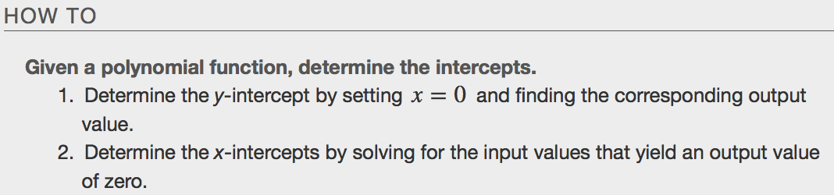

Examples

Comparing Smooth and Continuous Graphs
A ___________________________________ function has no breaks in its graph: the graph can be drawn without lifting the pen from the paper. A smooth curve is a graph that has no sharp _____________________. The turning points of a smooth graph must always occur at rounded curves. The graphs of polynomial functions are both continuous and smooth.
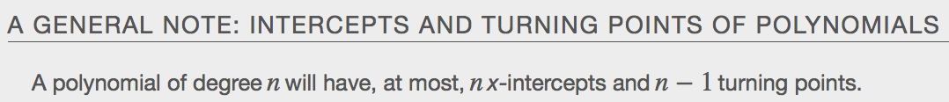
Examples
