5.1 – Quadratic Functions
Recognizing Characteristics of Parabolas

Vertex:

Vertex:

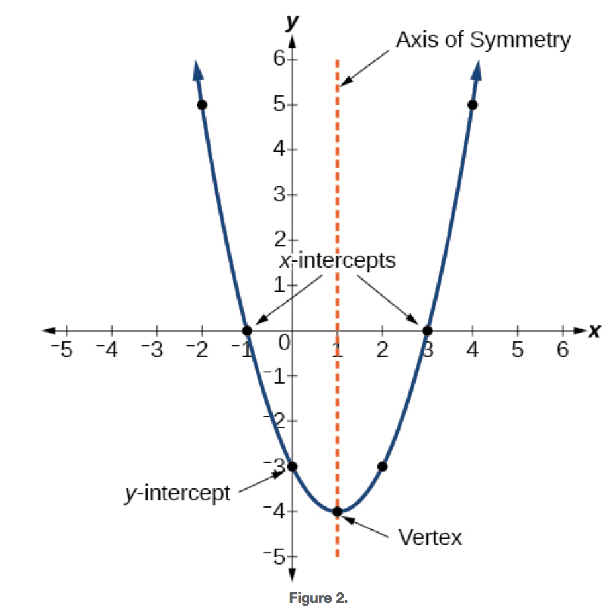

Example
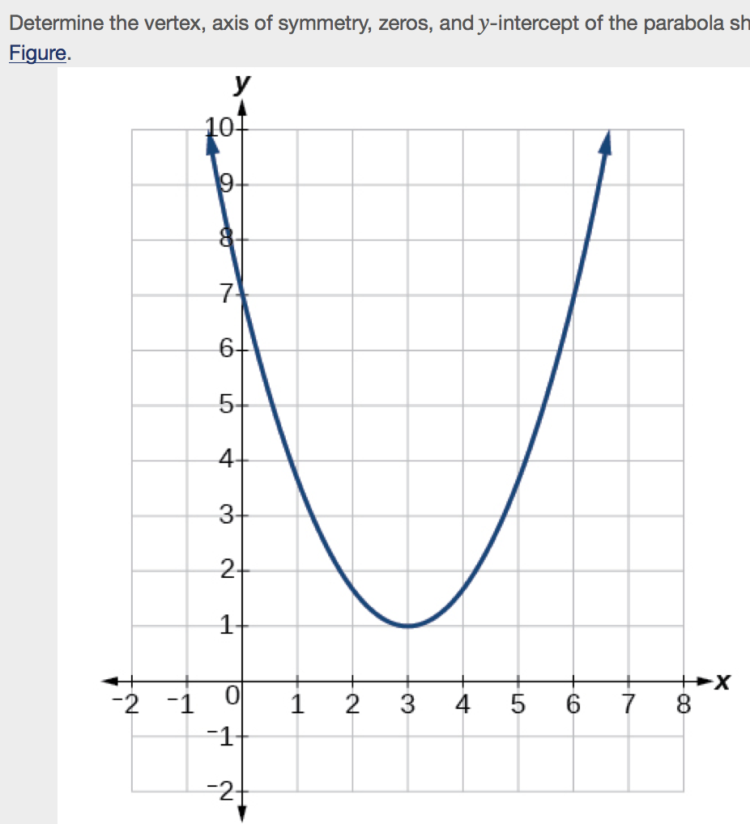

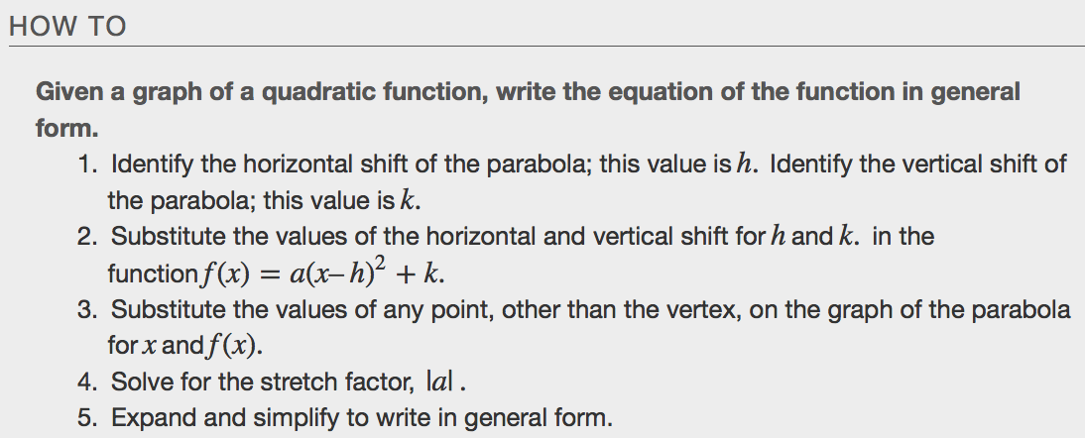
Examples
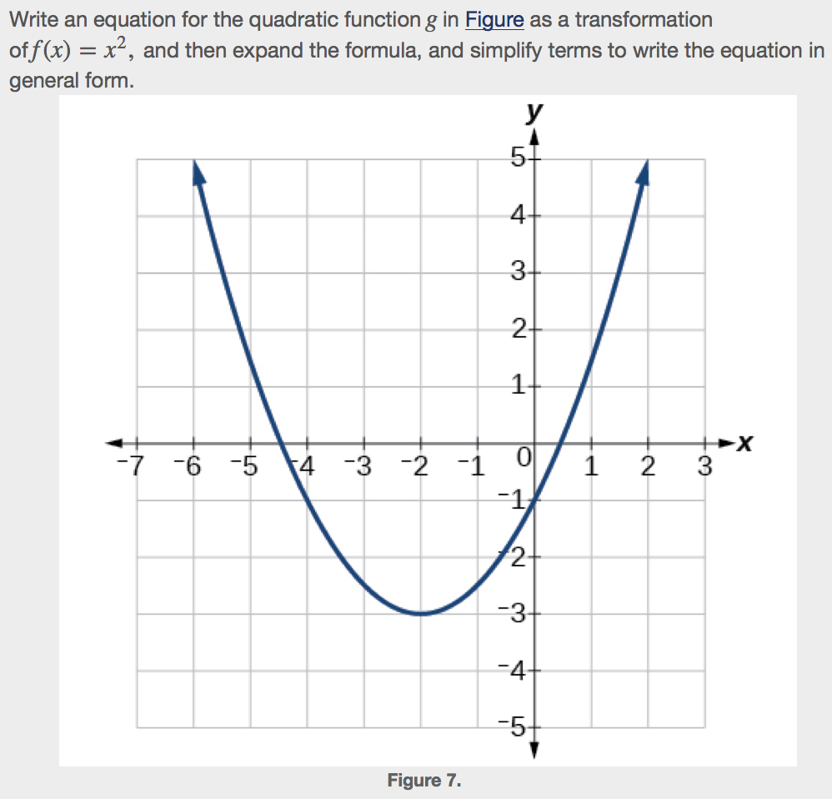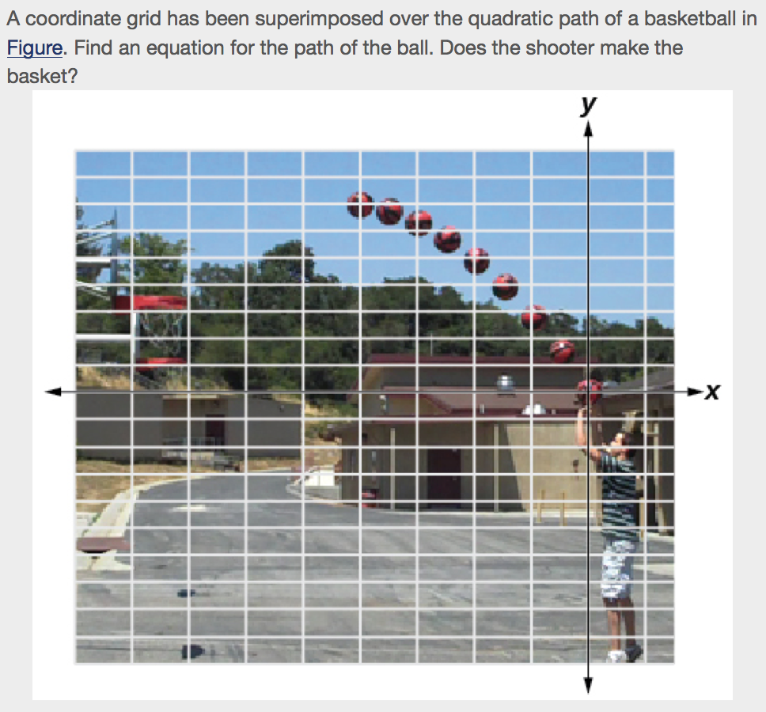

Finding the Vertex (Maximum/Minimum) of a Parabola
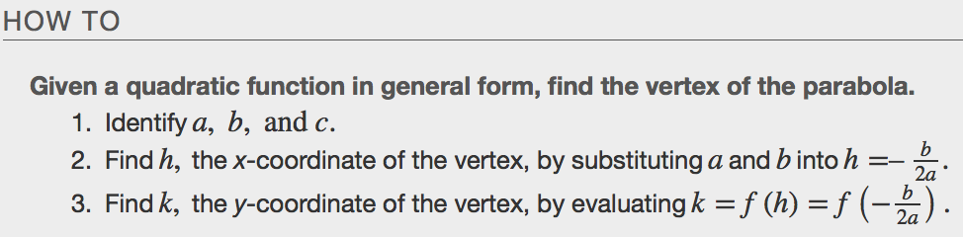
Examples

Identifying Domain and Range of a Quadratic Function
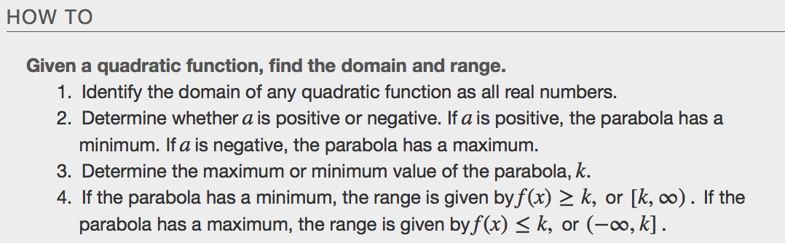
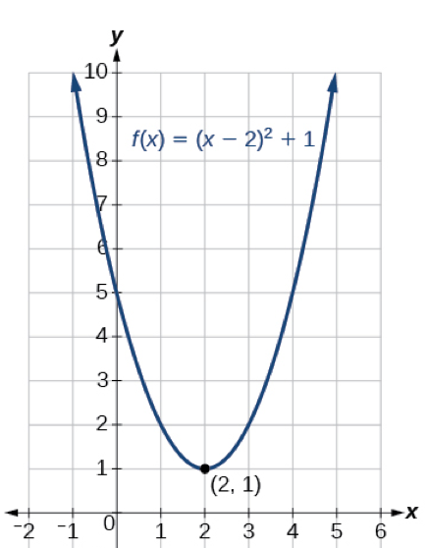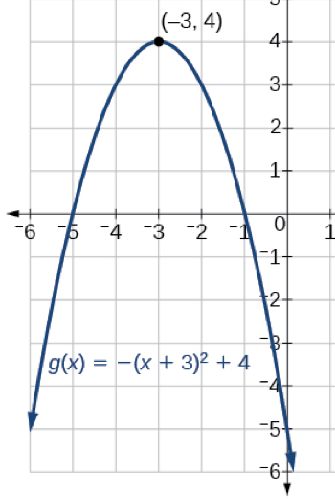

Examples
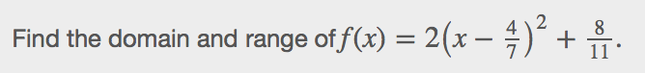

Determining the Maximum and Minimum Values of Quadratic Functions
The output of the quadratic function at the vertex is the maximum or minimum value of the function, depending on the orientation of the parabola. We can see the maximum and minimum values in Figure.

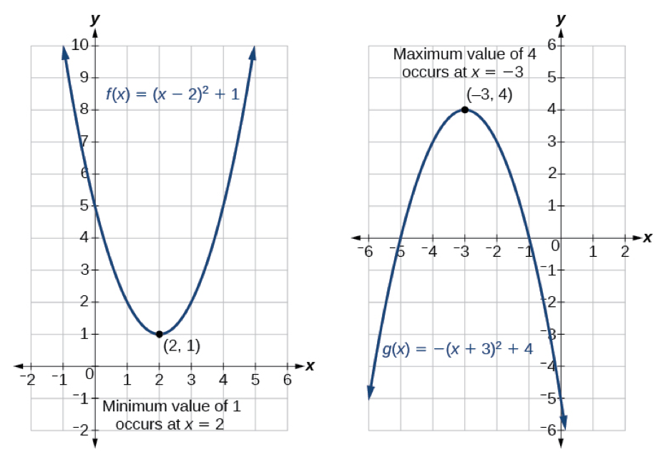
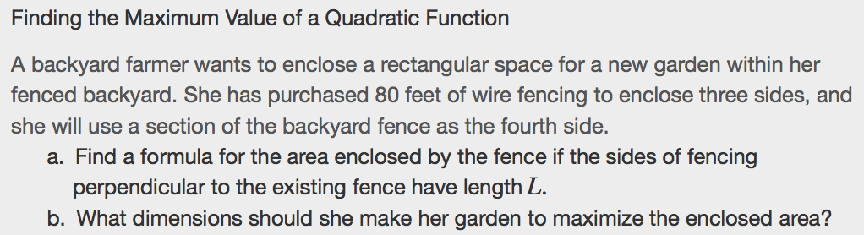

Finding the x- and y-Intercepts of a Quadratic Function
Much as we did in the application problems above, we also need to find intercepts of quadratic equations for graphing parabolas. Recall that we find they-intercept of a quadratic by evaluating the function at an input of _______________, and we find the x-intercepts at locations where the _____________________ is zero. Notice in Figure that the number of x-intercepts can vary depending upon the location of the graph.
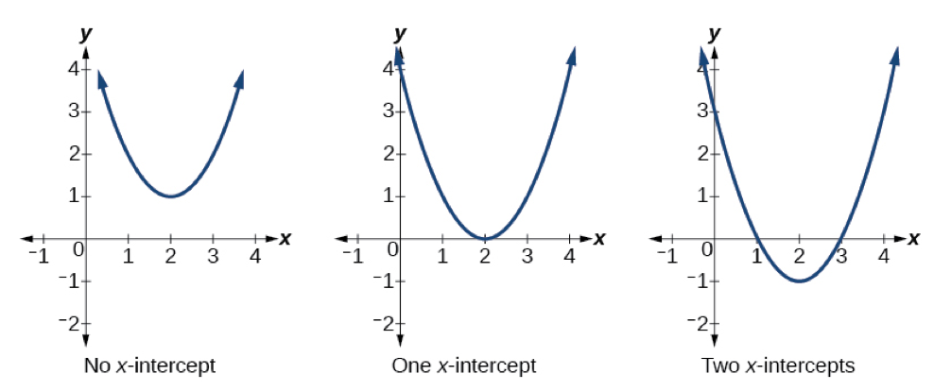
Example

