2.4 – Complex Numbers

Keep in mind that the study of mathematics continuously builds upon itself. Negative integers, for example, fill a void left by the set of positive integers. The set of rational numbers, in turn, fills a void left by the set of integers. The set of real numbers fills a void left by the set of rational numbers. Not surprisingly, the set of real numbers has voids as well. In this section, we will explore a set of numbers that fills voids in the set of real numbers and find out how to work within it.

Expressing Square Roots of Negative Numbers as Multiples of i

We know how to find the square root of any positive real number. In a similar way, we can find the square root of any negative number. The difference is that the root is not real. If the value in the radicand is negative, the root is said to be an imaginary number. The imaginary number i is defined as the square root of−1.
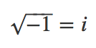
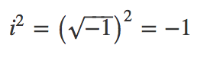
Example
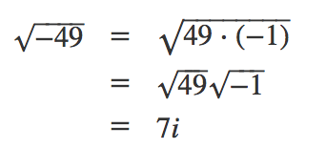
A complex number is the sum of a real number and an imaginary number. A complex number is expressed in standard form when written a+bi where a is the ______________________ part and b is the __________________________________ part.
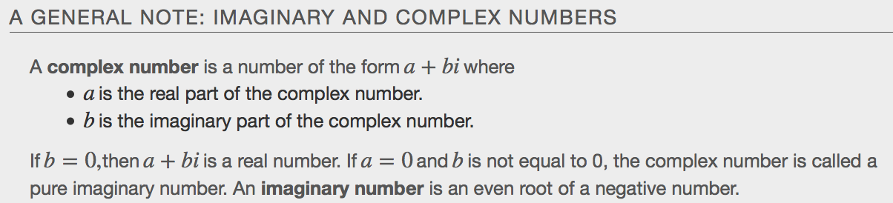

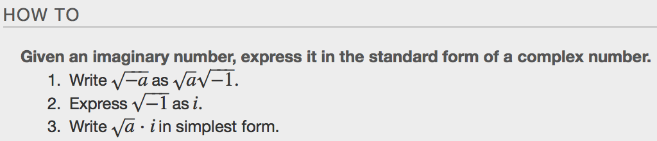
Examples

Plotting a Number on the Complex Plane
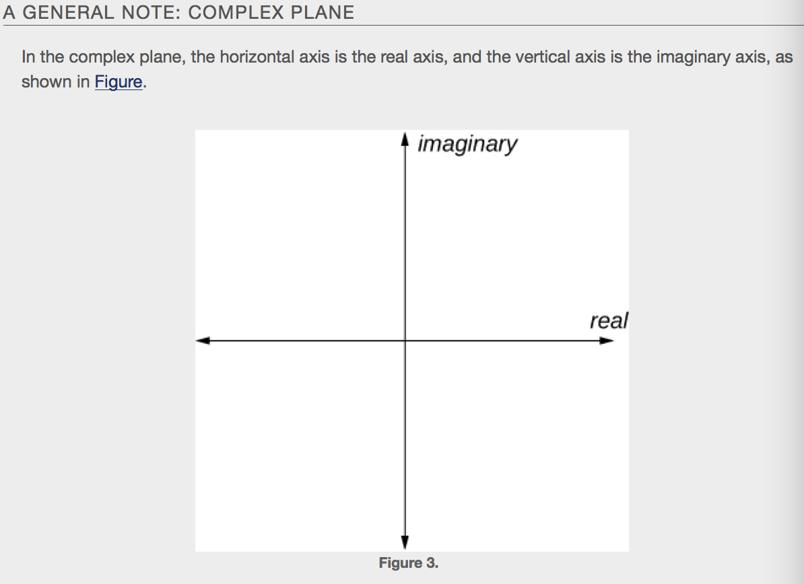

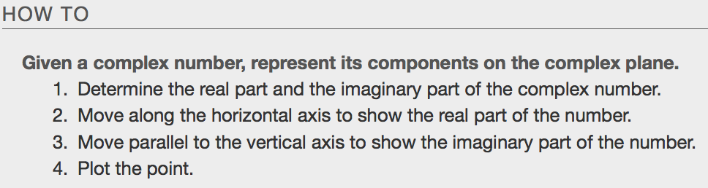
Examples

Adding and Subtracting Complex Numbers
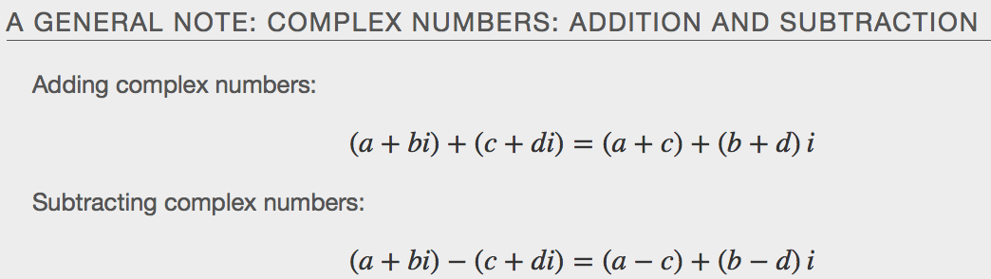
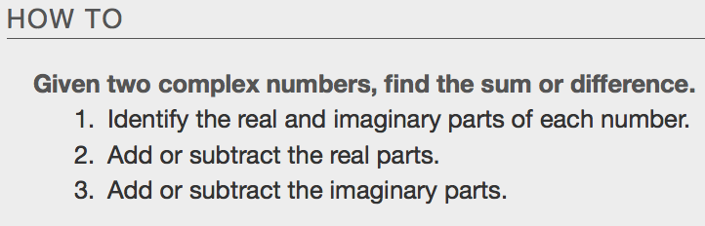
Examples
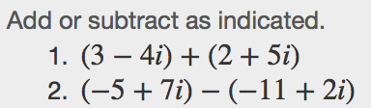

Multiplying Complex Numbers
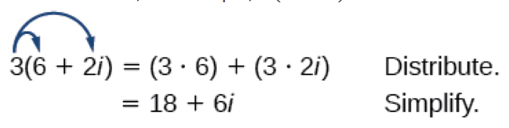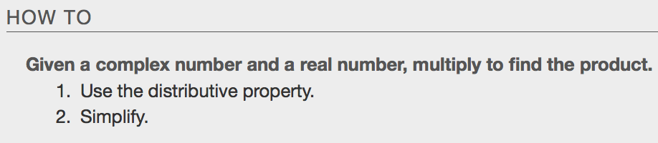
Examples
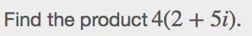

Multiplying Complex Numbers Together (Cycles of i)

$$\begin{matrix}i= & i^{5}= & i^{9}= \\ i^{2}= & i^{6}= & i^{10}= \\ i^{3}= & i^{7}= & i^{11}=\end{matrix}$$
$$\begin{matrix}i^{4}= & i^{8}= & i^{12}=\end{matrix}$$

What is $i^{37}$?

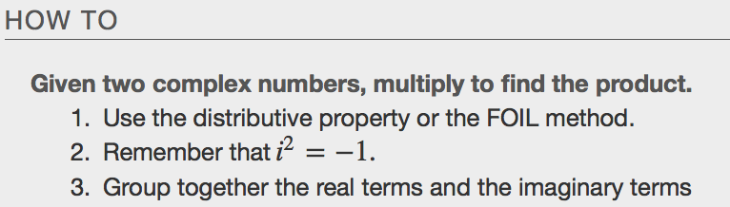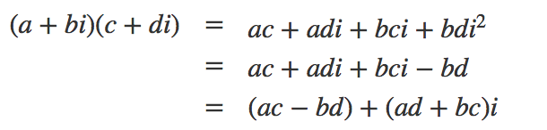
Examples

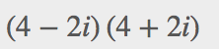 What do you notice that is different about this answer?

Dividing Complex Numbers
Dividing two complex numbers is more complicated than adding, subtracting, or multiplying because we cannot divide by an imaginary number, meaning that any fraction must have a real-number denominator to write the answer in standard form______________________. We need to find a term by which we can multiply the numerator and the denominator that will eliminate the imaginary portion of the denominator so that we end up with a real number as the denominator. This term is called the complex conjugate of the denominator, which is found by changing the sign of the imaginary part of the complex number.
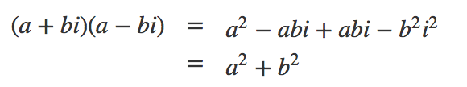
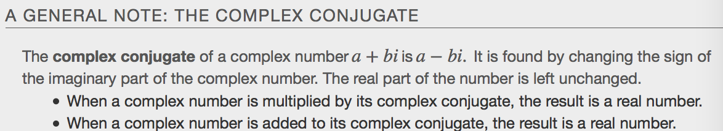
Examples
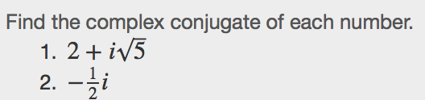

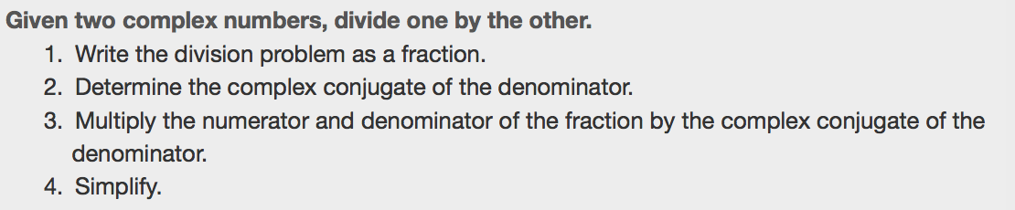
Examples
