3.7 – Inverse Functions
A reversible heat pump is a climate-control system that is an air conditioner and a heater in a single device. Operated in one direction, it pumps heat out of a house to provide cooling. Operating in reverse, it pumps heat into the building from the outside, even in cool weather, to provide heating. As a heater, a heat pump is several times more efficient than conventional electrical resistance heating.
If some physical machines can run in two directions, we might ask whether some of the function “machines” we have been studying can also run backwards. Figure provides a visual representation of this question. In this section, we will consider the reverse nature of functions.
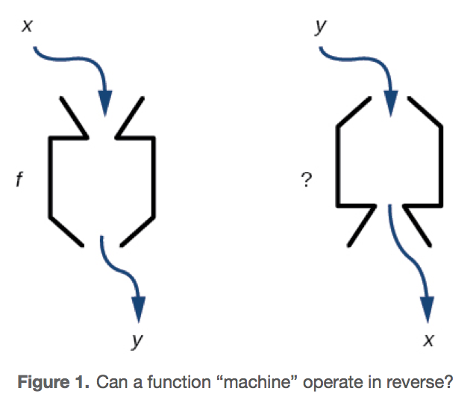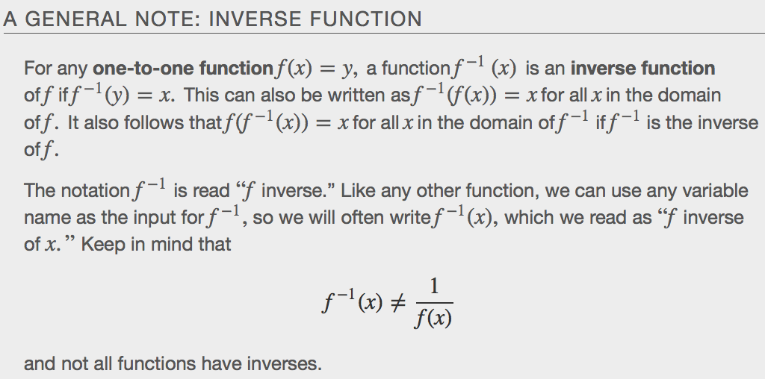

Verifying if Two Functions Are Inverse Functions
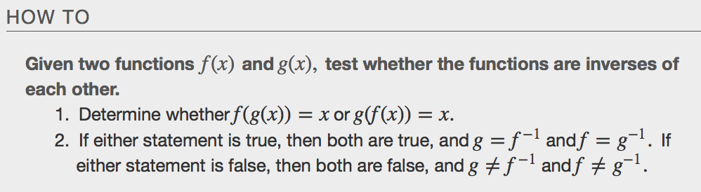
Example
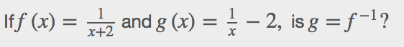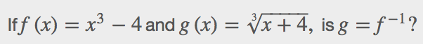

Finding Domain and Range of Inverse Functions
The outputs of the function f are the inputs tof−1,so the range of f is also the domain of f⁻¹.Likewise, because the inputs to f are the outputs of f⁻¹,the domain of f is the range of f⁻¹.We can visualize the situation as in Figure.
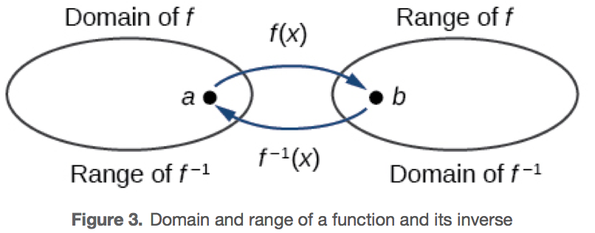
When a function has no inverse function, it is possible to create a new function where that new function on a limited domain does have an inverse function. For example, the inverse of $f\left(x\right)-\sqrt{x}$ is $f^{-1}\left(x\right)=x^{2}$, because a square “undoes” a square root. But, the square is only the inverse of the square root on the domain $[0,∞)$, since that is the range of $f\left(x\right)=\sqrt{x}.$
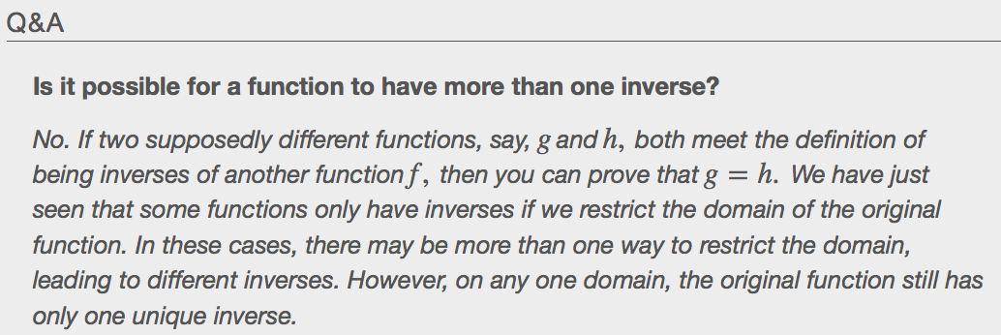
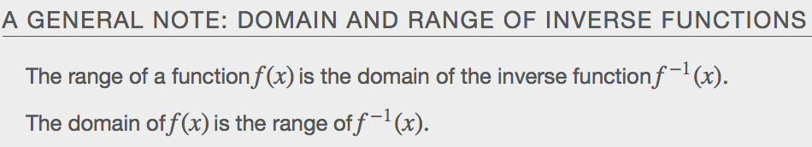

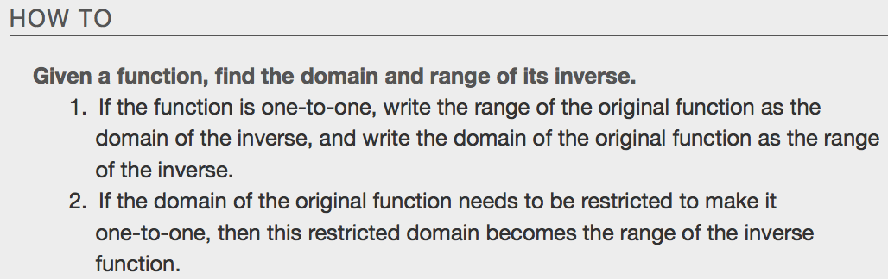

Example
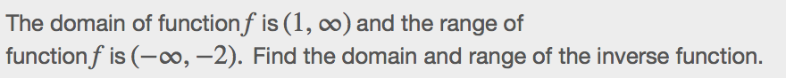

Finding and Evaluating Inverse Functions

Inverting Tabular Functions
Suppose we want to find the inverse of a function represented in table form. Remember that the domain of a function is the range of the inverse and the range of the function is the domain of the inverse. So we need to interchange the domain and range.Each row (or column) of inputs becomes the row (or column) of outputs for the inverse function. Similarly, each row (or column) of outputs becomes the row (or column) of inputs for the inverse function.
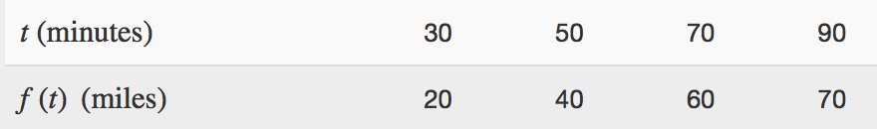
Evaluating the Inverse of a Function, Given a Graph of the Original Function
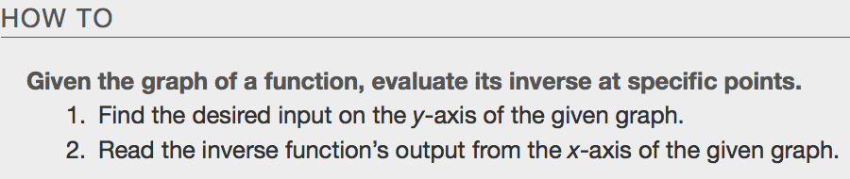
Example
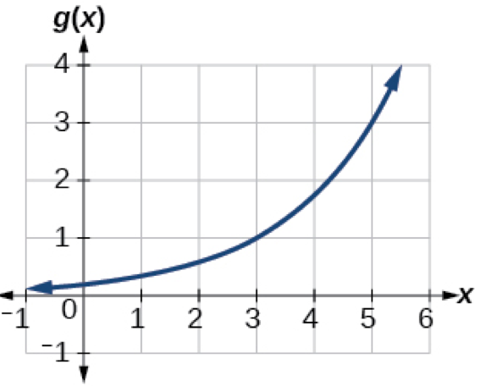
Finding Inverses of Functions Represented by Formulas
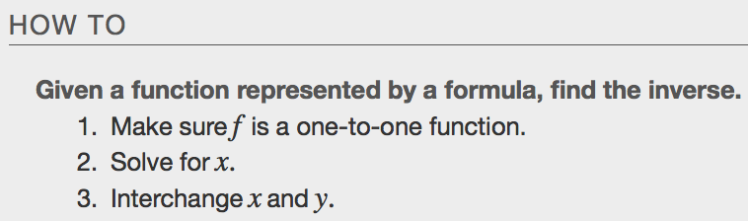
Example
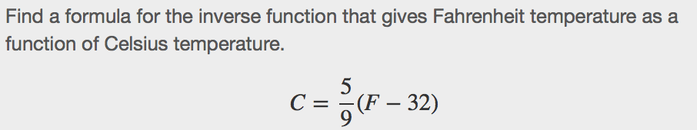

Finding Inverse Functions and Their Graphs
Graph $f\left(x\right)=x^{2} restricted to the domain [0,∞)$. Find the inverse function and graph it on the same set of axes.
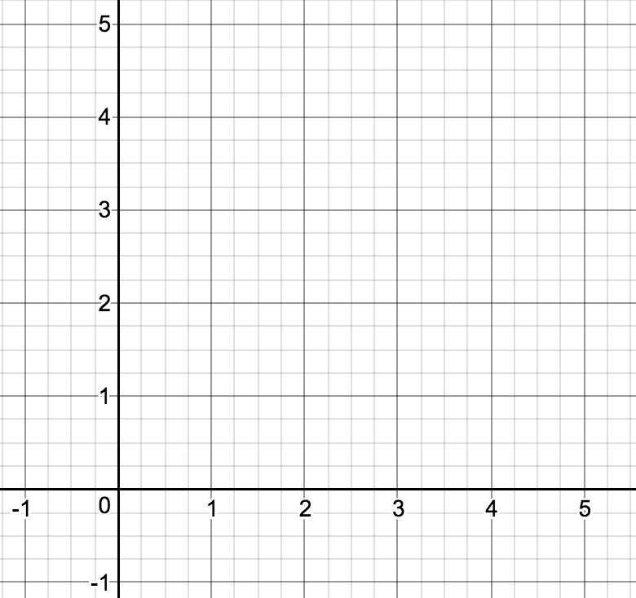

Graph $f\left(x\right)=x^{3}-1$. Find the inverse function and graph it on the same set of axes.
