3.5 – Transformations of Functions

Like a carnival funhouse mirror, it presents us with a distorted image of ourselves, stretched or compressed horizontally or vertically. In a similar way, we can distort or transform mathematical functions to better adapt them to describing objects or processes in the real world. In this section, we will take a look at several kinds of transformations.

Graphing Functions Using Vertical and Horizontal Shifts
One method we can employ is to adapt the basic graphs of the toolkit functions to build new models for a given scenario. There are systematic ways to alter functions to construct appropriate models for the problems we are trying to solve.

Identifying Vertical Shifts
One simple kind of transformation involves shifting the entire graph of a function up, down, right, or left. The simplest shift is a vertical shift, moving the graph up or down, because this transformation involves adding a positive or negative constant to the function. In other words, we add the same constant to the output value of the function regardless of the input. For a function g(x)=f(x)+k,the function f(x)is shifted vertically k units. See Figure for an example.
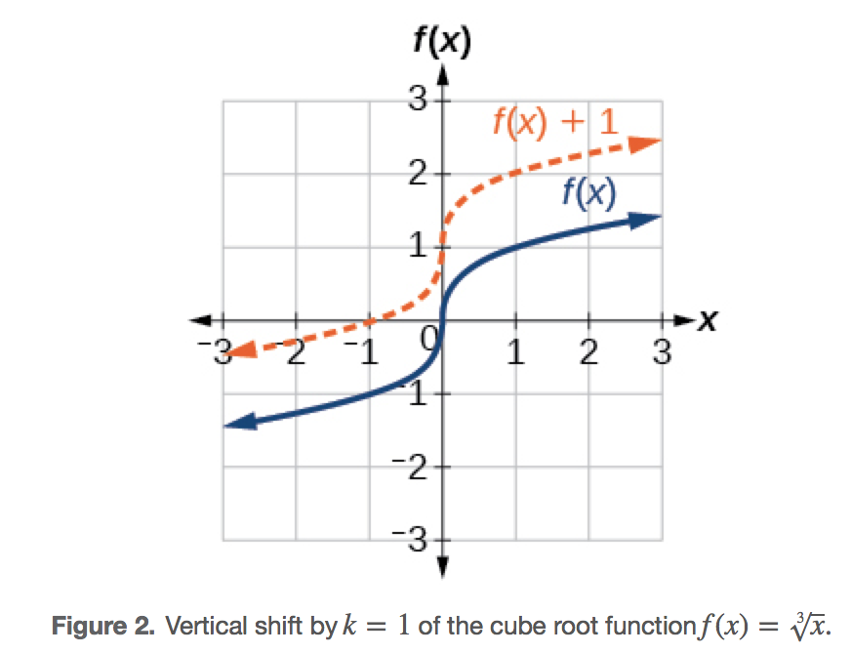
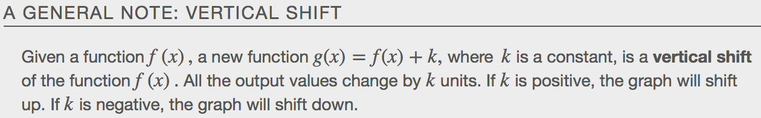
Example
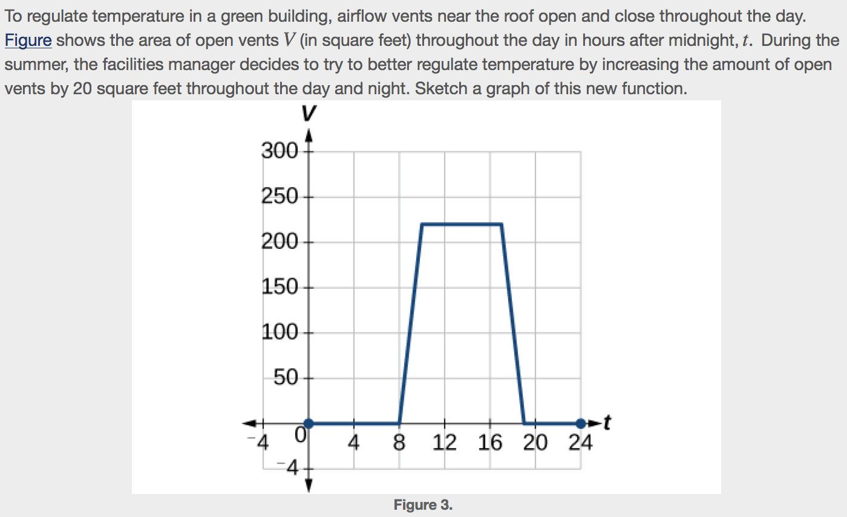
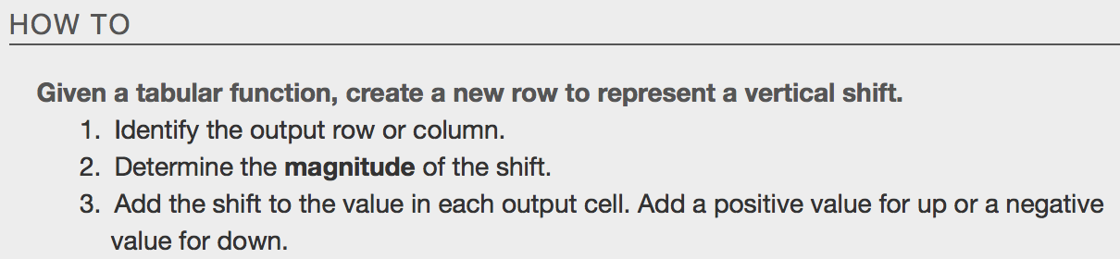

Example
a.

b.
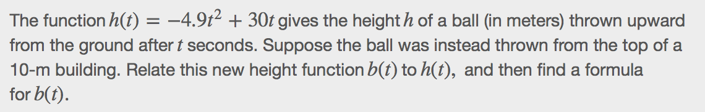

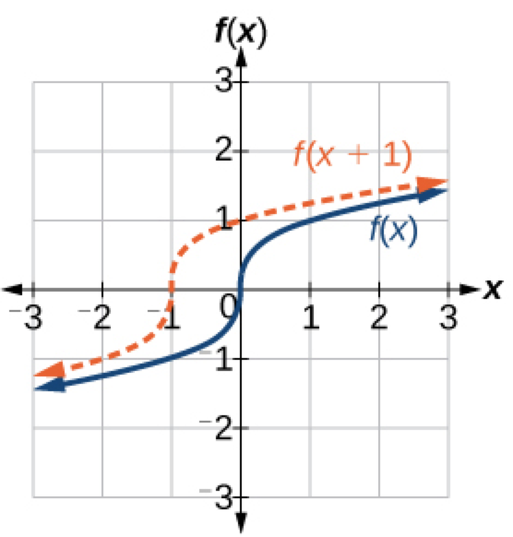
Identifying Horizontal Shifts
We just saw that the vertical shift is a change to the output, or outside, of the function. We will now look at how changes to input, on the inside of the function, change its graph and meaning. A shift to the input results in a movement of the graph of the function left or right in what is known as a horizontal shift, shown in Figure.

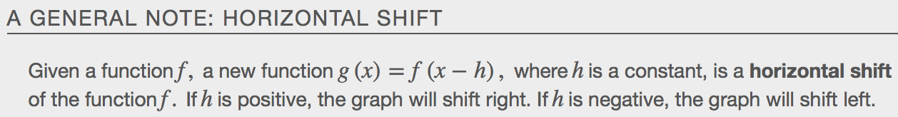
Example
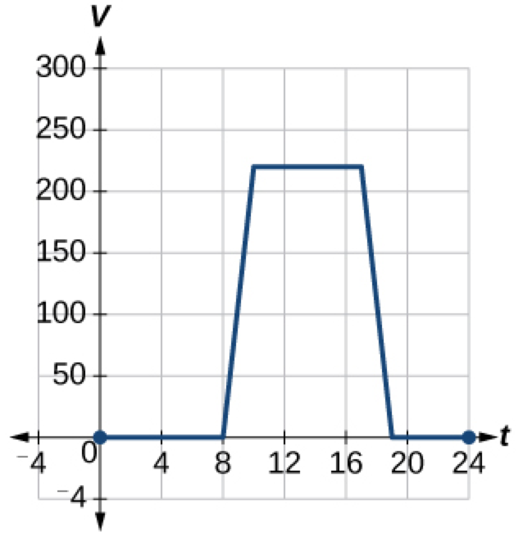

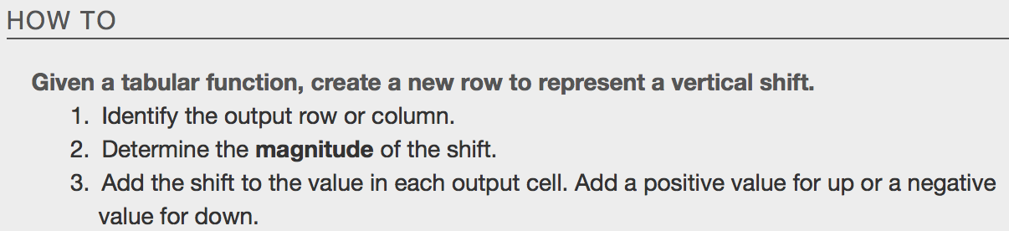
Example
a.

b.
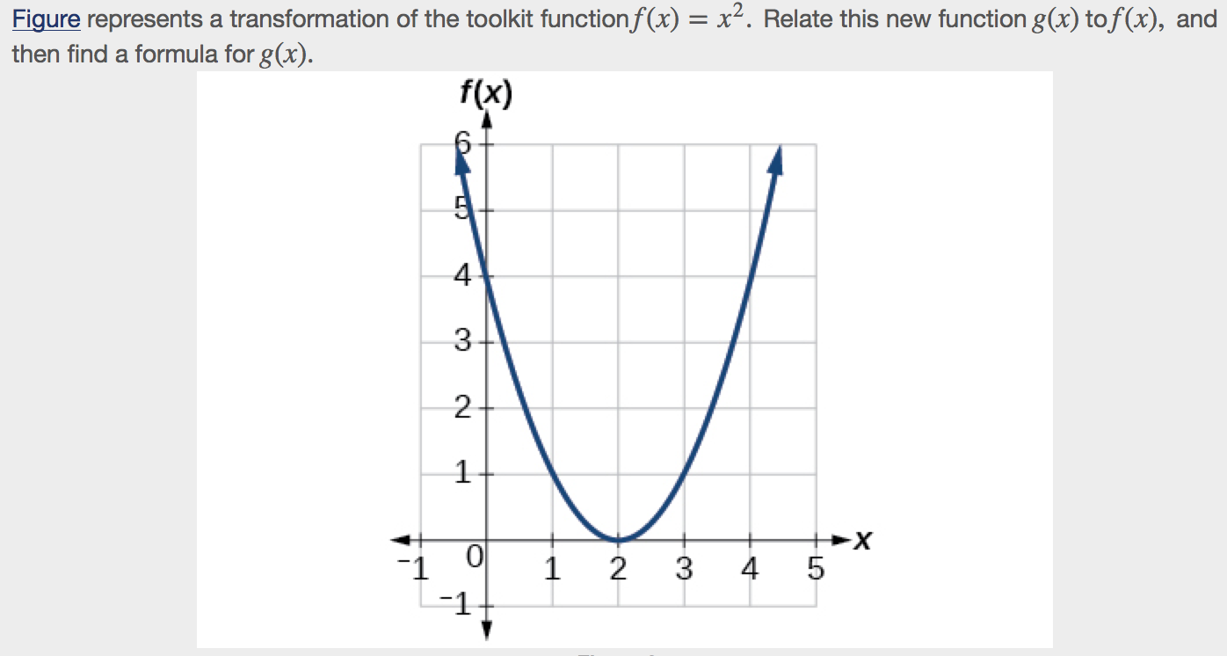

c.

d.
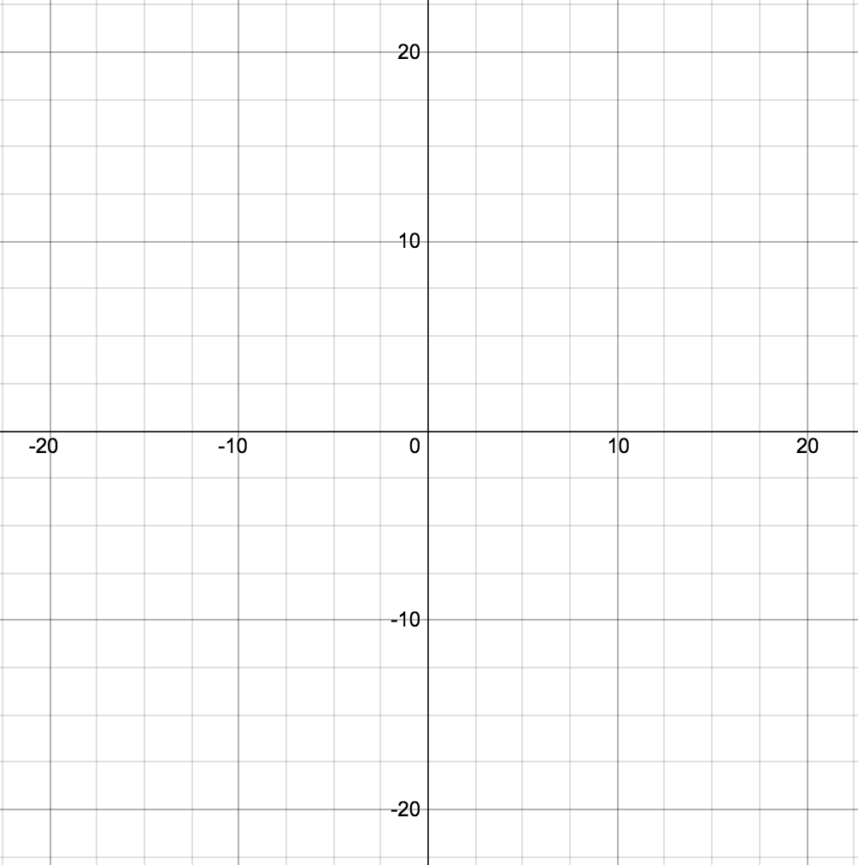
Combining Vertical and Horizontal Shifts
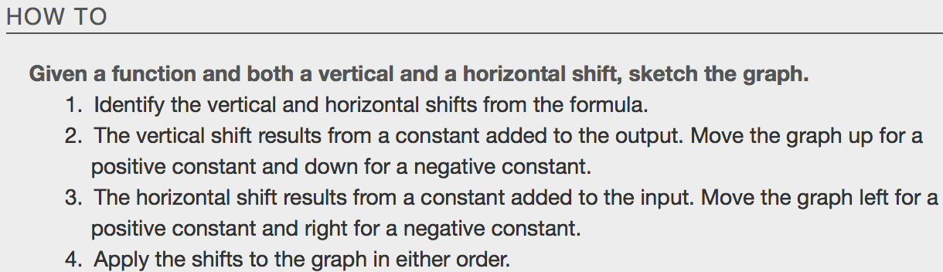
Example
a.

b.
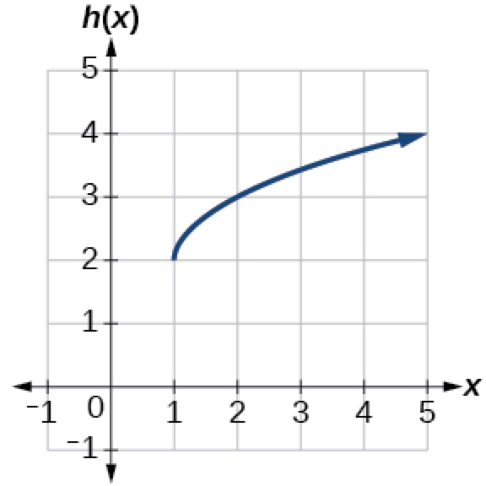

c.

Graphing Functions Using Reflections About Axes
Another transformation that can be applied to a function is a reflection over the x- or y-axis. A vertical reflection reflects a graph vertically across the ____-axis, while a horizontal reflection reflects a graph horizontally across the ____-axis. The reflections are shown in Figure.
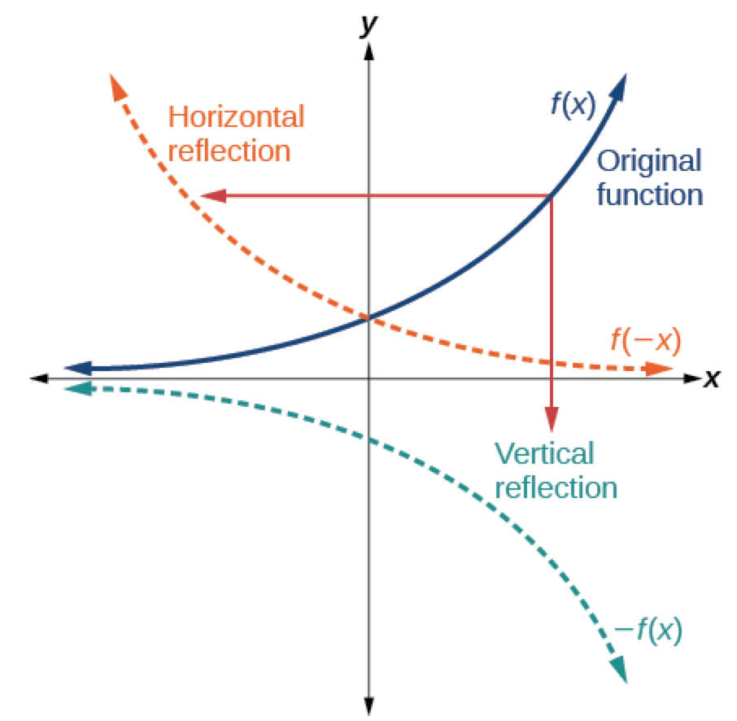
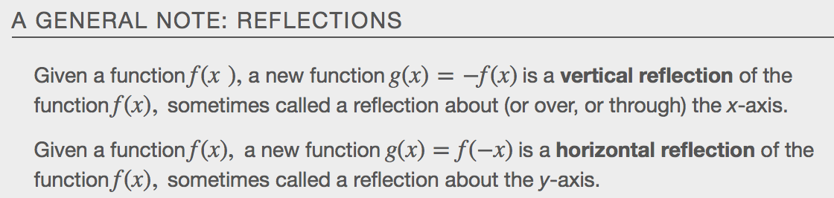

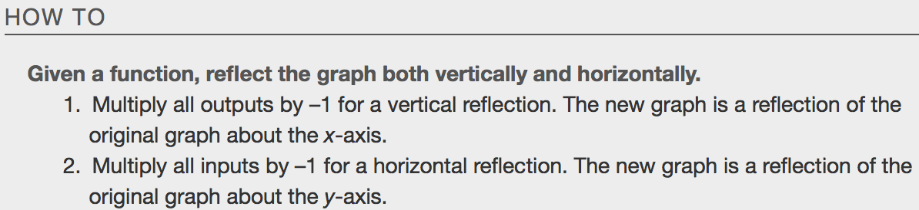
Example
a.
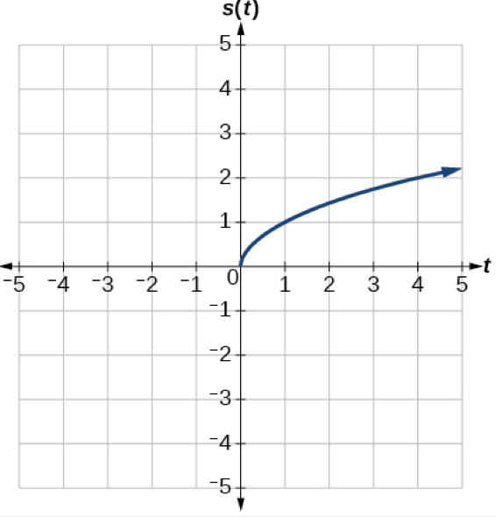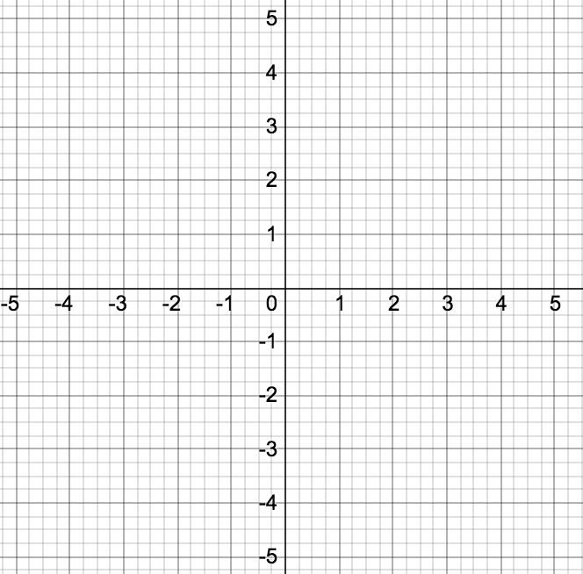
b.
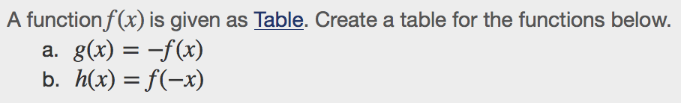
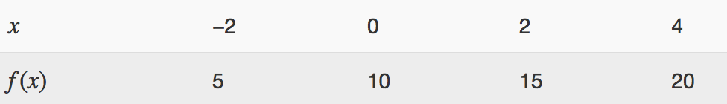

Even and Odd Functions
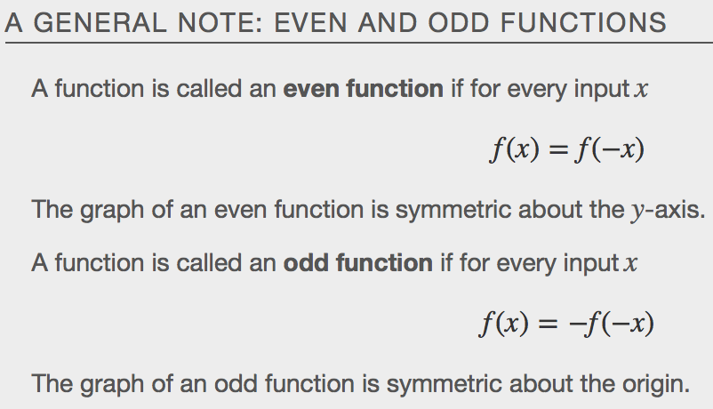

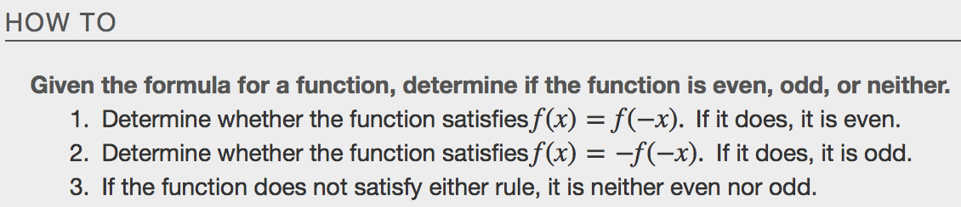

Example
a.

b.

Graphing Functions Using Stretches and Compressions
Adding a constant to the inputs or outputs of a function changed the position of a graph with respect to the axes, but it did not affect the shape of a graph. We now explore the effects of multiplying the inputs or outputs by some quantity. We can transform the inside (input values) of a function or we can transform the outside (output values) of a function. Each change has a specific effect that can be seen graphically.

Vertical Stretches and Compressoins
When we multiply a function by a positive constant, we get a function whose graph is stretched or compressed vertically in relation to the graph of the original function. If the constant is _____________________ than 1, we get a _______________________ ___________________; if the constant is between ___ and ___ , we get a ______________________ ___________________. Figure shows a function multiplied by constant factors 2 and 0.5 and the resulting vertical stretch and compression.
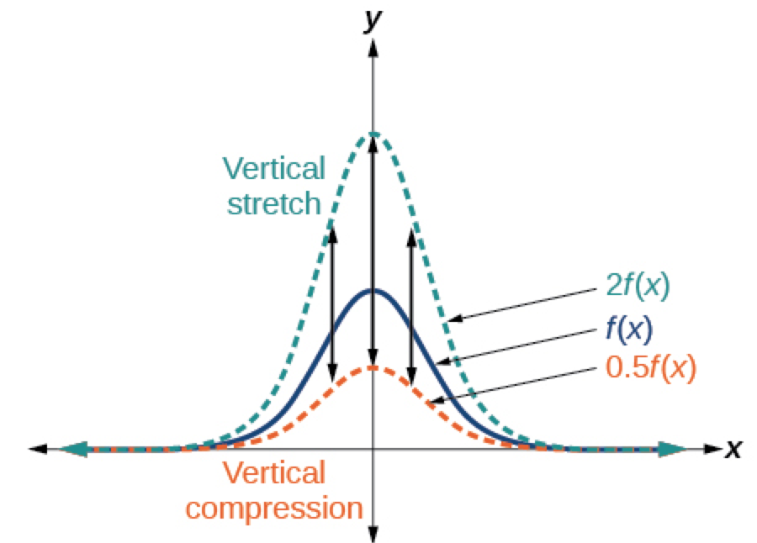

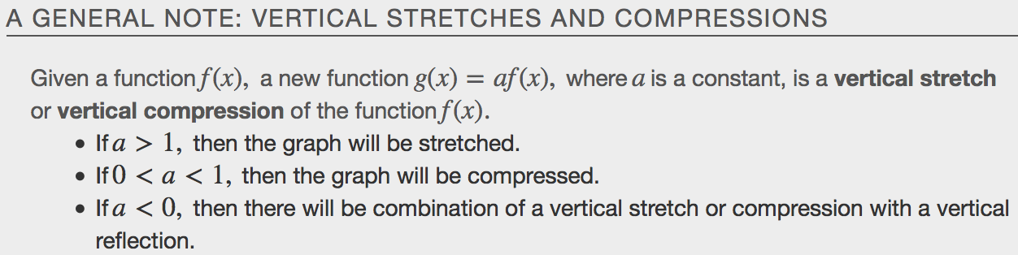

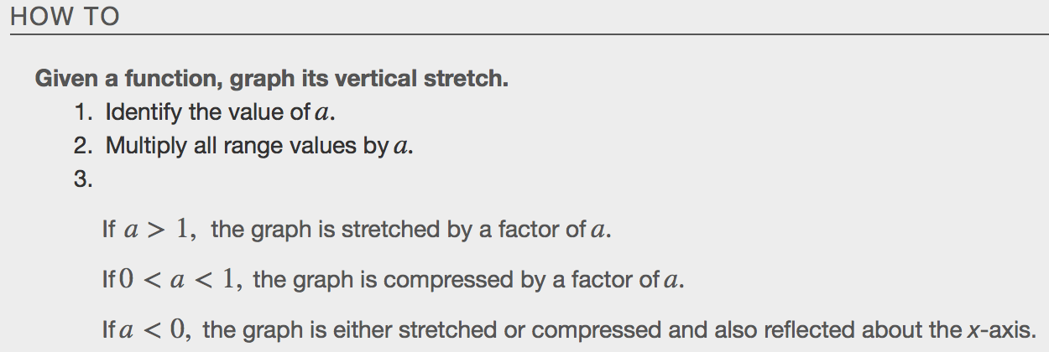
Example
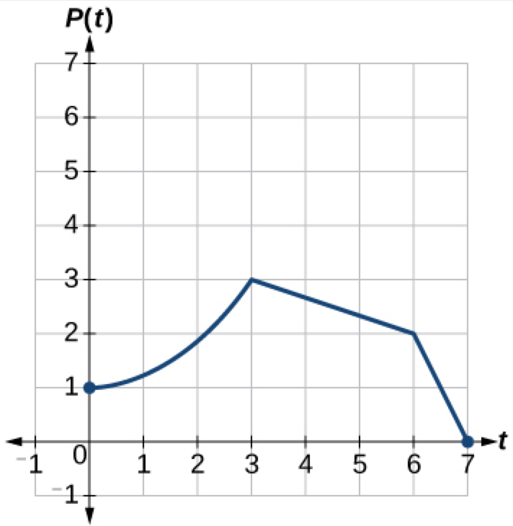
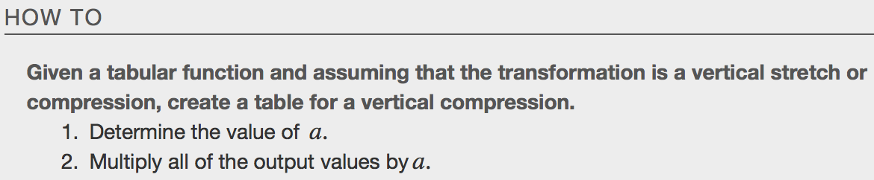
Example
a.
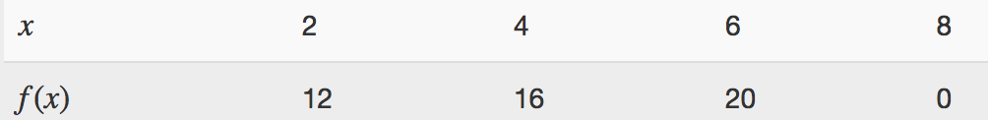

b.

Horizontal Stretches and Compressions
Now we consider changes to the inside of a function. When we multiply a function’s input by a positive constant, we get a function whose graph is stretched or compressed horizontally in relation to the graph of the original function. If the constant is between _____ and _____, we get a horizontal _______________; if the constant is greater than _____, we get a horizontal ____________________________ of the function.
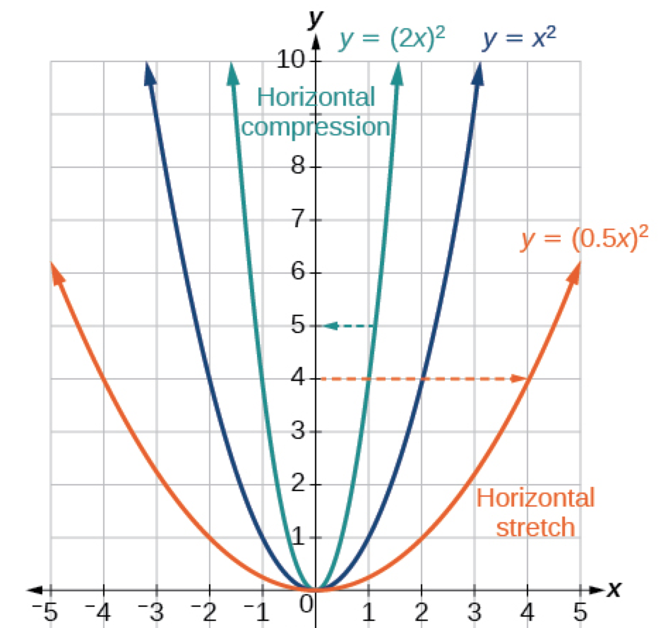

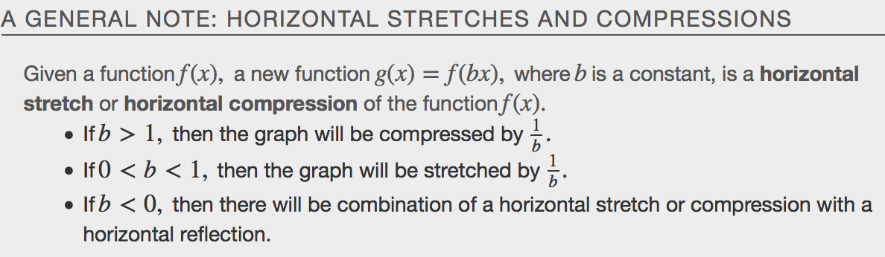

Example
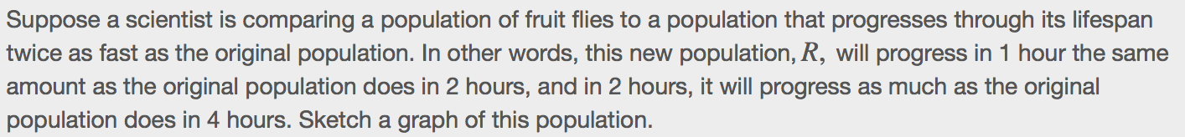

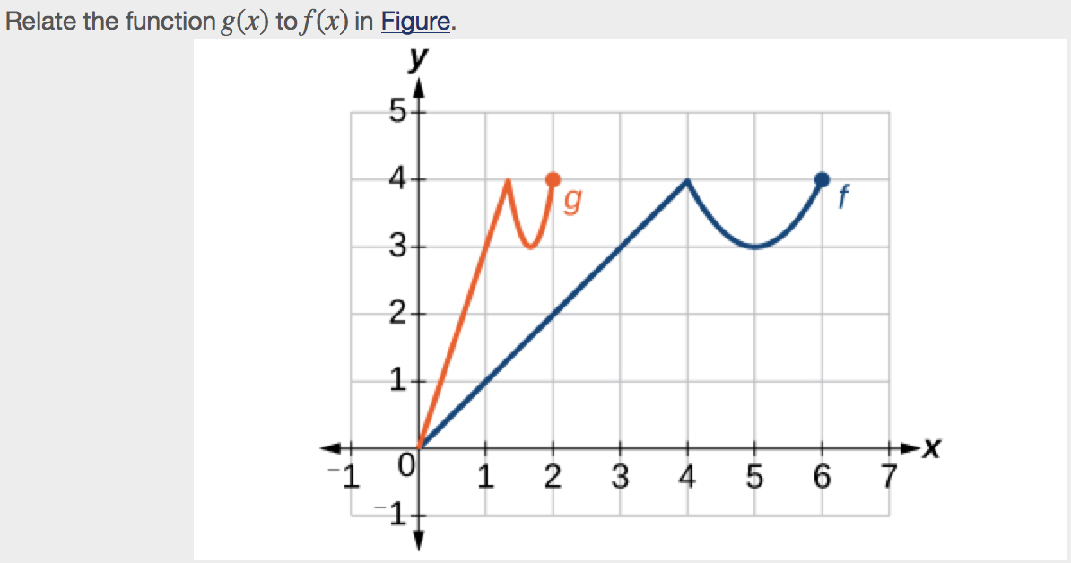

Performing a Series of Transformations
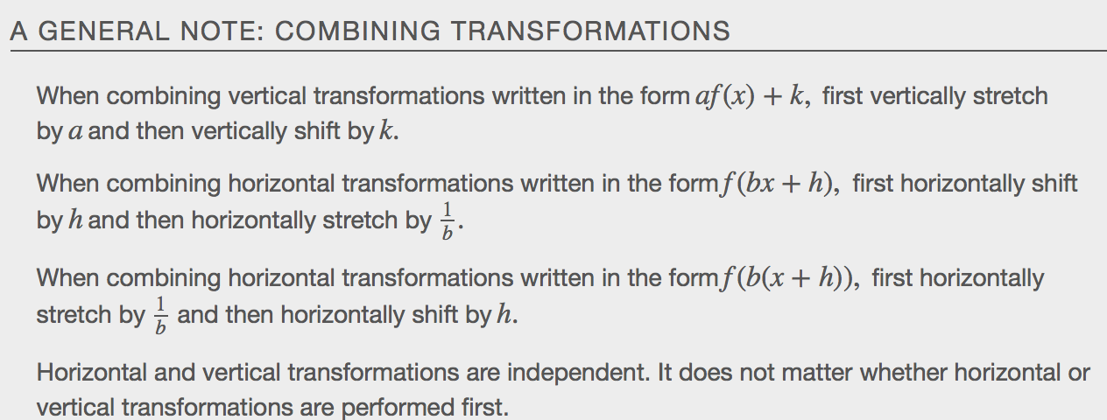

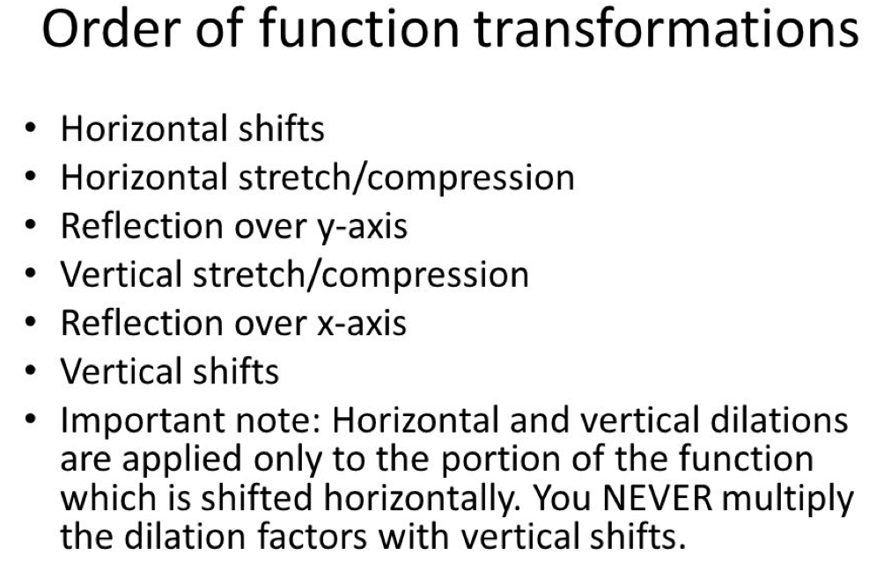
Example
