3.4 – Composition of Functions

Function __________________________________ is only one way to combine existing functions. Another way is to carry out the usual algebraic operations on functions, such as addition, subtraction, multiplication and division. We do this by performing the operations with the function outputs, defining the result as the output of our new function.
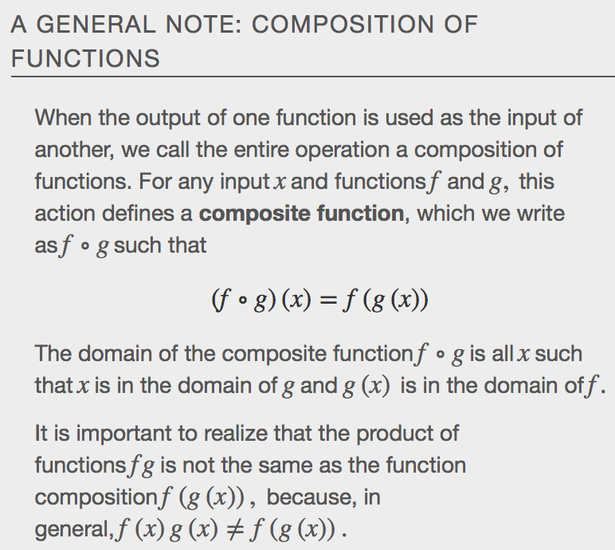
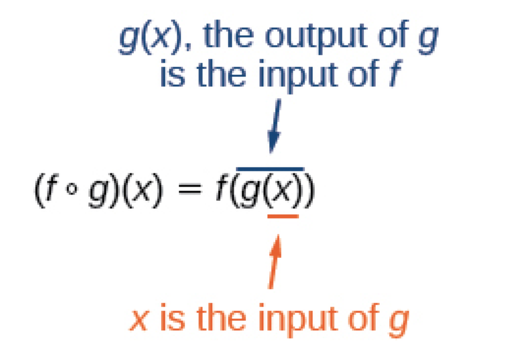
Example
a.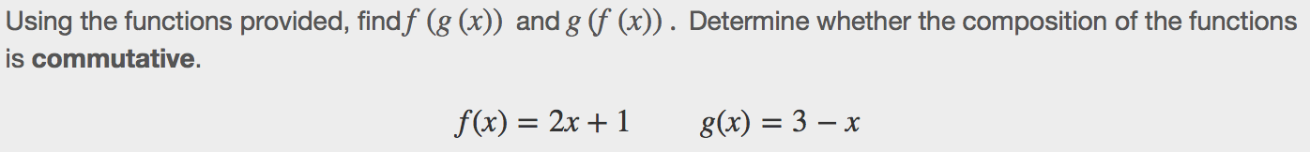

b.

c.

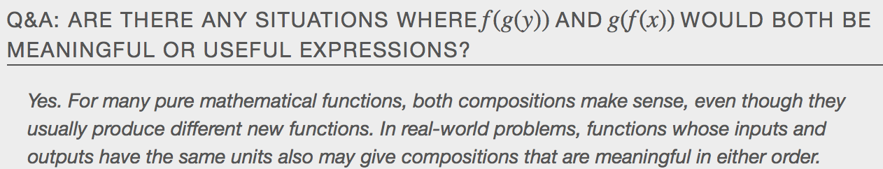

Evaluating Composite Functions
Once we compose a new function from two existing functions, we need to be able to evaluate it for any input in its __________________________. We will do this with specific numerical inputs for functions expressed as tables, graphs, and formulas and with variables as inputs to functions expressed as formulas. In each case, we evaluate the _______________________ function using the starting input and then use the inner function’s _________________ as the _________________ for the outer function.

Evaluating Composite Functions Using Tables
Once we compose a new function from two existing functions, we need to be able to evaluate it for any input in its domain. We will do this with specific numerical inputs for functions expressed as tables, graphs, and formulas and with variables as inputs to functions expressed as formulas. In each case, we evaluate the inner function using the starting ________________and then use the inner function’s ______________ as the ___________________for the outer function.

Example
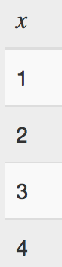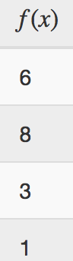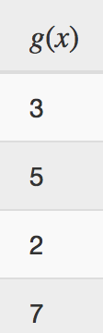

Evaluating Composite Functions Using Graphs
When we are given individual functions as graphs, the procedure for evaluating composite functions is similar to the process we use for evaluating tables. We read the input and output values, but this time, from thex- and y-axes of the graphs.

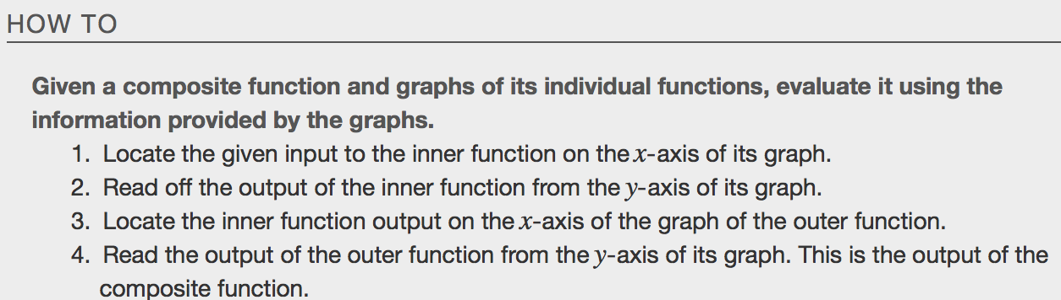

Example
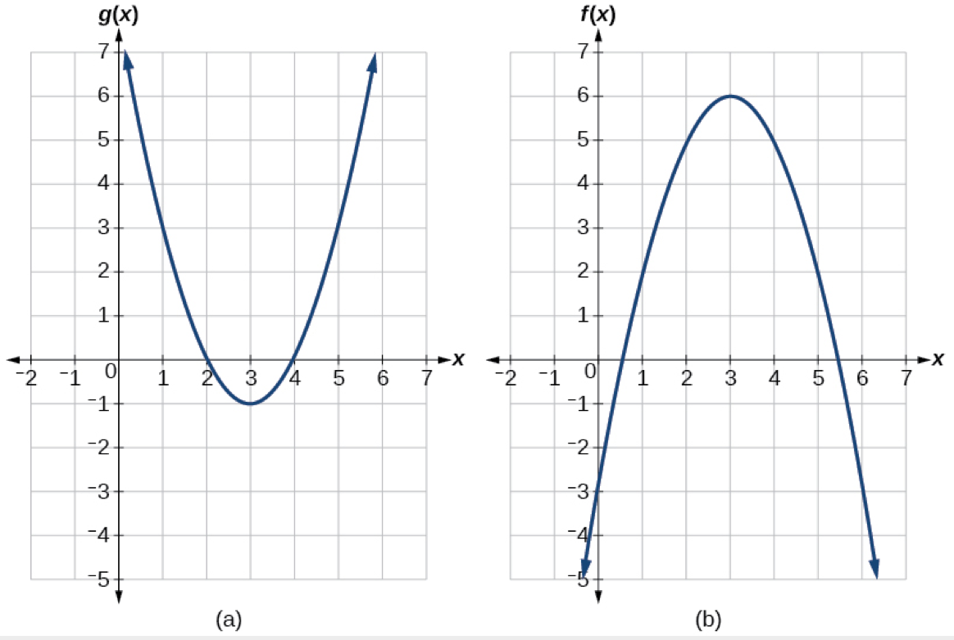

Evaluating Composite Functions Using Formulas
When evaluating a composite function where we have either created or been given formulas, the rule of working from the inside out remains the same. The input value to the outer function will be the output of the inner function, which may be a numerical value, a variable name, or a more complicated expression

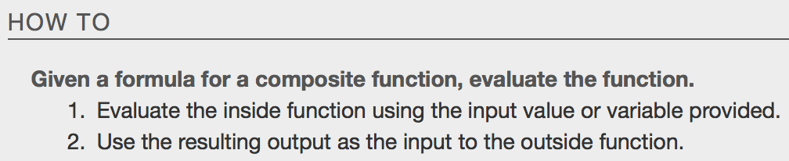

Example
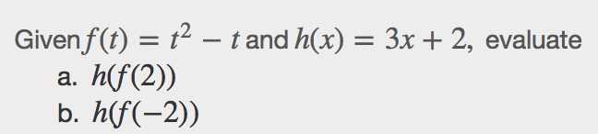

Finding the Domain of a Composite Function
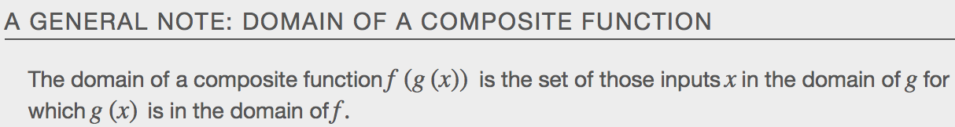

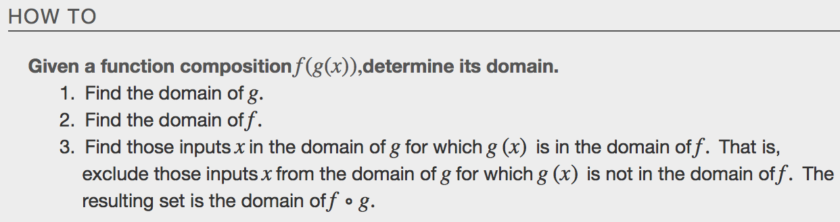

Examples
a.
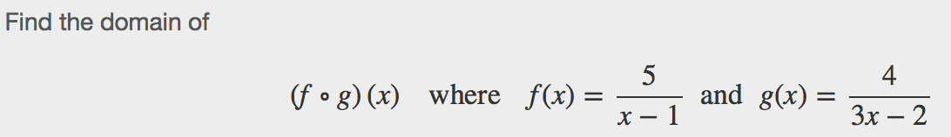

b.
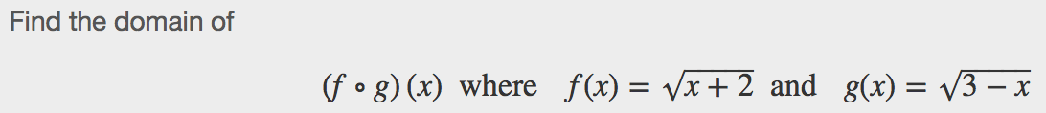

c.
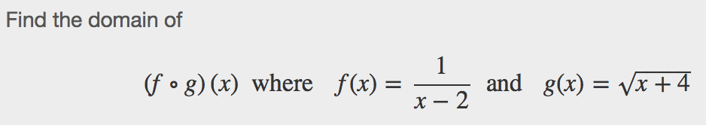

Decomposing a Composite Function
In some cases, it is necessary to _______________________________ a complicated function. In other words, we can write it as a composition of __________ simpler functions. There may be ____________ than __________ way to decompose a composite function, so we may choose the decomposition that appears to be most expedient.
Example
a. b.

