3.3 – Rates of Change and Behavior of Graphs

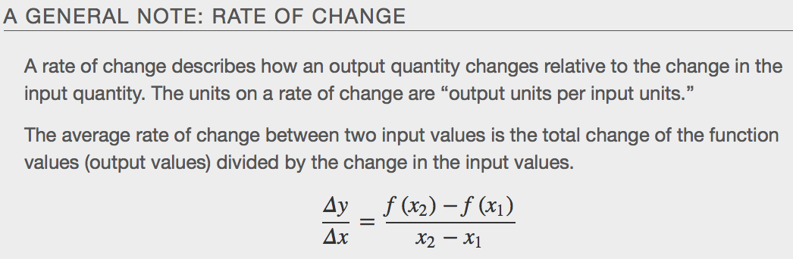
Some examples of rates of change include:
- A population of rats increasing by 40 rats per week
- A car traveling 68 miles per hour (distance traveled changes by 68 miles each hour as time passes)
- A car driving 27 miles per gallon (distance traveled changes by 27 miles for each gallon)
- The current through an electrical circuit increasing by 0.125 amperes for every volt of increased voltage
- The amount of money in a college account decreasing by $4,000 per quarter

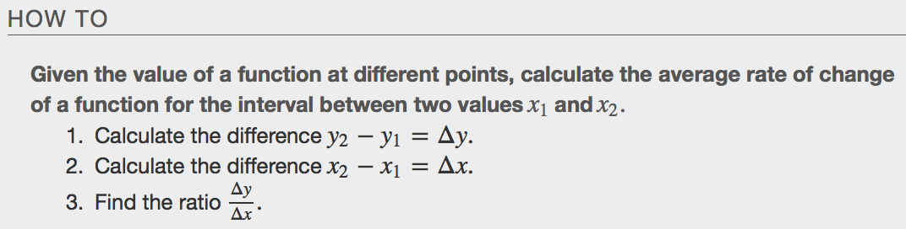

Example:
- Gasoline costs have experienced some wild fluctuations over the last several decades. Table¹ lists the average cost, in dollars, of a gallon of gasoline for the years 2005–2012. The cost of gasoline can be considered as a function of year.

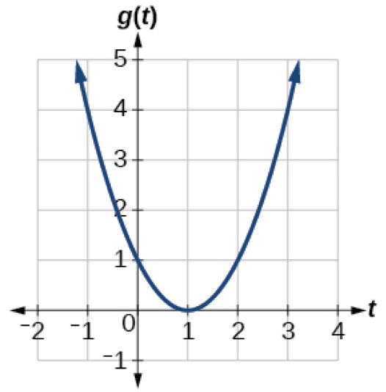

Using a Graph to Determine Where a Function is Increasing, Decreasing, or Constant

As part of exploring how functions change, we can identify intervals over which the function is changing in specific ways. We say that a function is ___________________________ on an interval if the function values increase as the input values increase within that interval. Similarly, a function is ________________________ on an interval if the function values decrease as the input values increase over that interval. The average rate of change of an increasing function is positive, and the average rate of change of a decreasing function is negative.
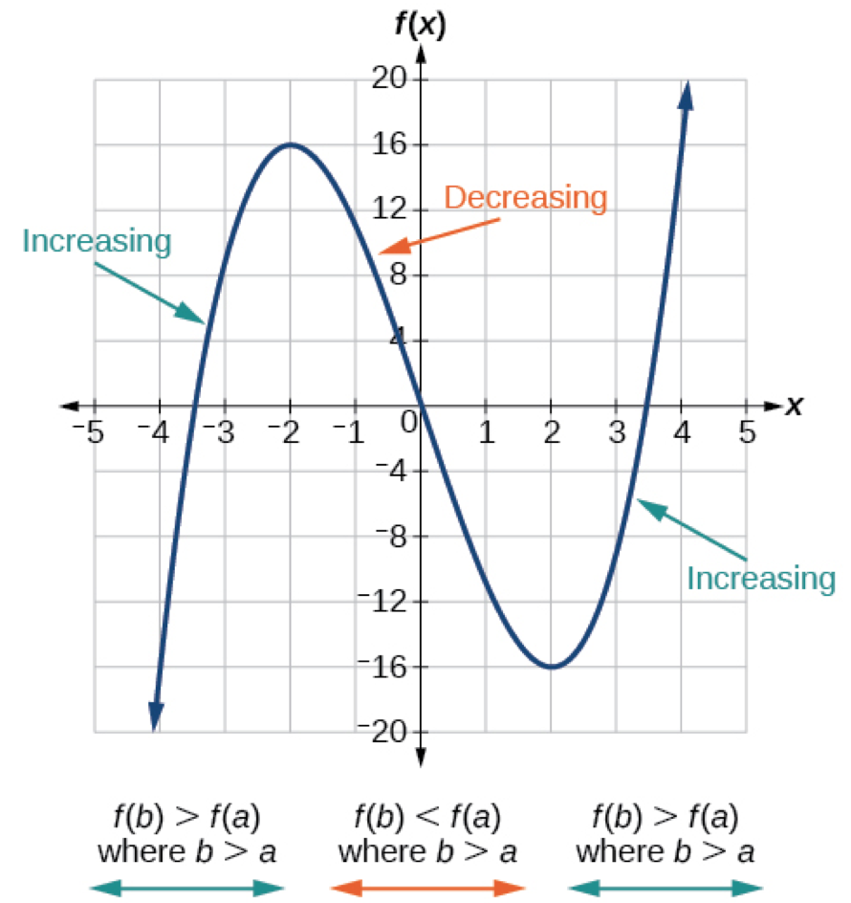

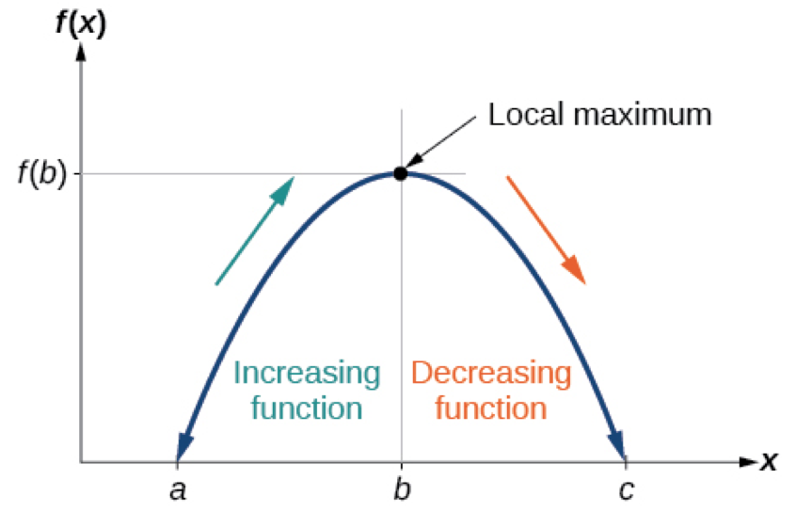
Local maxima:

Local minima:

Local Extrema:

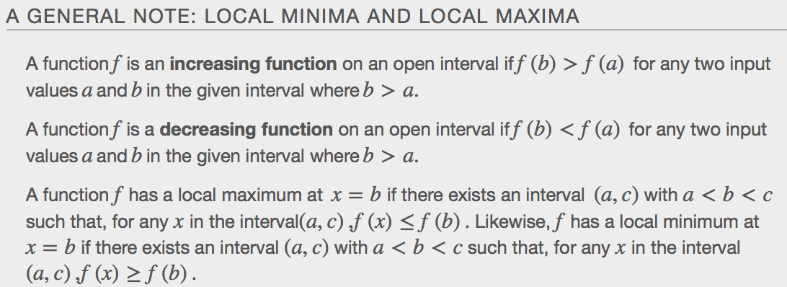
Examples

- Given the functionp(t)in Figure, identify the intervals on which the function appears to be increasing and decreasing.
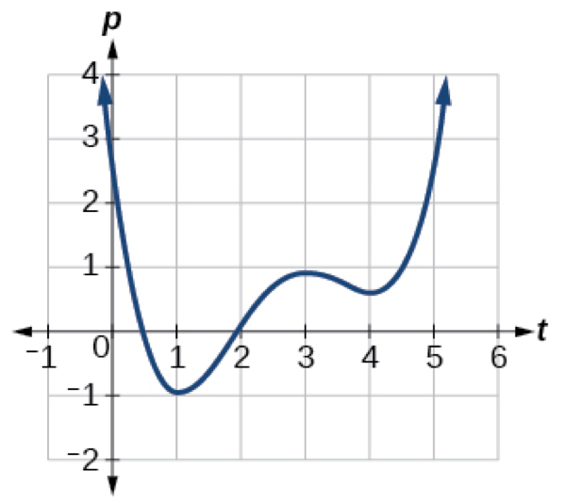

- 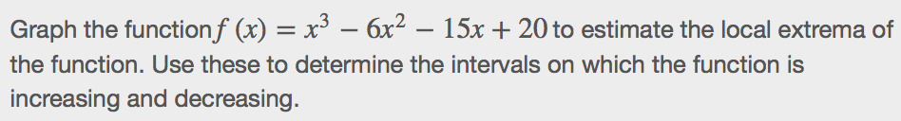
TI-83 or TI-84 calculator or www.desmos.com

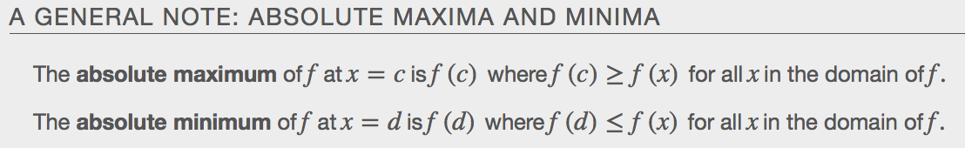

- Identify the following for the graph given.
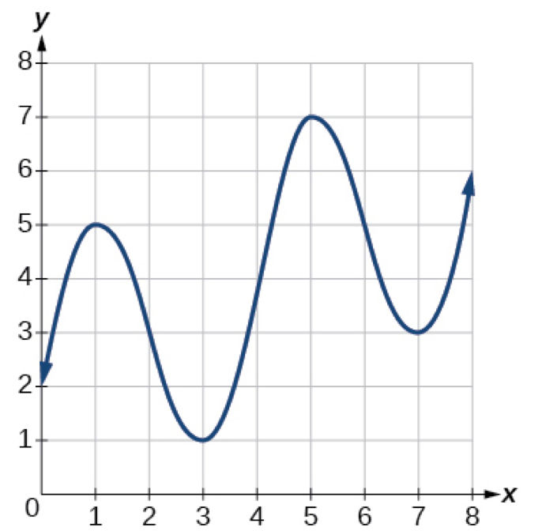
  - Average rate of change from x=1 to x=4

  - Increasing intervals

  - Decreasing Intervals

  - All local extrema

  - Absolute maximum and absolute minimum (if possible)

