4.1 – Linear Functions

There are many situations that involve constant change over time. We will investigate a kind of function that is useful for this purpose, and use it to investigate real-world situations.

Representing Linear Functions
A _________________________________ function, which is defined as a function with a constant rate of change. This is a polynomial of degree ____. There are several ways to represent a linear function, including word form, function notation, tabular form, and graphical form.

Example
Suppose a maglev train travels a long distance, and maintains a constant speed of 83 meters per second for a period of time once it is 250 meters from the station. How can we analyze the train’s distance from the station as a function of time?

Representing a Linear Function in Word Form.
The train’s ____________________________ from the station is a function of the _______________ during which the train moves at a ___________________________ speed plus its ______________________ distance from the station when it began moving at constant speed.

The speed is the rate of change. Recall that a rate of change is a measure of how quickly the dependent variable changes with respect to the independent variable. The rate of change for this example is constant, which means that it is the same for each input value. As the time (input) increases by 1 second, the corresponding distance (output) increases by 83 meters. The train began moving at this constant speed at a distance of 250 meters from the station.

Representing a Linear Function in Function Notation
Another approach to representing linear functions is by using function notation. One example of function notation is an equation written in the ____________-____________________________ form of a line, where ___ is the input value, ___ is the rate of change, and ___ is the initial value of the dependent variable.
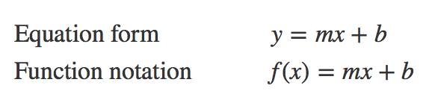
In the example of the train, we might use the notation D(t)where the total distance D is a function of the time t.

Representing a Linear Function in Tabular Form

t | 0 | 1 | 2 | 3
D(t)

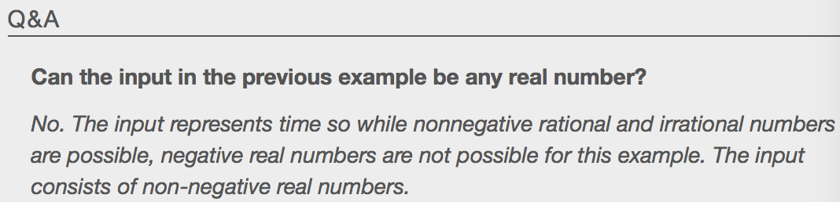
Representing a Linear Function in Graphical Form
When we plot a linear function, the graph is always a _________________. The rate of change, which is constant, determines the slant, or ___________________ of the line. The point at which the input value is zero is the vertical intercept, or ___-intercept, of the line. We can see from the graph that the y-intercept in the train example we just saw is (0,250) and represents the distance of the train from the station when it began moving at a constant speed.
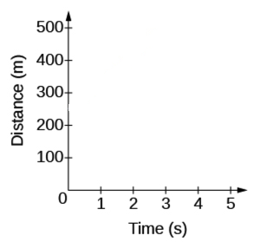
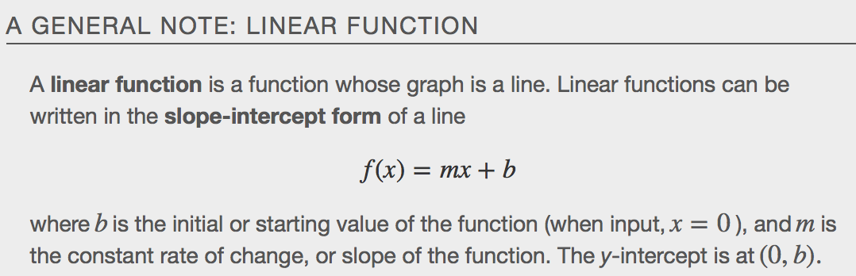

Example
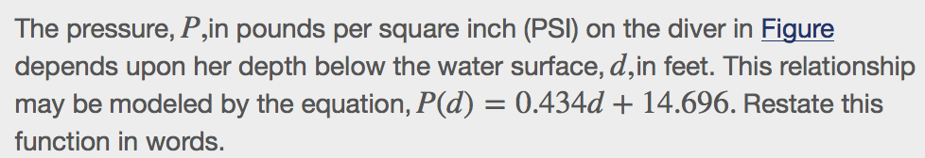

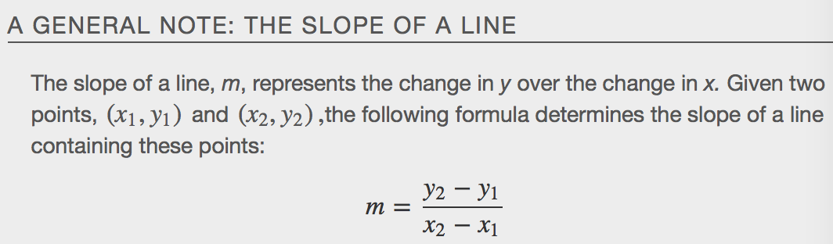Determining Whether a Linear Function Is Increasing, Decreasing, or Constant
A linear function may be increasing, decreasing, or constant. For an increasing function, as with the train example, the output values increase as the input values increase. The graph of an increasing function has a _______________________________ slope. A line with a positive slope slants __________________ from left to right as in Figure(a). For a decreasing function, the slope is ______________________. The output values decrease as the input values increase. A line with a negative slope slants _____________________ from left to right as in Figure(b). If the function is constant, the output values are the same for all input values so the slope is zero. A line with a slope of zero is horizontal as in Figure(c).
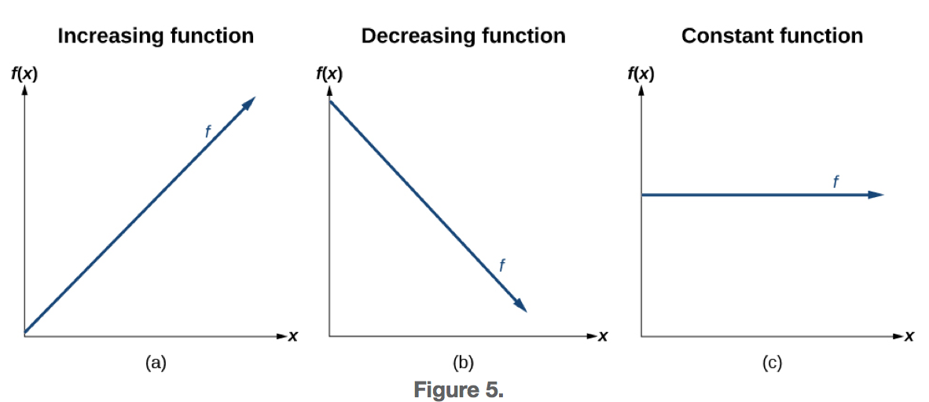
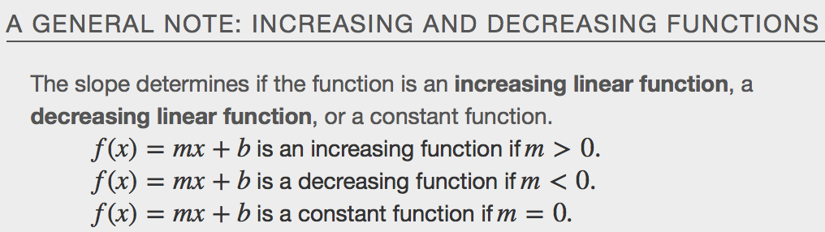
Example
Some recent studies suggest that a teenager sends an average of 60 tests per day. For each of the following scenarios find the linear function that describes the relationship between the input and the output value. Then determine whether the graph of the function is increasing, decreasing, or constant.
- The total number of texts a teen sends is considered a function of time in days. The input is the number of days, and the output is the total number of texts.
- A teen has a limit of 500 texts per month on his/her data plan. The input is the number of days, and output is the total number of texts remaining that month.
- A teem has an unlimited number of texts in his or her data plan for a cost of $50 per month. The input is the number of days, and the output is the total cost of texting each month.
Interpreting Slope as a Rate of Change
In the examples we have seen so far, the slope was provided to us. However, we often need to calculate the slope given input and output values. Recall that given two values for the input,x1andx2,and two corresponding values for the output,y1andy2—which can be represented by a set of points,(x1, y1)and(x2, y2)—we can calculate the slope m.
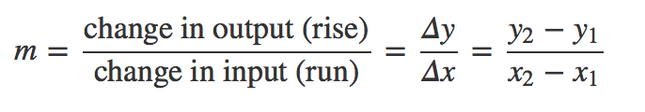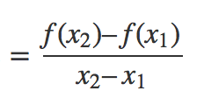
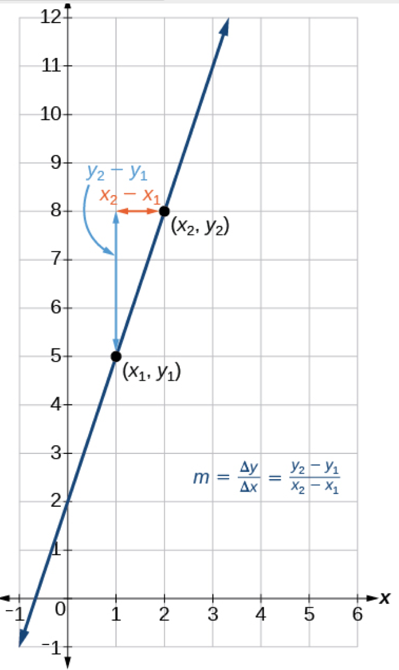

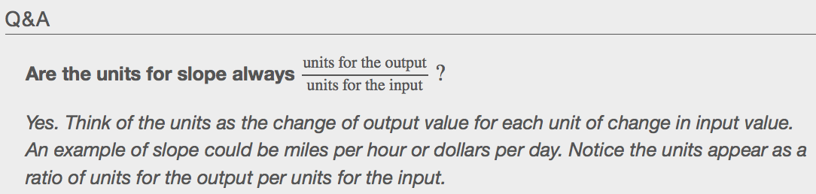

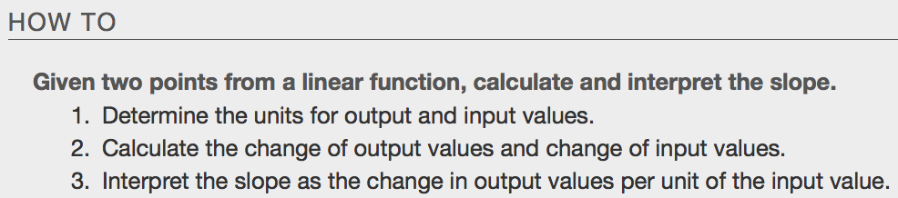

Example

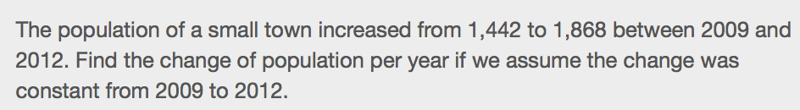

Writing and Interpreting an Equation for a Linear Function
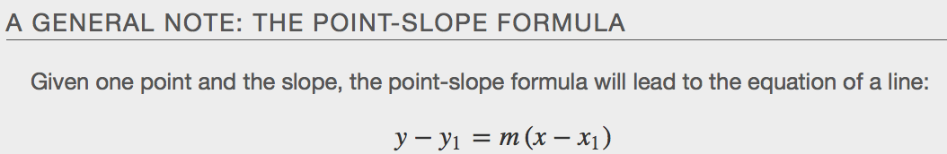

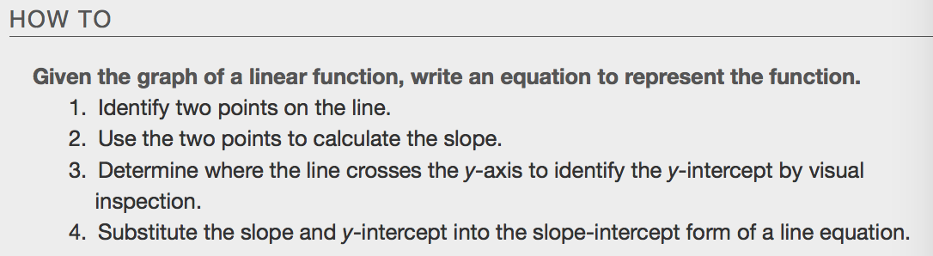Example
- Write the point-slope and slope-intercept form of the equation for the graphed line.
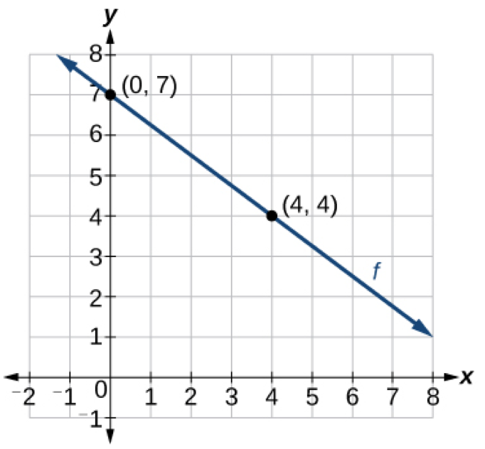

- 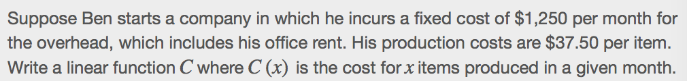

Modeling Real-World Problems with Linear Functions
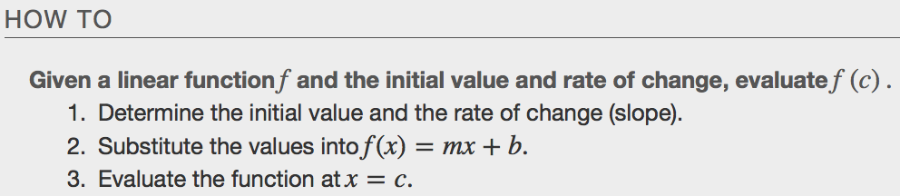
Examples

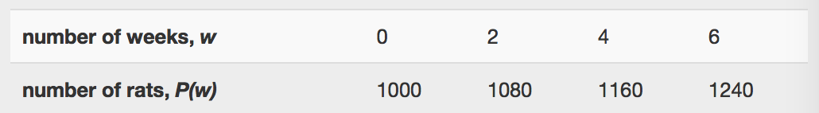

- 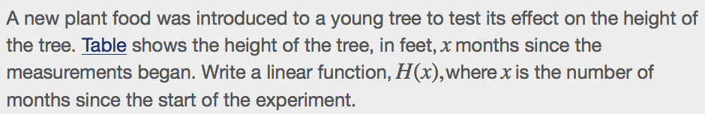
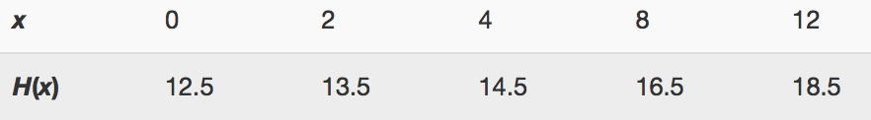

Graphing Linear Functions

Graphing a Function By Plotting Points
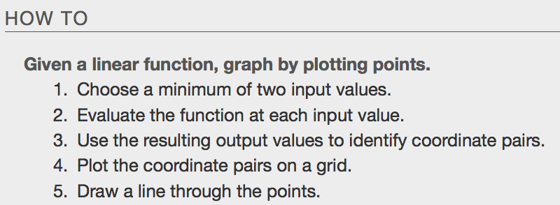
Example
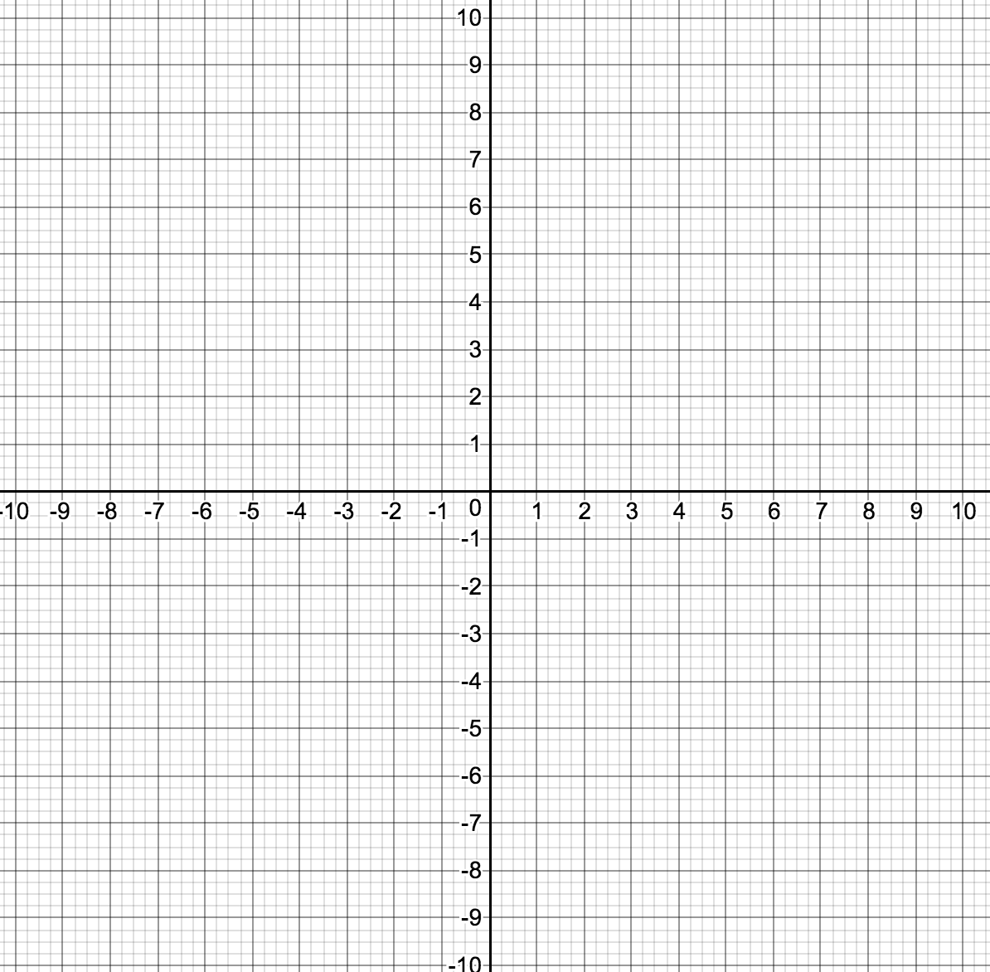

Graphing a Linear Function Using y-intercept and Slope
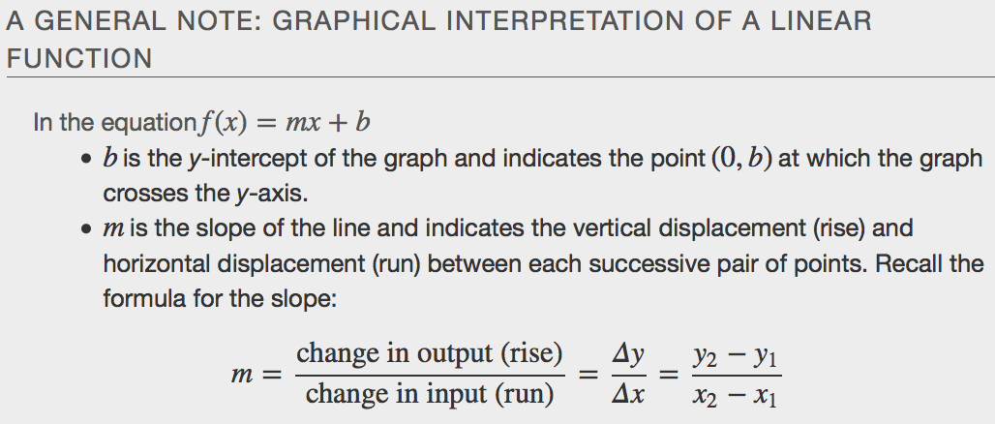
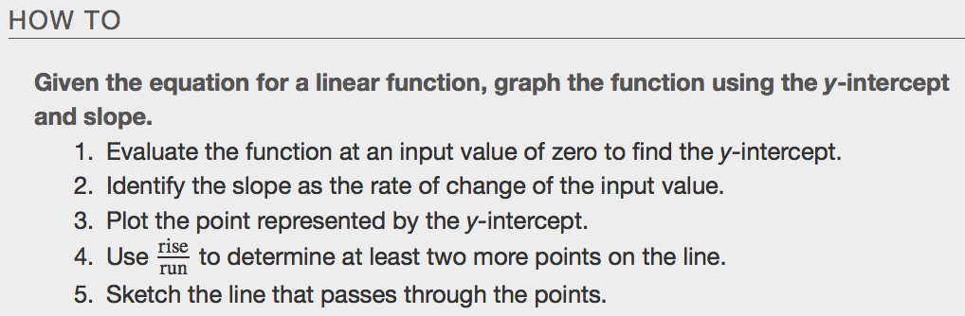
Example

Graphing a Function Using Transformations

Vertical Stretch or Compressions Vertical Shift
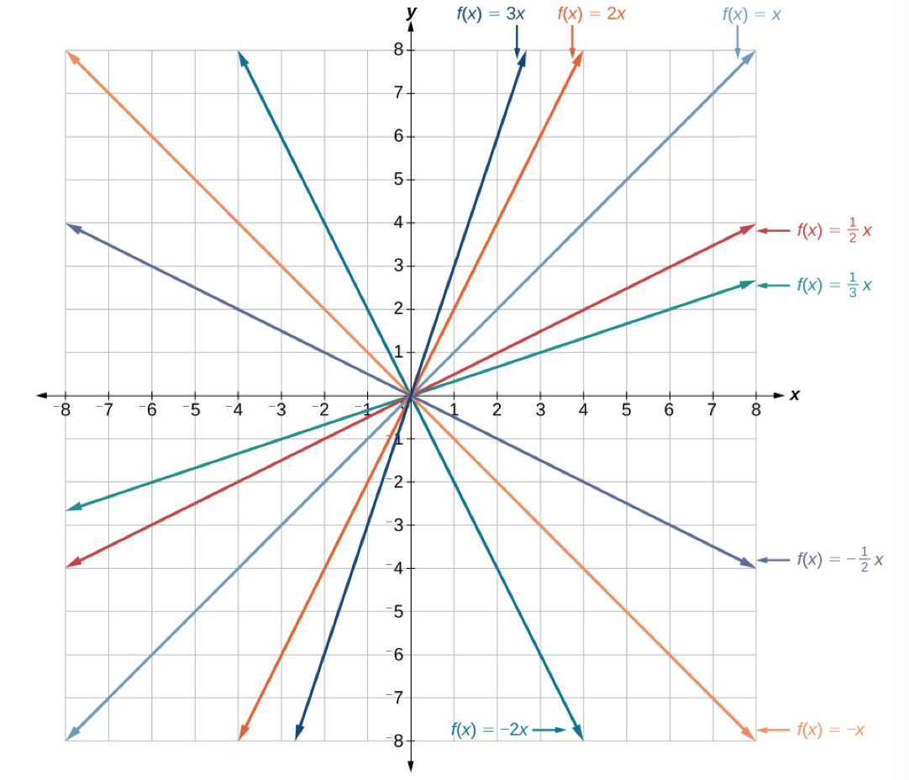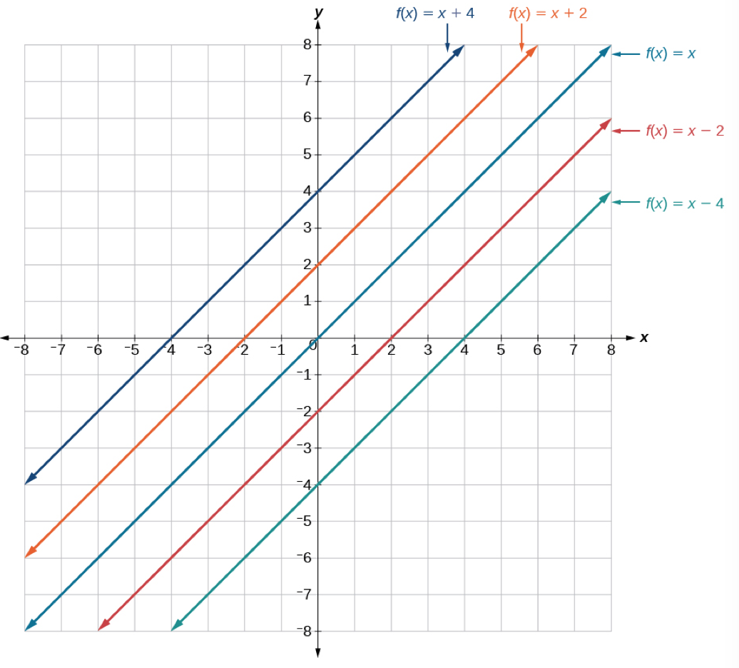
Example

Writing the Equation for a Function from the Graph of a Line
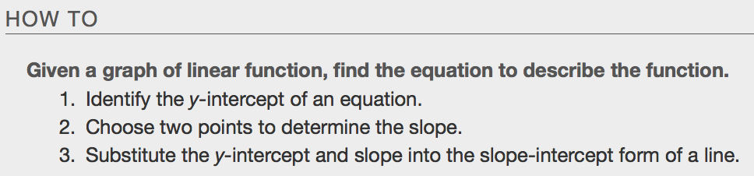

Example
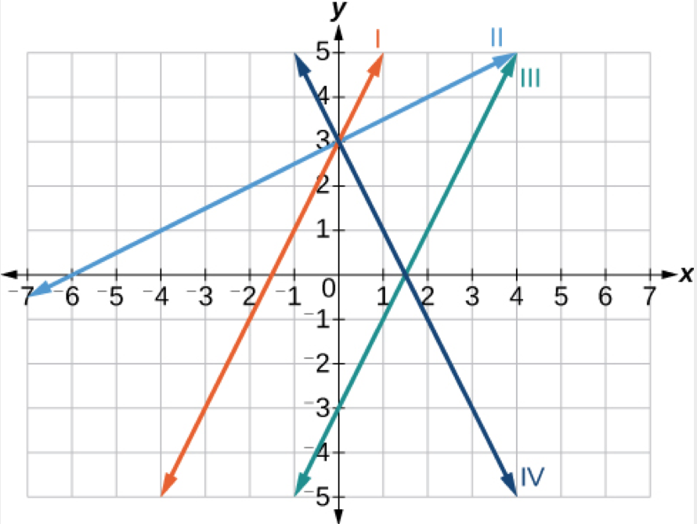
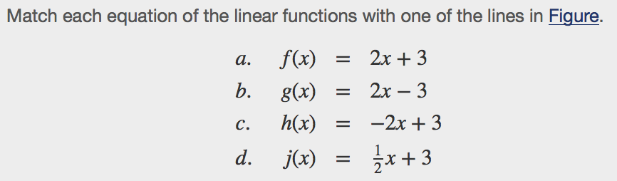

Finding the x-intercept of a Line

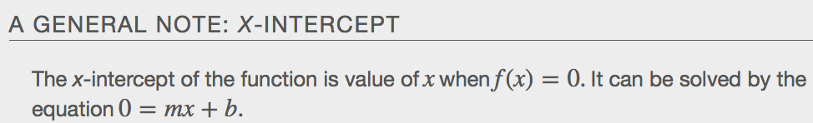

Example

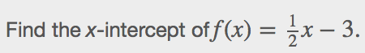

Describing Horizontal and Vertical Lines
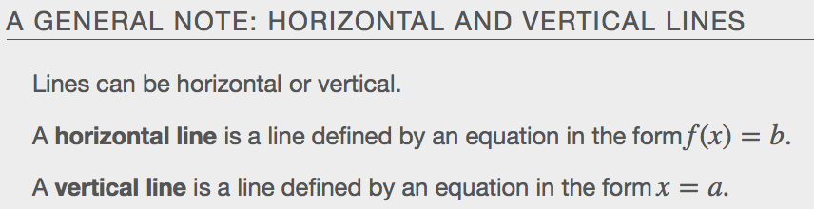

There are two special cases of lines on a graph—horizontal and vertical lines. A ________________________________line indicates a constant output, or y-value. A ____________________ line indicates a constant input, or x-value.
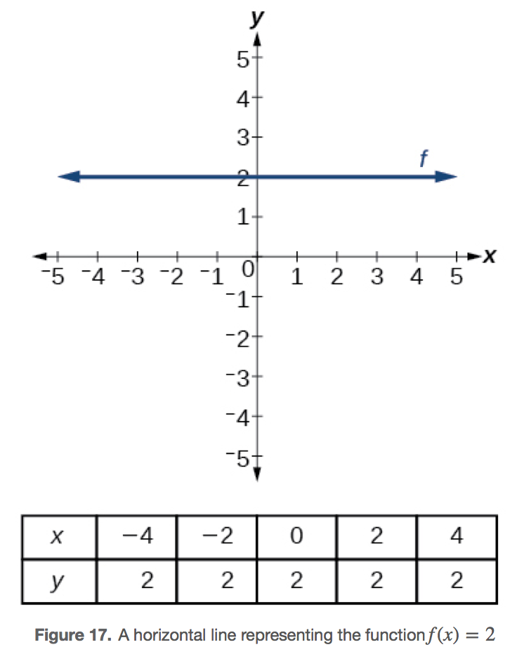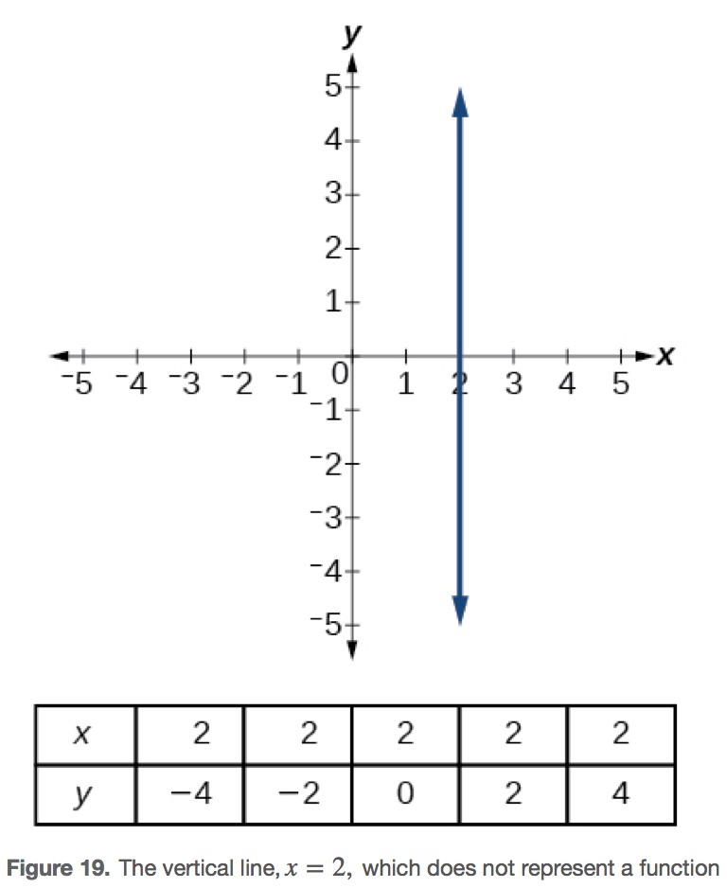

Example
Write the equation of each of the following lines.
- b.
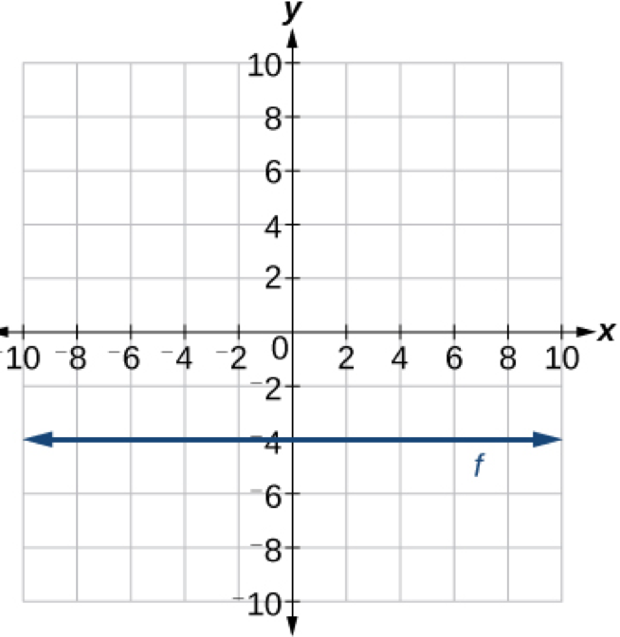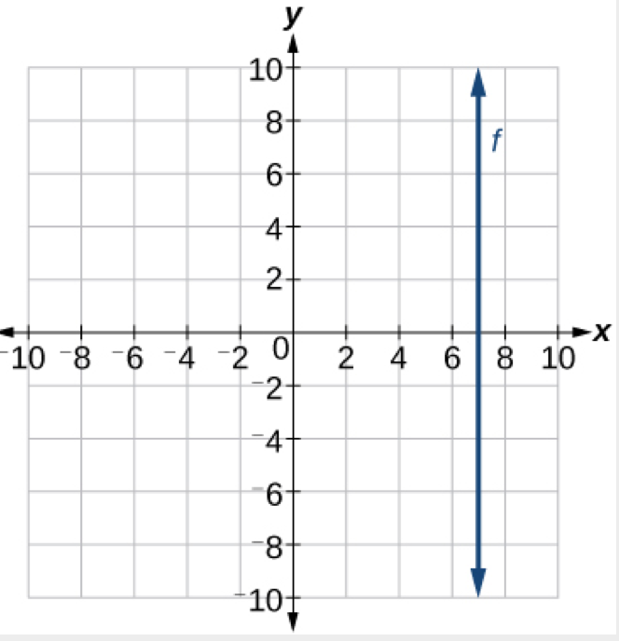

Determining Whether Lines are Parallel or Perpendicular
____________________________ lines do not have the same slope. The slopes of perpendicular lines are different from one another in a specific way. The slope of one line is the negative reciprocal of the slope of the other line. The product of a number and its reciprocal is1.So, if m1 and m2 are negative reciprocals of one another, they can be multiplied together to yield–1.
m1m2=−1
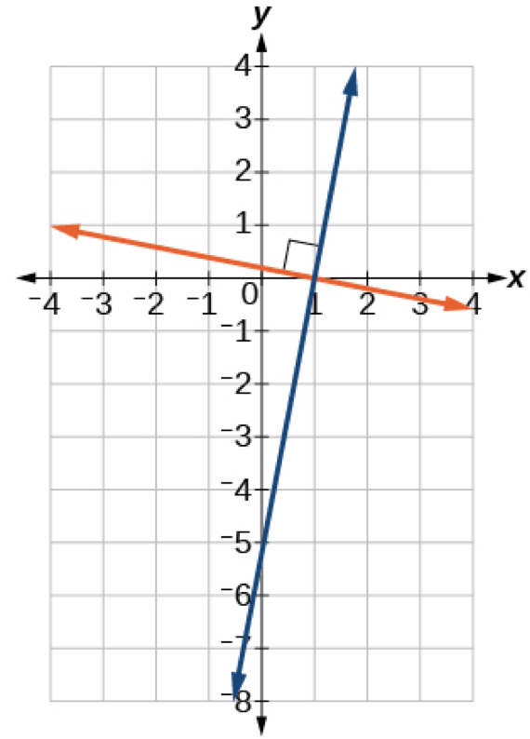
If two lines are _____________________ lines, they will never intersect. They have exactly the same steepness, which means their slopes are identical. The only difference between the two lines is the y-intercept. If we shifted one line vertically toward the other, they would become coincident.
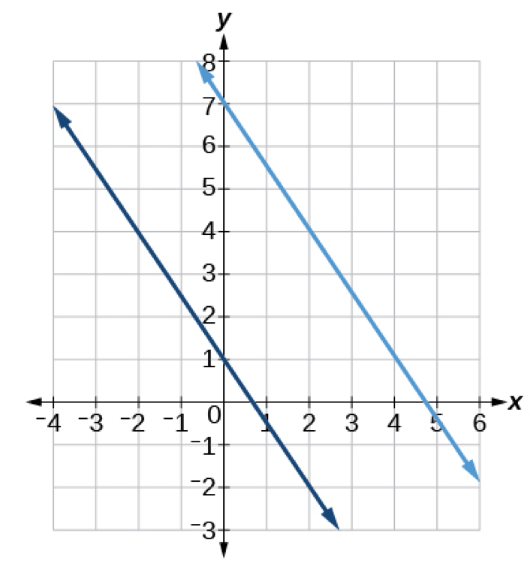
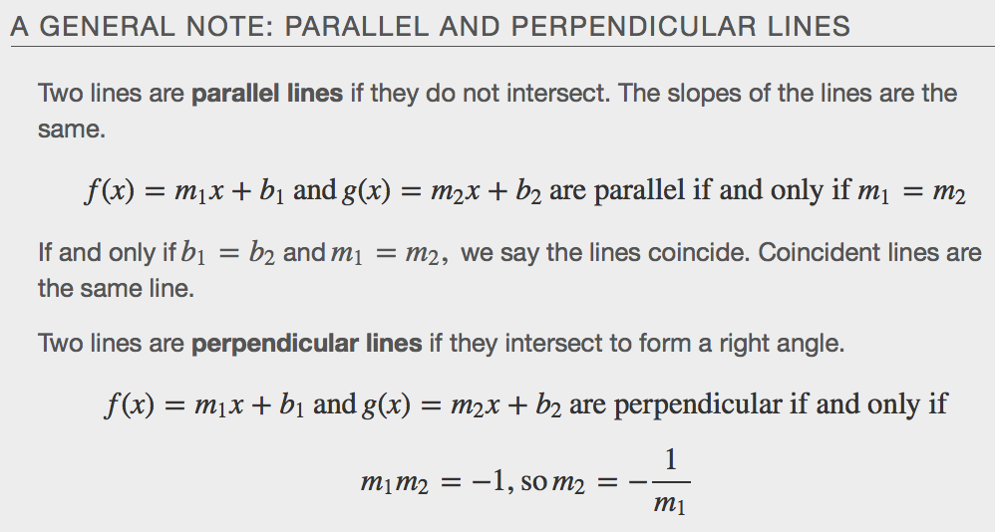

Example

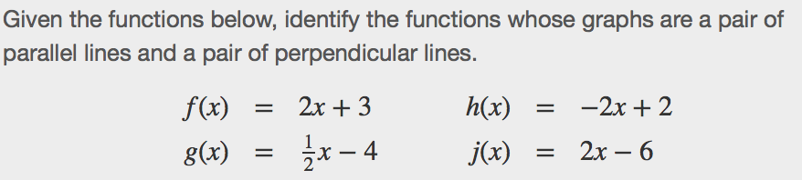

Writing the Equation of Parallel and Perpendicular Lines
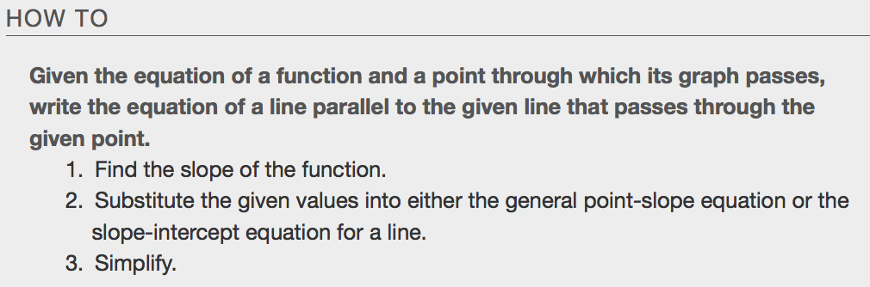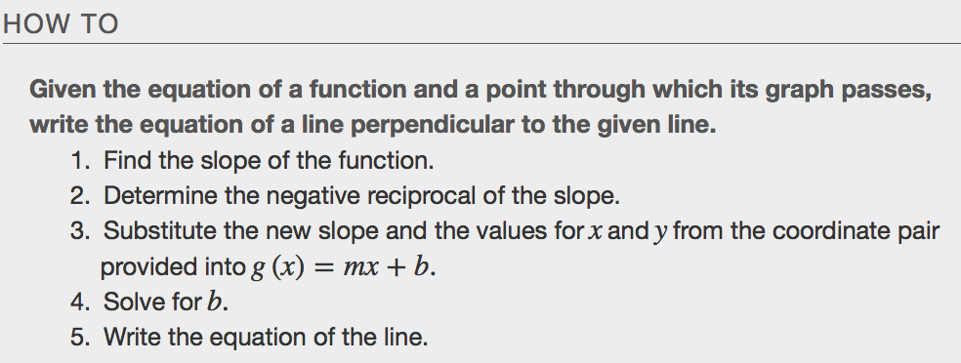

Example
