3.2 – Domain and Range

In creating various functions using the data, we can identify different independent and dependent variables, and we can analyze the data and the functions to determine the domain and range. In this section, we will investigate methods for determining the domain and range of functions such as these.
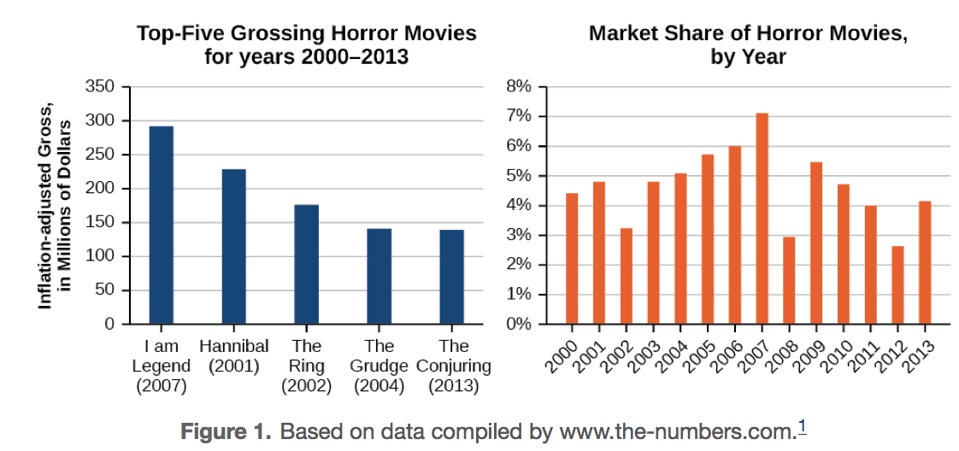
What do we need to consider when identifying domain and range?
- _________________ roots of ___________________________ numbers
- Division by _________________________
- Combination of both.

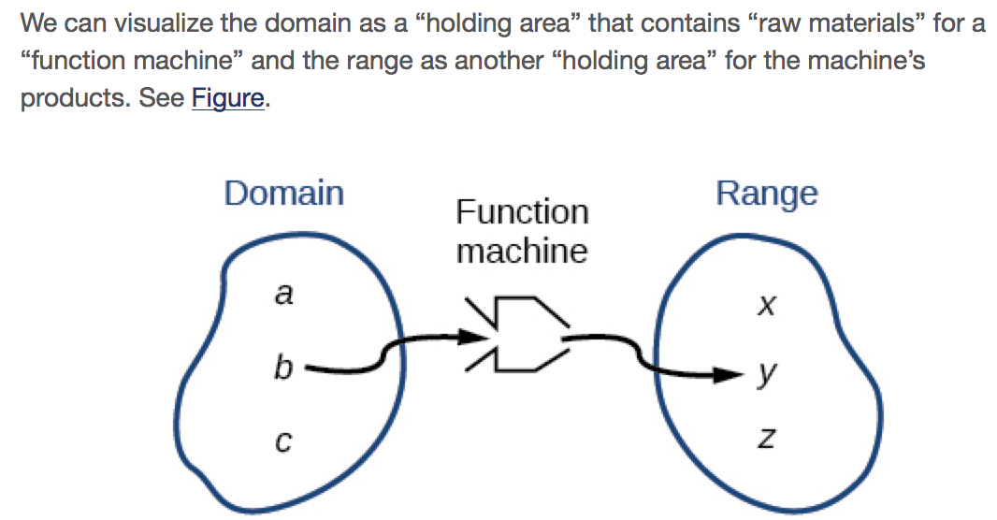

****We write domain and range as what IS possible, excluding values that are not. It is written in ______________________ notation. ***
Convention of Interval Notation
- The smallest number from the interval is written _____________________.
- The largest number in the interval is written second, following a _____________________.
- Parentheses, ( or ), are used to signify that an endpoint value is ________included, called ________________________________.
- Brackets, [ or ], are used to indicate that an endpoint value ______ included, called ____________________________.
- Infinity ________ and negative infinity __________ are NEVER included. (Always use ________________________________)

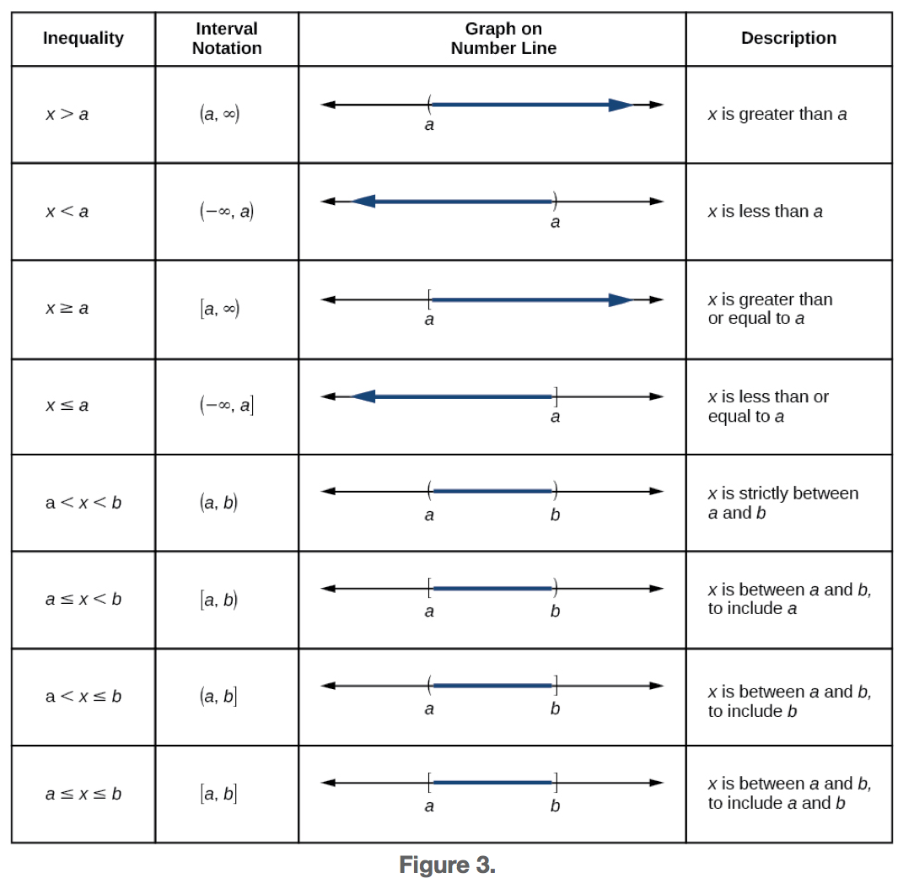
Example:
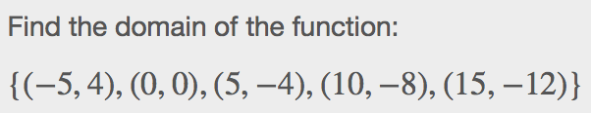
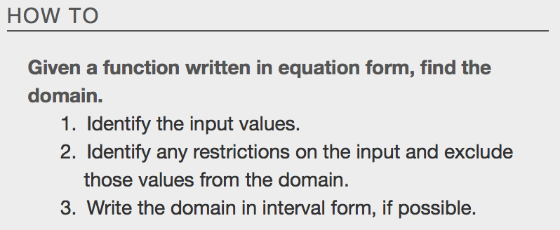
Examples:
- 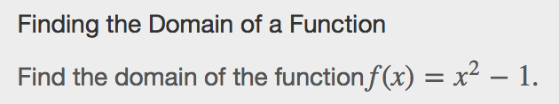 b. 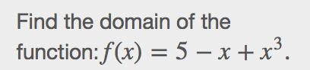

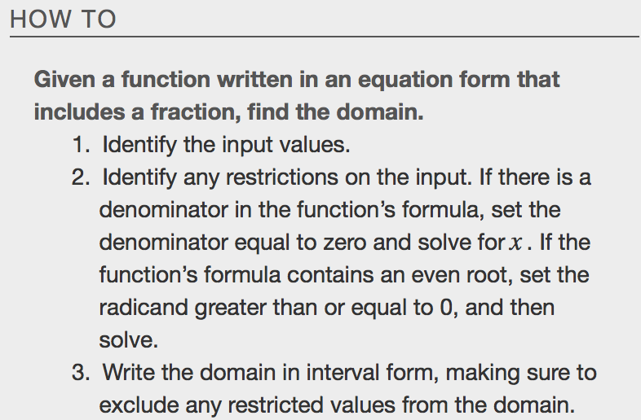
Example
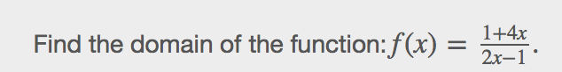

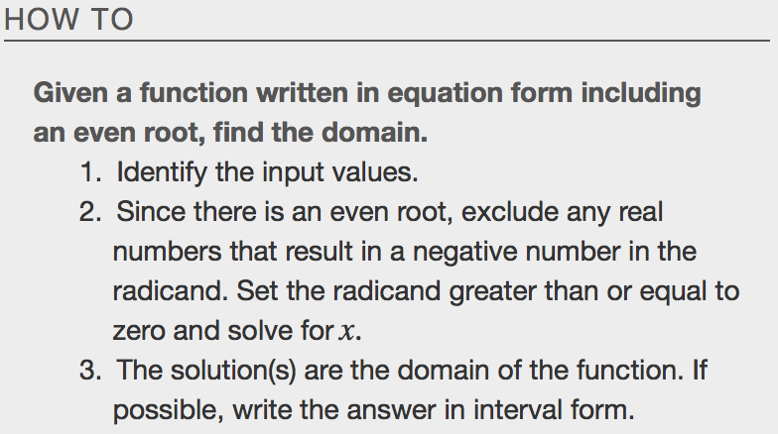
Example
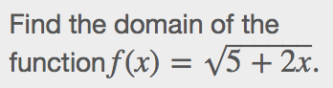

Other Notations for Domain and Range
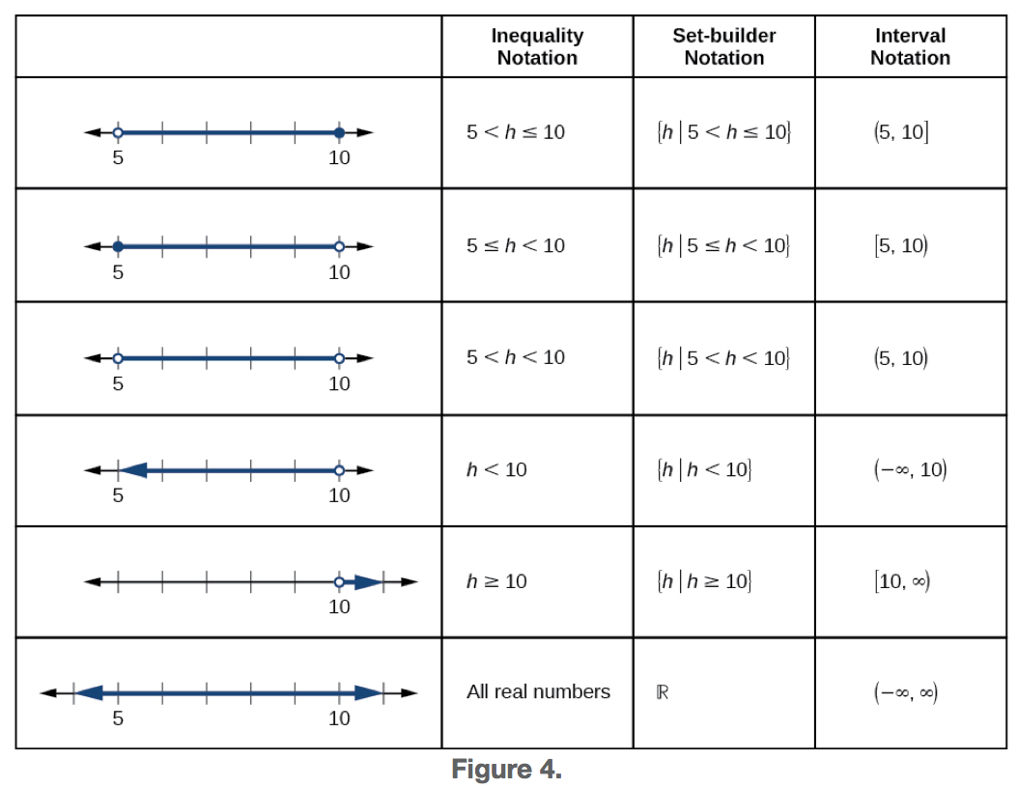
Example
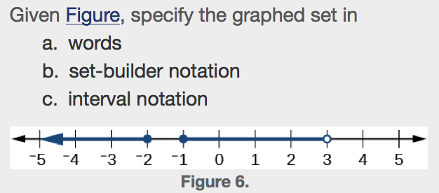

Identifying Domain and Range from a Graph
Another way to identify the domain and range of functions is by using graphs. Because the domain refers to the set of possible input values, the domain of a graph consists of all the input values shown on the x-axis. The range is the set of possible output values, which are shown on the y-axis. Keep in mind that if the graph continues beyond the portion of the graph we can see, the domain and range may be greater than the visible values. See Figure.
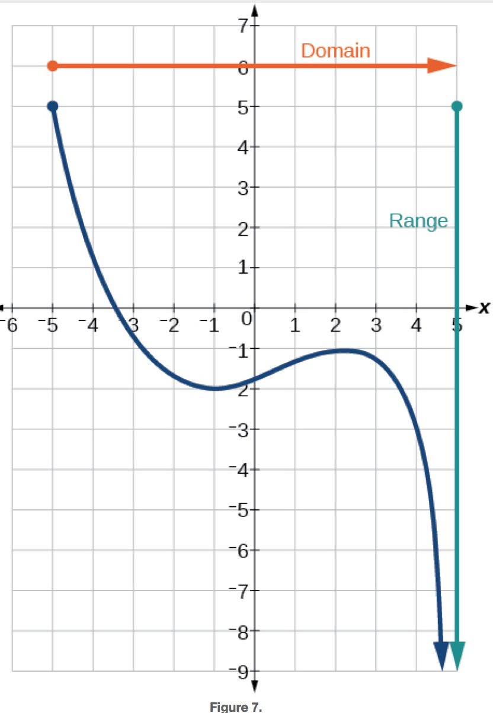
Examples – Find the Domain and Range
- 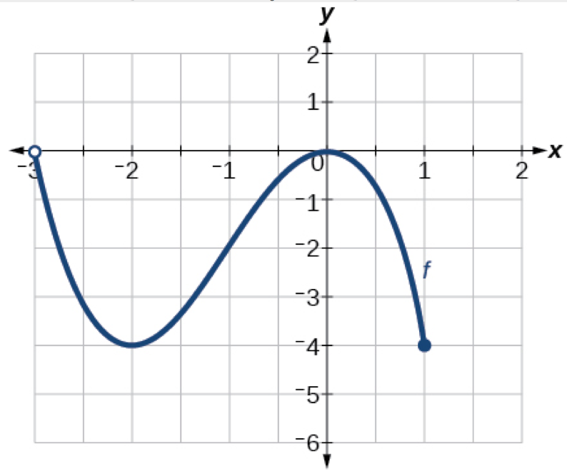b. 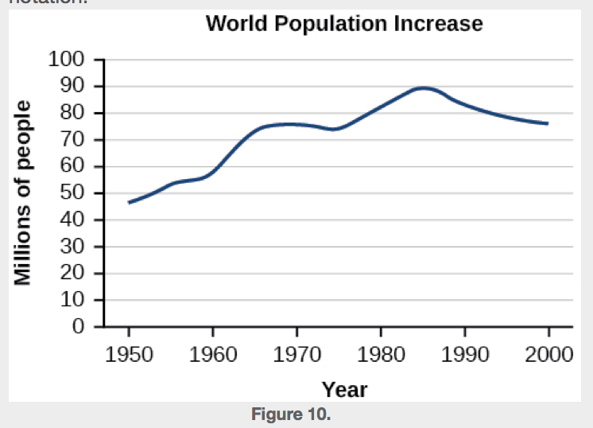

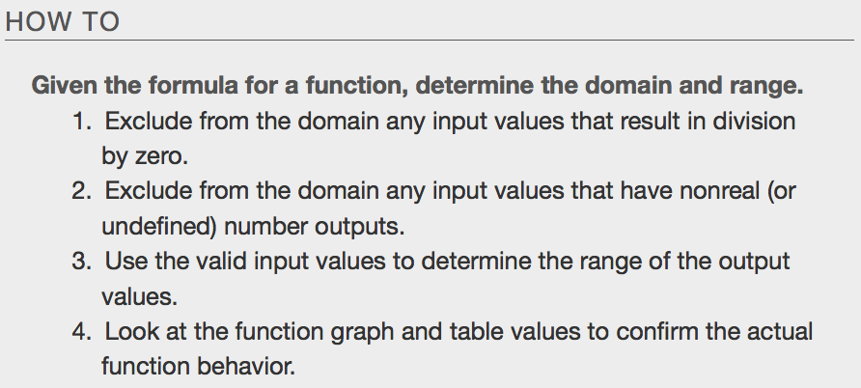
Examples – check them out visually at www.desmos.com
- b. 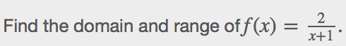

c.

Piecewise Functions
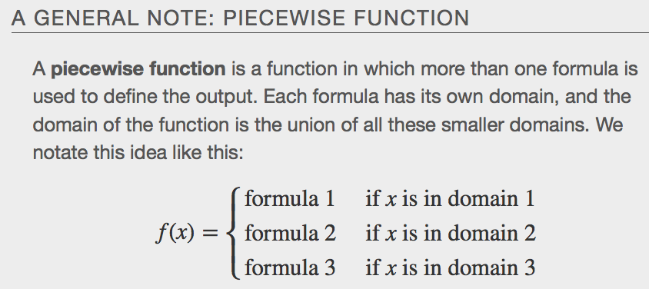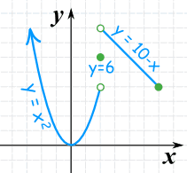

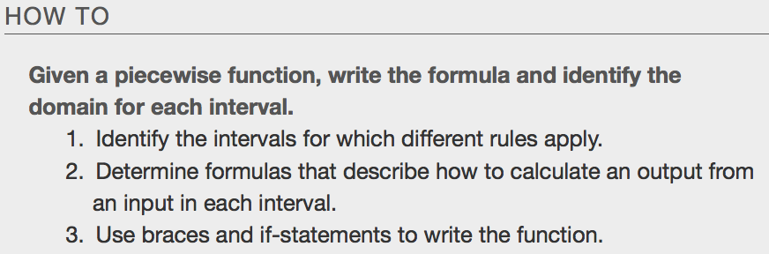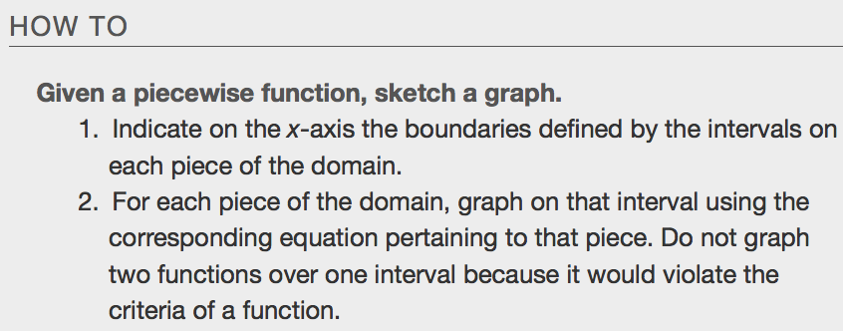

Example
- 