3.1 – Functions and Function Notation
A ________________________________ is a set of ordered pairs. The set consisting of the first components of each ordered pair is called the _____________________, and is also known as the ____________ or _____________________________________ variables. The set consisting of the second components of each ordered pair is called the ________________ and is also known as the ________________ or ______________________________ variables.
Consider the following set of ordered pairs. The first numbers in each pair are the first five natural numbers. The second number in each pair is twice that of the first.
{(1,2),(2,4),(3,6),(4,8),(5,10)}
Domain/Input/Independent:
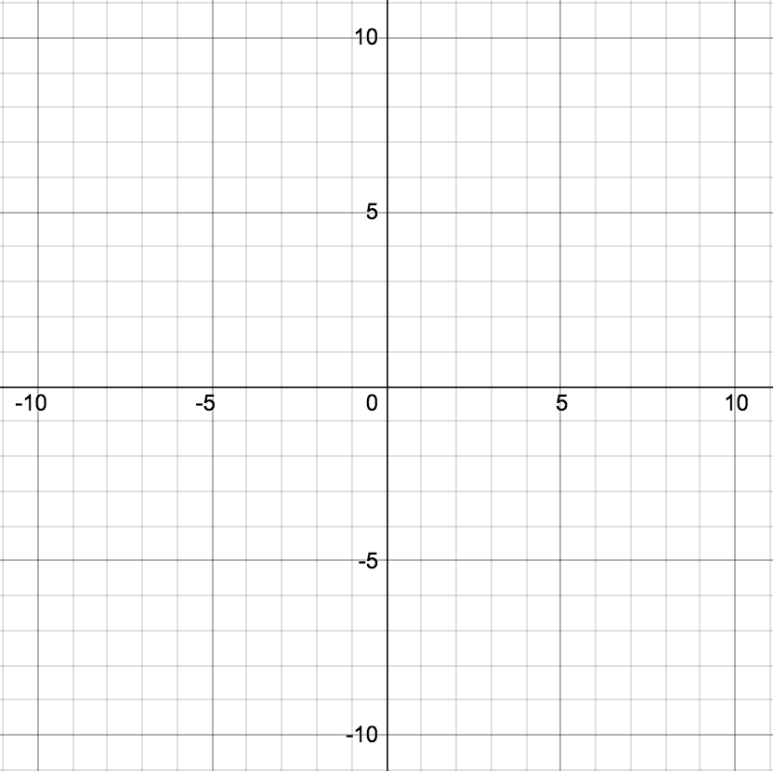
Range/Output/Dependent:

x | y

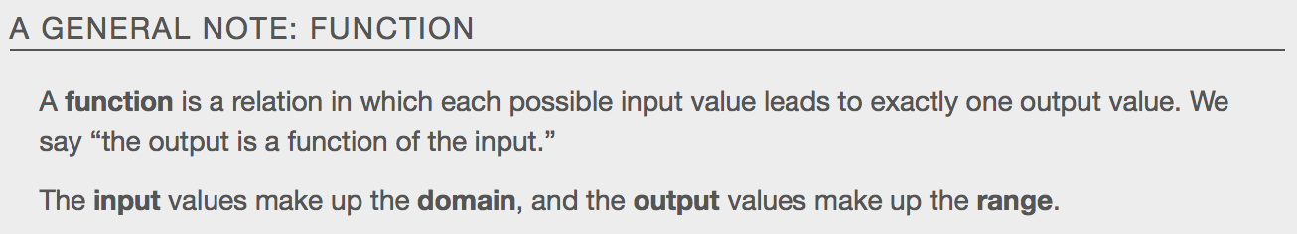
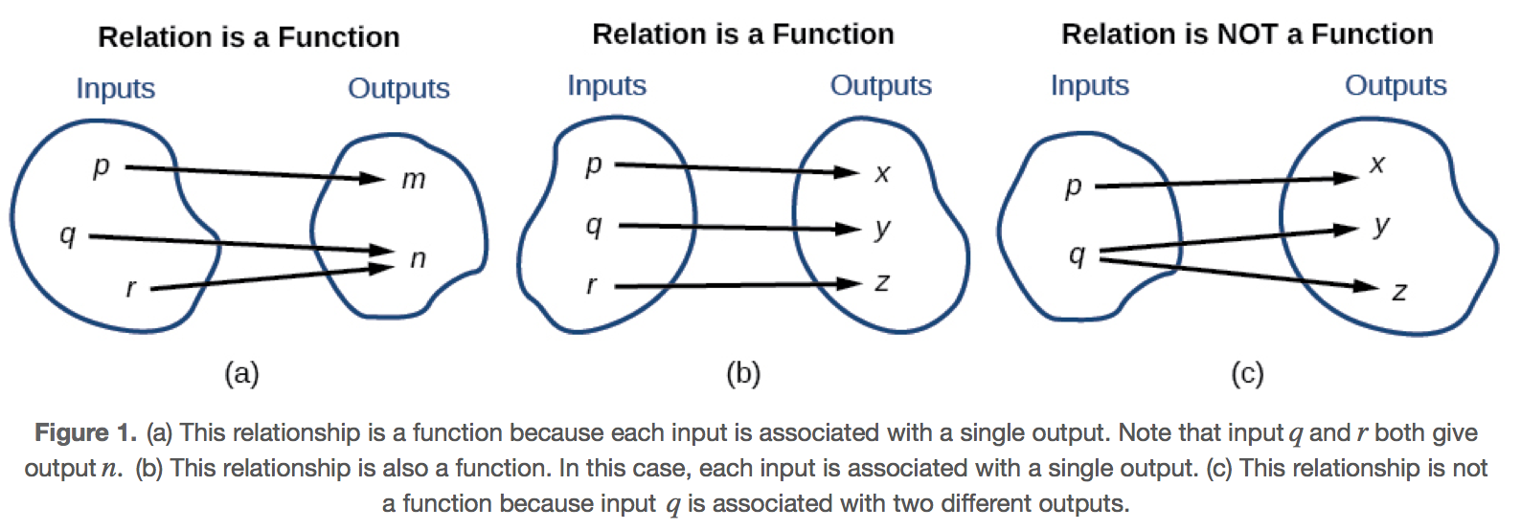
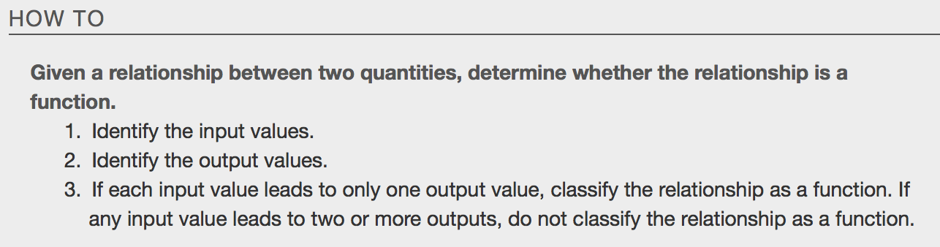

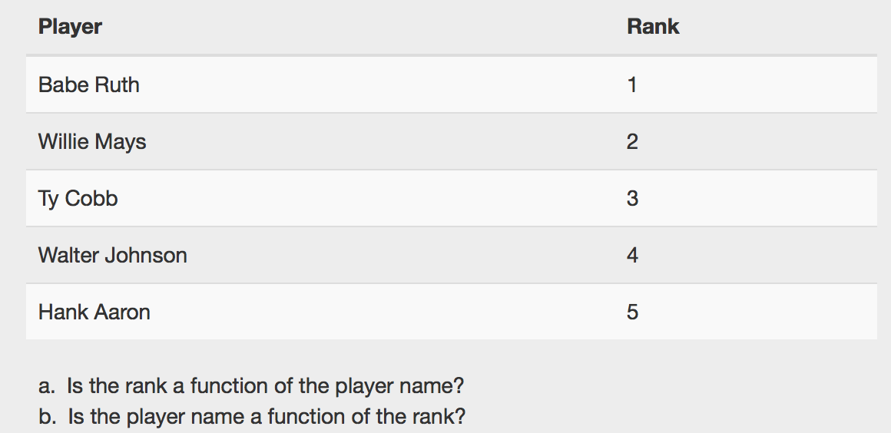

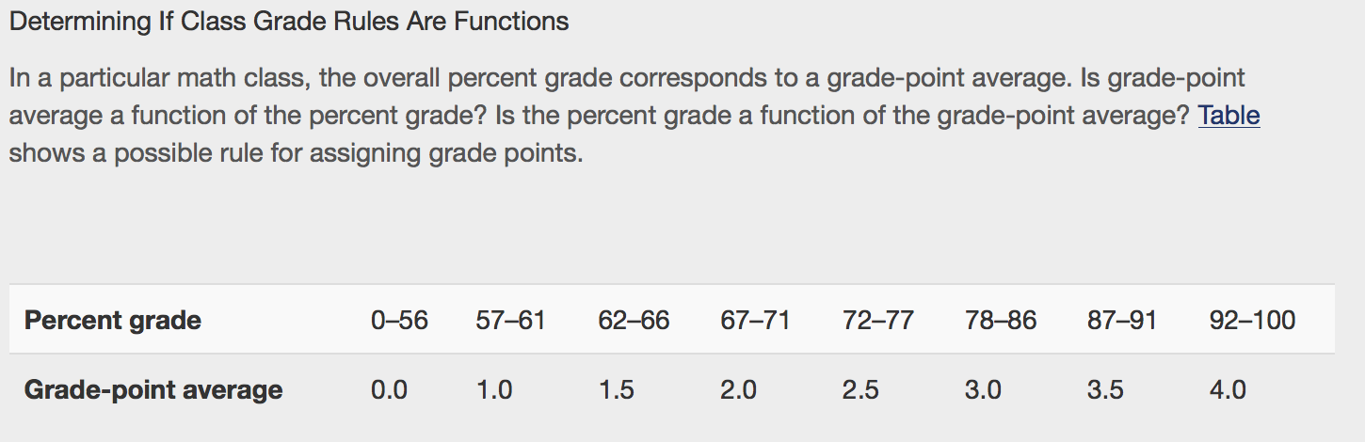

Using Function Notation
Once we determine that a relationship is a function, we need to display and define the functional relationships so that we can understand and use them, and sometimes also so that we can program them into graphing calculators and computers. There are various ways of representing functions. A standard __________________ _____________________ is one representation that facilitates working with functions.
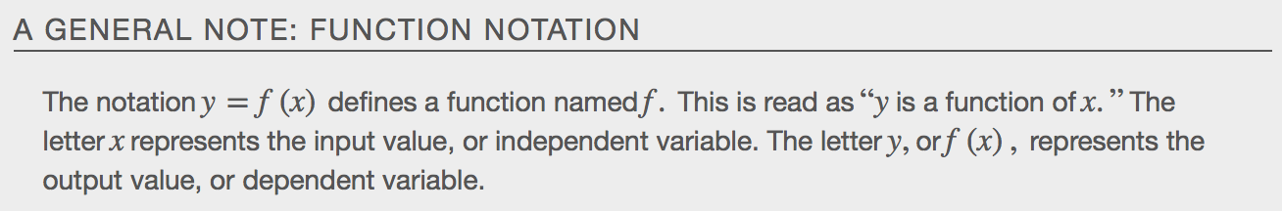
We can use any letter to name the function; the notation h(a)shows us that h depends on a. The value a must be put into the function h to get a result. The parentheses indicate that age is input into the function; they do not indicate multiplication.

We can also give an algebraic expression as the input to a function.
For example f(a+b) means “first add a and b, and the result is the input for the function f.” The operations must be performed in this order to obtain the correct result.

Example

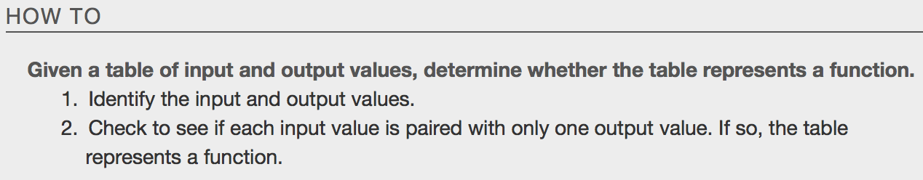
Do the following tables represent functions?
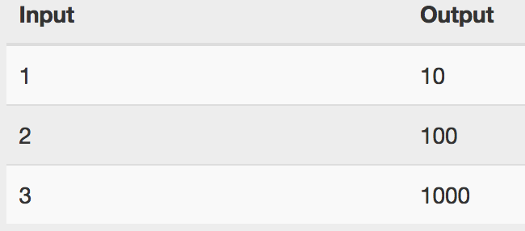

Finding Input and Output Values for Functions
When we know an input value and want to determine the corresponding output value for a function, we ________________________________ the function. Evaluating will always produce one result because each input value of a function corresponds to exactly one output value.
When we know an output value and want to determine the input values that would produce that output value, we set the output equal to the function’s formula and ____________________for the input. Solving can produce more than one solution because different input values can produce the same output value.
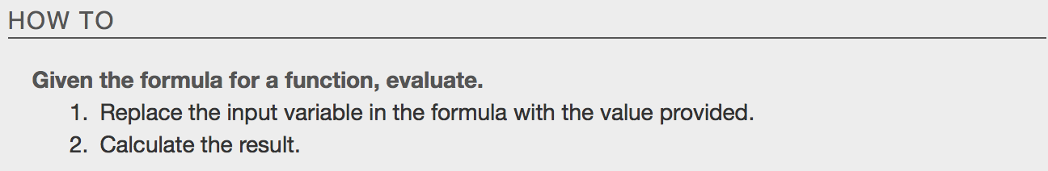
Examples:
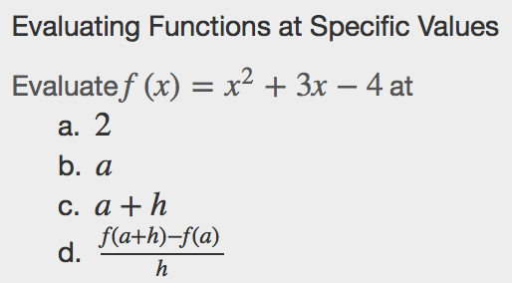

Evaluating Functions Expressed in Function Form
Some functions are defined by mathematical rules or procedures expressed in equation form. If it is possible to express the function output with a formula involving the input quantity, then we can define a function in algebraic form.
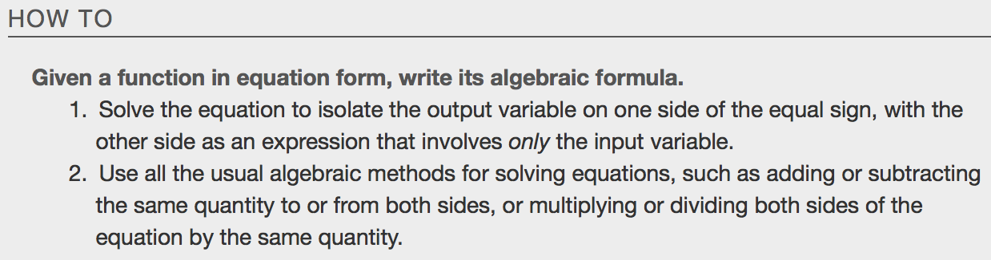

Examples

Evaluating a Function Given in Tabular Form
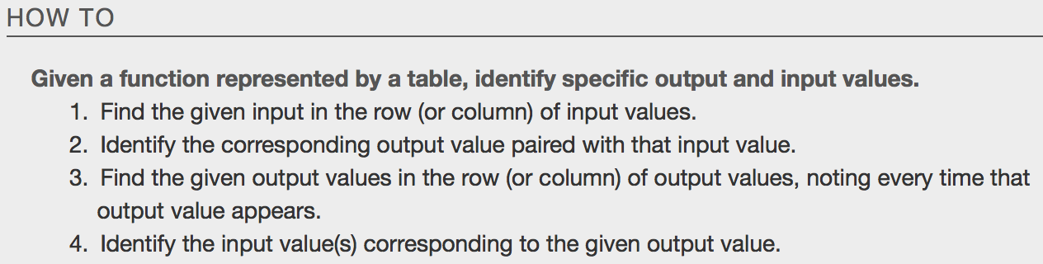
Examples
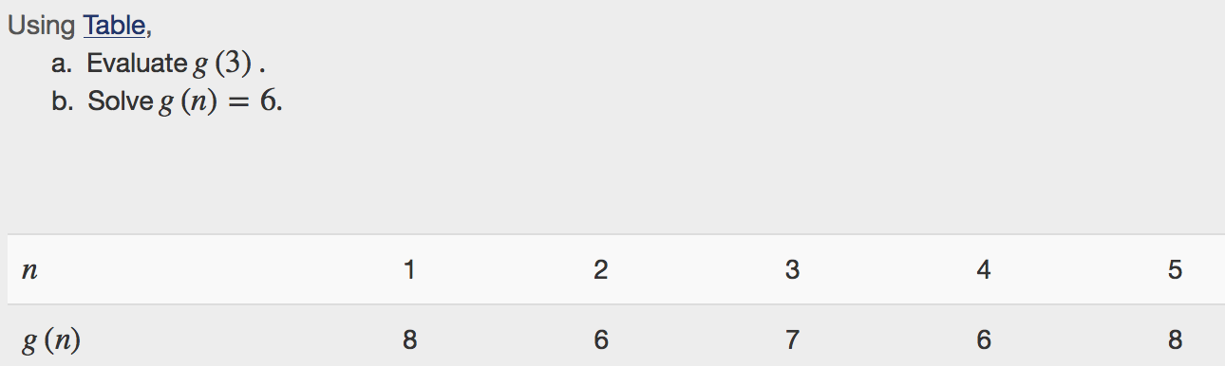

Finding Function Values from a Graph
Evaluating a function using a graph also requires finding the corresponding output value for a given input value, only in this case, we find the output value by looking at the graph. Solving a function equation using a graph requires finding all instances of the given output value on the graph and observing the corresponding input value(s)
Examples

- Find f(-1)
- Solve f(x) = 1
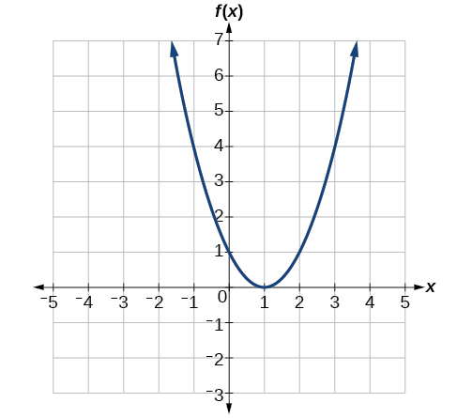
Determining Whether a Function is One-To-One
Some functions have a given output value that corresponds to two or more input values. However, some functions have only one input value for each output value, as well as having only one output for each input. We call these functions _______-____-_______ functions
Example
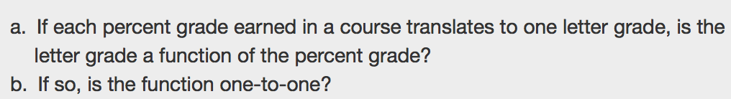

Using The Vertical Line Test
The ____________________ __________ ____________ can be used to determine whether a graph represents a function. If we can draw any vertical line that intersects a graph more than once, then the graph does not define a function because a function has only one output value for each input value. If the function sends any input to more than one output, the resulting graph will have points that stack on top of each other, resulting in a failure of the vertical line test for a function.
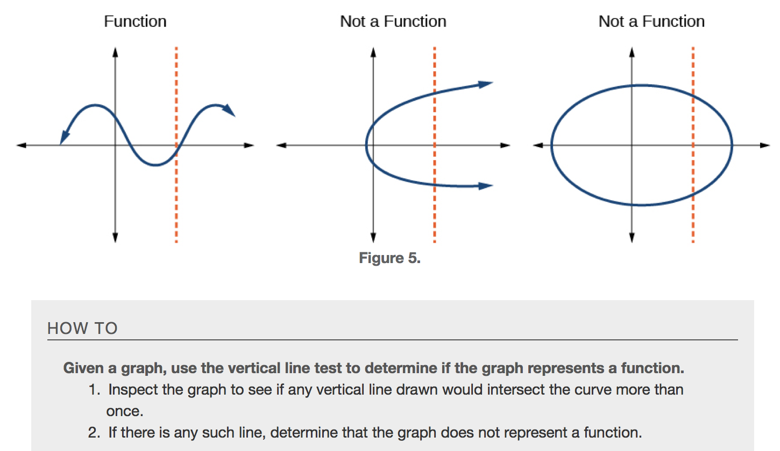
Example:
- Does the graph represent a function?
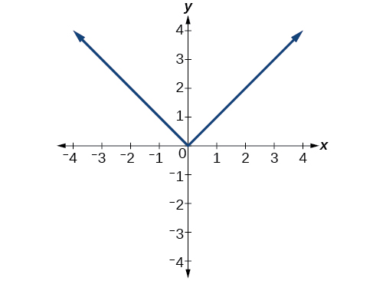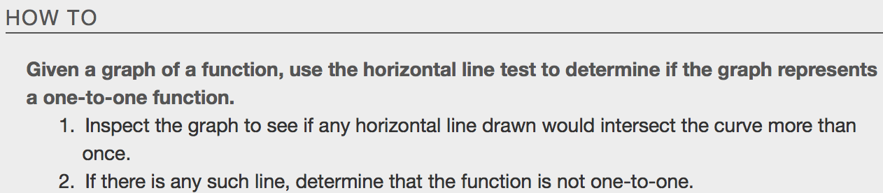

- Is the function one-to-one?

Identifying Basic Toolkit Functions (Parent Functions)
