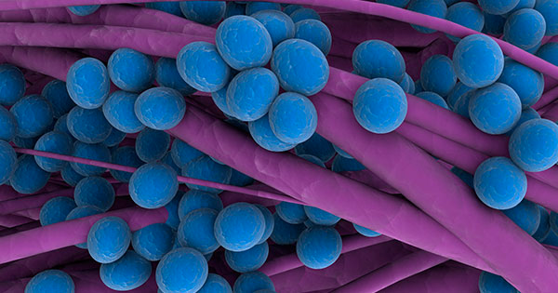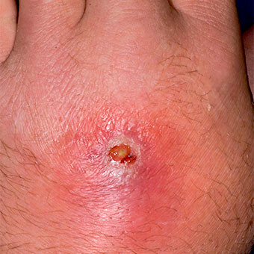

**MRSA**

Methifillin-resistant Staphylococcus aereus

## 

## **PREVENTION**

### 3 ways to ensure your protection from MRSA

1. Wearing a N94 mask for protection from yourself or others in a public setting
2. Frequently wash your hands with warm, soapy water to reduce germs and risks of MRSA
3. Wearing disposable gloves in public to reduce your risk of infection

INFORMATION BY JUSTIN ADAMS & MADISON MCPHEE

* **Symptoms of MRSA depend on where you are infected.**
* **Most symptoms it causes mild infections on the skin, like sores or boils.**
* **More serious symptoms can cause serious skin infections or infect surgical wounds, the bloodstream, the lungs, r urinary tract.**
* **For more information go to website below.**

## **Symptoms**

Medicine.net.com/mrsa

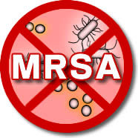

# MRSA

* MRSA infections are common among people who have weak immune systems and are in hospitals, nursing homes, and other health care centers.
* Infections can appear around surgical wounds or invasive devices, like catheters or implanted feeding tubes.

MRSA (Methicillin-resistant Staphylococcus aureus)

* **It is a specific "**[**staph**](http://www.medicinenet.com/staph_infection/article.htm)**" bacteria (a type of germ) that is often resistant to (is not killed by) several types of antibiotic treatments. Most S. aureus is methicillin-susceptible (killed by methicillin and most other common treatments).**
* **About one out of every three people (33%) are estimated to carry staph in their nose, usually without any illness. About two in 100 (2%) carry MRSA.**
* **Though most MRSA infections aren't serious, some can be life-threatening. Many public health experts are alarmed by the spread of tough strains of MRSA. Because it's hard to treat, MRSA is sometimes called a "super bug."**