Who are we?
Directions :
- Log into Google (type Google sign in into the Google search bar).
- Click the blue “sign in” button in the upper left corner.
- Click on this icon in the upper right corner to open Google Drive.
- Open your writing 1 folder by double clicking.
- Open a new document. (click the red button that says new, choose Google Docs from the menu) REMEMBER it should ask you about sharing the doc, click ok.
- Title the document your name. (don’t forget to click the upper left hand corner of Google Docs where it says UNTITLED DOCUMENT)
- Type the answers to the questions. Be sure they are in complete sentences. They will make a paragraph.
- Insert your picture into the document. (Use the one you take today from photo booth).

PHOTO BOOTH DIRECTIONS:
Photo Booth is a program that lets the computer take your picture. It is very easy to use. Here are the directions.

- Go to top right corner of the computer and click on the magnifying glass.

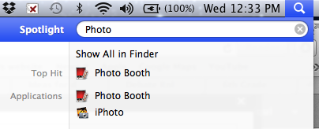
- It should open up a search box. Type Photo Booth and it should come up under your search. Click Photo Booth.

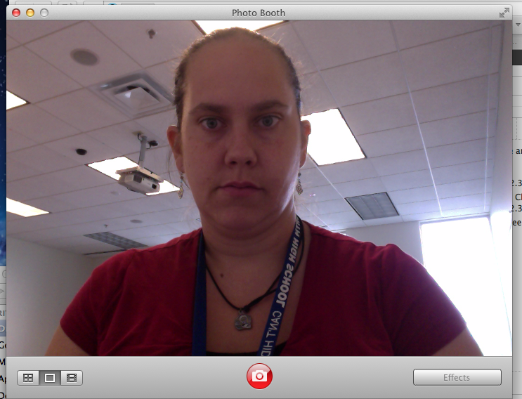
- It should open a window that looks like this and you should see yourself on the computer screen.

- Look at the camera (dot on the top of the computer moniter/screen Click the red shutter button in the middle at the bottom. Photo booth will count down from 3 and take your picture.

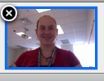
- After you have taken your photo it will show up in the bottom right hand corner of photo booth. Click on the picture and don’t let go. We want to drag the picture to the desktop (onto the background behind the window).

NOW we will do two things with this picture!!!
  - Copy and paste it into your document.
  - Insert your picture in schoology.

**NOTE: If you do not want your picture in your document or schoology, that is ok. Go through the steps even if you do not want to add your picture**
DIRECTIONS FOR INSERTING PICTURE:
- Make sure your Google document is open and you can see your picture on the desktop. 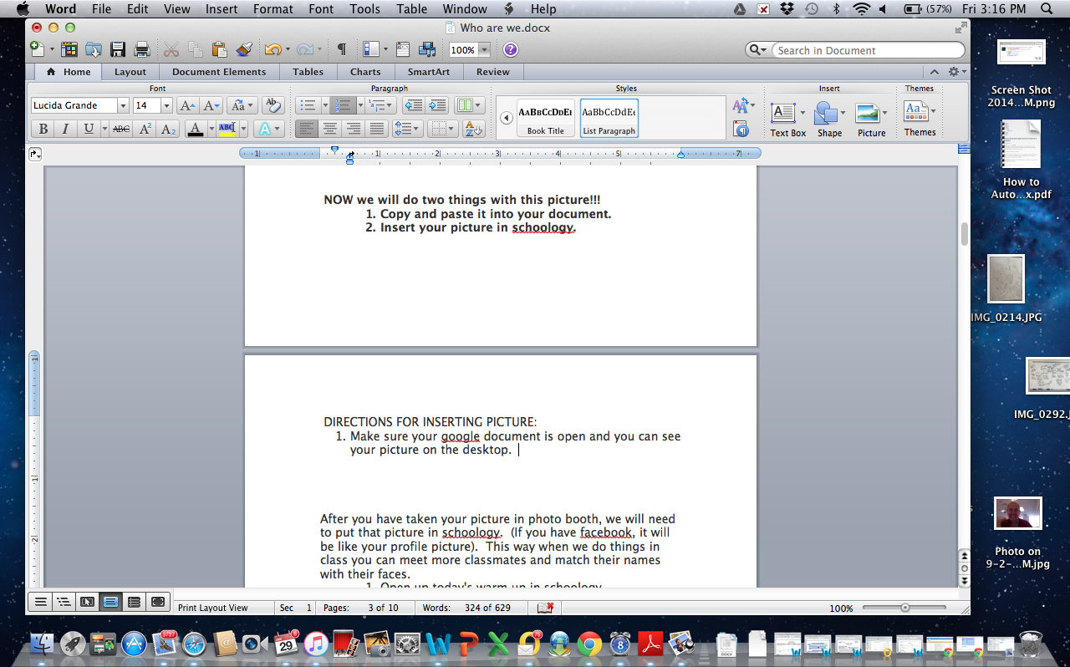

- Next click on your picture (and don’t let go) and drag it into your Google doc. Once the picture is over the document, let go (unclick). Your picture should now be in the document. 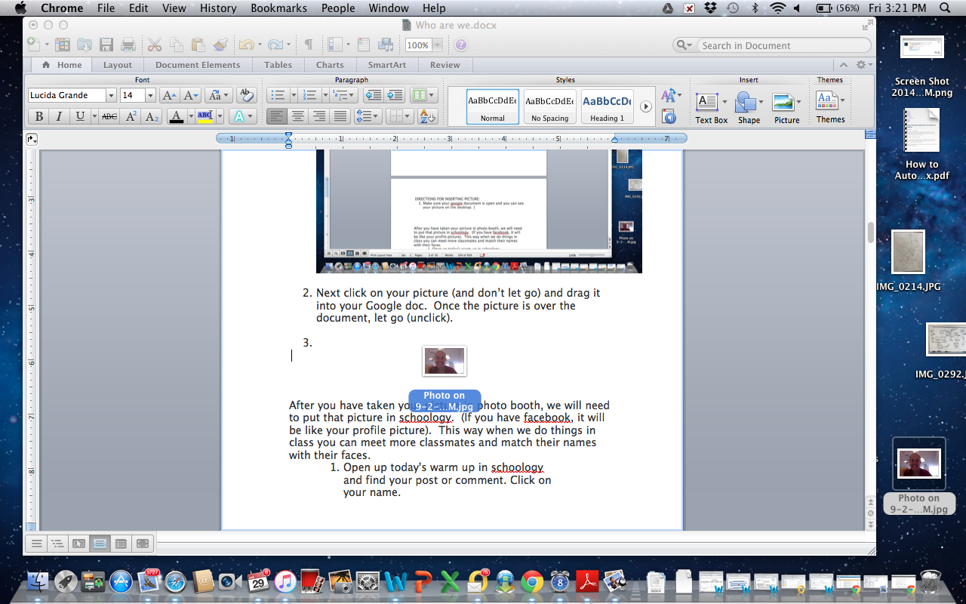

- IF THIS DOESN’T WORK. See if a neighbor can help. If you, your neighbor and your teacher cannot figure it out, leave it and I can help when I return.

DIRECTIONS FOR INSERTING PICTURE IN SCHOOLOGY:
After you have taken your picture in photo booth, we will need to put that picture in schoology. (If you have Facebook, it will be like your profile picture). This way when we do things in class you can meet more classmates and match their names with their faces.

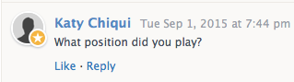
- Open up today's warm up in schoology and find your post or comment. Click on your name.

- You should see your profile screen. It looks like this.
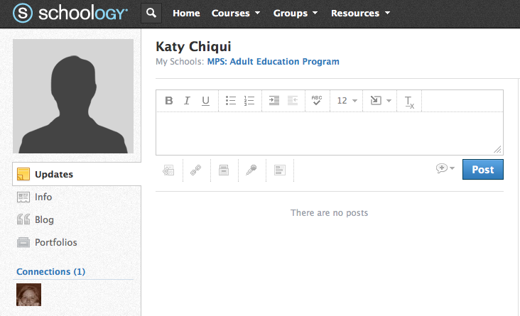

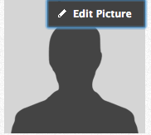

3. Click on the profile image where is says edit picture to edit or add the picture we took.
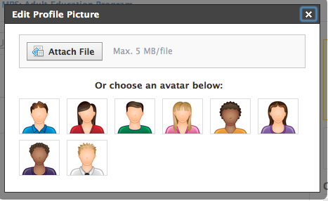
4. The Edit Profile Picture Window should open up. Click Attach File. (or if you don’t want your picture, choose one of the ones provided below)

5. Now we need to locate our photo. Look for your picture in the folder desktop and click on it. Watch me first. If you are still having trouble. Raise your hand. (remember to help your neighbor if you understand).

6. If you did it right you should see your picture show up on the screen like this.

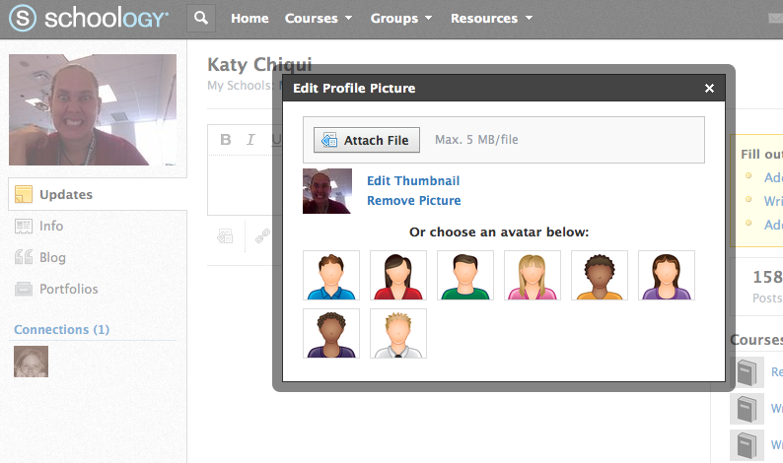
GREAT JOB! YOU ARE DONE!

Name: __________________________ Partner’s name:_____________________________

Ask your partner the questions below and write down their answers in complete sentences. Read over the answers, do they make sense? Have the teacher check them when you are done. When you are both done, switch papers so you have your answers.

- What is your name?
________________________________________________________________________________________________________________________________________________

- What is the meaning of your name?
________________________________________________________________________
________________________________________________________________________
________________________________________________________________________________________________________________________________________________

- What country are you from?
________________________________________________________________________________________________________________________________________________

- How many languages do you speak? What are they?
________________________________________________________________________
________________________________________________________________________
________________________________________________________________________

- What is your favorite thing or activity to do?
________________________________________________________________________
________________________________________________________________________________________________________________________________________________
________________________________________________________________________

- Why are you here (in school) to learn English?
________________________________________________________________________
________________________________________________________________________________________________________________________________________________
________________________________________________________________________

- What is your dream job?
________________________________________________________________________
________________________________________________________________________________________________________________________________________________
________________________________________________________________________

- If you could live anywhere, where would you live? Why?
________________________________________________________________________
________________________________________________________________________________________________________________________________________________
________________________________________________________________________

