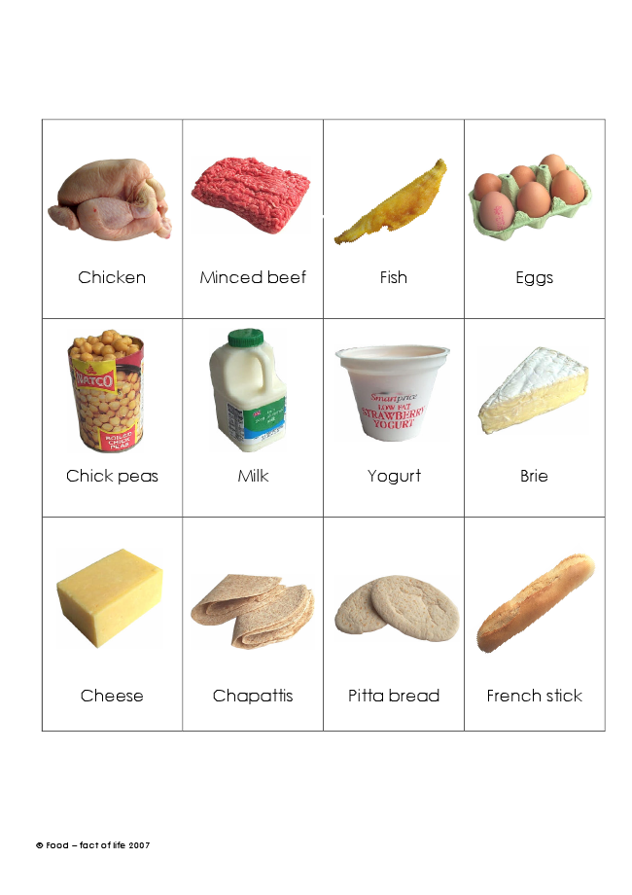
© Food – fact of life 2007
Chicken Minced beef Fish Eggs
Chick peas Milk Yogurt Brie
Cheese Chapattis Pitta bread French stick

