Algebra in Our World (Answer Key)
from the Law and Algebra: SVU (Special Visual Unit)
2015 COABE presentation
by Heidi Schuler
Heidi.Schuler@ChattahoocheeTech.edu

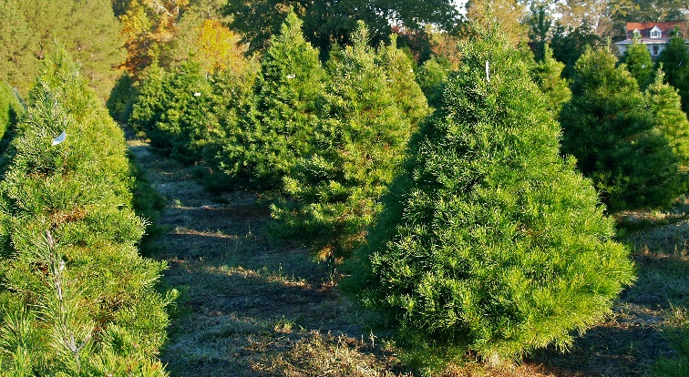
- When Heidi was a kid, her parents grew Virginia pine trees to sell as Christmas trees to supplement the family (teaching) income. They would plant this popular pine from 6 inch (or half a foot) tall seedlings they had purchased from the Georgia Forestry Commission. The growth rate of this pine is about 2 feet per year.
  - Make a rule in words that describes how to calculate the height of the Christmas trees for any given year.
  - Create an equation from the rule in words.
  - Make a table of data for the height of the Christmas trees when first planted (0 years), as well as after 2, 3, and 5 years at their tree farm.
  - Label the y-intercept and the slope.
  - Use the equation or the table of data to draw a line on the graph provided.

Rule in Words
To get the total height of the tree, multiply 2 feet by the number of years and add .5 (for the 6 inches, or half a foot, for the seedling height when first planted.
Equation y = 2x + .5

y-intercept ( 0 , .5 )

Slope 2

Years | Height
0 | .5
2 | 4.5
3 | 6.5
5 | 10.5
Table of Data
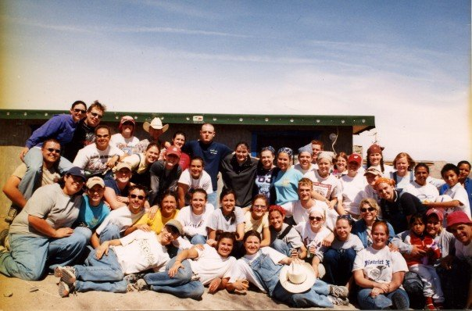
- Every spring break Patty would take a group of college students to Juarez, Mexico, to build houses for some families in need. One of the things she had to calculate in advance was how much food and water to purchase at the local Sam’s Club before crossing from El Paso, TX, into Juarez. She estimated that they would need 2.5 gallons of drinking water for each person for the 4 days they would be working in Juarez, including water for the worksite, cooking, brushing teeth, and washing hands.
  - Make a rule in words that describes how Patty would figure up the total amount of water needed for any given number of students going on the trip.
  - Create an equation from the rule in words.
  - Complete the table of data for the amount of water needed for 20, 30, 40, and 45 students.
  - Label the y-intercept and the slope.
  - Use the equation or the table of data to draw a line on the graph provided.

Rule in Words
To get the total amount of water, multiply 2.5 gallons by the number of students.
Table of Data
Students | Water
20 | 50
30 | 75
40 | 100
45 | 112.5
Equation y = 2.5x

y-intercept ( 0 , 0 )

Slope 2.5 (or $2\frac{1}{2} or \frac{5}{2}$ )

- Lisa had used satellite TV for years, as cable TV was not an option in her area. Her satellite TV bill was $85 per month. She then learned about streaming TV and decided to do some comparison shopping. The streaming TV player had a one-time fee of $50, and the two channels she wanted to watch cost a total of $16 per month.

Part 1:
  - Make a rule in words that describes how to calculate Lisa’s monthly bill for the streaming TV option.
  - Create an equation from the rule in words.
  - Make a table of data for the streaming TV player’s accumulated cost for the 1st, 4th, 8th, and 12th month.
  - Label the y-intercept and the slope.
  - Use the equation or the table of data to draw a line on the graph provided.

Rule in Words
To get the total accumulated cost for streaming TV, multiply $16 by the number of months and add $50 for the cost of the streaming TV player.
Table of Data
Equation y = 16x + 50

y-intercept ( 0 , 50 )

Slope 16

Month | Accumulated  Cost
1 | 66
4 | 114
8 | 178
12 | 242

Part 2:
  - Make a rule in words that describes how to calculate Lisa’s monthly bill for the satellite TV option.
  - Create an equation from the rule in words.
  - Make a table of data for the satellite TV player’s accumulated cost for the 1st, 4th, 8th, and 12th month.
  - Label the y-intercept and the slope.
  - Use the equation or the table of data to draw a line on the graph provided.
Equation y = 85x

Y-intercept ( 0 , 0 )

Slope 85

Rule in Words
To get the total accumulated cost for satellite TV, multiply $85 by the number of months.
Month | Accumulated Cost
1 | 85
4 | 340
8 | 680
12 | 1020
Table of Data

Follow-up questions for #3 (Parts 1 and 2):
Compare the graphs of the streaming TV option to what Lisa had been paying with the satellite TV option.
- Was there ever a point where it was cheaper to use the satellite TV option? If so, where? If not, why do you think that is?
No, there was no single month where it was cheaper to use the satellite TV option because the rate of change (slope) was larger for the satellite TV even though the y-intercept was greater for the streaming TV option.
- What pattern did you notice in the table of data for the satellite TV option?
You could double month 4 to get month 8 and then add month 4 and 8 together to get month 12.
- Did that pattern work for the streaming TV option? Why or why not?
No, that pattern did not work for the streaming TV option because if you doubled any given month you would also double the $50 for the streaming TV player, which was a one-time fee.
- (Challenge Problem) Use the following equation to create a table of data and graph, as well as a story, situation, or scenario that matches the equation, table, and graph.
y = 3x

Sample scenarios:
- The blueprints showed that each square was equal to 3 linear feet in the actual structure.
  - How many linear feet are needed for a structure that has 2 squares? 5 squares? 7 squares?
- My famous biscuit recipe only serves about 4 people, so I always have to triple the ingredients to have enough to feed my whole family at big gatherings.

- (Challenge Problem) Use the following equation to create a table of data and graph, as well as a story, situation, or scenario that matches the equation, table, and graph.
y = x + 3

Sample scenarios:
- Tickets for the rides at the county fair are just $1 each, but you also have to pay $3 for parking.
  - How much will it cost me in total to ride 5 rides? 7 rides? 10 rides?
- I am 3 years older than my cousin.
  - How old am I if he is 37?
  - How old was I when he was 5?
  - How old was my cousin when I was 18?

Graphs

- Virginia pine Christmas trees

- Water for Mexico mission trip

- TV options
  - Part 1 (streaming TV)

  - Part 2 (satellite TV)

- Challenge Problem (y = 3x)

- Challenge Problem (y = x + 3)

