Cape Cod Vacation

When you vacation at the Cape, you will probably want to search the beach for seashells.

Whether you are interested in finding things for an art project or just picking up mementos of your visit, shell collecting can be fascinating. It’s an easy and cheap hobby and popular with many people.

The Cape consists of 300 miles of coast and offers excellent beaches for collecting shells. You will find many types of shells: periwinkles, conch, razor and surf clams, scallops, oysters, and mussels.

Buy a good shell guide, check the local newspaper for the time of low tide, and head for one of the Cape’s sandy beaches. You’ll like this popular seaside activity a lot!

When you start, you will want to make sure you have a plastic bucket or bag, a glass jar for storing your very delicate shells, a notebook and pencil to take notes, sneakers to protect your feet, plenty of suntan lotion, and a sifter.
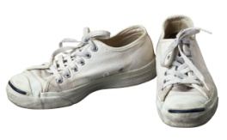
You can begin to look for your shells at the high-tide waterline—many are hidden on the beach between the debris and seaweed.
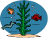
The best time to find shells is at low tide or after a storm. You can possibly find some of these seaside treasures on the rocks or under pieces of driftwood.
