Home Alone

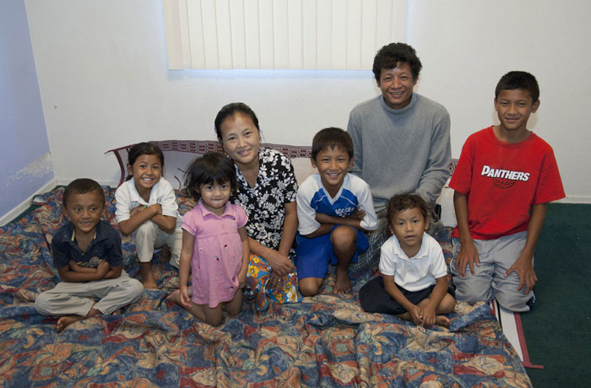

The family is from Burma.
Now they live in Minnesota.
There is a mother and a father.
They have six children.

Source: http://www.rescue.org/news/a-new-home-and-a-dream-come-true-a-refugee-family-arizona-9633
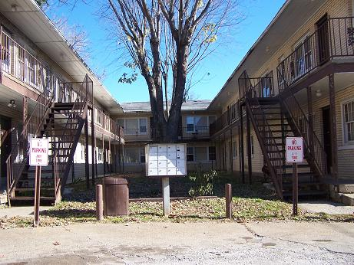

The family lives in an apartment.
They have many neighbors.

Source: http://www.lowincomehousing.us/CA/merced.html

Monday | Tuesday | Wednesday | Thursday | The father works at a factory.  He works Monday to Friday.  He goes to work at 4:00pm.  He comes home at 2:00am.  Friday
Work:  4:00pm to 2:00am | Work:  4:00pm to 2:00am | Work:  4:00pm  to  2:00am | Work:  4:00pm to 2:00am | Work:  4:00pm to 2:00am

Monday | Tuesday | Wednesday | Thursday | The mother works at a store.  She works Monday to Friday.  She goes to work at 9:00am.  She comes home at 6:00pm.  Friday
Work:  9:00am to 6:00pm | Work:  9:00am to 6:00pm | Work:  9:00am  to  6:00pm | Work:  9:00am to 6:00pm | Work:  9:00am to 6:00pm

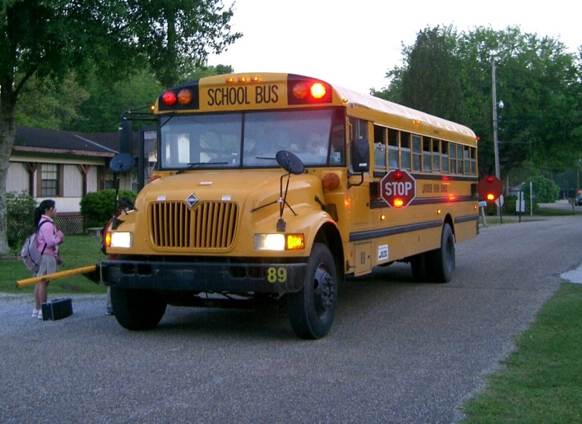

The children go to school.
They ride the bus.
They come home from school at 3:45.

Source: https://en.wikipedia.org/wiki/School_bus_traffic_stop_laws

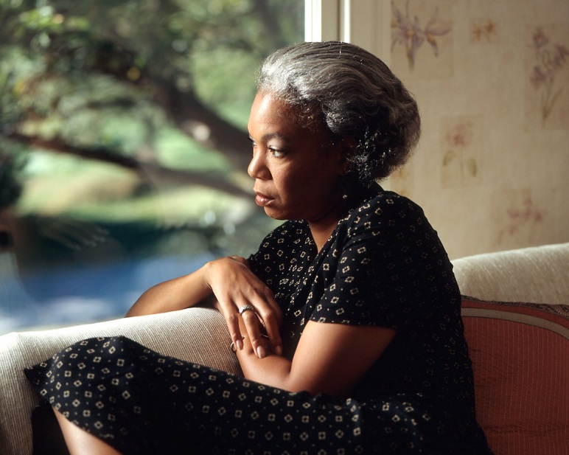

The neighbor sees the children are home alone.
She is worried.
She calls the police.

The police officer goes to the apartment.
He knocks on the door.
He talks to the oldest son.
Source: http://www.mystatecollegelawyer.com

The boy tells the police officer, “I am
12 years old.”
“I take care of my sisters and brothers.”

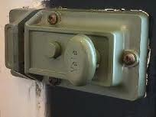

The boy tells the police officer, “I always lock the door.”

Mother Work
(651) 489-5847

Father Work
(612) 884-0926

Emergency
911

The boy tells the police officer, “I know my father and mother’s work numbers.”
“I know how to call 911.”

The police officer says, “The children are okay to stay home alone.”

Flickr User: Tony Webster https://www.flickr.com/photos/diversey/2813513602

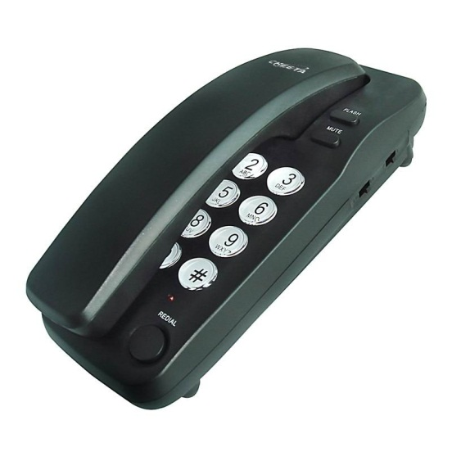
Important Telephone
Numbers
What telephone numbers should everyone in your family know?
Name Number
_____________________ ______________________
_____________________ ______________________
_____________________ ______________________
_____________________ ______________________
_____________________ ______________________
_____________________ ______________________
Where should you put these numbers?

Safe or Dangerous?
Circle the things that are safe for children when they are home alone.
Cross out the things that are dangerous.
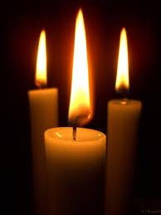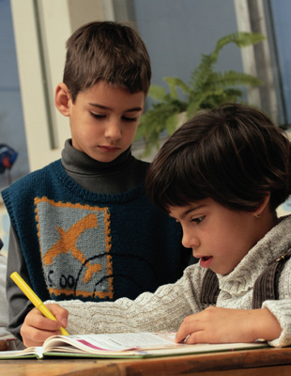
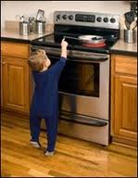
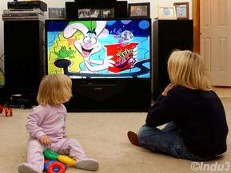
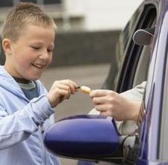

How many children do you have?
How old are your children?
Who takes care of your children when you are not home?

Do your children stay home alone?
Do your children know how to call 911?
Do your children know how to get outside in a fire?

Do your children cook food?
Do your children always lock the door?
Do your children have a key to your apartment?
Do you know your neighbors?
Do you talk to your neighbors?
Do you like your neighbors?
Do you know your neighbors?
Do you talk to your neighbors?
Do you like your neighbors?
Do you always lock your apartment door?
What are your neighbor’s names?
Where are your neighbors from?
Do you know how to call 911?
What is your address?
What is your phone number?

Safe

Draw the picture. Write the word.
Dangerous

Draw the picture. Write the word.
Safe

1______________________

2______________________

3______________________

4______________________

5______________________

6______________________

Dangerous

1______________________

2______________________

3______________________

4______________________

5______________________

6______________________

Safe
Write what is safe for children. Why?

1_____________________________________________

2_____________________________________________

3_____________________________________________

4_____________________________________________

Dangerous
Write what is dangerous for children. Why?

1_____________________________________________

2_____________________________________________

3_____________________________________________

4_____________________________________________

