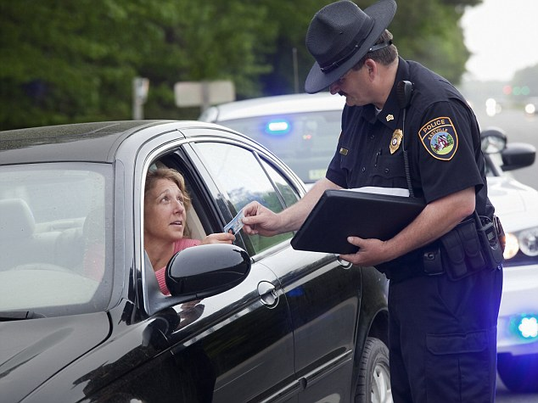
Source: http://collegetrendsdaily.com
Who do you see?
What are they doing?
How does the driver feel?

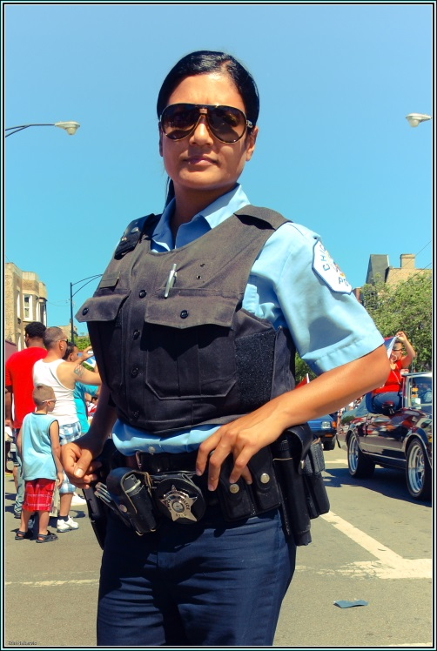
Flicker User: TheeErin https://www.flickr.com/photos/theeerin/4718404476
Who do you see?
What does she do?
Do you see women police in Minnesota?
Do you see women police in your country?
Source: https://www.youtube.com/watch?v=eHrLOtYOQ88
Who do you see?
What are they doing?
Do you have a booster seat?

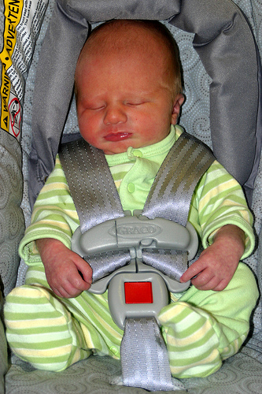
Flicker User: Mark Evans https://www.flickr.com/photos/chimothy27/2723866254
Who do you see?
What are they doing?
Do you have a car seat?
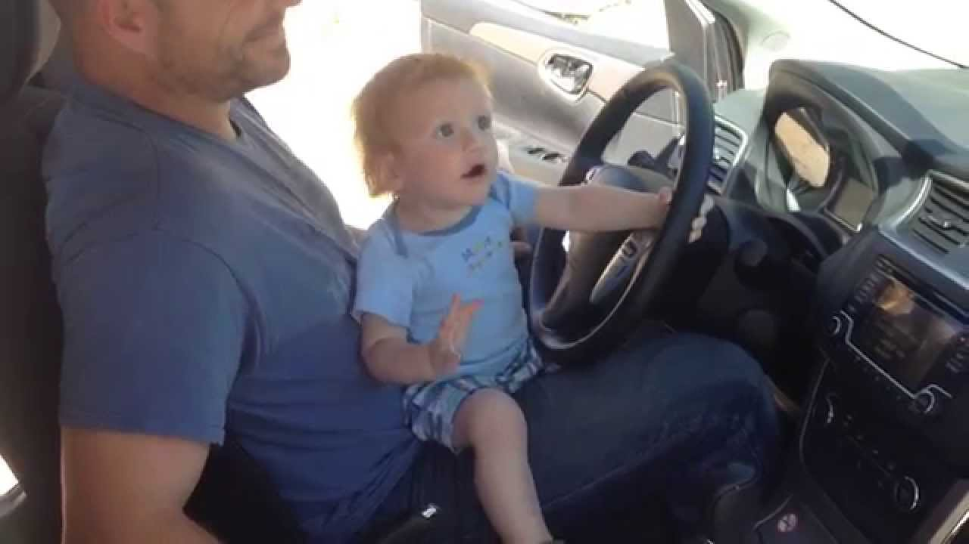
Source: https://www.youtube.com/watch?v=Sx4Jc1i8mSE
Who do you see?
What are they doing?
Is this okay?
What is the problem?

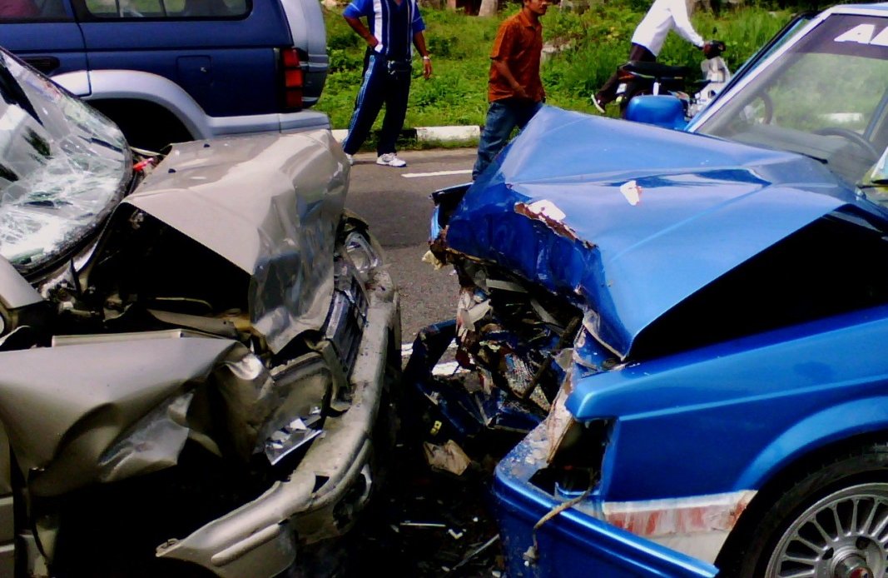
Source: https://en.wikipedia.org/wiki/Traffic_collision
What do you see?
Do you have a driver’s license?
Do you ever have an accident?
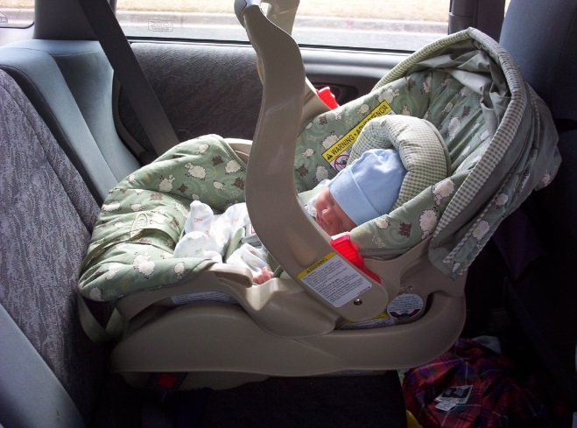
Flickr User: Chris Wiegand https://www.flickr.com/photos/chriswiegand/125486076

Source: https://vimeo.com/73548700

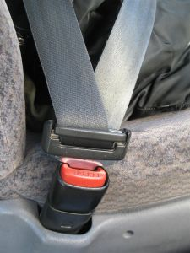
Public Domain Image

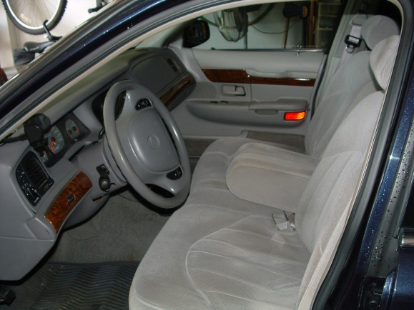
https://en.wikipedia.org/wiki/Mercury_Grand_Marquis
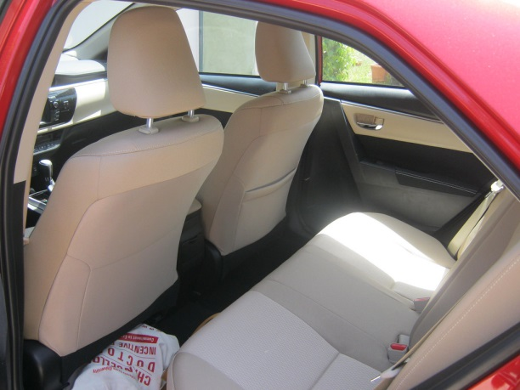
Flickr User: Bob Perry https://www.flickr.com/photos/rudyperry/14171015951

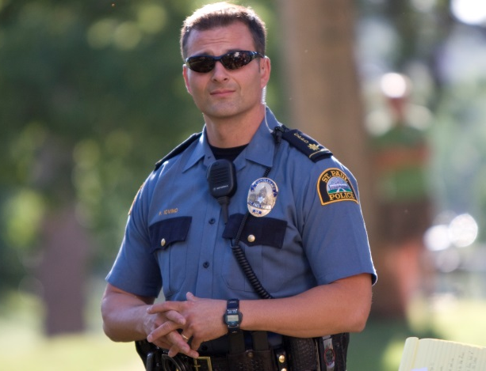
Flickr User: Tony Webster https://www.flickr.com/photos/diversey/2813513602

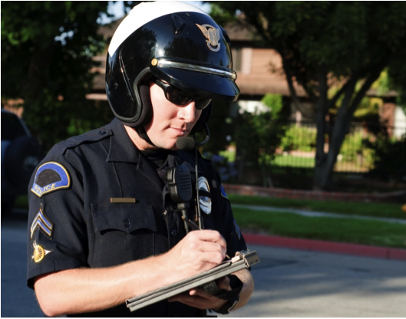
Source: http://blog.aisinsurance.com/2013/10/22/

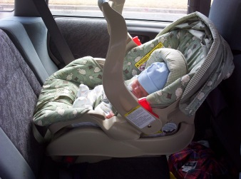

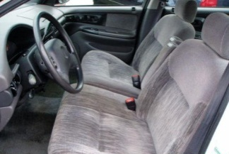
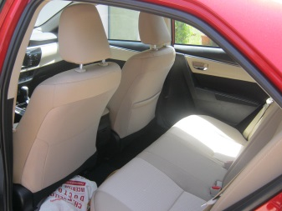
Front Seat

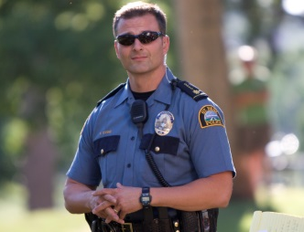

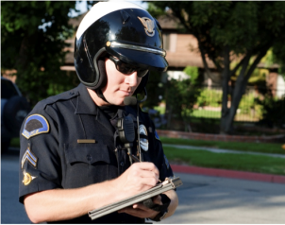

seatbelt

back seat

car seat

ticket

booster seat

front seat

police officer

Write the words.

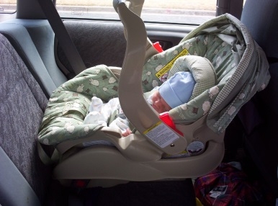
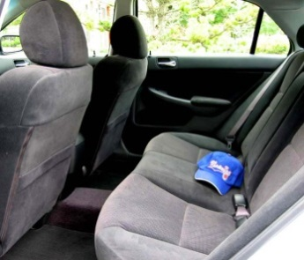
___________________________ ______________________________

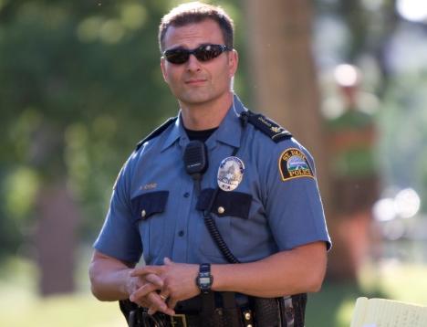

______________________________ ______________________________

_________________________________ _________________________________

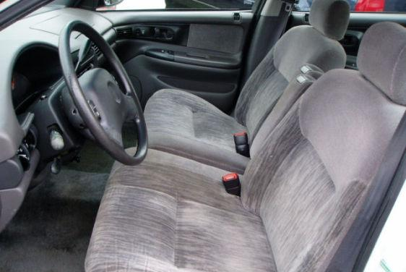

_________________________________
Write the law.

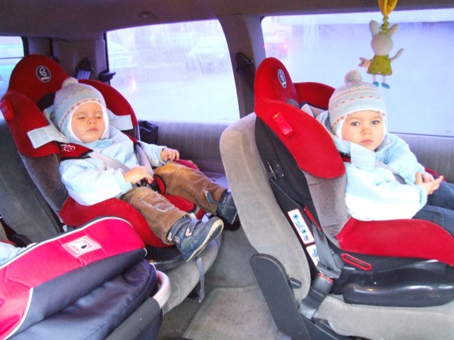
____________________________________________________________________________________________________
Source: https://en.wikipedia.org/wiki/Child_safety_seat

____________________________________________________________________________________________________
Flickr User: State Farm https://www.flickr.com/photos/statefarm/18927509421

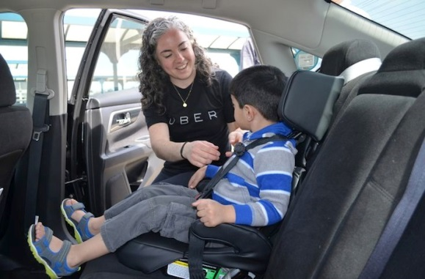
____________________________________________________________________________________________________
http://www.sassymamasg.com/car-safety-in-singapore-ridesafer-travel-vest/

Questions:
Do you understand the laws? Y / N
Do you use a car seat? Y / N
Do you use a booster seat? Y / N
Do you use a seatbelt? Y / N
Do you have a driver’s permit? Y / N
Do you want a driver’s license? Y / N
A Police Ticket
The mother wants to go shopping with her baby.
She doesn’t have a car.
She calls her friend.
She asks “Will you drive me to go shopping?”
The mother sits in the front seat.
She holds her baby.
Her friend asks, “Do you have a car seat?”
The mother answers, “No I don’t. It’s no problem.”
The police officer stops the car.
The police officer asks “Where is your car seat?”
The mother answers, “I don’t have one.”
The police officer writes her a ticket.
The mother is very sad.
She has to pay money for the ticket and a car seat.

Name | How many children do you have? | How old are your children? | Do you have a car seat? | Do you have a booster seat?
Name | How many children do you have? | How old are your children? | Do you have a car seat? | Do you have a booster seat?

