A New Apartment

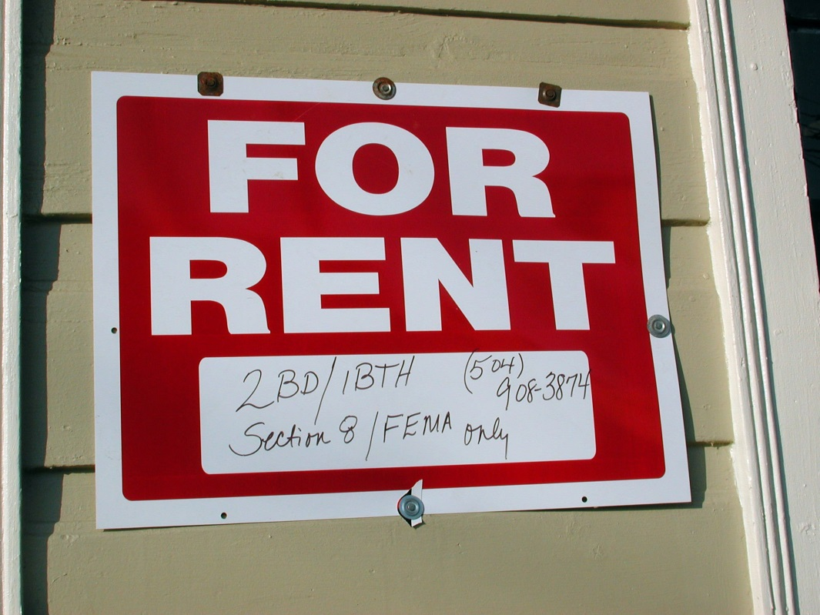
Look at the pictures.
What do you see?

Flicker User: Bart Everson https://www.flickr.com/photos/editor/1225566388

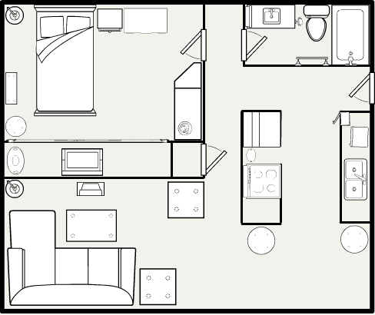
Flicker User: Elissa Merola https://www.flickr.com/photos/elissamae/1405195369

A New Apartment

1. Maryan and Hassan want a new apartment.
2. They look at many different apartment buildings.
3. They find a nice apartment in Minneapolis.
4. The apartment has three bedrooms.
5. The apartment has a big bathroom.
6. The bathroom has two sinks, a toilet, and a shower.
7. The apartment has a big kitchen.
8. The kitchen has a big stove and a big refrigerator.
9. The apartment has a big living room.
10. The living room has tall windows and ceilings.
11. The apartment has two doors with locks.
12. The heat in the apartment is very good.
13. Maryan and Hassan like the apartment.
14. They sign a one-year lease.

A New Apartment

Write TRUE or FALSE.

1. _______ 1. Maryan and Hassan want a new house.
2. _______ 2. They find a nice apartment.
3. _______ 3. The apartment has two bedrooms.
4. _______ 4. The apartment has a small kitchen.
5. _______ 5. The heat in the apartment is not good.
6. _______ 6. They sign a one year lease.

Listen. Write the letters.

1. apa____ment 6. ___indows
2. be___rooms 7. si____
3. ba____room 8. lo___
4. ki______en 9. ___ease
5. ___ove 10. re___igerator

Talk about the questions.

1. Where do you look for an apartment?
2. Do you have a one year lease?

A New Apartment

1. Maryan and Hassan want a new _________________.
2. They look at many different apartment buildings.
3. They find a nice apartment in _______________________.
4. The apartment has three ____________________.
5. The apartment has a big bathroom.
6. The bathroom has two sinks, a toilet, and a ____________.
7. The apartment has a big kitchen.
8. The kitchen has a big ____________ and a big refrigerator.
9. The apartment has a big living room.
10. The living room has tall ________________ and ceilings.
11. The apartment has two doors with _____________.
12. The ___________ in the apartment is very good.
13. Maryan and Hassan like the apartment.
14. They sign a one-year _____________.

A New Apartment
Maryan and Hassan want a new ________________. They look at many different apartment _____________. They find a nice apartment in ________________. The apartment has three _____________. The apartment has a big __________________. The bathroom has two ___________, a toilet, and a ______________. The apartment has a big ___________________. The kitchen has a big ______________ and a big refrigerator.
The apartment has a big _____________________. The living room has tall _________________ and _______________. The apartment has two doors with _____________. The ___________ in the apartment is very good. Maryan and Hassan like the apartment. They sign a one-year ______________.

What rooms do you see?
1.
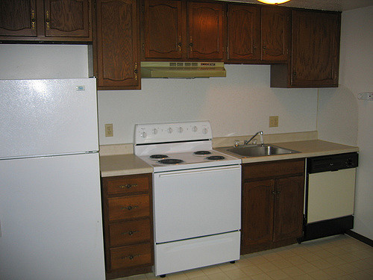
https://www.flickr.com/photos/erieapartments2007/523378658

2.
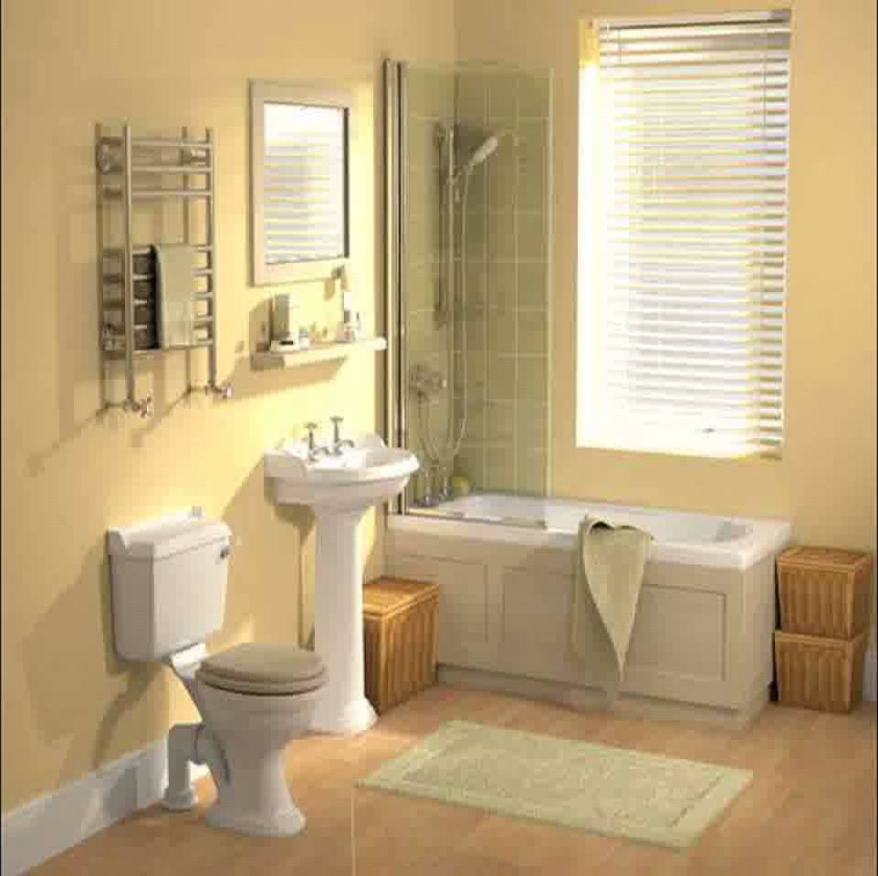
https://www.youtube.com/watch?v=Wmm8hc9-TeM

3.
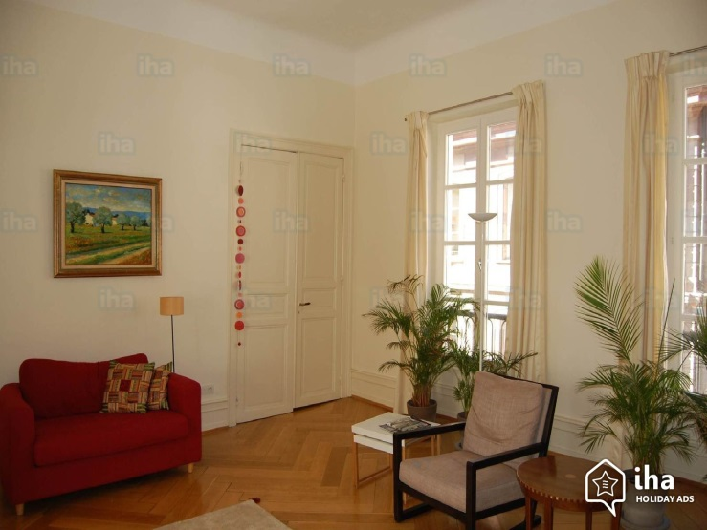
http://www.iha.com/gite-self-catering-charming-apartment-strasbourg_72304
Write the words.
1.
_________________________

_________________________

_________________________

_________________________

2.
_________________________

_________________________

_________________________

_________________________

3.
_________________________

_________________________

_________________________

_________________________

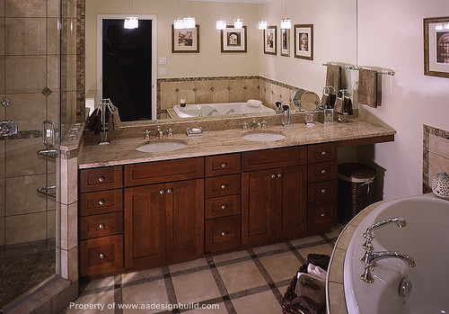

Flickr user A & D Design Build Remodeling
https://www.flickr.com/photos/aa_design_build_remodeling/4206217842

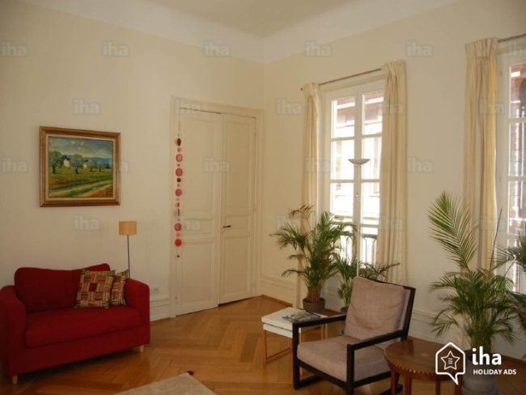
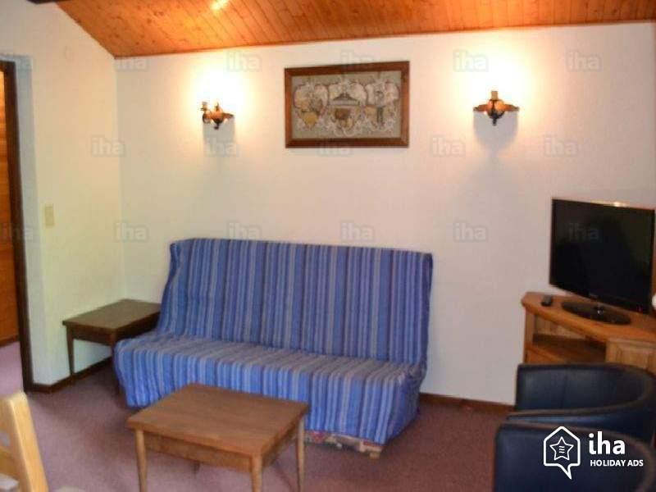

http://www.iha.sg/holiday-lettings-flat-apartments-chatel_43440

https://www.flickr.com/photos/erieapartments2007/523378658

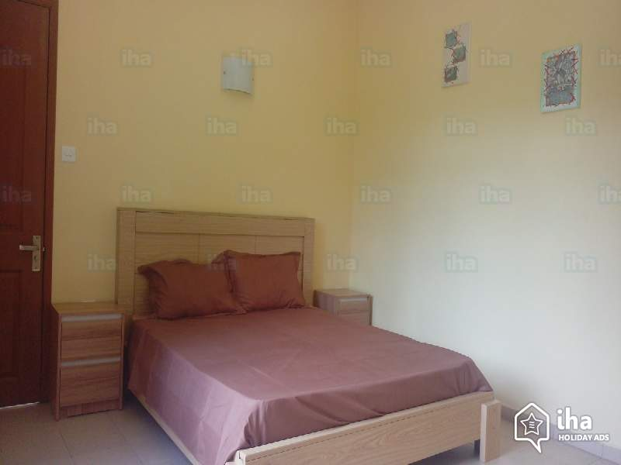
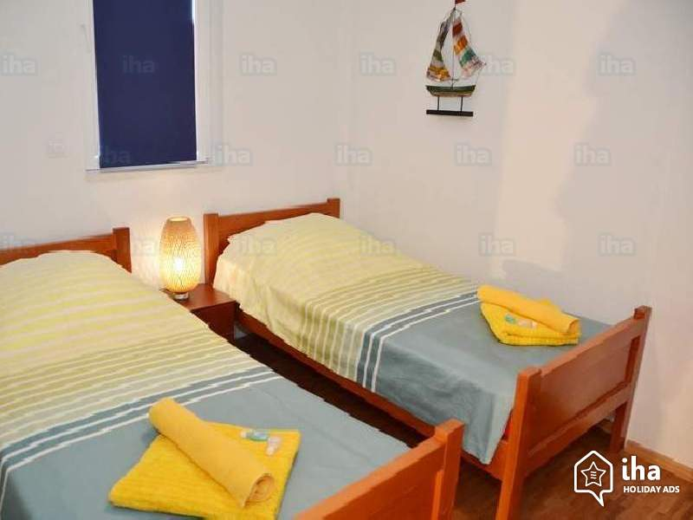
http://www.ph.iha.com/short-term-rentals-apartment-flat-ohrid-municipality_54584

https://www.youtube.com/watch?v=Wmm8hc9-TeM

http://www.iha.ie/holiday-lettings-flat-apartments-la-gaulette_43011
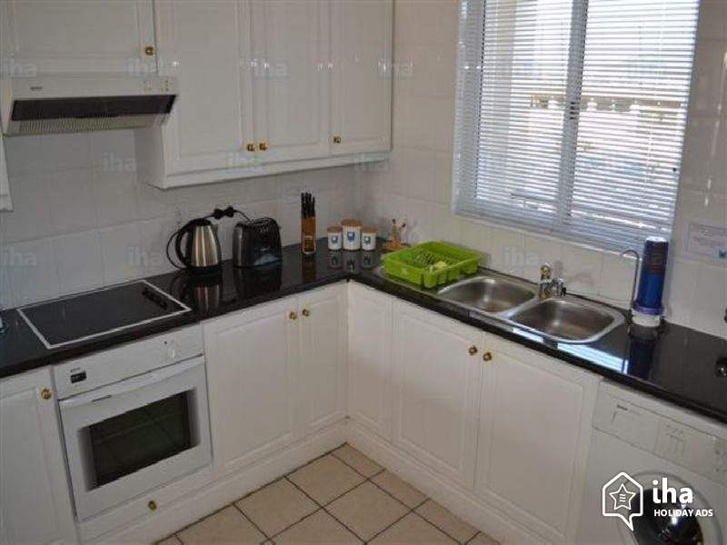
http://www.iha.com/short-term-rentals-apartment-flat-knysna_59775

http://www.iha.ie/holiday-lettings-flat-apartments-la-gaulette_43011

e t h a
____________________

k i s n
____________________

w s r h e o
____________________

l t i t e o
____________________

r m d e o b o
____________________

k l o c
____________________

h r o m b t a o
____________________

n k i e c t h
____________________
buildings.
many
They
look
at
different
apartment
The
apartment
has
two
doors
with
locks.
The
kitchen
has
a
big
stove
and
a
big
refrigerator.
They
find
a
nice
apartment
in
Minneapolis.
The
apartment
has
three
bedrooms.
The
apartment
has
a
big
living room.
My Home
Name: _________________________________ Date: __________________
Address: ____________________________________________________________
City: _________________________ State: _______ Zip Code: ____________

