A Small Apartment

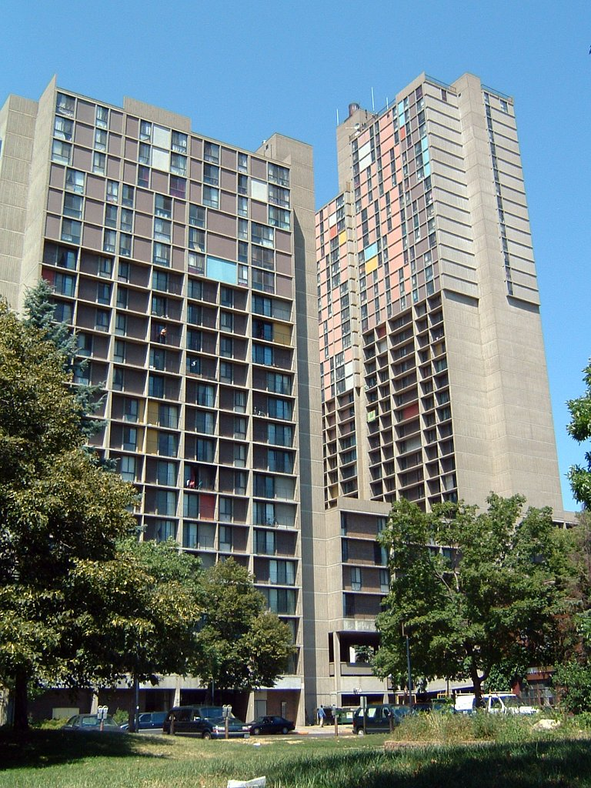
Look at the pictures.
What do you see?

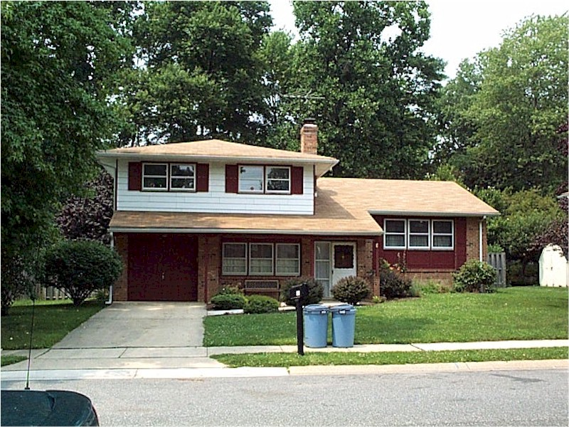

https://en.wikipedia.org/wiki/File:Traditional_Side_Split_Level_Home.jpg

A Small Apartment

1. Maryan and Hassan have three children.
2. They live in an apartment building.
3. Their apartment has one small bathroom.
4. It has two small bedrooms.
5. It has a small kitchen and a small living room.
6. It is very crowded.
7. In April, Maryan will have a new baby.
8. Maryan and Hassan want a new apartment.
9. They want to have three bedrooms.
10. They want to have a big living room.
11. They want a nice apartment for their family.

A Small Apartment

Write TRUE or FALSE.

1. _______ 1. Maryan and Hassan have four children.
2. _______ 2. They live in a house.
3. _______ 3. Their apartment has one bedroom.
4. _______ 4. Maryan will have a new baby in April.
5. _______ 5. Maryan and Hassan want a new apartment.
6. _______ 6. They want to have four bedrooms.

Listen. Write the letters.

1. ____ant 6. apartme____
2. ____ig 7. be___room
3. ____all 8. li__ing room
4. ____ildren 9. ba____room
5. ____owded 10. kit____en

Talk about the questions.

1. Do you live in a house or an apartment?
2. How many bedrooms do you have?
3. Is your home big or small?
My
apartment
is
small
The
living room
big
I
want
two
bedrooms
He
has
a
one
bedroom
She
nice
have
three
bathroom
Her
His
.

A Small Apartment

1. Maryan and Hassan have three ________________.
2. They live in an apartment __________________.
3. Their apartment has one small __________________.
4. It has two small ___________________.
5. It has a small _________________ and a small living room.
6. It is very crowded.
7. In April, Maryan will have a new ______________.
8. Maryan and Hassan want a new __________________.
9. They want to have ____________ bedrooms.
10. They want to have a big ______________________.
11. They want a ____________ apartment for their family.

A Small Apartment

Maryan and Hassan have three ________________. They live in an ________________ ______________. Their apartment has one small ________________. It has two small _________________. It has a small ______________ and a small _____________ ________. It is very __________________.

In _____________, Maryan will have a new ____________. Maryan and Hassan want a new ________________. They want to have three _________________. They want to have a big _____________ __________. They want a _________ apartment for their _______________.

Rooms

Name | Do you live in a house or apartment? | How many bedrooms? | How many bathrooms?

Write sentences.
1. _______________ lives in a __________________. 3. _______________ lives in a __________________.
______ has _____ bedrooms. ______ has _____ bedrooms.
______ has _____ bathroom___. ______ has _____ bathroom___.

2. _______________ lives in a ___________________. 4. _______________ lives in a ___________________.
______ has _____ bedrooms. ______ has _____ bedrooms.
______ has _____ bathroom___. ______ has _____ bathroom___.

Rooms

Name | Do you live in a house or apartment? | How many bedrooms? | How many bathrooms?

Write sentences.
1. _____________ lives in a ____________________. 3. ________________________________________
______ has _____ bedrooms. ________________________________________
______ has _____ bathroom___. ________________________________________

2. _____________ lives in a ____________________. 4. ________________________________________
______ has _____ bedrooms. ________________________________________
______ has _____ bathroom___. ________________________________________
House or Apartment
18
17
16
15
14
13
12
11
10
9
8
7
6
5
4
3
2
1
House Apartment
Bedrooms
18
17
16
15
14
13
12
11
10
9
8
7
6
5
4
3
2
1
1 bedroom 2 bedrooms 3 bedrooms 4 bedrooms 5 bedrooms

Bathrooms
18
17
16
15
14
13
12
11
10
9
8
7
6
5
4
3
2
1
1 bathroom 2 bathrooms 3 bathrooms

Questions
House or Apartment
1. How many people live in a house? ________
2. How many people live in an apartment? ________

Bedrooms
1. How many people have 1 bedroom? ________
2. How many people have 2 bedrooms? ________
3. How many people have 3 bedrooms? ________
4. How many people have 4 bedrooms? ________
5. How many people have 5 bedrooms? ________

Bathrooms
1. How many people have 1 bathroom? ________
2. How many people have 2 bathrooms? ________
3. How many people have 3 bathrooms? ________

