Expanding student understanding of Indigenous worldviews
Dr. Paul McKenzie-Jones

TYPE: This is a series of lesson plans and assignments drawn out over the course of a semester.

MOTIVATION: The purpose of this OER is to engage students with Indigenous cultures beyond the boundaries of Montana also the United States, in order for them to better understand the Indigenous cultures within Montana and the United States. One of the main deficiencies I wanted to correct in devising these lesson plans was the idea that ‘settlement’ of the land was as benign a transaction as a modern-day house sale. By removing the United States from the equation and using similar, English-speaking settler-colonial states as examples, it is easier for students to take a detached, unemotional view of Indigenous land removal. The second major corrective issue at stake was to remove the assumption that land loss and cultural disintegration are irreversible and result in eventual assimilation to the dominant culture. Ultimately the intention is to enable both Native and non-Native students to develop a wider cultural consciousness than they began with through exposure to other Indigenous cultures and the subsequent ‘rethinking’ of American Indians through comparative indigineity.
USA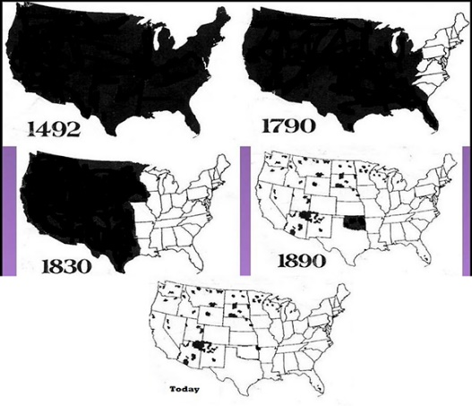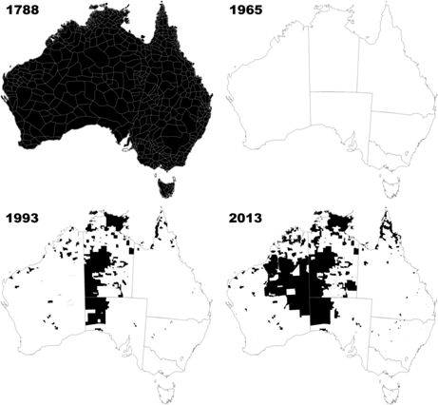Australia
IEFA: While IEFA focusses upon Montana Indian histories and experiences, I ask students to engage broadly with other indigenous communities within and outside of the United States. Often these examples are shown next to local forms of cultural expression. This exposure, its comparative component, and the analytical discussion of such, has proven to help them understand and appreciate the local indigenous perspectives more clearly than when these local perspectives are studied/discussed in isolation. This is especially so in terms of cultural relevancy, when they can see similar historical patterns between local cultures and those overseas, as well make direct cultural connections between American Indian communities and First Nations and Polynesian cultures.
MATERIALS & TECHNOLOGIES INVOLVED: I use a wide variety of materials and technologies in these lesson plans: maps, Powerpoint, music, video, film, art, lecture material, Indigenous artwork, graphic novels, and computer games.
Canada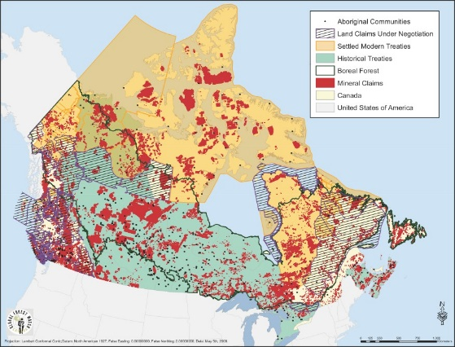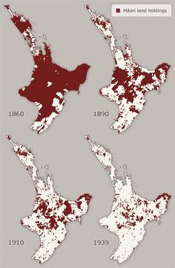Aotearoa

LEARNING OBJECTIVES/TARGETED OUTCOMES: By the end of the semester, students should be able to:
- Recognize and discuss such terms as settler-colonialism and Indigeneity as they relate to American Indians and other Indigenous cultures.
- Connect the history of American Indians with the global history of western expansion and Indigenous suppression, rather than simply through an American lens.
- Juxtapose the ideas of land loss and culture loss as permanent realities with the actual realities of, albeit slow and intermittent, land reclamation and more robust cultural rejuvenation, both in the United States and elsewhere.
- display better understanding of the contemporary legacies of settler-colonialism and the reality of Indigenous oppression in the modern era, rather than as remnants of a tragic but distant history of ‘discovery.’
- be able to understand and articulate why terms such as Native American/American Indian, First Nations, Aboriginals, etc. are constructs of settler-colonialism designed as a means of codifying and subjugating Indigenous peoples through the removal of mechanisms of self-recognition. 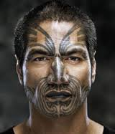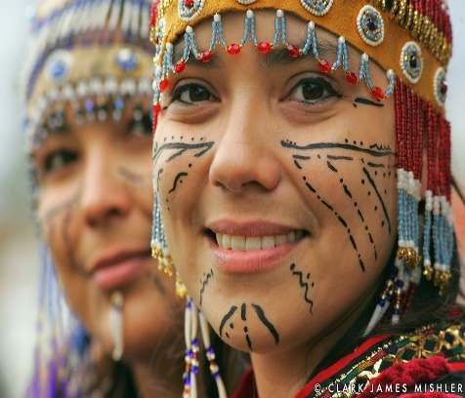
Activity or Module Sequence
These lesson plans occur throughout the semester, and a varying times depending on which course they are used in and which themes are being explored – activism, comparative history, material cultures, or contemporary issues. Generally each component begins with a Q&A discussion between instructor and students to ascertain levels of prior knowledge of mast basic components of forthcoming lecture.
Historical Comparisons: Compare narratives of ‘discovery’ and ‘encounter.’ Discuss such common themes as war, land loss, treaties, assimilation, forced adoptions, boarding schools and many more. Engage students with questions throughout the lectures in order to make them connect these Indigenous histories and other countries.
Sources used include: Roxanne Dunbar-Ortiz’s An Indigenous Peoples’ History of the United States and Arthur J Ray’s I Have Lived Here Since the World Began.
Comparative activism: Ask students to compare impulses of rebellion and rejection born out of the above-mentioned histories and connect them to contemporary indigenous movements of empowerment. Guide them through processes of recognition of similar patterns of oppression and connected forms of protest. Challenge them to unpick such acts of intolerance as cultural oppression in order to understand such seemingly inconsequential acts as language speaking as forms of activism.
Sources include: Paul McKenzie-Jones’ Clyde Warrior: Tradition, Community, and Red Power, The Kino-nda-niimi Collective’s The Winter We Danced, Gary Foley’s The Aboriginal Tent Embassy: Sovereignty, Black Power, Land Rights and the State, and http://www.teara.govt.nz/en/te-ture-maori-and-legislation/page-1
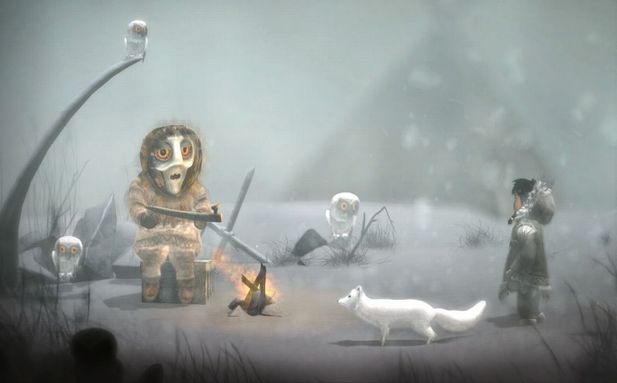

Material Cultures: Rather than look for similarities in form between different types of Indigenous song, dance, language etc. engage the students in seeking similar forms of meaning and relationality in these seemingly common aspects of Indigenous cultures, such as drums, dance, ceremony, body paint, tattoos etc. If we seek meaning rather than definition, what can we learn, rather than assume and take, from indigenous peoples? And how can we translate that process of learning to Indigenous peoples in our own state? If we see indigenous rather than American Indian, does that give us clearer paths towards seeing distinctions between Crow, Blackfeet, Salish, and Kootenai etc.?
Sources here include: You Tube films, cd’s, websites, video games, graphic novels, and other forms of material (expressive) cultures, such as https://www.youtube.com/watch?v=0XlEkeot7HM (didgeridoo player), https://www.youtube.com/watch?v=aPGBpFltqtE (Native American flute), https://www.youtube.com/watch?v=KNb2ZDjeiU4 (Inuit Throat Singing), https://www.youtube.com/watch?v=3BoNmpvkavo (Maori Haka), https://www.youtube.com/watch?v=ITyVKJ7wwRo (Men’s Northern Traditional) http://neveralonegame.com/ (Immerisve Inupiat Video Game), http://www.darobertson.ca/publications/7-generations/ (7 Generations Graphic Novel)
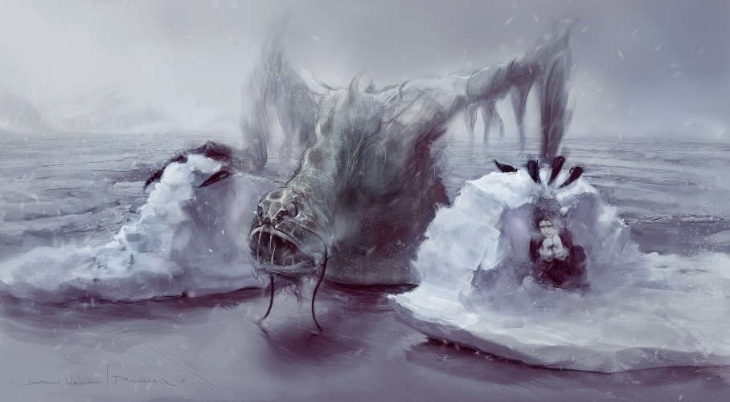
Contemporary Issues: Generally, students enter the classroom assuming that all detrimental contemporary American Indian issues are their own fault through ‘laziness’ or some other pejorative label. If this is so, how do we explain exactly the same issues affecting those Indigenous peoples in other settler states with almost exactly the same histories of settler-colonial oversight and oppression? At what point do we stop pointing the finger at our Indigenous populations and start examining how much our own imposed systems of capitalism and enforced quasi-sovereignty are truly responsible? Comparative contemporary issues are a speedy way for students to make those connections and begin that period of self-reflection.
Sources used include: http://www.ourgeneration.org.au/trailer, (Aboriginal community closures), https://www.youtube.com/watch?v=ksESR2BVlqY (Idle No More), http://www.nwac.ca/wp-content/uploads/2015/05/Fact_Sheet_Missing_and_Murdered_Aboriginal_Women_and_Girls.pdf (Missing/Murderd Women), http://www.scoop.co.nz/stories/PA1405/S00149/maori-unemployment-soars-under-national.htm (Maori Unemployment), http://www.pewresearch.org/fact-tank/2014/06/13/1-in-4-native-americans-and-alaska-natives-are-living-in-poverty/ (American Indian/Alaska Native Unemployment) http://thinkprogress.org/health/2015/11/25/3725814/native-community-food-insecurity/ (American Indian Food Insecurity), http://www.healthinfonet.ecu.edu.au/health-risks/nutrition/reviews/other-reviews (Aboriginal & Torres Strait Islander Food Insecurity)

Assessment(s): As with the above, assessments take many forms depending upon the course, and the cultural components being studies. Assignments can vary from playing cultural immersive video games (Never Alone/Qalupalik (forthcoming), reading graphic novels (written and drawn by indigenous storytellers and artists – many based on traditional stories), listening to music, or writing connective/comparative research essays or presentations. Grading is focused upon critical analysis, cultural understanding, respect rather than paternalistic sentiment, empathetic interpretation (especially in relation to the more ambiguous forms of storytelling represented in Indigenous graphic novels), displayed awareness of connectedness among ‘settled’ Indigenous peoples, and connectedness to the material being written or presented.
Revision: While I have successfully used most of the comparative/connected lesson plans for several years, the video game and graphic novel assignments were both experimental additions this semester. In both cases, they were a roaring success. Students engaged with the visual material, and were highly receptive to the Indigenous themes and messages being portrayed because of the medium that was used to convey the messages. The immersive video game resulted in several high quality, culturally sensitive essays that were extremely respectful rather than romantic about Indigenous relationships to the land, with animals, and with the environment. The process of unlocking cultural insights as rewards throughout the game also realigned several student’s attitudes from assuming entitlement to Indigenous cultures to attitudes of gratitude for having those cultural insights shared. This was a major bonus and much more than I expected to see as a result of the assignment. One potential next step for revision, notwithstanding institutional approval, will be to construct a new course based entirely around Indigenous comic art and video gaming.

