- The Block diagram Shown below is for:

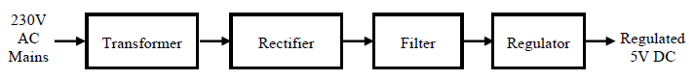

- AC power Supply
- DC Regulated power supply
- Rectifiers
- Diodes

- In half wave Rectifier How many diodes are required?
- 2
- 4
- 1
- Not a single

- In half wave Rectifier, Diode acts as an Close switch only for
- Half cycle of the input
- Full cycle of the input
- Sometimes for half cycle sometimes for full cycle
- None of the above

- In Center-tap full wave rectifier which transformer is used
- Step-up
- Step-down
- Centre Tap
- All of these

- How many diodes are used in bridge rectifier?
- 1
- 2
- 3
- 4

