Curriculum Formatting Instructions
Trainer’s Guide
SECTION | DESCRIPTION  PERSON RESPONSIBLE
Pages 1– 8:  - Cover sheet  - Table of Contents  - Acknowledgments  - Blank page  - Introduction | Only the title changes on page 1 and in the footer.  Developer  Standard for all trainers guides.  Page 5-8 Standard for all trainers guides
Tips for Training This Curriculum | developer
Evaluation Protocols | CalSWEC Evaluation Specialist (Tenia)
Agenda | Developer provides
Learning Objectives | Varies by training  Developer includes
Lesson Plan | Varies by training  Developer provides , example provided on pages 15-19
Segments | Each segment should have:  - Segment number followed on same line by Title of segment  - Activity time  - Trainee content  - Materials  - PPT slide number(s) when appropriate  For the following, if PPT slides are used, then create a two-column table with text on left and accompanying thumbnail of slide(s)  - Description of activity  - Before the activity  - During the activity  Developer, example provided on pages 15-19
Handouts | Developer
Reference/Bibliography | Developer
Materials Check List | Developer
Appendix | Developer

Classroom PPT
- Standard for every classroom training | 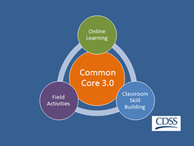
- edit title and date

- Add classroom specific information
Standard for every classroom training  - If you are doing group agreements, go over the basic group agreements included on the slide and use chart pad paper to add agreements or modify the one provided.  Offer the following brief explanations of the group agreements as needed (this will depend on whether or not this group has already worked to establish group agreements). This activity provides a model for the group work social workers will do with child and family teams, so you may wish to make that connection as well.  - Collaboration - We need partnership to have engagement and that works best if we trust each other and agree we are not here to blame, or shame. We are here because we share a common concern for the safety and well-being of children. Remind them how this skill will be needed when working with families as they are the experts on their family so social workers have to be able to foster collaboration to be able to do a good assessment of the situation. Families will need to feel a little bit of trust before they will genuinely go inside themselves and be able to look at a problem from their part in it.  - Ask lots of questions - Point out that the trainer can’t make the training relevant for each person because there are many people in the room with different experiences and different needs. So participants have to make it relevant for themselves by asking lots of questions and deciding how the experience might be helpful or not helpful to them.  - Enjoy have fun - Explain that when people are relaxed we are able to be present and learn more. When our brains are relaxed and ready we can join up and get more out of the day.  - What the Heck attitude - As professionals we feel more comfortable and competent sticking with what we know. We don’t always like it when new things come along. Sometimes it feels uncomfortable to try new things so we tend to back away from the new thing telling ourselves things like “she doesn’t know what she’s talking about...she has never worked in our community with the people we work with...” But to learn something new we have to go through the uncomfortable stage to get to the other side where it feels natural and comfortable. With this group agreement, they are agreeing to say “What the Heck!” and try new things even if they feel uncomfortable.  - Make Mistakes - As professionals we don’t like to make mistakes. And when we make mistakes we feel discouraged and beat ourselves up. But, if we are going to learn new things, we have to make mistakes. Mistakes are informative; they tell us which path to go down and they point the way.  Confidentiality - This is just a reminder that information about families or other trainees shared in the training room should be kept confidential. | 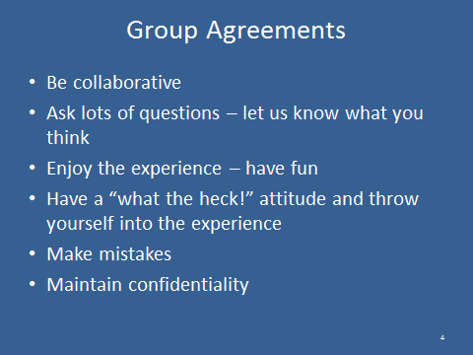

Trainee’s Guide
SECTION | DESCRIPTION  PERSON RESPONSIBLE
Pages 1–4  - Cover sheet  - TOC  - Introduction to Common Core  - Curriculum Introduction | Only the title changes on page 1 and in the footer.  Developer  Standard for all trainers guides.  Developer, sop information stays the same
Agenda | Same as Trainer’s Guide
Learning Objectives | Varies by training, Developer provides
Curriculum/Materials/Worksheets | developer
Resources/References/Bibliography | developer

Shared by trainer Betty Hanna

